Prevention of Infection: Oral Hygiene
Key Stage 2

Lesson 8: Oral Hygiene
Students play an interactive memory card game to highlight the similarities between human and animal health.

Learning Outcomes

All students will:
- Understand what dental plaque is and how it forms.
- Understand which foods and drinks cause tooth decay.
- Understand the consequences of tooth decay.
- Understand how to brush teeth effectively.
- Understand that limiting sugary foods and drinks can reduce tooth decay Understand that what you do to help your pet be healthy is the same as what you need to do for yourself.

Curriculum Links

PHSE/RHSE
- Health and prevention

Science
- Working scientifically
- Animals, including humans

English
- Reading & comprehension

Lesson 8: Oral Hygiene

Resources Required

Main Activity: Attack the Plaque

Per group
- Water
- Food colouring (any colour but white)
- Cornflour
- Flour (optional)

Per student
- Toothbrush
- Yoghurt pot
- Paint brush

Activity 2: Sugar Drink Activity

Per Group
- Empty Drinks Bottles
- Teaspoon
- Self-Sealing Bag
- Sugar

Extension Activity: Tooth Brushing Diary

Per student
- Copy of SW1

Additional Resources:
- Copy of PP1 (available from the e-bug.eu website)

Supporting Materials
- SW1 Brushing Diary/Chart
- PP1 Oral Hygiene MS PowerPoint Presentation

Advanced Preparation
During the lesson or the week before, distribute the tooth brushing diary (SW1) alongside the weekly homework. Students should tick if they brushed their teeth that morning or the previous night. Results do not have to be discussed in class.
Set up PP1 (available on the e-Bug website, e-bug.eu).


Lesson 8: Oral Hygiene

Key Words
Plaque
Disease
Enamel
Fluoride
Hygiene
Teeth brushing

Health & Safety
For safe microbiological practices in the classroom consult CLEAPPS
www.cleapps.org.uk

Weblinks
e-bug.eu/eng/KS2/lesson/ Oral-Hygiene

Introduction
Begin the lesson by explaining to the students that tooth decay is a preventable disease using the information contained in the teacher refresher section. Explain students will learn what causes tooth decay and the simple steps they can take to prevent it. Show the students PP1. Use the questions within the presentation to begin a discussion and gather student knowledge.
- Complete the Main Activity – Keeping your teeth healthy – Attack the Plaque experiment
- Complete Activity 2 – Healthy Diet – Sugar drink activity
Key message - you can stop tooth decay by:
Students should learn that you can prevent tooth decay by eating sugary foods and drinks less often, and in smaller amounts, and by brushing teeth with a fluoride toothpaste last thing before bed and in the morning.

Guidance for Teachers
Below is an example of a nutrition label that can be used to identify the sugar content of foods and drinks. Red = high sugar content; Amber = medium sugar content; Green = low sugar content Note: Nutrition labels give the total sugar content, not just added sugar, therefore, some dairy products may be graded amber due to naturally occurring sugars despite having no added sugar.
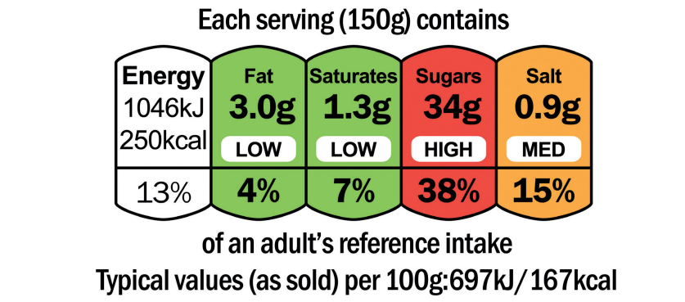

Activity

Main Activity: Attack the Plaque
- Ask students to mix a small amount of water with cornflour and a drop of food colouring.
- Paint this mixture onto the outside of small white yoghurt pots.
- Wait for yogurt pots to dry.
- Now ask the students to try brushing the cornflour mixture (representing plaque) off the yoghurt pots with a toothbrush.
- Notice that when the cornflour mixture (representing plaque) dries, it is very difficult to brush off. If we don't brush our teeth twice a day, the plaque can harden and become more difficult to remove.

Extension Activity: Attack the Plaque Scientific Investigation
This experiment can be expanded to include scientific investigation of the effects of not brushing teeth regularly verses everyday:
Set up three yoghurt pots as below:
- No cornflour = brush twice a day
- Wet cornflour = brush once a day
- Dry cornflour = no brushing
Ask the students to try brushing the cornflour mixture off the pots with a toothbrush. Which is easiest to remove the plaque from?
Students should recognise that brushing teeth everyday makes brushing easier, and that plaque can be hard to remove over time if left on teeth. Hardened plaque is called calculus.

Activity 2: Sugar Drink Activity
This activity is for groups of 2-3 students.
- Provide each group with a different empty drink bottle from a popular brand (include flavoured and plain water and a range of soft and fizzy drinks), a teaspoon, a bag of sugar and a clear plastic bag (such as a sandwich bag).
- Before they begin, ask students to look at the nutritional information label and identify how much sugar is contained within each bottle. Help students locate the sugar content on the label, check the amounts and explain the use of the red, amber, green system on the food label. For foods:
  - Red = high amount of sugar
  - Amber = medium amount of sugar
  - Green = low amount of sugar
- Ask students to fill each bag with the equivalent amount of sugar contained within each drink (1 teaspoon is approximately 4 grams).
- Once the activity is complete, each group can present their findings (drink name, amount of sugar in grams and number of teaspoons of sugar) to the rest of the class.
- Students can collate the project and produce a 3D poster board for display within the classroom; containing drink bottles and sugar bags attached to the paper.

Discussion
Check for understanding by asking students the following questions.

How do we get dental decay?
Answer: Plaque is a build-up of bacteria on our teeth, the bacteria within the plaque breakdown sugars we eat and use them to produce substances including acid. If plaque is not brushed away regularly or if there is too much sugar in the diet, the acid formed dissolves our teeth causing cavities (holes).

Which foods should we limit, and only have occasionally?
Answer: Foods and drinks containing sugar should be limited and only had occasionally. Snacking during the day and at bedtime on sugary foods and drinks (especially fizzy drinks!) should be avoided to prevent dental decay. Sugary foods include fizzy drinks, fruit juice and smoothies, full sugar squash, sweets, chocolate, cakes, biscuits, jams, ice-cream, some breakfast cereals, honey and syrups. It’s also best to eat dried fruit with a meal, such as with breakfast cereal, instead of as a snack – dried fruit can stick to teeth and cause tooth decay.

Is it OK to drink fizzy drinks that do not contain sugar?
Answer: Although these drinks do not contain sugar and are better than sugary versions, the acid can dissolve our tooth enamel over time, making them smaller and sometimes painful. The best drinks are plain water and plain (non-flavoured) milk with no added sugar/sugar-free squash.

How often should we brush our teeth, and how?
Answer: It is essential to brush our teeth twice daily, at night and in the morning, as soon as they erupt (around 6-9 months of age), with a smear of toothpaste containing fluoride for under 3 years. Once aged 3 years old, we should use a pea-size amount of toothpaste containing fluoride. Tooth brushing should be supervised by an adult until 7 years of age. After brushing it is important to spit but not rinse (to leave a protective layer of fluoride on the surface of our teeth). Fluoride helps to keep enamel strong, reducing the chance of acid damaging the teeth.

What event occurs at around the age of 6 years?
Answer: At around age 6, the first permanent molar teeth (at the back of the mouth) erupt. These teeth can be mistaken for milk teeth and often missed when brushing. It is essential to brush these teeth effectively to prevent the onset of dental decay.

How can we remember to brush our teeth?
Answer: To remember to brush our teeth, it is best to add tooth brushing to a twice daily hygiene routine morning and night.

Extension Activities

Tooth Brushing Diary
Provide students with tooth brushing diary SW1 during the lesson or 1 week before. Students can keep track of their tooth brushing, encouraging them to brush their teeth as part of their daily routine.

Timing tooth brushing practice
- In groups encourage pupils to practice their tooth brushing technique on models.
- Each pupil should demonstrate how long they think it takes to clean the whole mouth effectively.
- See how long they took compared to the ideal 2 minutes.
Note-students may use their electric toothbrushes if they have them.
Tip: Music can help demonstrate to pupils how long they need to brush for. Consider playing a pop song that lasts 2 minutes whilst they practice brushing again.

Learning Consolidation
At the end of the lesson, ask the class the questions below.
- What is the sticky substance made up of bacteria that clump together on our teeth? Answer: Plaque
- What sweet substance found in many food and drinks can lead to bacteria and acid attacking our teeth? Answer: Sugar
- Why should we limit the number of times we eat foods and drinks with added sugar? Answer: To prevent plaque build up and tooth decay
- How many times a day should we brush our teeth with fluoride toothpaste? Answer: At least twice a day



SH1 – Class discussion

Tick for every time you brush your teeth
Week total
Day 7
Day 6
Day 5
Day 4
Day 3
Day 2
Day 1

Day


Brushing Diary
Write the day of the week in the diary and tick each time you have brushed your teeth in that box that day

