

SH1 - The Chain of Infection Poster

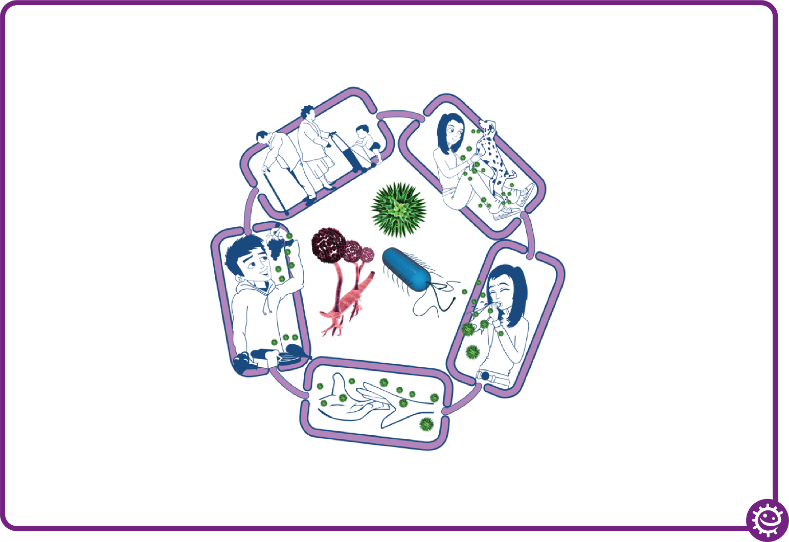
Spread of infection
Harmful microbes need a way to be passed from a source to a person. This can be through:
• Direct touch/contact
• Sexual transmission
Harmful microbes are also spread via:
• Hands, hand contact surfaces (e.g. door handles, keyboards, toilets)
• Food contact surfaces
• Air
Source of infection
Someone or something carrying the harmful microbes that causes the infection. There are many different sources of infection, these can include:
• People already infected
• Pets or animals
• Contaminated food
Way out for microbes
Harmful microbes need a way to get out of an infected person or source before they can spread to someone else. Routes include:
• Sneezing, coughing, saliva
• Bodily fluid
• Juices from raw meat and poultry

The Chain of Infection
People at risk from
infection
We are all at risk from
infection, but some are at greater risk:
• People on medication
e.g chemotherapy
• The very young/elderly
• People with underlying diseases e.g HIV/AIDS, diabetes
Way in for microbes
Harmful microbes need a
way to enter the body before they can cause an infection. This can be
through:
• The food we eat
• Inhalation of aerosols
or droplets
• Open cuts or sores
• Things we put in our
mouths

SH2 - Breaking the Chain of Infection Poster
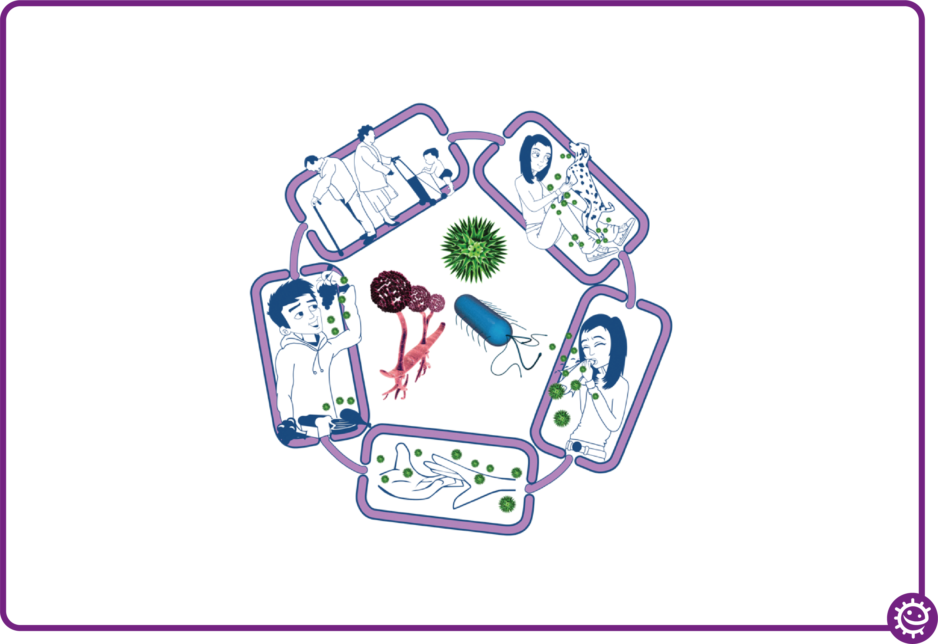
Spread of infection
• Wash hands thoroughly and regularly
• Cover cuts and open sores
• Take appropriate precautions during
sexual activity
Source of infection
• Isolate infected people
• Take care with raw food
• Wash pets regularly
• Treat pets for pathogens when needed
• Dispose of nappies and soiled clothing appropriately
Way out for microbes
Prevent any:
• Coughs and sneezes
• Faeces
• Vomit
• Bodily fluid
Getting onto surfaces or hands

Breaking the Chain of Infection
People at risk from
infection
Everyone:
• Take appropriate vaccinations
High risk people:
• Keep away from people who are infectious
• Take extra care about cleanliness
• Take extra care when cooking and preparing food
Way in for microbes
• Cover cuts and open sores with a water proof dressing
• Cook food properly
• Take care to drink only clean water

