Food Hygiene & Safety

Food Safety Scenarios Student Worksheet

Scenario 1
Hannah gets symptoms of foodborne illness after eating at a barbecue. Hannah visits the pharmacist to talk about her symptoms
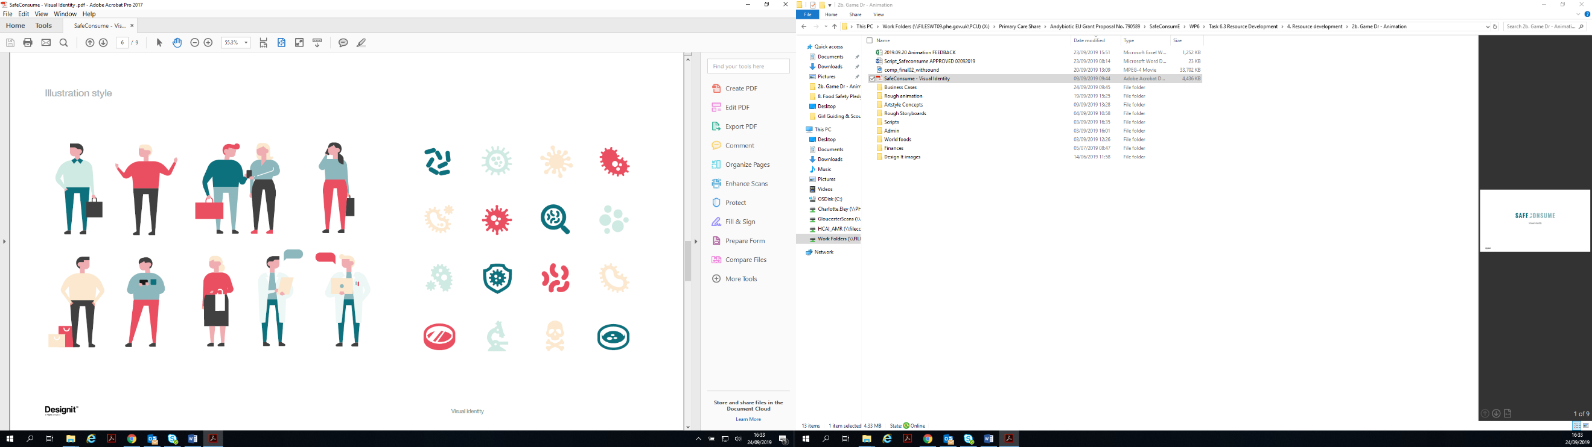
- Do you agree or disagree with Hannah’s statement about whether foodborne infections keeps our immune systems strong, and why?

- Why might foodborne illness be more dangerous for some groups of people such as pregnant women, the elderly, children under five and people with weakened immune systems?

- How can you ensure food is prepared safely when preparing for a barbecue? Think about safety of the consumer (the person eating the food), personal safety, and keeping tools and equipment hygienic

Scenario 2
Tiago’s mum is preparing chicken for dinner that evening and takes the chicken to the sink to wash it

- Do you agree or disagree with Tiago’s comments about washing chicken and why?
- Why might it be difficult to change food hygiene habits in the family home?

- What food hygiene habits may you have picked up at home? Are they good or bad?

- How can you remind yourself to follow good food hygiene rules and pick up good habits in the kitchen at home, school or work?

Scenario 3
Hugo is making his lunch for the next day. He checks the fridge to see what he can use

- Do you agree or disagree with Hugo about using the ham that is past its use by date and why?

- What are the differences between use by and best before dates?

- What examples of foods can you think of that have use by dates, and best before dates? How are they different?

Scenario 4
Stavros and his family are having dinner at home. They are talking about a family who got ill from eating out a buffet restaurant last week

- Do you agree or disagree with Stavros’s and his daughter’s comments about eating out?
- Do you agree or disagree with Stavros’s wife’s comments about foodborne illness and why?
- Why might people think that eating at buffets or restaurants is riskier than eating at home?

Scenario 5
Maria and her brother are preparing lunch for their guests. Maria has prepared the vegetables and is about to prepare the meat.

- Discuss the food hygiene practices that Maria should have followed while preparing the vegetables, salad, and meat. What temperature should the fridge be set to? Where should different food items be kept in the fridge?

- Discuss whether plastic chopping boards are safer than wooden chopping boards and why?
- Discuss how cross-contamination may occur if equipment were not used correctly in food preparation, and cleaning of surfaces?
- Discuss whether you would use different coloured chopping boards in your household

