

SH2 – Hand Washing Poster

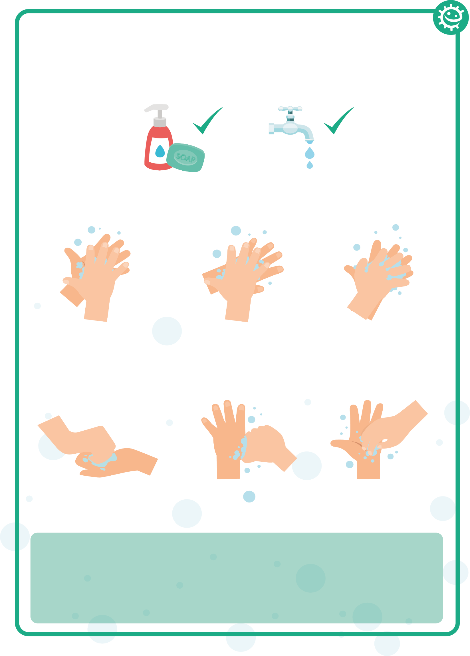
1
2
3
4
5
6
Palm to palm
Back of hands
Between fingers
Back of fingers
Thumbs
Tip of fingers

Wash your hands with soap and water for 20 seconds

To help keep time, sing ‘Happy Birthday’ twice

