Antibiotic awareness experiment
Difficulty:4 | Ages: 5-16 | Scientific | Time: 10-20 mins

Learning objectives
- Antibiotics are special medicine that only work on bacteria
- Antibiotics don’t work on viral infections like most coughs, colds and flu
- Bacteria are becoming resistant to antibiotics. We can help prevent more bacteria from becoming resistant to antibiotics by using them responsibly

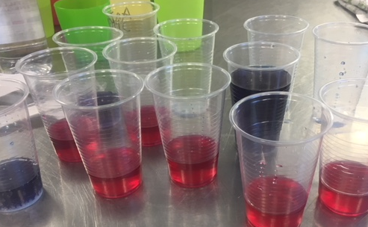
Pictured: Plastic cups with red cabbage water indicator

Equipment
- Red cabbage indicator (see steps below)
- White vinegar
- Bicarbonate of soda
- Lemon Juice
- Clear plastic cups
Worksheet: Disease list

Advanced preparation
- Before the meeting you will need to make some pH colour changing water:
  - Roughly chop the red cabbage – raw/fresh not pickled
  - Put half of this (i.e. an eighth of the whole cabbage) into a jug and cover with hot water
  - Allow the steep for 30 minutes.
  - Pour into a large bottle. Repeat until you have 2 litres
  - Place in the fridge until cool* *It’s a good idea to make the indicator an hour or two before the activity as it can start to smell if kept for more than a few hours.
- Prepare separate labelled containers for each of the red cabbage indicator (patient), lemon juice (virus) and bicarbonate of soda (bacteria).

- The leader will need to be aware of which illnesses are caused by a virus or a bacteria:
- Flu (Virus) – https://www.nhs.uk/conditions/flu/
- Common Cold (Virus) – https://www.nhs.uk/conditions/common-cold/
- Chicken Pox (Virus) – https://www.nhs.uk/conditions/Chickenpox/
- Norovirus (Virus) – https://www.nhs.uk/conditions/norovirus/
- Sore Throat (Virus usually) – https://www.nhs.uk/conditions/sore-throat/
- Food poisoning (Bacteria usually) – https://www.nhs.uk/conditions/food-poisoning/
- Spots and Acne (Bacteria) – https://www.nhs.uk/conditions/acne/
- Tooth decay (Bacteria) – https://www.nhs.uk/conditions/tooth-decay/
- Infected Cut (Bacteria) – https://www.nhs.uk/conditions/staphylococcal-infections/

Activity Instructions
- Give everyone a cup half full (about 50-75 mL) with the indicator. Explain that this represented them (their body) and we’re going to look at the effects of infections and how we can treat them.
- Get each participant to take a card with an illness written on it
- Ask them whether it is a viral or bacterial illness. Do they know what the difference between viruses and bacteria?
- When you confirm what type of microbe is causing the infection, put the infective substance in:
- Bacterial = half teaspoon of baking soda. Virus = 2 tsp lemon juice
- Note the colour change. “You are now infected”
- Ask them what they could take to treat their illness. What would they go to the GP to get to treat their infection?
- Give each participant half a teaspoon of antibiotic (vinegar) into their glass.
- Get them to note the colour change if any. Those with bacterial infections will see a colour change. Those with viral will not.
- Discuss that antibiotics only affect bacterial infections and have no effect on viruses. Take one of the viral infections and add another two to three half-teaspoons of antibiotic. Still no colour change.

Discussion
- Ask children what are the dangers of using antibiotics for the wrong illness (i.e. viral infections) or too often (i.e. mildly infected cuts). The bacteria can change and become resistant to antibiotics. This means that infections may become harder, even impossible to treat and if you have resistant bacteria you can spread them to your friends and family. The next activity ‘Antibiotic-resistant balloons’ is a good introduction to what antibiotic resistance is.
- Ask them how they should manage viral infections:
  - See your community pharmacist:
    - Pain killers
    - Drink plenty of fluids, warm if preferred
    - Throat lozenges or syrups
    - Get plenty of rest
If symptoms don’t go away in a few weeks, go and see GP.
- Ask them what is the best way to prevent themselves from getting these common viral infections.(Washing their hands, vaccinations)

Explanation of experiment
Antibiotics work to treat bacterial infections but do not work to treat viral infections. We demonstrated this in the experiment using changes in pH level. Cabbage contains chemicals that change colour when they are in solutions with different pH levels. This allows us to use the cabbage water as an indicator. The baking soda and water solution was alkaline, so as we added antibiotics (acid) the colour changed and the patient got better. The lemon juice and water solution was acid so as we added antibiotics (acid) the colour did not change and the patient did not get better.

