Antibiotic scenarios
Scenario 1: Ash had a runny nose and really sore throat so he went to the doctor.
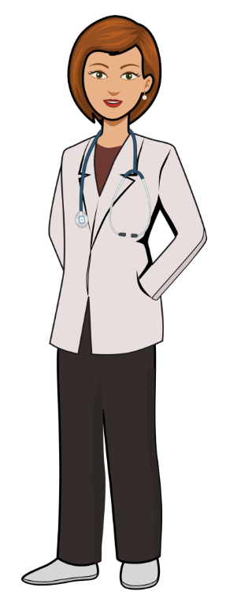
Doctor: A runny nose isn’t helped by antibiotics. Go home and go to bed, take some painkillers for your sore throat.
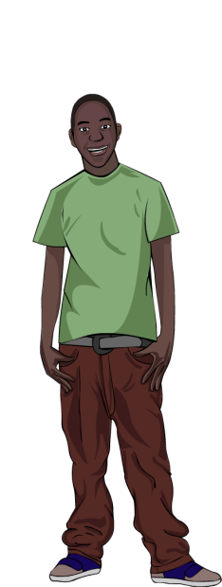

Ash: But I’m really ill. Surely antibiotics will help?

Doctor: I know sore throats can make you feel really ill and they can last a week. The pharmacist will be able to give you something for your pain.

Ash: What if I get really bad?

DISCUSSION

Discuss whether you agree or disagree with Ash going to the pharmacy?
Discuss what you think Ash might be worried about?

Scenario 2: Alisha is talking to her friend Anna about her urine infection. Alisha has been prescribed antibiotics by her doctor.
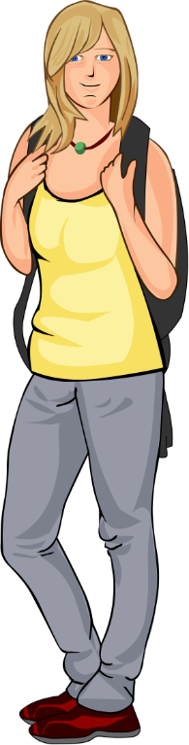

Alisha: I’ve been given antibiotics for my urine infection. The doctor told me to take them for 3 days, morning and evening. After 3 days I’ve still got some left, what shall I do with the ones left over now I feel better?

Anna: Why don’t you just take them, it will make sure you get rid of all the infection.

DISCUSSION
Discuss whether you agree or disagree with Anna?
Discuss what you think Alisha should do with
her leftover antibiotics?

Scenario 3: Chloe was talking to her friend Jamie about her headache and cough.


Chloe: My headache really hurts and I have a bad cough
Jamie: Don’t you have any antibiotics in a cupboard at home you could take?

What should Chloe say? Discuss the correct and incorrect options.

Statement | Correct | Incorrect
Gosh no, I shouldn’t take anyone else’s antibiotics.
Great idea – we have some left-over from when my sister had an ear infection.
Yes I had a cough a few weeks ago and went to the out-of-hours and they gave me a prescription, but I didn’t bother to cash it in. I’ll do it now!
I don’t have any antibiotics in the cupboard – don’t you always take them back to the chemist?
I’ve never had any antibiotics – so we don’t have any in the cupboard.
I had a urinary tract infection last month. I’ll use the left-over antibiotics from them.
I shouldn’t take antibiotics that are left over.
I don’t have any at home, but I’ll ask Josie, she is always at the doctor with her coughs.
I only take antibiotics if the doctor prescribes them.
I think I should just take some pain relief and go to bed.

