How clean is your kitchen?
Difficulty:4 | Ages: 5-14 | Scientific | Time: 10-20 mins

Learning objectives
- Microbes are found on most of our food, but harmful ones are mainly found on uncooked meat and raw vegetables
- It is important to wash your hands before and after preparing food and to wash cooking utensils and surfaces

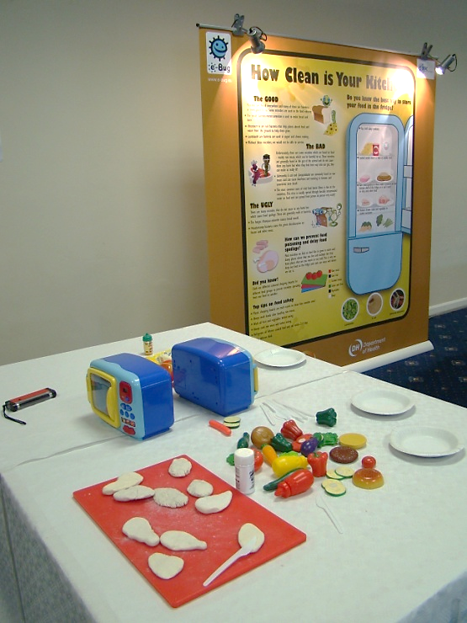
Pictured: Chicken fillets made from modelling clay covered in UV powder in a play kitchen

Equipment
- UV glowing gel or powder and UV torch
- Pink or beige coloured modelling clay
- Chopping boards of different colours
- Bread and salad or plastic toy food
- Toy oven or box labelled ‘oven’
- Plastic knives

Advanced preparation
- Prepare ‘chicken fillets’ from the modelling clay and cover in UV powder.
- Set out the ‘kitchen area’ with the food, chopping boards, knives and toy ovens.

Activity Instructions
- Invite the children to prepare a chicken sandwich using the play dough chicken fillet. Ask them to cut up the chicken with a plastic knife, cook the chicken in the ‘oven’ and add other foods to the sandwich.
- Afterwards ask them what they forgot to do whilst making their food - wash their hands? Change chopping boards? Use different knives?
- Point out that they should have used different chopping boards for the chicken and preparing the raw ingredients, microbes from the chicken can contaminate other raw food.
- Dim the lights in the room and say you can see where the germs from the chicken fillet have spread using the special ‘microbe detector’ UV light.
- Float the UV light over their hands and kitchen equipment to show where the bad germs have spread. The UV powder should have spread all over the ‘kitchen’ area
Ask children if they know any types of harmful bacteria that can be found on raw meat. Older children may be aware of bacteria such as salmonella or Campylobacter. Younger students may be able to name foods that can contain harmful microbes such as raw meat, eggs, and raw vegetables. Explain the importance of hand washing whilst cooking and before eating a meal.

