

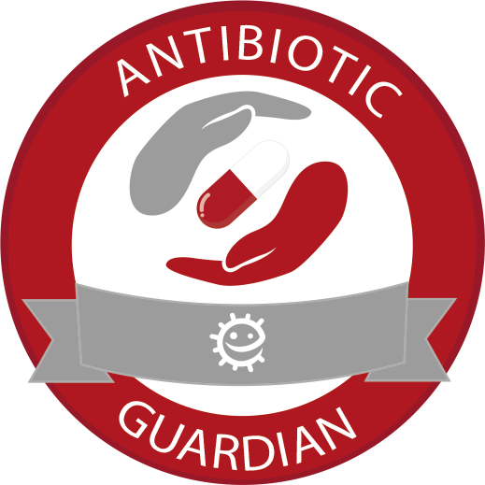

ANTIBIOTIC GUARDIAN
YOUTH BADGE
Leader and Volunteer Activity Pack
To engage young people in the community on the issue of antibiotic resistance and motivate them to help to keep antibiotics working through reducing infections and using antibiotics responsibly.

Acknowledgements
Thank you to the following individuals and groups who helped in the development of this resource:

UK Health Security Agency staff
Catherine Hayes  Charlotte Eley  Magda Hann  Cliodna McNulty  Alicia Demirjian  Diane Ashiru-Oredope  Steve Morton  Faustina Montsho-Hammond | Research Assistant  Project Manager  Project Assistant  Joint Clinical Lead  Joint Clinical Lead  Lead Pharmacist  Health and Wellbeing Manager  Senior Health Protection Practitioner

Antibiotic Guardian Badge steering group members

Charlotte Makanga  Ryan Hamilton  Clare Liptrott  Neil Mawby  Lyn Rowe  Amy John  Jodie Sabin  Catriona Innes  Saba Tyson  Lisa Coulthwaite  Emily Christopher  Karen McKessack | To Betsi Cadwaladr UHB/International Commissioner Girlguiding  Antimicrobial Pharmacist  University of Salford, Manchester  Teacher  Deputy County Scout Commissioner  Cwm Taf University Health Board  Leader with Girlguiding Gloucestershire  Girlguiding Orkney  9th Cheam CSL (GLSW)/ Greenshaw High School (Science)  Manchester Metropolitan University  University of Manchester Graduate/Leader Girlguiding Bedfordshire  Pharmacist, Aberdeen Royal Infirmary
Thank you to the following youth groups for piloting this resource and providing feedback during development:

7th Dunstable Brownies  1st Dyce Cubs  24th Kingswood Warmley Brownies  12th Widnes St Luke’s Cubs  6th Worsley Beavers and Cubs  27th Aberdeen Cubs | 24th Kingswood Warmley Rainbows  1st Newtonhill and Muchalls Brownies  1st Boscombe Down Guides  1st Larkhill Guides  1st Bude cubs  13th Leigh scouts
Thank you to the Scottish Antimicrobial Prescribing Group (SAPG) and Health Protection Scotland for their support in the development of this programme. Thank you to Girlguiding South West England for support in piloting and promoting this resource.




Table of Contents
Acknowledgements 2

Introduction to the programme 4
Who can run this programme 5
How to run the programme 5

Section 1: Activities (Microbes) 7
Modelling microbes (ages 5 – 16) 8
How big is a microbe (ages 5 – 11) 10
Magazine microbes (ages 7 – 16) 12
Microbe Mayhem top trumps (ages 11 – 18) 13

Section 1: Activities (Spread of infection) 15
Snotgun Runway (ages 5 – 16) 16
Super slimy snot (ages 5 – 11) 18
Illness spreading game (ages 5 – 16) 20
Healthy Hands (ages 5 – 16) 21
Pepper and water experiment (ages 5 – 14) 23
How clean is your kitchen? (ages 5 – 14) 25

Section 1: Activities (Antibiotics) 27
Antibiotic awareness experiment (ages 5 – 16) 28
Resistance balloons (ages 5 – 16) 31
Antibiotic myths (ages 5 – 16) 33
Infected game (ages 7 – 16) 35
Antibiotic-resistance stuck in the mud-chain tag (ages 11 – 16) 37
Antibiotic-resistant tag (ages 7 - 16) 39
Comics and additional resources on antibiotics (ages 5 – 16) 40

Section 2: Creative activity 42

Section 3: Antibiotic Guardian pledge 43

Introduction to the programme

Reducing rates of infection is a key aim of UK Health Security Agency and the UK Government.

The problem:
Antibiotics are special medicines that treat bacterial infections. However, bacteria are becoming resistant to antibiotics, meaning antibiotics no longer work against them. This process, called antibiotic resistance, makes it harder than ever to treat infections.
Antibiotic resistance is one of the biggest threats facing us today because it can lead to more deaths and complications for people receiving medical treatment. However, we can act now to help protect these precious medicines, by making small changes to our behaviour to prevent infection and take better care of antibiotics.

There are simple everyday actions that can help protect antibiotics:

- Prevent the spread of infection by engaging in good infection prevention practices such as hand hygiene and using a tissue, or sleeve (not our hands) when we sneeze
- Prevent infections by ensuring we are up to date on vaccinations
- Use antibiotics as directed by a health professional and never take leftover antibiotics or someone else’s antibiotics
- Not using antibiotics for illnesses caused by microbes that are not bacteria, like colds and coughs or influenza (the “flu”), which are caused by viruses

Why should you run this programme?
Children and young people tend to have higher rates of infection and commonly take antibiotics as treatment. Reducing rates of infection in your community can help to protect those most vulnerable, improve the health of all and reduce absence from school and work.

Today’s youth are the antibiotic users and prescribers of tomorrow; teaching young people is a key factor in reducing rates of infection and helping develop lifelong behaviours that will help them stay healthy and ensure the safety of antibiotics in the future.

The programme consists of many fun, interactive,and creative activities related to science, technology, engineering, and mathematics (STEM) and links to the programmes and themes of various existing youth groups.

How will your youth group benefit?
This badge will help youth groups to take action on a major health issue that is of local, national and international importance.

By helping children understand the importance of reducing the spread of infection, they will gain an understanding of looking after their and other people’s health. As Antibiotic Guardians, young people will grow up with the knowledge and motivation to protect our antibiotics!

Who can run this programme

This programme can be run with any youth group by any leader, you do not need to have background knowledge on the topic, but this may help. It was developed with input from uniformed youth groups and links to many of themes around science, health and wellbeing and community action.

Suitable youth groups include, but are not limited to:

- Uniformed youth groups
- Faith-based groups
- Service cadets e.g. junior fire cadets and volunteer police cadets
- Military cadet organisations e.g. army cadets
- Other scouting organisations
- Other groups e.g. Young Farmers
- Schools, science clubs or after school clubs
Please note this is not an official badge of volunteer youth organisations listed here.

How to run the programme

Running the programme
This programme incorporates 3 sections:
- Section 1: Interactive activities: split into topics of microbes, infection prevention and antibiotics
- Section 2: Creative activity: create something to show others or to be displayed in the community (a poster, video, song, or social media messaging)
- Section 3: Make a pledge or promise to be an Antibiotic Guardian and complete an action to help protect antibiotics
The programme is designed to be flexible, you may complete the activities in as many sessions as needed. Choose activities based on the ability and needs of your group, resources and time available.

Interactive activities
Activities are labelled under three categories: physical activity, creative thinking and scientific thinking. We recommend choosing a range of activity types and a range of topics relating to microbes, spread of infection and antibiotics.

Age range for activities
Each activity is labelled with the recommended age groups that it can be completed with, however please use your judgement on your group’s ability, many activities can be adapted for other age groups.

Timing
An estimated time has been provided for each activity. Please note groups may go through activities in a shorter or longer amount of time depending on ability and how it is run. Please use your judgement and prepare for extension activities that can be completed if you finish early.

Difficulty rating
Activities have been given a rating from 1 (easy) to 5 (difficult) related to difficulty in running or background knowledge needed. If doing this programme for the first time we recommend choosing those with a lower rating.

Leader information and support
Please visit the website for further information, support and additional reading you can do on these topics to support delivery of this programme.

Antibiotics and antibiotic resistance can be a difficult topic to communicate to children. We recommend using the ‘comics and additional resources on antibiotics’ on page 28 to help describe the concepts of antibiotic resistance and the correct use of antibiotics.

Ordering embroidered badges
There is a limited number of embroided badges freely available for groups on a first come first serve basis. To order these badges, please contact us using the contact form at the bottom of this web page: https://e-bug.eu/antibiotic-guardian-youth-badge . Within the form, you will need to provide feedback on how your session went.You will be invoiced for postage and packaging only.

Recommended outline
We recommend the following activities if completing in one day or evening:

Microbes | Spread of infection | Antibiotics | Resource and pledge
- Modelling  microbes  (20 mins) | - Snotgun Runway (15 mins)  And/or  - Healthy hands  (15 mins) | - Antibiotic awareness  (15 mins)  And/or  - Antibiotic resistance balloons (10 mins) | - Antibiotic Guardian pledge (10 mins)  - Poster/resource development at home to be presented at next session

We recommend the following activities if completing across several days or weeks:

Session 1: Microbes | Session 2: Spread of infection | Session 3: Antibiotics and pledge
Complete 3-4 activities | Complete 3-4 activities | Complete 2-3 activities  Complete resource development and pledge within session

Section 1 activities: Microbes

Modelling microbes
Difficulty:2 | Ages: 5-16 | Scientific | Creative | Time: 10-15 mins

Learning objectives
- Understand that there are three different types of microbes; bacteria, viruses and fungi which can be found everywhere
- Microbes can come in different shapes and sizes. Fungi are the largest, followed by bacteria then viruses
- Some microbes are harmful and can cause infections, but most are harmless, and many are in fact very useful and help us to survive

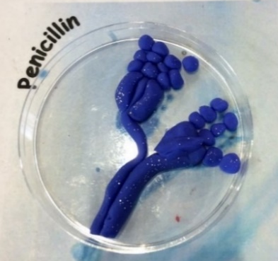 Pictured: Clay model Penicillin in petri dish

Advanced preparation
- Print and laminate the example microbes and place around the activity area
- If running alternative activities, prepare coloured icing and jelly
- For younger children, provide the colour in microbe sheets

Equipment
- Modelling clay in a variety of colours
- Black marker pen, coloured pens and pencils
- Paper plates, plastic dishes or petri dishes
- Alternative activity 1: Small dishes, edible jelly, selection of sweets, coloured icing
- Alternative activity 2: round digestive biscuits, coloured icing
- Worksheets: Microbe example sheets, Microbe colouring in sheets

Introduction
- Explain that microbes are the smallest living creatures on earth and that the word micro-organism refers to micro: small and organism: life. Microbes are so small that they cannot be seen without the use of a microscope.
- Show the group that there are three different types of microbe: bacteria, viruses and fungi. Although they are too small for us to see with the naked eye they can be found everywhere, in the air, the ground and in our bodies!
- Show the children the example microbes and explain that when scientists look at microbes under a microscope they are all different shapes and sizes. Different microbes have different features, which help scientists distinguish them from one another. Encourage children to look at the microbe fact cards and ask if they have heard of any.

Main activity
- Ask each child to recreate one of the example microbes or invent their own within their plates using the modelling clay and coloured pens.

- Ask children to label the plate or dish with their own name, the name and type of microbe, and whether it could be useful or harmful to humans.

Alternative activity
- Alternative 1: provide children with shallow dishes or pots with set coloured jelly. Explain to children that scientists grow microbes on a substance called agar which looks like jelly and provides microbes with the food they need to grow. Children can then decorate the surface of the jelly with coloured icing and sweets to resemble microbes.

- Alternative 2: Provide children with round digestive biscuits, coloured icing and other decorations such as sweets and gummy laces. Ask children to create microbes on their biscuits using the decorations.

How big is a microbe?
Difficulty:2 | Ages: 5-11 | Scientific | Time: 10 mins

Learning objectives
- Understand that there are three different types of microbes; bacteria, viruses and fungi which can be found everywhere
- Microbes can come in different shapes and sizes, fungi are the largest, followed by bacteria then viruses
- Some microbes are harmful and can cause infections, but most are harmless, and many are in fact very useful and help us to survive

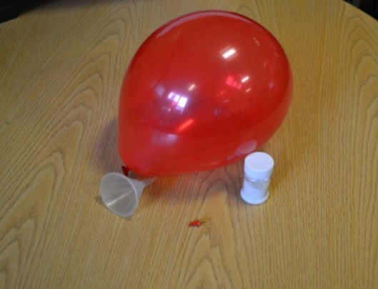 Pictured: Balloon, funnel, glitter and drawing pin.

Advanced preparation
- Fill the balloon with glitter using a funnel and blow the balloon up.
- Prepare as many as needed to demonstrate the activity.

Equipment
- Balloon(s)
- Glitter or sustainable alternative
- Drawing pin

Introduction
- This activity would work well at the start of a meeting as a demonstration.
- Ask the group if they know what a microbe is, explain that there are 3 types of microbes: fungi, bacteria and viruses and they can be both harmful and useful to us.
- Fungi are the largest microbe. Give an example of useful and harmful fungi, for example Penicillium is useful fungi used to create the antibiotic penicillin and mushroom (some!) is a fungi that can be used as food. Harmful fungi causes the condition athlete’s foot.
- Bacteria are the middle-sized microbes. Lactobacillus are useful bacteria found in yoghurts that can aid in our digestion of food. Examples of harmful bacteria are ones that can cause chest infections or food poisoning in spoiled food. Bacteria also come in different shapes: rods, balls or spirals.
- Viruses are the smallest type of microbe; they can cause illnesses such as colds and flu.

Main activity
- Remind the group of the names of the microbes and their sizes. Explain that most microbes are too small to see with the naked eye and that it can be hard to understand their shapes and sizes.
- Ask the group to imagine that if a fungi, the largest of the 3 microbes, was the size of the room they are in, how big do they think a bacteria would be in comparison? Show the group the balloon and explain that this is how big the bacteria would be. Ask how big they think a virus would be in relation to this. Pop the balloon and explain that a virus would be the size of a piece of glitter.

Magazine microbes
Difficulty:2 | Ages: 7-16 | Scientific | Creative | Time: 15-20 mins

Learning objectives
- Microbe are found everywhere, and most are harmless
- We carry microbes in and on our bodies and some microbes are essential for us to live

Pictured: Selection of magazines

Equipment
- A selection of magazines/newspapers
- Crafting materials including scissors, glue, colouring pens
- A3 or larger paper to make collage

Activity instructions
- Provide individuals or groups with different magazines, paper and craft materials
- Ask the group where they think microbes can be found, on the body, in the air, in food and drinks, on surfaces?
- Stress that microbes are found all over our skin, mouths, gut and especially hands. Most are completely harmless that we carry without knowing.
- Ask the group to look through the magazines and find images of places where microbes can be found. Ask the group to cut out the images using scissors and stick onto an A4 piece of paper to make a collage with the title “Where can microbes be found?”
- At the end of the activity, stress to the group that microbes can be found everywhere, even on the magazine they were looking through!
- Ask each child to present their collage and why they chose certain images
- You may want to make a larger collage or display in your venue or ask children to take their collages home to teach their families about microbes.

Microbe Mayhem (Bug trumps)
Difficulty:3 | Ages: 11-18 | Scientific | Time: 15-20 mins

Learning objectives
- Microbes, including bacteria, viruses and fungi are found everywhere
- Most microbes are harmless however some can be harmful and cause illness
- We carry microbes in and on our bodies and some microbes are useful for our health and used in industry.
- Some bacteria are becoming resistant to medicines called antibiotics.

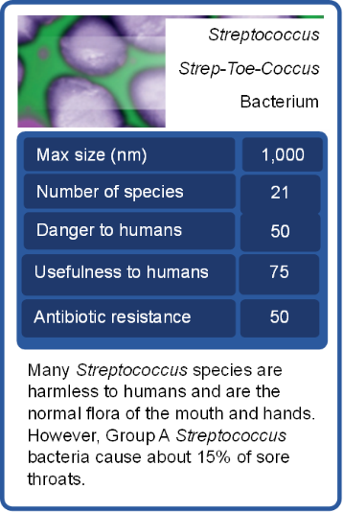Pictured: A Microbe Mayhem top trump card

Advanced preparation
- Print and laminate the Microbe Mayhem cards, enough for groups of 2-3 to play.

Introduction
- In this activity, groups of 3 - 4 children play a card game which helps them remember some of the technical words relating to microbes as well as familiarising them with a variety of microbial names and facts.
- Prior to game play ask children if they can name any examples of microbes, are they harmful or useful to humans? Can they think of any illness that are caused by microbes?
- Ask children if they have ever had antibiotics for an infection? Explain that antibiotics are used to treat bacterial infections. Bacteria are clever and can change to avoid the effect of the medicine, sort of like a super power. This means that some bacterial infections have become harder to treat.

Activity instructions
- The dealer should mix the cards well and deal all the cards face down to each player. Each player holds their cards face up so that they can see the top card only.

- The player to the dealer's left starts by reading out an item from the top card in their hand (e.g. Size 50). In a clockwise direction, the other players then read out the same item. The player with the highest value wins, taking the other players top cards and placing them to the bottom of their pile. The winner then selects the item to read out from the next card in their hand.

- If 2 or more players have the same value then all the cards are placed in the middle and the same player chooses again from the next card. The winner then takes the cards in the middle as well.

- The person with all the cards at the end is the winner.

- Finish up the activity with a quick discussion. What have you learnt? Which microbes were the most useful to humans? Were many bacterial microbes resistant to antibiotics?

Disclaimer: Please note the scores relating to danger, usefulness and antibiotic resistance are to be used only as guidance in gameplay; there is not an official formula to calculate these. The figures relating to maximum size and number of species are correct at time of development but may change as new species are discovered.

Section 1 activities:
Spread of infection

Snotgun runway
Difficulty:1 | Ages: 5-16 | Scientific | Time: 10-15 mins

Learning objectives
- Microbes can cause illnesses like colds and flu which make you sneeze and have a runny nose
- Microbes can spread easily between people through snot and sneezes
- We can stop microbes spreading by covering our sneeze with a tissue or our sleeve (not our hands) and washing our hands

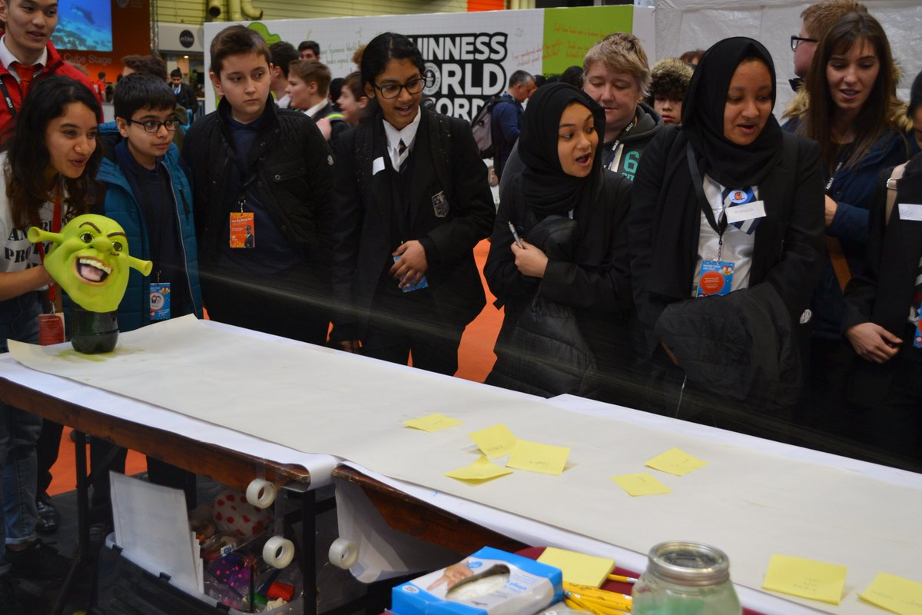Pictured: Snot gun demonstration

Equipment
- Long roll of paper such as wallpaper
- Measuring tape or 2m ruler
- Pump action spray bottle
- Green food colouring
- Disposable plastic/vinyl gloves
- Kitchen roll
- Pens and sticky notes (optional)
- Optional: a funny mask to cover the spray bottle

Advanced preparation
- Create a sneeze runway using a roll of wallpaper along a long table or on the floor
- Fill the spray bottle with water and green food colouring
- Cover the bottle with a funny mask and place at the end of the runway

Activity instructions
Ask the group “Why we sneeze?” To keep airways clean, to get rid of particles and microbes from the nose. What illnesses are spread through sneezes? What can we do to present spreading illnesses?

- Ask the group to write their name or draw a picture of themselves on a sticky note, or write directly on the runway at the furthest point they think it will reach. Ask the group to imagine that the runway is a party or a bus and the children can place themselves where they think they will avoid the sneeze.

- Hold the bottle at the end of the sneeze runway and simulate a sneeze by squeezing the trigger and work out who was closest to the actual distance. Count down from 3 and encourage the group to shout ACHOO when the snot is launched. You may repeat and allow children to have a go at ‘sneezing’

- Ask a child to measure how far and how wide the sneeze spreads with a meter ruler or tape measure and determine which child guessed the closest.

- Ask the group what you would usually do when sneezing – put a hand over your nose.

- Ask one child to put on a glove and place their hand over the nozzle to demonstrate putting a hand over your nose as you sneeze. Pull the trigger again after predicting what will happen. Ask children if this is an effective way to stop the microbes in the snot spreading to others? The microbes stay on our hands and can spread to anything we touch.

- Ask someone to put a piece of kitchen towel over the nozzle to demonstrate holding a tissue over your nose as you sneeze. Pull the trigger after predicting what will happen. The sneeze is successfully caught in the tissue and won’t infect anyone else if the tissue is thrown in the bin straight away. Ask the sneeze catcher to throw the tissue away.

- Ask the group to recite what they have learned, for example by repeating the phrase ‘catch it, bin it, kill it’. Reinforce that catching a sneeze in a tissue is the best way to prevent the spread of microbes to others.

Super slimy snot
Difficulty:2 | Ages: 5-11 | Scientific | Creative | Time: 10-15 mins

Learning objectives
- Our bodies have natural defences to protect us from infections
- Snot helps to protect us from infection by trapping harmful microbes
- If we sneeze we can spread these microbes to others, so it is important to use a tissue and then throw this away, or our sleeve if we have no tissue.

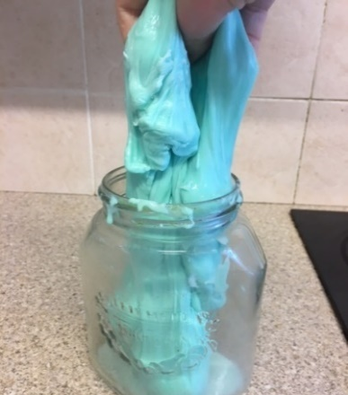 Pictured: Example of the ‘super slimy snot’ in a jar

Equipment
- Laundry starch (or other slime activator such as borax powder) and warm water
- Polyvinyl acetate (PVA) glue
- Green food colouring
- Spoons and container for each child
- Optional: Green/red glitter (or eco alternative) or ultraviolet
- (UV) gel and torch

Advanced preparation
- To save time, mix up enough ‘slime activator’ for the group: depending on the size of the group, fill one container with warm water and add enough laundry starch to create a milk coloured solution when dissolved
- The starch dissolves best in warm water and may need re-stirring every so often
- If using a different slime activator, follow instructions provided on the label

Activity instructions
- Explain that snot is special, it is our first defense against inhaling harmful microbes.
- Sneezing is a way in which our body tries to get rid of harmful microbes and dust.
- Our nose and throat are also home to beneficial microbes known as flora who live there naturally without harming us and can help to protect us from harmful microbes.
- Ask children how much snot they think our nose makes in one day. The answer is two pints – the same amount as a medium bottle of milk. The majority of this is swallowed without knowing! Ask children if they think this will increase when you are ill with a cold.
- Explain to children that they will be making their own slimy snot which they can take home with them.
To make snot:

- Provide each child with a container, place two tablespoons of PVA glue in each container and one drop of green food colouring to each container and mix well

- Add slime activator drop by drop while stirring the mixture. The slime will begin to form.
- Stop adding activator when desired sliminess is reached!
- Children can add green (friendly microbes) and red (harmful microbes) glitter to their slimy snot. Alternatively, you can add UV gel or powder and show how the snot fluoresces under UV torch.
- Discuss with children why it is important to use a tissue, or our sleeve (not our hands) when we have a runny nose or sneeze and wash our hands if we touch snot as harmful microbes within the snot can pass to our friends and family and make them ill.

Illness spreading game
Difficulty:1 | Ages: 5-16 | Scientific | Physical | Time: 10 mins (2 minutes prep.)

Learning objectives
- Infections can spread easily without you knowing
- Hands offer an easy way to spread microbes from one person to another
- Washing our hands is the most effective way to stop infections spreading

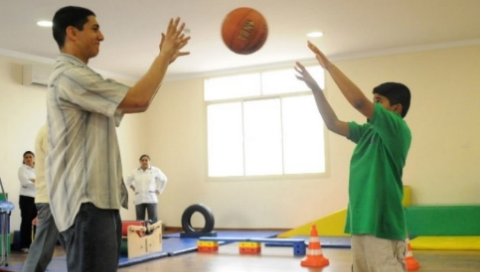 Pictured: Children throwing and catching a ball

Equipment
- Object to pass around the group e.g a ball, cup and saucer, relay baton
- UV gel or powder and UV torch or lamp

Activity Instructions
- Choose a game which involves passing an object around the group, this could be a ball game (such as dodge ball or a catching game), or a cup and saucer game. Choose a game the group is familiar with and enjoys, encouraging engagement.
- Around 30 minutes before playing the game you will need to coat the item(s) with the UV gel or powder. For example – cover the ball in UV gel if you are playing a ball game. White items work better as the gel has a white/opaque colour.
- Play the chosen game and ensure all children join in and touch the object. Once the game has finished ask the children to gather around you in a circle.
- Turn the lights off and use the UV torch on the game item e.g ball. Explain it is covered in germs. You could try and get a reaction by saying that you sneezed or coughed on the item before the game started.
- Tell members to hold their hands out, palms facing upwards. Go around with the UV light to show how the germs have spread onto their hands.
- Ask the group to shout out examples of what other items commonly spread germs. Examples are: door handles, chairs, tables, toilet seats, pens and pencils, mobile phones, tablets, games console controllers, keyboards and mouse.
- We recommend running the next activity ‘healthy hands’ straight after so children have a chance to wash their hands.

Healthy hands
Difficulty:2 | Ages: 5-16 | Scientific | Physical | Time: 10-20 mins

Learning objectives
- Harmful microbes can spread to others via hands and cause illness
- The best way to stop harmful microbes from spreading is to wash your hands with soap and water.
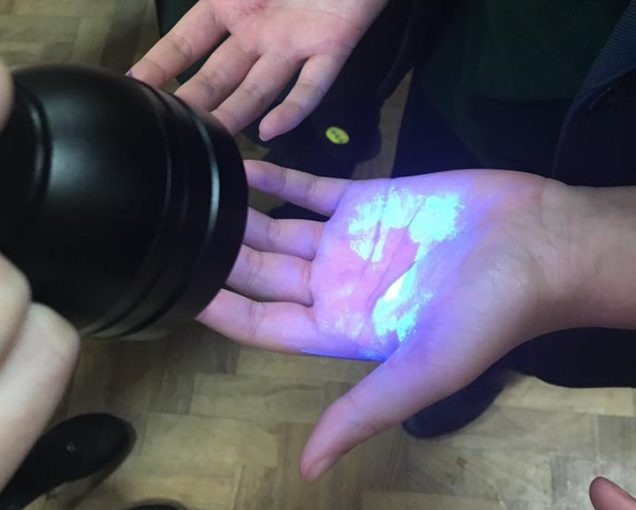
Pictured: UV torch lightling up UV gel, representing the microbes

Equipment
- Ultraviolet (UV) gel or powder and UV torch or lamp
- Alternative to UV is to use eco glitter or glitter substitute such as other pepper or salt
- Access to hand washing facilities with soap and a print out of the ‘Six Steps of Handwashing’

Activity Instructions
- Explain to the group that microbes are everywhere, and they get on to our hands from the things that we touch, or by coughing and sneezing. We then pass these on to other people through touching each other or touching things that others will then touch. Washing our hands is the best way to remove microbes from our hands before they spread to others.
- Ask the group when we should wash our hands e.g. before and after preparing food, after using the toilet, after touching animals and after coughing or sneezing.
- Explain to the group that they are going to demonstrate how microbes spread from person to person. Explain that you will use UV gel/alternative to demonstrate this, ask the group to imagine that the UV is pretend microbes, as microbes themselves are too small to see with the naked eye.
- Ask children to get into lines of 4-5 children. Place UV gel or alternative on the hand of the first child and ask them to shake hands with the person behind them, and so on until all have shaken hands.
- If you used UV gel turn off the lights and show how the gel has spread from child to child. If alternative show how this has spread to each child.
- Demonstrate the proper way to wash hands with soap and ask them to follow your movements: do the six-step technique. Use the torch again to show how well children have washed hands.

Extension:
Ask children to put the six steps of handwashing poster around the venue in handwashing areas. If time allows ask children to make their own version of the poster, or their own song to wash their hands to (this could be done as part of section 2: resource development).

Pepper and water experiment
Difficulty:2 | Ages: 5-14 | Scientific | Time: 10-15 mins

Learning objectives
- Microbes can ‘stick’ to the natural oils on our hands making them hard to remove with water alone
- Soap removes the oil on our hands and helps wash microbes away

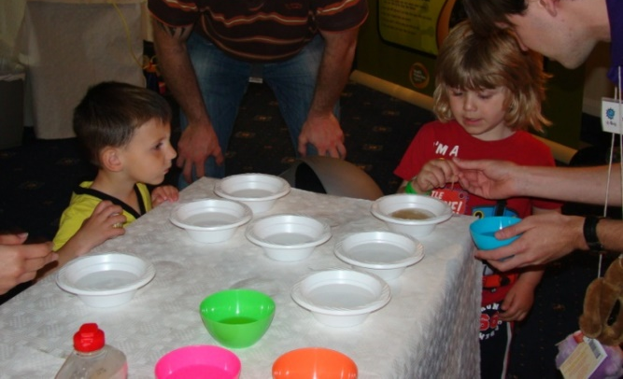Pictured: Children using soapy cocktail sticks in a bowl of water and pepper to visualise how soap works on our hands

Equipment
- Shallow bowls or dishes
- Access to fresh water and soap
- Ground pepper or other spice such as cinnamon
- Cocktail stick

Activity Instructions
- Fill the bowl with water and sprinkle the ground pepper or spice across the surface of the water.
- Demonstrate this activity to the group first. Tell children that the surface of the water represents their hands, and that the pepper represents harmful microbes that need to be washed away.
- Dip the end of a cocktail stick into a plain bowl of water and then dip into the pepper water. Nothing happens to the microbes, using water alone to wash your hands only moves the microbes around.
- Dip the cocktail stick into a bowl of soap and then into the pepper water. The pepper ‘microbes’ should move towards the edges of the bowl as the soap hits the surface of the water.
- Tell the children that this shows why using soap when you wash your hands is important, because it breaks up the oils on the surface of your hands that microbes stick to and then they can be rinsed away under running water.
- Split the group into pairs or groups of 3 and ask them to repeat the experiment.
- Discuss what happened with the group. The experiment with and without soap should have been different. When the soap was added to the bowl the pepper should have moved towards the edges of the bowl. This is because the soap removes the oils on your hands and the oil pushes the pepper towards the edge of the bowl. Microbes like to stick to the oils on your hands, which is why we should wash our hands with soap.

How clean is your kitchen?
Difficulty:4 | Ages: 5-14 | Scientific | Time: 10-20 mins

Learning objectives
- Microbes are found on most of our food, but harmful ones are mainly found on uncooked meat and raw vegetables
- It is important to wash your hands before and after preparing food and to wash cooking utensils and surfaces

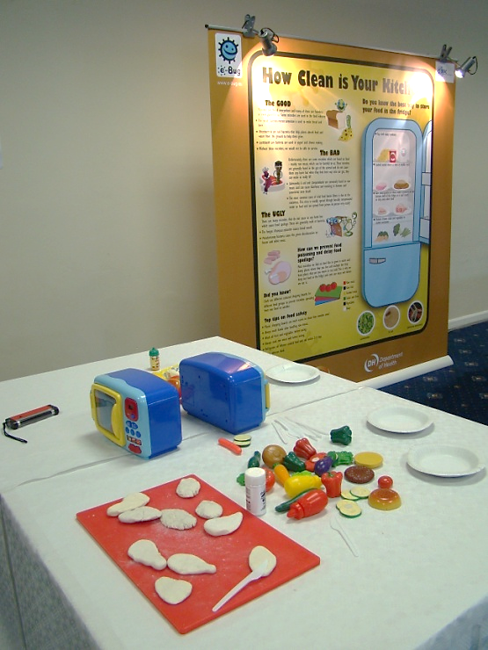
Pictured: Chicken fillets made from modelling clay covered in UV powder in a play kitchen

Equipment
- UV glowing gel or powder and UV torch
- Pink or beige coloured modelling clay
- Chopping boards of different colours
- Bread and salad or plastic toy food
- Toy oven or box labelled ‘oven’
- Plastic knives

Advanced preparation
- Prepare ‘chicken fillets’ from the modelling clay and cover in UV powder.
- Set out the ‘kitchen area’ with the food, chopping boards, knives and toy ovens.
Activity Instructions
- Invite the children to prepare a chicken sandwich using the play dough chicken fillet. Ask them to cut up the chicken with a plastic knife, cook the chicken in the ‘oven’ and add other foods to the sandwich.
- Afterwards ask them what they forgot to do whilst making their food - wash their hands? Change chopping boards? Use different knives?
- Point out that they should have used different chopping boards for the chicken and preparing the raw ingredients, microbes from the chicken can contaminate other raw food.
- Dim the lights in the room and say you can see where the germs from the chicken fillet have spread using the special ‘microbe detector’ UV light.
- Float the UV light over their hands and kitchen equipment to show where the bad germs have spread. The UV powder should have spread all over the ‘kitchen’ area
- Ask children if they know any types of harmful bacteria that can be found on raw meat. Older children may be aware of bacteria such as salmonella or Campylobacter. Younger students may be able to name foods that can contain harmful microbes such as raw meat, eggs, and raw vegetables. Explain the importance of hand washing whilst cooking and before eating a meal

Section 1 activities:
Antibiotics

Antibiotic awareness experiment
Difficulty:4 | Ages: 5-16 | Scientific | Time: 10-20 mins

Learning objectives
- Antibiotics are special medicine that only work on bacteria
- Antibiotics don’t work on viral infections like most coughs, colds and flu
- Bacteria are becoming resistant to antibiotics. We can help prevent more bacteria from becoming resistant to antibiotics by using them responsibly

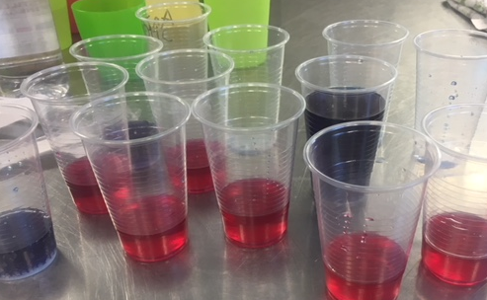
Pictured: Plastic cups with red cabbage water indicator

Equipment
- Red cabbage indicator (see steps below)
- White vinegar
- Bicarbonate of soda
- Lemon Juice
- Clear plastic cups
Worksheet: Disease list

Advanced preparation
- Before the meeting you will need to make some pH colour changing water:
  - Roughly chop the red cabbage – raw/fresh not pickled
  - Put half of this (i.e. an eighth of the whole cabbage) into a jug and cover with hot water
  - Allow the steep for 30 minutes.
  - Pour into a large bottle. Repeat until you have 2 litres
  - Place in the fridge until cool* *It’s a good idea to make the indicator an hour or two before the activity as it can start to smell if kept for more than a few hours.

- Prepare separate labelled containers for each of the red cabbage indicator (patient), lemon juice (virus) and bicarbonate of soda (bacteria).

- The leader will need to be aware of which illnesses are caused by a virus or a bacteria:
- Flu (Virus) – https://www.nhs.uk/conditions/flu/
- Common Cold (Virus) – https://www.nhs.uk/conditions/common-cold/
- Chicken Pox (Virus) – https://www.nhs.uk/conditions/Chickenpox/
- Norovirus (Virus) – https://www.nhs.uk/conditions/norovirus/
- Sore Throat (Virus usually) – https://www.nhs.uk/conditions/sore-throat/
- Food poisoning (Bacteria usually) – https://www.nhs.uk/conditions/food-poisoning/
- Spots and Acne (Bacteria) – https://www.nhs.uk/conditions/acne/
- Tooth decay (Bacteria) – https://www.nhs.uk/conditions/tooth-decay/
- Infected Cut (Bacteria) – https://www.nhs.uk/conditions/staphylococcal-infections/

Activity Instructions
- Give everyone a cup half full (about 50-75 mL) with the indicator. Explain that this represented them (their body) and we’re going to look at the effects of infections and how we can treat them.
- Get each participant to take a card with an illness written on it
- Ask them whether it is a viral or bacterial illness. Do they know what the difference between viruses and bacteria?
- When you confirm what type of microbe is causing the infection, put the infective substance in:
- Bacterial = half teaspoon of baking soda. Virus = 2 tsp lemon juice
- Note the colour change. “You are now infected”
- Ask them what they could take to treat their illness. What would they go to the GP to get to treat their infection?
- Give each participant half a teaspoon of antibiotic (vinegar) into their glass.
- Get them to note the colour change if any. Those with bacterial infections will see a colour change. Those with viral will not.
- Discuss that antibiotics only affect bacterial infections and have no effect on viruses. Take one of the viral infections and add another two to three half-teaspoons of antibiotic. Still no colour change.

Discussion
- Ask children what are the dangers of using antibiotics for the wrong illness (i.e. viral infections) or too often (i.e. mildly infected cuts). The bacteria can change and become resistant to antibiotics. This means that infections may become harder, even impossible to treat and if you have resistant bacteria you can spread them to your friends and family. The next activity ‘Antibiotic-resistant balloons’ is a good introduction to what antibiotic resistance is.
- Ask them how they should manage viral infections:
  - See your community pharmacist:
    - Pain killers
    - Drink plenty of fluids, warm if preferred
    - Throat lozenges or syrups
    - Get plenty of rest. If symptoms don’t go away in a few weeks, go and see GP.

- Ask them what is the best way to prevent themselves from getting these common viral infections.(Washing their hands, vaccinations)

Explanation of experiment
Antibiotics work to treat bacterial infections but do not work to treat viral infections. We demonstrated this in the experiment using changes in pH level. Cabbage contains chemicals that change colour when they are in solutions with different pH levels. This allows us to use the cabbage water as an indicator. The baking soda and water solution was alkaline, so as we added antibiotics (acid) the colour changed and the patient got better. The lemon juice and water solution was acid so as we added antibiotics (acid) the colour did not change and the patient did not get better.

Resistance balloons
Difficulty:4 | Ages: 5-16 | Scientific | Time: 10-20 mins

Learning objectives
- Antibiotics are special medicine that only work on bacterial infection, not viral infections like most coughs, colds and flu
- Bacteria are becoming resistant to antibiotics.
- We can help prevent more bacteria from becoming resistant to antibiotics by using them responsibly
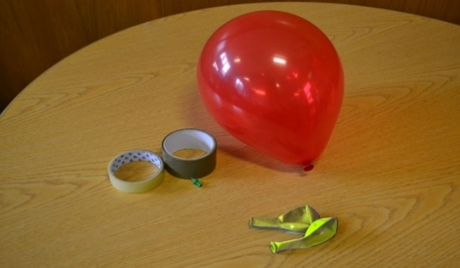 Pictured: Balloons, sticky tape and a drawing pin

Equipment
- Balloons of at least two different colours
- A drawing pin
- Sticky tape or electric tape

Advanced preparation
- Blow up balloons of two different colours e.g three x red and 1 x yellow
- On two of the red balloons and the yellow balloon place several layers of sellotape over the thickest area of the balloon. You should have three balloons with Sellotape and one without

Activity instructions 1/2
- Ask the group to sit in front of you for a demonstration. Explain to the group that bacteria that cause infections are continually developing ways to avoid being killed by antibiotics, the medicine used to treat them. This is known as antibiotic resistance. Antibiotic resistant bacteria can be very dangerous.

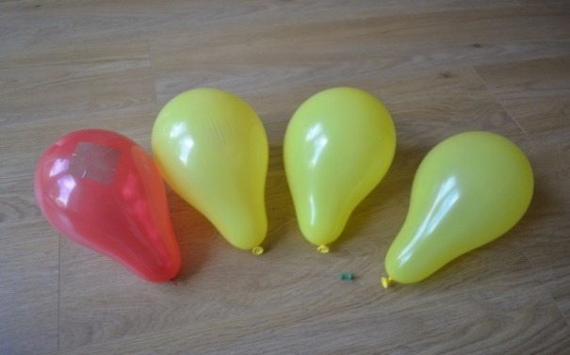
Normal Bacteria
Antibiotic resistant bacteria
Antibiotic

- Hold up two of the balloons, a red balloon with tape and the red balloon without tape. Tell the group that the balloons represent bacteria. For older children you may wish to make it more advanced by using an example of a bacteria they are familiar with (e.g E. coli).
- Show the pin and tell them that it represents an antibiotic. When we take an antibiotic, usually the antibiotic will help our bodies kill the bacteria. Pop the balloon without tape with the pin.
- Hold the second balloon but do not bring attention to the Sellotape. Tell the group that this represents the same bacteria (same colour), it causes the same illness however it has become resistant to the antibiotic. Place the pin through the tape and the balloon will not pop. The bacteria can resist the effect of the antibiotic and it will not be killed or cleared from the body.
- Explain that bacteria are clever and that they can also pass the information on how to resist antibiotics to other bacteria, like passing a secret. Show the remaining red balloon and yellow balloon (representing different bacteria) which each have tape. For older children you can explain that bacteria are able to pass their DNA onto other bacteria to become stronger.
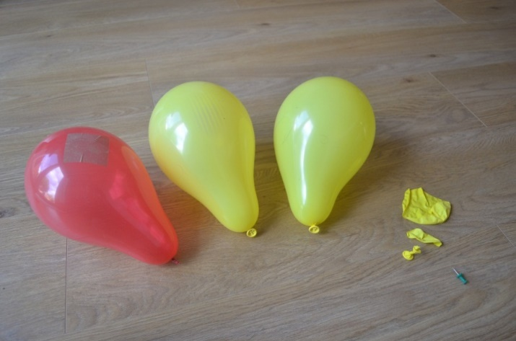
Bacteria killed by antibiotic
Antibiotic resistant bacteria are not killed by antibiotic

Activity instructions 2/2
- To help explain antibiotic resistance you can use an analogy such as that the bacteria have developed a super power to either hide from the antibiotic or stop it working. This is why you sometimes hear antibiotic resistant bacteria called ‘Superbugs’. If your group is older you can say that the tape represents a change in the bacteria DNA.
- Bacteria can become superbugs when they come into contact with an antibiotic, they meet the antibiotic and learn a way to overcome its effect. If you take too many antibiotics or take them when you don’t need to you are increasing the risk of bacteria in your body learning how to resist the antibiotic.
- Finish by saying that sometimes we have serious infections that need antibiotic treatment. To keep antibiotics working for when we really need them we need to use them correctly and not take them when they are not needed.

Antibiotic myths
Difficulty:3 | Ages: 5-16 | Scientific | Time: 10-20 mins

Learning objectives
- Antibiotics are special medicine that only work on bacteria.
- Antibiotics don’t work on viral infections like coughs, colds and flu.
- Bacteria are becoming resistant to antibiotics.
- We can help prevent more bacteria from becoming resistant to antibiotics by using them responsibly.

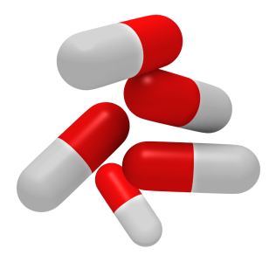Worksheet: Antibiotc myth sheet
Activity instructions
- Ask the group if anyone has taken antibiotics before, how did they take them and what infection did they have? ‘Superbugs’ or antibiotic resistant bacteria are able to resist the effects of antibiotics. The more antibiotics we take the more chance we give bacteria to learn to be ‘superbugs’, therefore it’s important that we take antibiotics correctly and don’t misuse them.
- Explain to the group that you will hold up eight different statements (from the antibiotic myth sheet) and they have to say whether they think it is right or wrong.
- To make the activity interactive, ask children to stand up if they think the statement is right, and if they think it is wrong, to remain sitting. Ask a few children who are standing or sitting why they think the statement is right or wrong. Alternatively ask children to run to one side of the room if they agree or the other side if they disagree.
- After discussing the statement, tell them the answer and then the reason why (see below)
Activity answers
1 | Wrong | Most common infections will get better by themselves through time, bed rest, liquid intake and healthy living. Antibiotics do not work on viruses.
2 | Right | Take antibiotics exactly as given by your doctor or nurse.
3 | Wrong | You must not use other people’s or any leftover antibiotics.
4 | Right | Most common infections will get better by themselves through time, bed rest, liquid intake and healthy living. Antibiotics do not work on viruses.
5 | Wrong | Antibiotics can help severe infections such as meningitis, pneumonia or kidney/urine infections.
6 | Wrong | Take antibiotics exactly as given by your doctor or nurse. Even if you feel better after 3 days you might still have the infection.
7 | Wrong | Most common infections like flu will get better by themselves through time, bed rest, liquid intake and healthy living. Antibiotics do not work on headaches or viruses.
8 | Right | If you over use antibiotics they might not work when you really need them for a severe infection.

- Finally explain that it is important we do not do any of the ‘wrong’ things with antibiotics as some bacteria are becoming resistant to antibiotics and these can be very dangerous.

Infected game
Difficulty:4 | Ages: 7-16 | Scientific | Physical | Time: 10-20 mins

Learning objectives
- Antibiotics are special medicine that only work on bacteria
- Antibiotics don’t work on viral infections like coughs, colds and flu
- Bacteria are becoming resistant to antibiotics
- We can help prevent more bacteria from becoming resistant to antibiotics by using them responsibly

Equipment
- Access to a chair
- Two different coloured sets of stickers

Activity instructions

Game play 1:
- Choose one child to be infected, this child will sit on a chair in the middle of the room.
- Choose 3-4 children to hold hands and make a circle around the chair. These children represent the “immune system” and must form a defence around the chair.
- The rest of the children are armed with stickers, these stickers are the “bacteria” and they must try and infect the person on the chair with stickers.
- The children representing the immune system must fend off the bacteria attack by protecting the child on the chair, but to make it extra tricky they are not allowed to let their hands go!

Game play 2:
- Try the game again but this time the people in the circle around the chair are antibiotics.
- The person who is infected is infected by non-resistant bacteria and the antibiotics are allowed to let one of their hands go at a time to pick off any bacteria (stickers).

See how many stickers are left on the person at the end of the game. Have the antibiotics done their job?

Game play 3:
- As game 2 but the children representing bacteria are now resistant and non-resistant bacteria (shown by two different coloured stickers). Give half of the children one colour, and the other half a different colour
- The antibiotics can let one of their hands go at a time to pick off any non-resistant bacteria but are not allowed to pick off the resistant bacteria stickers.
- See how many stickers are left on the child at the end of the game. Have the antibiotics done their job?

Discussion
At the end of game play 3, the child should be covered in antibiotic resistant bacteria. Discuss with the group:
- Why were the ‘antibiotics’ unable to protect the child from the antibiotic resistant infections?
- What does this mean for when we get serious infections that need medicine?
- How can we try to prevent antibiotic resistant infections and keep antibiotics working?

Antibiotic-resistant stuck in the mud-chain tag
Difficulty:5 | Ages: 11-16 | Scientific | Physical | Time: 10-20 mins

Learning objectives
- Antibiotics are special medicine that only work on bacteria
- Bacteria are becoming resistant to antibiotics
- We can help prevent more bacteria from becoming resistant to antibiotics by using them responsibly

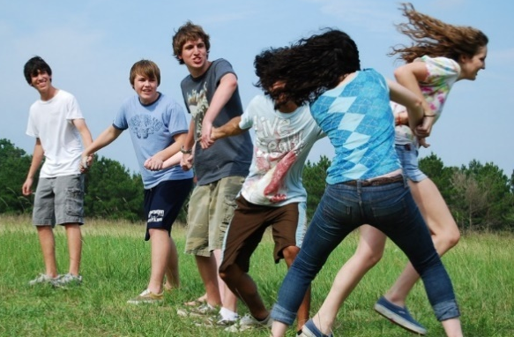
Pictured: Children playing Stuck in the Mud-Chain Tag

Equipment
- High visibility jackets, coloured t-shirts, Stickers or arm bands

Activity instructions

Game 1
- This game plays like stuck in the mud with a twist. Choose one child to represent antibiotic-resistant bacteria, this child wears the high visibility jacket or a coloured t shirt.
- Depending on the size of the group choose 2 -4 children to be Antibiotic-sensitive bacteria. Give these children an identifier such as a different colour t-shirt, arm bands or stickers.
- The rest of the group represent antibiotics until they are caught or tagged by a child who is bacteria. Once they have been tagged they represent a person with an infection.
- The role of the children who are bacteria is to infect the other children by tagging them
- The role of the children who are representing antibiotics is to treat as many of the ‘infected people’ before they have all been tagged.
- If a child is tagged by the antibiotic-resistant bacteria they have to stand with their legs closed, if they are tagged by antibiotic-sensitive bacteria they stand with their legs open.
- The children cannot be set free (treated by an antibiotic) if their legs are closed, they must remain standing for the rest of the game. Those with their legs open can be set free (i.e. treated) if an antibiotic goes through their legs.
- You can see how quickly bacteria can become resistant and once a child has been tagged by the antibiotic resistant bacteria you cannot reverse it.

Game 2 (chain tag)
- Play the game again but this time, it incorporates chain tag.
- At the same time as infecting people, the antibiotic resistant bacteria can also make the antibiotic-sensitive bacteria become resistant by tagging them (chain tag), this means tagging and holding on to each child in the chain.
- Anybody the chain tags (infects) must stand with their legs closed and cannot be set free.
- If the chain tags another antibiotic –sensitive bacteria, they will also become resistant and become part of the chain.
- Soon there will be no antibiotic-sensitive bacteria and everyone who is infected will be standing with their legs closed unable to be set free (treated) by antibiotics.
- This again shows how quickly bacteria can become resistant and also that bacteria can share their resistance ‘super power’ with other bacteria.

Antibiotic-resistant tag
Difficulty:3 | Ages: 7-16 | Scientific | Physical | Time: 10-20 mins

Learning objectives
- Antibiotics are special medicine that only work on bacteria
- Bacteria are becoming resistant to antibiotics

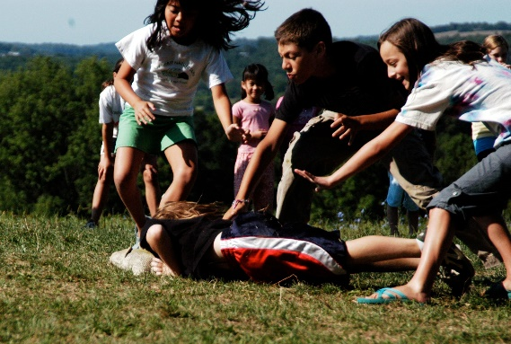
Pictured: Children playing Antibiotic-Resistant Tag

Equipment
- Two coloured t-shirts or arm bands
- Stickers or tokens (enough for three per child)

Activity instructions

Game 1
- Choose one member of the group to represent a bacterial infection, for instance bacteria that causes a chest or ear infection. Ask this child to wear one of the t-shirts or arm bands
- Give each of the other children 3 stickers/tokens which represent antibiotics
- The ‘bacteria’ chase the children and when they catch one, that person is infected. They must give up a sticker to the bacteria (ie they have used an antibiotic) to clear the infection and remain in the game. Once they have used all of their antibiotics (they have been infected 3 times) they are out of the game and must sit on the side.
- The game continues until only the bacteria remains

Game 2
- Repeat the game but this time ask 2 children to be bacteria and wear the two different coloured t shirts/arm bands. One of the children is ‘antibiotic sensitive’ bacteria and the other ‘antibiotic resistant’ bacteria.
- The game plays as before, however the antibiotic stickers do not work against the antibiotic resistant bacteria and children caught by this player are immediately out of the game.
- The game should finish a lot quicker than previously. Discuss with children the effect that having antibiotic resistant bacterial infections had in the game and what this might mean for real life.

Comics and additional resources on antibiotics
Difficulty:1 | Ages: 5-16 | Scientific | Physical | Time: 10-20 mins

Learning objectives
- Antibiotics are special medicine that only work on bacteria.
- Antibiotics don’t work on viral infections like coughs, colds and flu.
- Bacteria are becoming resistant to antibiotics.
- We can help prevent more bacteria from becoming resistant to antibiotics by using them responsibly.
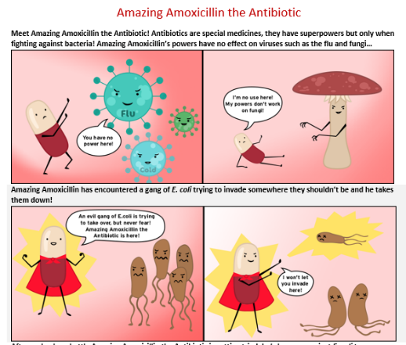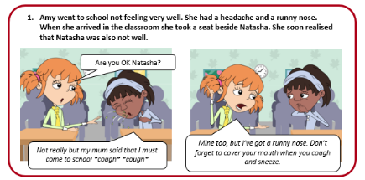

Activity Instructions
Four visual based resources to help you discuss antibiotics and antibiotic resistance with your groups:

Activity 1: Antibiotic storyboard (suitable for ages 5 – 11)
- Follow Amy’s day learning about infections and antibiotics. At each section of the story discuss with children what is happening
- Use the leader discussion points

Activity 2: Antibiotic word match up (suitable for ages 5 – 11)
- Complete with children to revise the definitions of terms used throughout this programme
- Answers to definitions are below

Antibiotic | Special medicine used to treat bacterial infections | Painkiller | A drug used to take pain away
Bacteria | Very small microbe that can be helpful or harmful | Virus | The smallest of the microbes – can be helpful or harmful
Infection | A disease caused by a microbe | Symptom | A sign of illness e.g headache, diarrhoea
Medicine | A drug used to treat disease or injury

Activity 3: Antibiotic scenarios (suitable for ages 11 – 16)
- 3 scenarios featuring young people discussing antibiotics and infections
- Ask young people to read the scenarios in groups and discuss the questions posed
- Use the leader discussion points

Activity 4: Amazing Amoxicillin the Antibiotic (suitable for ages 7 – 16)
- Comic showing how antibiotics work and how bacterial resistance occurs
- Use it as a discussion piece with young people or an aid to help you explain antibiotic resistance
- Extension activity: ask young people to create their own comic involving amazing amoxicillin or their own characters

Section 2:
Creative activity

Young people are given the opportunity to share what they have learnt through a creative medium. Suggestions are provided below; however, you may like to allow members to choose what type of resource they would like to make.

Posters
Develop an eye-catching poster to show others how and why they should protect antibiotics.

Young people should be encouraged to focus on one area they feel strongly about:
- Microbes
- Hand Washing
- Respiratory Hygiene
- Spread of infection
- Not using antibiotics for viral infections
- Going to the pharmacy before a GP for colds, coughs and sore throats
- Getting vaccinated to prevent getting ill

Send us your posters at e-bug@ukhsa.gov.uk if you would like to add them to the website gallery!

Take it further:
- Make a display of posters around the meeting location such as in the toilets.
- Encourage young people to take posters home and present to family
- Send to your local public health team or hospital to share with others in the community
- Share your resource on twitter with the hashtags #AntibioticGuardianBadge #AntibioticGuardian and #KeepAntibioticsWorking and tag @eBug_UK

Ideas for other resources
- Develop a song or jingle as a group and invite parents to listen at the end of a session
- Create fridge magnets that can be displayed at home with key hygiene messages
- Develop a social media campaign: posters and infographics to be shared online (may be appropriate as part of a larger project for older children)

Section 3:
Antibiotic Guardian Pledge

Young people are given the opportunity to use what they have learnt to make a pledge to protect antibiotics, thereby earning the title ‘Antibiotic Guardian’. It is best to do this at the end of the programme, so the group can reflect on everything they have learnt.

- Discuss with the group why it is important that we protect antibiotics, one of our most important medicines, for the future.

What are the risks of using antibiotics incorrectly (e.g for a viral infection where it is not needed?)
- The bacteria can become resistant to the treatment
- Infections become harder to treat and can be life threatening
- Operations and cancer treatment rely on antibiotics to prevent and treat infections, without effective antibiotics it will be much harder to do these treatments

- Discuss with the group the best ways to prevent the need for antibiotics by not getting ill. How can you stop infections from spreading and protect yourself and others?
- Wash hands while preparing food, before eating, after using the bathroom etc
- Use a tissue, or sleeve (not our hands) when we sneeze and throw it away in a bin
- Vaccinations

- Ask the group what else they have learnt and what they will do differently in the future to protect antibiotics.

- Ask the group to each make an Antibiotic Guardian pledge and promise to always do one thing to help protect antibiotics, this may be as simple as washing hands or something more advanced like teaching others about antibiotics depending on age of group.

- You could also ask children to pledge directly online at: www.antibioticguardian.com

Once all the pledges have been made, take a group photo with the pledges and/or posters and share on social media with the hashtags #AntibioticGuardian and #KeepAntibioticsWorking
Please follow your group GDPR guidelines for taking images with children and if unsure just share images of the pledges and posters.

Encourage the group to go home and ask their friends and family to become antibiotic guardians via the website: www.antibioticguardian.com

