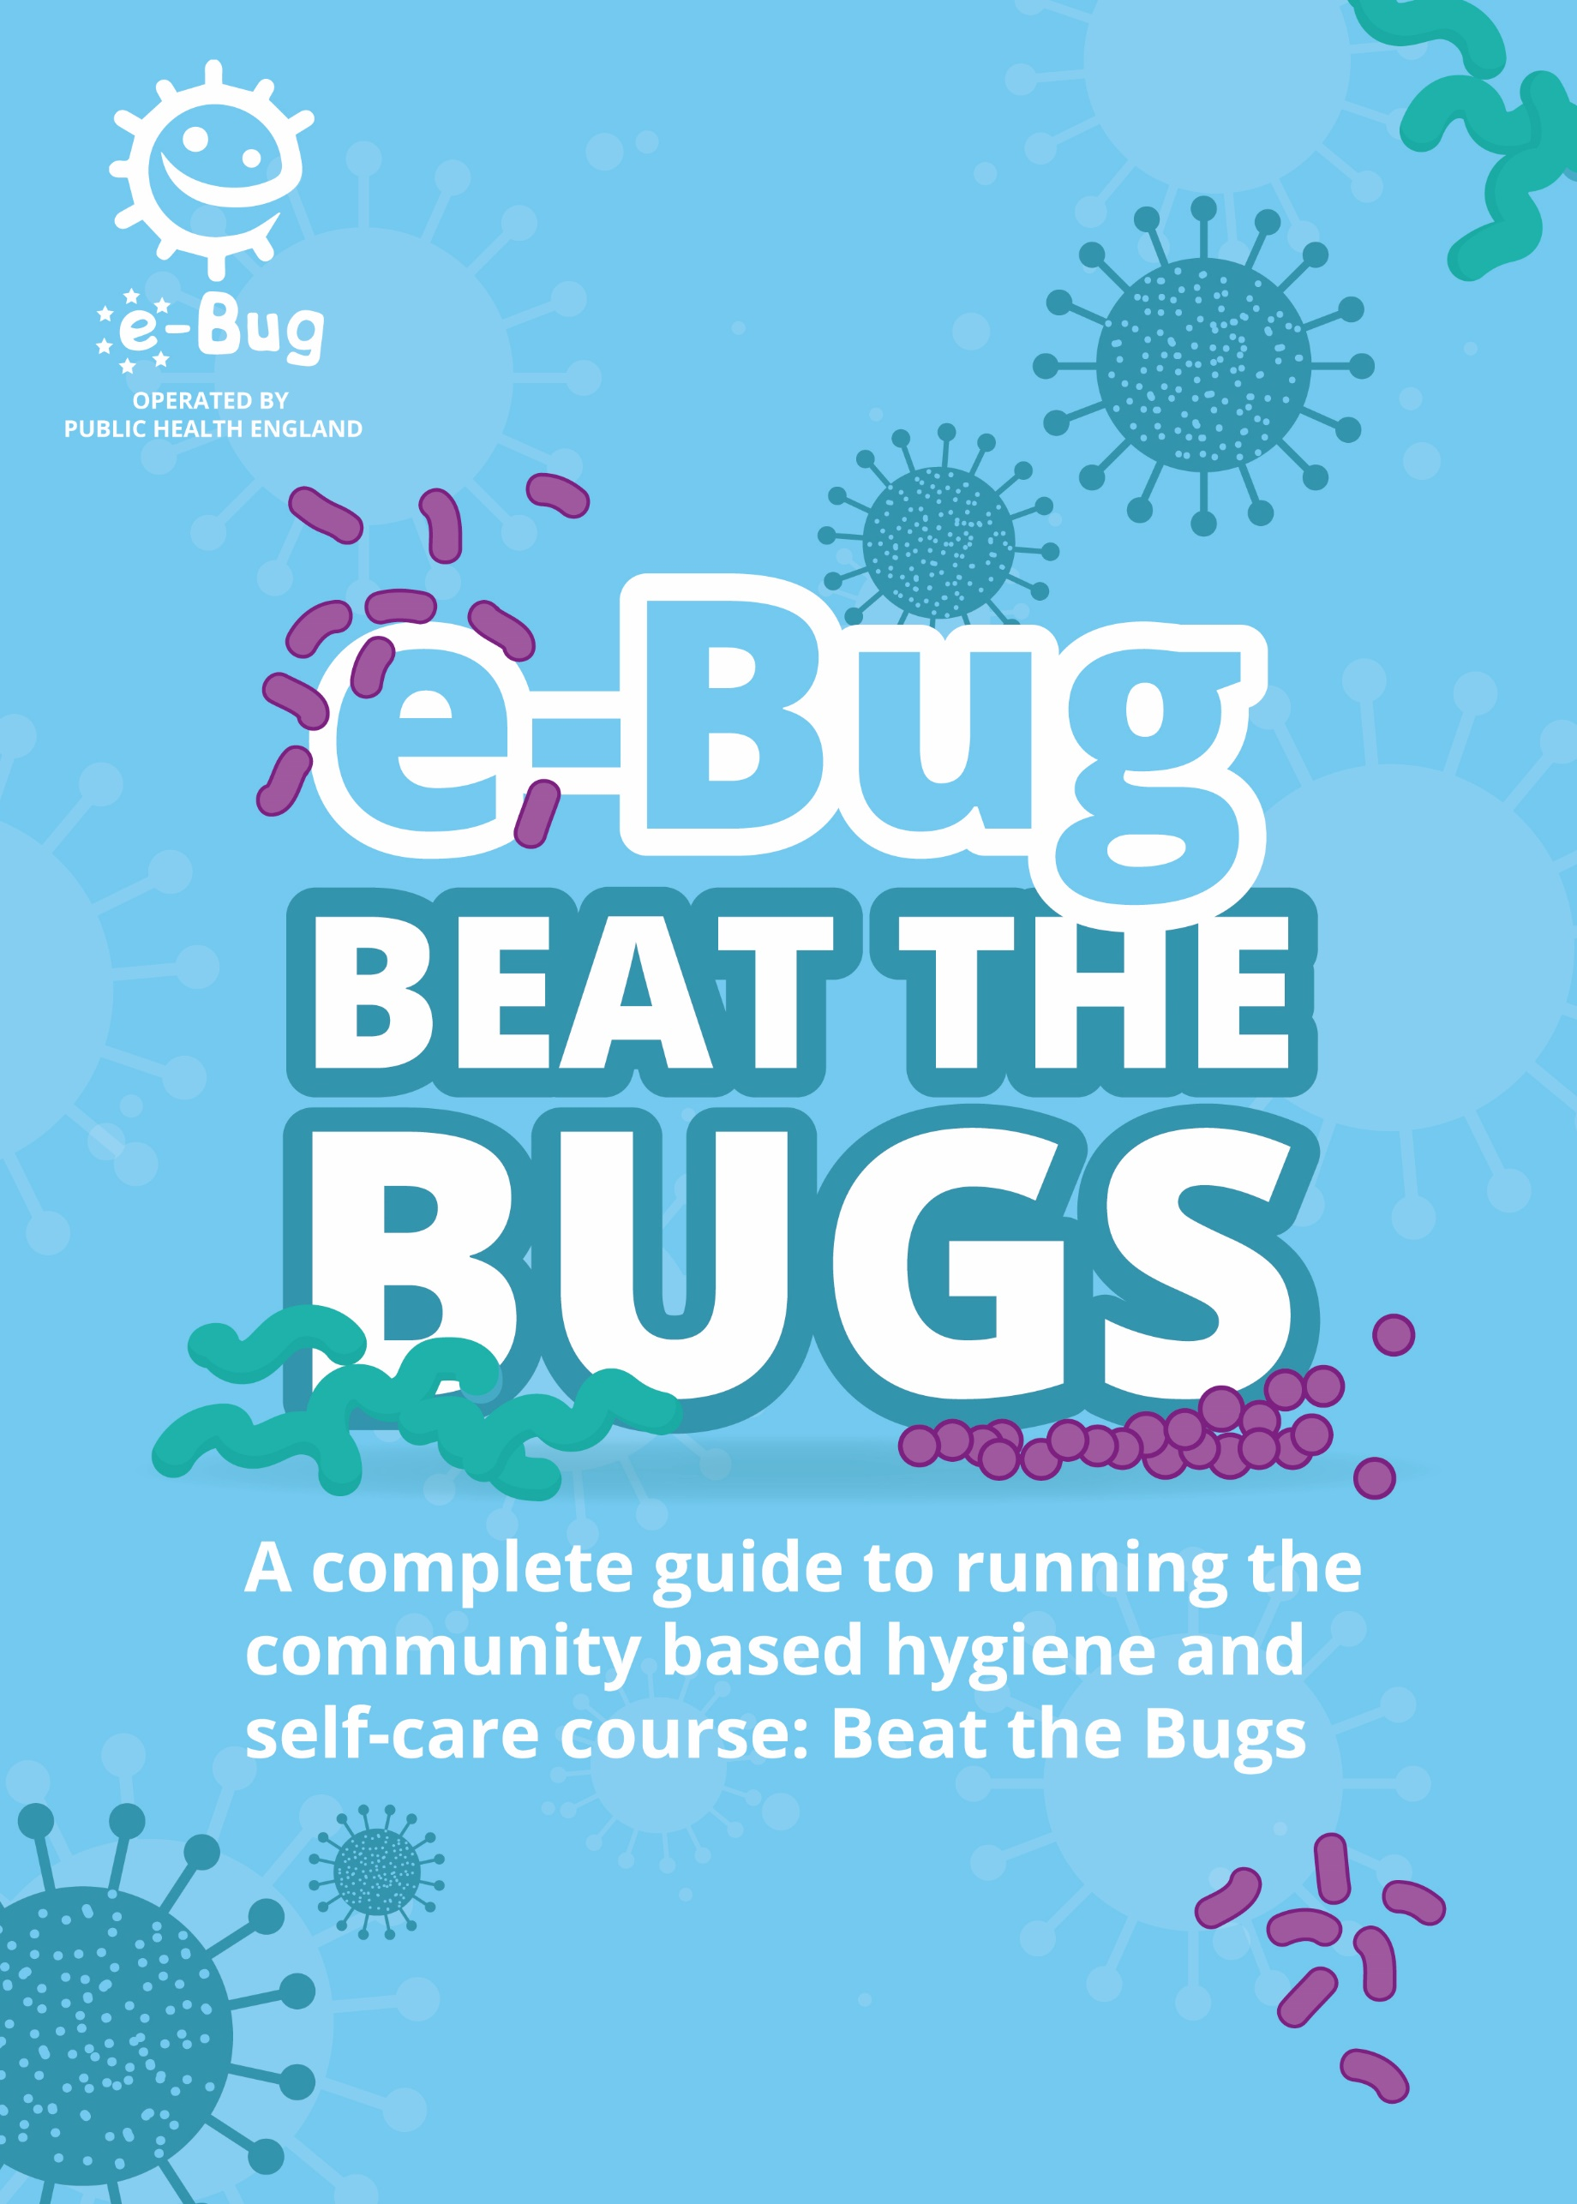

Welcome


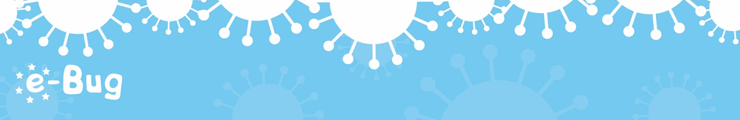
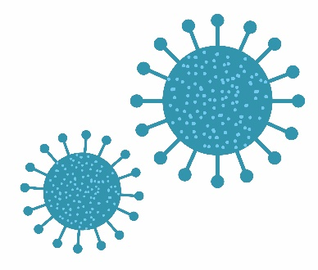
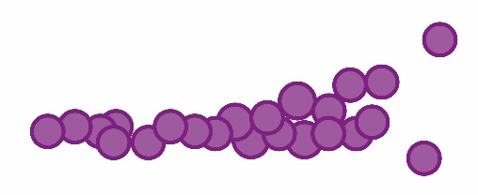

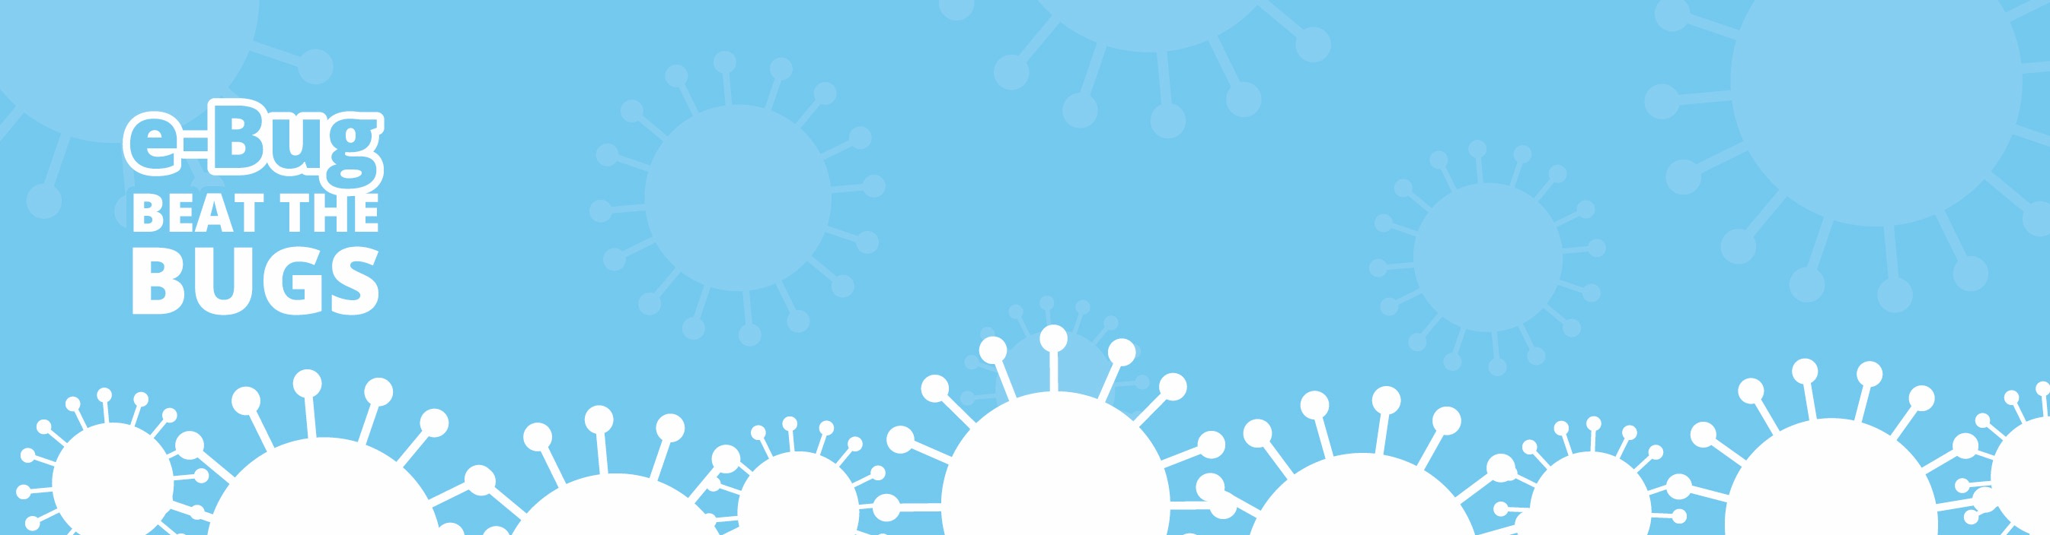
2
Overall Aims
By the end of the course we hope participants will have learned improved behaviours concerning health, hygiene and self-care. More specifically, they will learn how easily microbes spread, how to prevent this spread, and how to self-care when ill.

Setting:
This course is designed for use in a community setting.

Group Participants:
The learning abilities within the group may vary, so it important to engage in activities that are most appropriate for your group, to give visual and practical reinforcement of the skills to be learned.

How to run the course:
1. Use the experience and examples raised by people in the group as much as possible to help anchor the material to where they are currently ‘at’ so that suggested change is a natural next step.
2. Some activities take longer than others; each has been given an estimated time (this may vary depending on the abilities of the group). Plan carefully to fit the time available.
3. Each session has recommended and optional activities. Choose activities which best suit your group.
4. The introduction for each session lists the equipment required.
5. Allow time for discussion and have prompts to get the discussion started
6. Repeat key learning outcomes throughout the session
7. Use open questions where possible.

This should be a fun and informative course – make it so!
Page 2
Contents

This pack contains a series of educational resources for community groups and covers the topics of microbes, the spread of infection, treating infections and self-care.

Introduction | 4-5
Session 1: Meet the Bugs | 7-27
Session 2: Spreading Bugs | 29-45
Session 3: Food Bugs | 47-67
Session 4: Mouth Bugs | 69-86
Session 5: Bug Busters | 87-98
Session 6: Know Your Bugs | 99-111
Certificate of Completion  Action Plans | 113  115-117
3
Introduction

Equipment needed for the introduction:

- Stickers (for name badges) + Felt Tips
- Flipchart + Stand + Pens
- Attendance Sheet

Start on time. Get participants used to the fact that your sessions will start and finish on time. Allow latecomers to slip in with as little disruption as possible.

As each participant arrives, hand each one a sticker for them to write their name on (help if appropriate).

Ask participants to sign in on the attendance sheet.

Begin the course:

Welcome to this first of (6) sessions of the ‘Beat the Bugs’ course. We hope this is going to be time well invested for you and those around you as we explore ways of keeping ourselves safer and healthier in our every day life.

Introduce yourself briefly and run through local housekeeping information:

- Toilets
- Fire Alarms
- Fire Exits
- Fire Assembly Point
- First Aid Post / First Aiders
- Refreshments
- Classroom hazards
- Building information
- Lanyards/keeping safe

Get every participant to say their name, as way of introduction.
4
Page 4
Introduction

Setting Group Rules
For the emotional safety of the group, go through the following exercise on the flipchart:

What do I bring to the course / group | What can I get from the course / group
What am I a bit worried about | What guidelines shall we have for the group

- Ask participants what they bring to the course (they might be a nurse or might bring their “sense of humour”)
- Ask participants what they hope to get from the course
- Ask them if they are/were worried about anything to do with the course (could be meeting new people, role play, having to read or write)

Use what has been discussed above to put together group guidelines that work for that particular group.

Consider:
- Mobile phones
- Regular attendance
- Letting people know about absence
- Respect for each other
- Confidentiality
- How to ensure all feel included
- Time Keeping
- Self-disclosure
- Questions

Once the guidelines are drawn up, move onto course content, starting on the next page.
5
Meet the Bugs

6
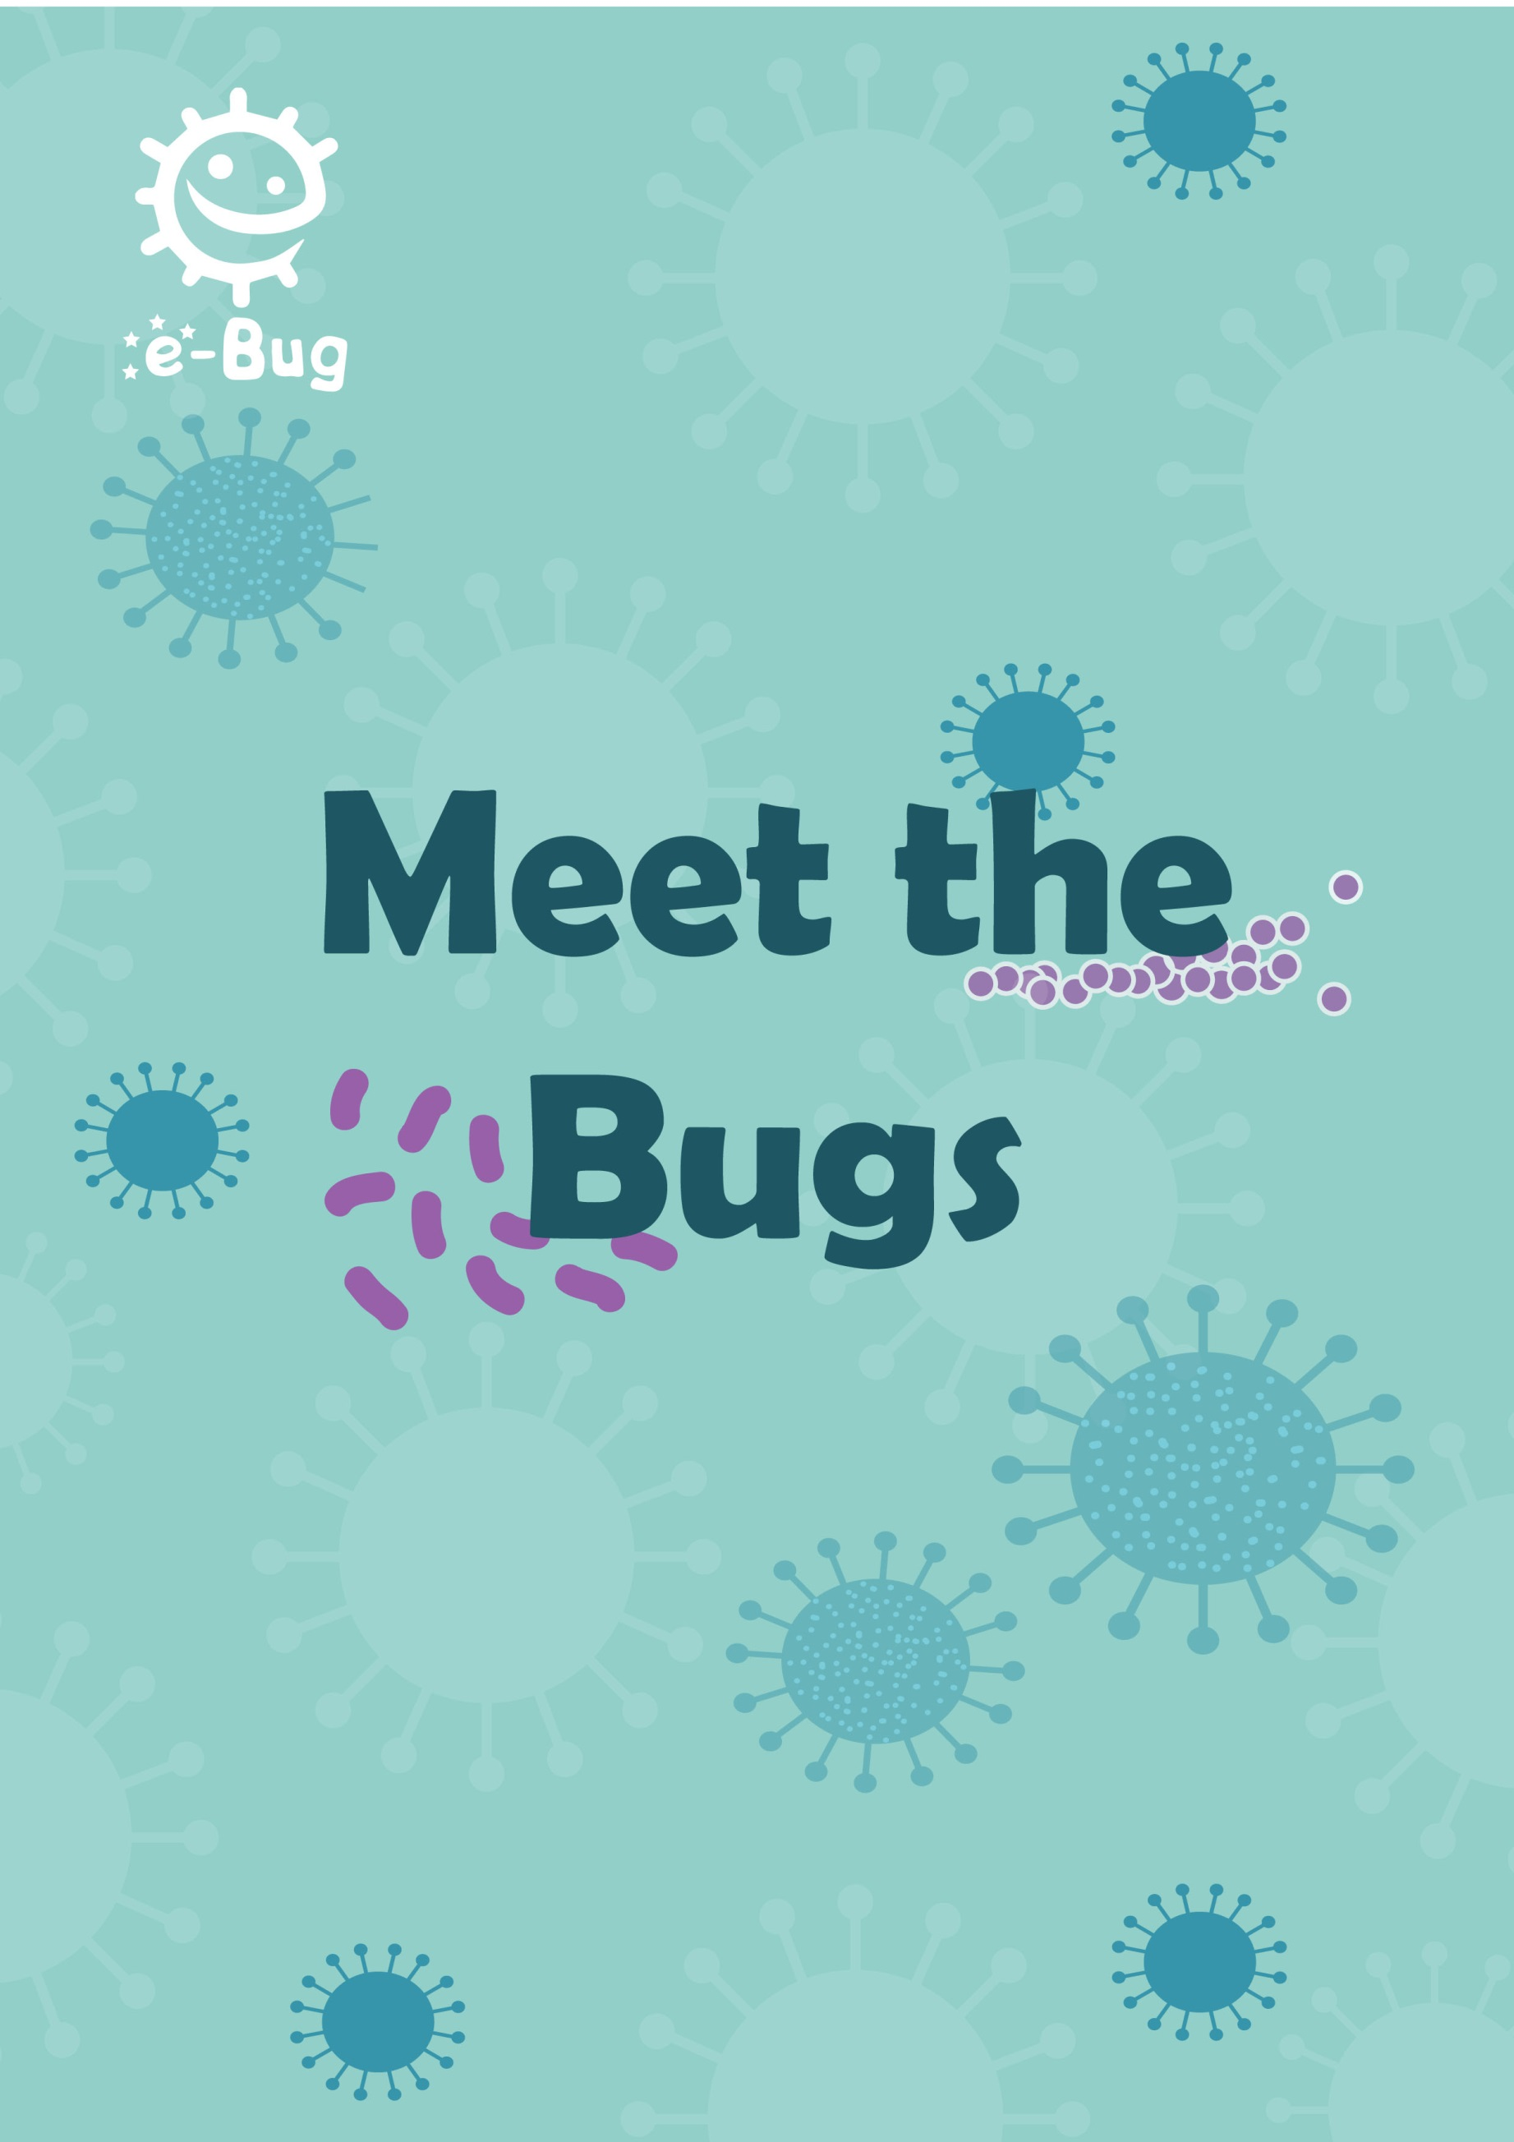

Meet the Bugs

Introduction
This session gives an overview of microbes. Participants are introduced to the world of microbes, firstly by exploring the different types and shapes of microbes and then, by discussing different useful and harmful microbes.

Learning outcomes
All participants will understand that:
- There are three different types of microbes, which can be found everywhere
- Useful bacteria are found in and on our body
- Many of our useful microbes are put to good use every day to help keep us healthy
- We need to protect our useful microbes
- Sometimes the harmful microbes can make us ill
Key words
Microbes
Virus
Fungi
Bacteria
Germ
Micro-organism
Available web resources
Videos of the activities.
Variety of microbial photographs.
Participant handouts in MS PowerPoint format.
Meet the Bugs Poster

Materials required
Activity 1: 2 plastic cups, flour, yeast solution, sugar, 2 graduated cylinders, basin, hot water. A copy of Participation Handout 1 (PH1) and Participation Worksheet 1 (PW1).
Activity 2: Cut out and laminate set of playing cards PH2.
Activity 3: Magazines, A4 plain paper, scissors and glue.
Activity 4: Images of microbes, petri dishes and play dough.
Activity 5: A copy of PH3 and PW2.
Action plan: Copies of the 2 action plan sheets located at the back of this book for each participant.

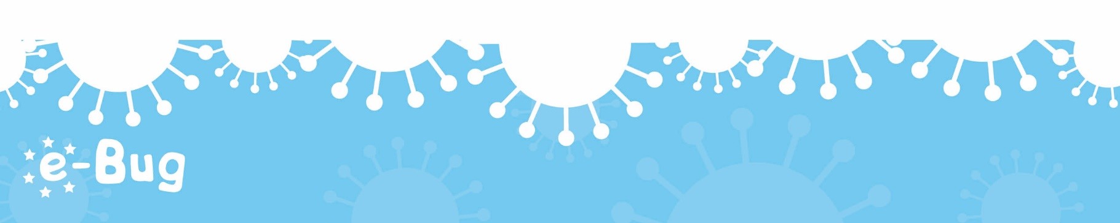

8
Meet the Bugs
Meet the Bugs

Background information

Micro-organisms (microbes) are living organisms too small to be seen with the naked eye. They are found almost everywhere on earth and can be both useful and harmful to humans. Although extremely small, microbes come in many different shapes and sizes. There are three main groups of microbes:

Viruses are the smallest of the microbes and many can cause illness in humans. Viruses cannot survive by themselves. They require a ‘host’ cell, such as a human cell, in which to live and reproduce. Once inside the host cell, they multiply and can destroy the cell in the process.

Fungi can be both useful and harmful to humans. Fungi range in size from being microscopic to very large. Harmful fungi can cause an infection such as athlete’s foot, or are poisonous to eat such as some mushrooms. Examples of useful or harmless fungi include Penicillium which produces the antibiotic penicillin and Agaricus which is the button mushroom and can be eaten. Fungi spread through the air in small hard seed-like spores. When these spores land, for example on bread or fruit, they open and grow under the right conditions (dampness).

Bacteria can multiply very quickly, on average once every 20 minutes. During their normal growth, some bacteria produce toxins which are extremely harmful to humans and cause disease such as tetanus. Some bacteria are completely harmless to humans, and some others are extremely useful to us (Lactobacillus in the food industry) and even necessary for human life such as those involved in plant growth (Rhizobacterium). Over 70% of bacteria are non-pathogenic (harmless) micro-organisms.

Bacteria can be simply divided into three groups by their shapes – cocci (balls), bacilli (rods) and spirals. Scientists use these shapes to help find out which infection a patient has.

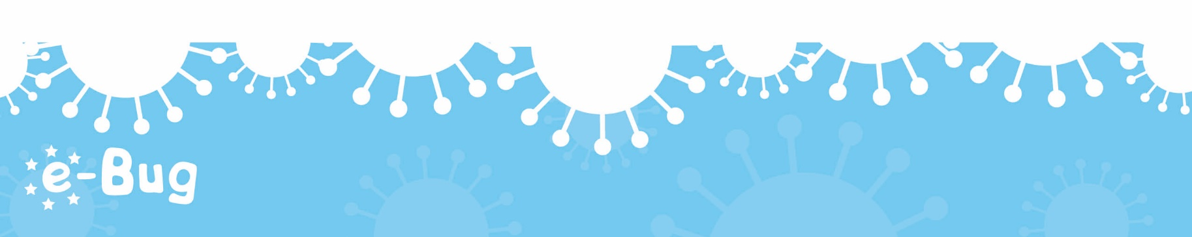

9
Meet the Bugs

As living creatures, microbes have certain growth requirements but these vary depending on where the microbe is found. For example, microbes which live in humans prefer a temperature of 37ºC, whereas microbes living in deep sea thermal vents prefer much higher temperatures. Microbes living in arctic regions prefer much lower temperatures. Microbes also vary in their nutrient requirements. A sudden change in the environment, such as an increase in temperature, can kill many microbes although it is important to remember that microbes are extremely adaptable and gradual changes can result in microbes adapting to suit their environment e.g. antibiotic resistant bacteria.

Many bacterial infections are easily treated with antibiotics. However, the bacteria are fighting back and some bacteria have developed resistance against antibiotics; these are called antibiotic resistant bacteria. For example, skin infections caused by Staphylococcus aureus used to be treated by Penicillin. However as resistance has developed over the years, first against penicillin and then another antibiotic, Flucloxacillin, these bacterial infections called MRSA (Methicillin Resistant Staphylococcus aureus) can now be life threatening.
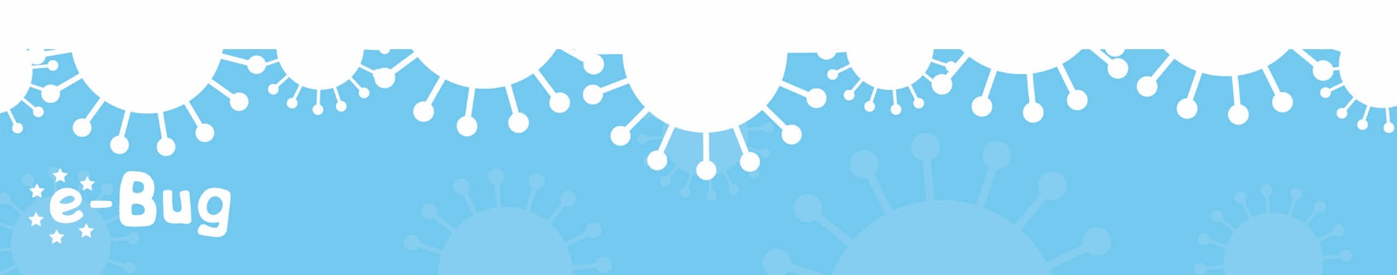
10
Meet the Bugs

Introduction
Begin the session by asking participants what they already know about microbes. Most participants will already know that microbes can cause illness but may not know that microbes can also be good for us. Ask the group where they would look if they wanted to find microbes. Do they think microbes are important to us?
Explain that microbes are the smallest living creatures on earth and that the word micro-organism literally translates into micro: small and organism: life. Microbes are so small they cannot be seen without the use of a microscope.
Show the group that there are three different types of microbe: bacteria, viruses and fungi. The ‘Meet the Bugs’ poster can be used to show the different types of microbes and images of microbes. Use PH3 to demonstrate how these three microbes vary in shape and structure. The web activity found at www.e-bug.eu can be used to help demonstrate the varying sizes of bacteria, viruses and fungi in relation to each other
(www.e-Bug.eu/movies/Microbe_Animation_V2_eng_eng.swf).

Emphasise that although microbes cause disease, there are also useful microbes. Ask participants to identify some benefits of useful microbes. These include Lactobacilli in yogurt and the fungus Penicillium which produces the antibiotic penicillin. Or the yeast in bread and beer which causes bread to rise and sugar to become fermented to alcohol respectively.
Highlight to the group that microbes can be found EVERYWHERE – floating around in the air we breathe, on the food we eat, in the water we drink and on the surface of and in our bodies. Emphasise that although there are harmful microbes that can make us ill, there are many more useful microbes that we can use, and other microbes that are everywhere that have no effect on us.

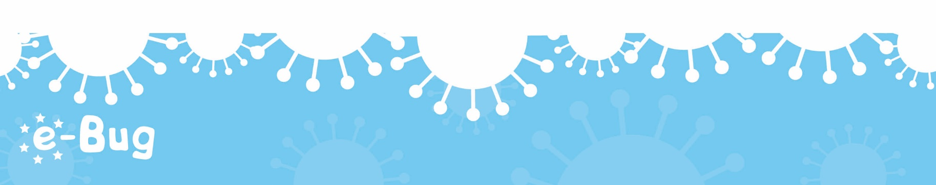
11
Meet the Bugs

Explain that we have useful microbes in our bodies and that we should try to protect our useful microbes. This video will help discuss the topic of useful microbes: www.youtube.com/watch?v=5DTrENdWvvM
Discuss with the group that antibiotics can treat many bacterial infections but some bacteria are fighting back and becoming resistant to the antibiotics. These resistant bacteria can spread just as easily.
The following pages describe 5 activities about microbes, some recommended and some optional. Choose the most appropriate activities for your group.
12
Meet the Bugs

Recommended Activities
The following three activities are recommended.

Activity 1 – Yeast Races (30 mins)
Advance preparation: Prior to starting the activity make up a liquid yeast solution as outlined on the yeast packaging, with water and dried yeast. This may vary between different brands. Do not add sugar until stated in the main activity. If made too far in advance the yeast will start to ferment.
- This activity is for groups of 2 – 5 participants.

- Highlight to the participants that a useful fungus known as yeast is used to make bread. The yeast helps the bread rise by a process known as fermentation.

- Supply the groups with the Yeast Races Recipe (PH 1). The recipe can also be found on the e-Bug Junior Useful Microbes Teacher website for white board use.

- Have participants carry out the activity in their groups. When the recipe is complete, participants should observe the yeast and record their observations on the participant worksheet (PW 1).

- Can the group explain why the yeast and sugar solution moved faster than the yeast alone? Fermentation was carried out at a faster rate when the sugar was present.

If this activity is used, enough time should be left to record observations for 30 minutes. Participants could move on to a second or third activity, taking time to measure the dough in between activities.

Learning outcomes achieved:
- There are three different types of microbes, which can be found everywhere
- Many of our useful microbes are put to good use every day to help keep us healthy
13
Page 13
Meet the Bugs

Activity 2 – Top Trumps (10-20 mins)
In this activity groups of 3 – 4 participants play a card game (PH2) which helps them remember some of the technical words relating to microbes as well as familiarising participants with a variety of microbial names, the differences in size, capability of causing harm and if antibiotic resistance occurs.

Please note: Microbe size and number of species are correct at the time of resource development; however, as new microbes are continuously being discovered and reclassified, these numbers may be subject to change. The numbers in the other headings used on the cards are only to be used as a guide, they are not accurate as there is no formulae to create these and they may be subject change i.e. bacterial species may develop resistance to more antibiotics resulting in them having a higher number in this column and being more dangerous to humans.

Game rules
- The dealer should mix the cards well and deal all the cards face down to each player. Each player holds their cards face up so that they can see the top card only.

- The player to the dealer's left starts by reading out an item from the top card in their hand (e.g. Size 50). In a clockwise direction, the other players then read out the same item. The player with the highest value wins, taking the other players top cards and placing them to the bottom of their pile. The winner then selects the item to read out from the next card in their hand.

- If 2 or more players have the same top value then all the cards are placed in the middle and the same player chooses again from the next card. The winner then takes the cards in the middle as well. The person with all the cards at the end is the winner.

- Finish up the activity with a quick discussion. What have you learnt? Which microbes were the most useful to humans? Were many bacterial microbes resistant to antibiotics?

14
Meet the Bugs

Alternatively, a similar game called ‘Bacteria Combat’ can be downloaded in app form for participants to play in class or at home. A link to download the game can be found on the e-Bug Young Adult Student games webpage.

Learning outcomes achieved:
- There are three different types of microbes, which can be found everywhere
- Useful bacteria are found in and on our body
- Many of our useful microbes are put to good use every day to help keep us healthy
- We need to protect our useful microbes
- Sometimes the harmful microbes can make us ill

Activity 3 – Magazine Microbes (10-20 mins)
- This activity can be done either individually or in groups.

- Provide participants with different magazines.

- Ask participants to look through the magazines and find images of places where microbes can be found (i.e. a picture of a fridge, kitchen worktop, shoes, clothes etc.)

- Ask participants to cut out the images using scissors and stick onto an A4 piece of paper to make a collage with the title “Where can microbes be found?”

- At the end of the activity, explain to the participants that microbes are found everywhere even on the magazine they were looking through. Stress that microbes are found all over our skin, mouths, gut and especially hands. Most are completely harmless that we carry without knowing.

- Discuss that the bacteria on our bodies are important as they act as a barrier to stop other more harmful bacteria entering your body and making you ill.

- If time permits and participants are comfortable to they can present their posters to the rest of the group.

15
Meet the Bugs
Meet the Bugs

Learning outcomes achieved:
- There are three different types of microbes, which can be found everywhere
- We all carry around bacteria on our bodies and we need to look after these useful microbes.

Optional Activities
Activity 4 – Make your own microbes (10-20 mins)
- This activity can be done either individually or in groups.

- Provide each group with either a colour handout (PH2) of the different types of microbes or place colourful posters on the classroom walls from the e-Bug student website downloads section. These handouts will show the range of shapes and sizes of microbes with names and whether they are useful or harmful microbes.

- Provide each group with play dough or other materials from the scrap store, in a variety of colours, and paper plates to make the microbes on.

- Ask each individual / group to recreate a microbe or groups of microbes based on the coloured images provided, or to design their own microbe.

- If designing their own, each individual must decide whether their microbe is useful or harmful and provide its name.

- Remind the group that fungi are the largest microbes and viruses are the smallest.

- If time permits and participants are comfortable to they can then present their microbes to the rest of the group, saying what type of microbe it is and whether it is useful or harmful.

- Finish up the activity with a quick discussion. What have you learnt?

Learning outcomes achieved:
There are three different types of microbes, which can be found everywhere.
16
Meet the Bugs

Activity 5 – What microbe am I? (15 mins)
1. Provide each participant with a copy of PH3 and PW2.

2. By reading the descriptions and using the information on their handouts participants must decide whether the microbes are bacteria, virus or fungi.

Answers:
  - Staphylococcus is a bacterium.
  - Lactobacillus is a bacterium.
  - Dermatophytes are fungi.
  - Influenza is a virus.
  - Penicillium is a fungus.
  - Campylobacter is a bacterium.

Learning outcomes achieved:
1. There are three different types of microbes, which can be found everywhere
2. Useful bacteria are found in and on our body
3. Many of our useful microbes are put to good use every day to help keep us healthy
4. Sometimes the harmful microbes can make us ill

17
Meet the Bugs

Discussion
Discuss what the group have learnt today with open questions and refer back to the ‘Meet the Bugs’ poster if necessary.
What have you learnt today?
What will you take home from today?

Lead the discussion to reflect back on the sessions learning objectives.
- There are three different types of microbes, which can be found everywhere
- Useful bacteria are found all over our body
- Useful microbes can help us keep healthy and most are beneficial
- We need to protect our useful microbes
- Sometimes the harmful microbes can make us ill

Extension questions:
1. What are microbes?
Microbes are living organisms too small to be seen with the naked eye.

2. Where are microbes found?
Microbes are found everywhere.

3. What are the three different types of microbes?
Viruses, Bacteria and Fungi.

4. What are the main difference between bacteria and viruses?
Bacteria are much more complex than viruses and can live virtually ANYWHERE, whereas viruses need to live in a host cell in order to survive. Viruses are not killed by antibiotics; antibiotics are only effective against bacteria.

5. How can we look after our useful microbes?
Eat healthy foods such as fruit and vegetables and yoghurt to help increase the useful microbes in our gut. Not using antibiotics if they are not needed as these can kill useful microbes as well as harmful.
18
Meet the Bugs

Action Plan
Ask participants to complete their action plan for this session, tell them that they will fill this out each week with what they have learnt. The ‘Action Plans’ (located at the back of this booklet) should be returned to the group leader but participants can take a copy of the ‘Action Plans’ home if they wish.
Please ensure that participants add their name to their ‘Action Plan’ worksheet. This worksheet will be used again in the final session, so it is important to collect each participant’s ‘Action Plan’ sheet at the end of the session to be recirculated in the next.
Ask participants to either choose one of the action plans from below or to make up their own if they are confident enough.

1. I will remember that there are 3 types of microbes; fungi, bacteria and viruses.
2. I will remember that microbes are found everywhere and are too small to be seen with the naked eye.
3. I will remember that we have useful microbes in our bodies which we should try to protect.

Acknowledgements
This session plan was written by the e-Bug team and assisted by the Kingfisher Treasure Seekers Community Group.
19
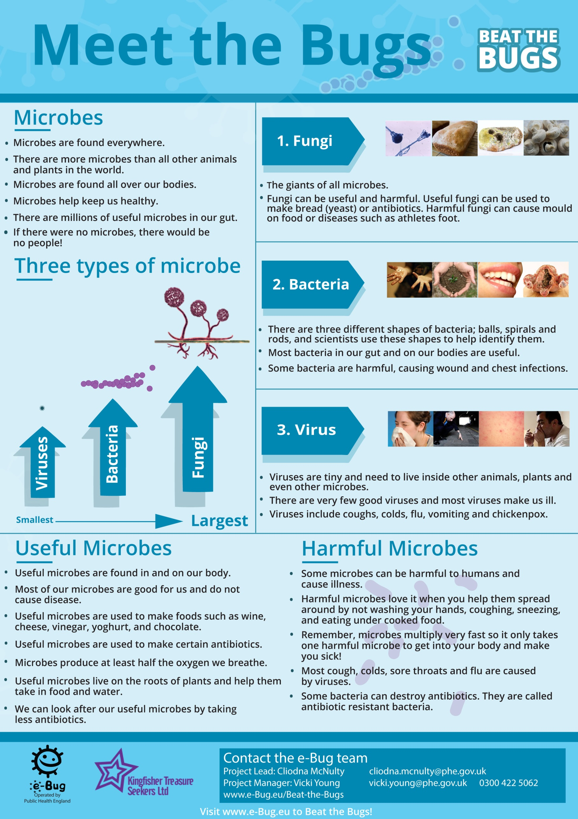

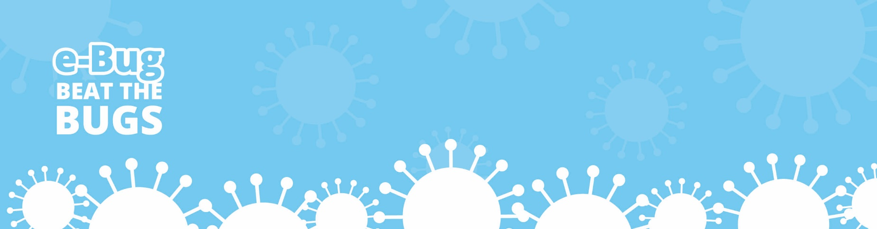
Yeast
Races
Participant Handout 1
Record the exact height of the dough in each
Pour the contents of cup B into graduated cylinder B until it reaches about 30ml

Pour the contents of cup A into graduated cylinder A until it reaches about 30ml
Add enough yeast and sugar solution to plastic cup B until it has the consistency of a thick milkshake.

Add enough yeast solution to plastic cup A until it has the consistency of a thick milkshake.
Label one of your plastic cups A and one B
Add 4 dessert spoons of flour to each of your cups
Place both measuring cylinders into a basin of hot water
Student Handout 2

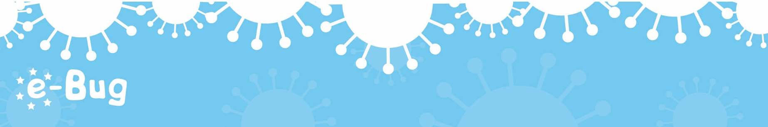
Measure the height of the dough every 5 minutes for 30 minutes

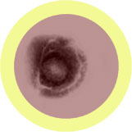
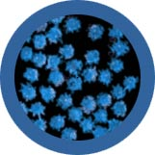
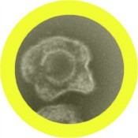
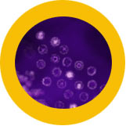
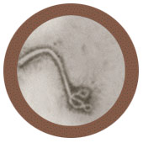
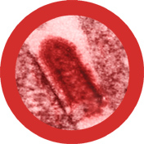
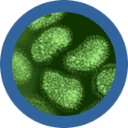
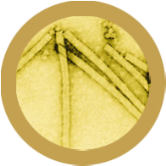
Participant Handout 2a

Lyssavirus

Tobamovirus

Lymphocryptovirus

Virus
Var-E-Cell-O-Virus
Virus
Rhino-Virus
Virus
Sim-Plex Virus
Lim-Foe-Cryp-Toe-Virus
Virus
Virus
E-Bowl-Ah
Lice-A-Virus
Virus
Virus
In-Flu-En-Za A
90
1
146
12
N/A
Max Size (nm) .................................

Antibiotic resistance .......................
Danger to humans .........................
Number of species .............................

Virus
Tob-A-Mo-Virus
200
Varicellovirus

2
21
7
N/A
Usefulness to humans ........................

Max Size (nm) ...............................

Antibiotic resistance .......................
Danger to humans ...........................
Number of species ..............................

2
Rhinovirus
25
28
14
N/A
Usefulness to humans ......................

Max Size (nm) .................................

Antibiotic resistance .......................
Danger to humans ...........................
Number of species ..........................

200
Simplex Virus

2
64
2
N/A
Usefulness to humans .......................

Max Size (nm) ................................

Antibiotic resistance .......................
Danger to humans ...........................
Number of species .............................

Herpes simplex is one of the oldest known sexually transmitted infections. In many cases, Herpes infections produce no symptoms at all but unsightly scab-like symptoms do occur in about one third of people infected.

110
7
37
2
N/A
Usefulness to humans ........................

Max Size (nm) .................................

Antibiotic resistance .......................
Danger to humans ............................
Number of species .............................

1500
1
200
0
N/A
Usefulness to humans ........................

Max Size (nm) ..............................

Antibiotic resistance .......................
Danger to humans .........................
Number of species .............................

Filovirus causes a disease more commonly known as Ebola. It is one of the more dangerous viruses known to humans due to the fact that there is no known preventative vaccine or treatment. 50 – 90% of victims die from the disease!
5
180
125
Danger to humans ..............................
10
74
N/A
Usefulness to humans ........................

Max Size (nm) .................................

Antibiotic resistance .......................
Danger to humans ............................
Number of species .............................

The Lyssavirus infect both plants and animals. The most common Lyssavirus is the Rabies virus and is usually associated with dogs. Rabies has been responsible for over 55,000 deaths worldwide but can be prevented by vaccination.
18
12
34
N/A
Usefulness to humans ......................
humans

Max Size (nm) ...................................

Antibiotic resistance .......................
Number of species ...........................

Influenza A

Ebola

Chickenpox is caused by the Varicella-Zoster virus. It is highly contagious although rarely serious and is spread through direct contact (or coughing and sneezing). Almost everyone caught chickenpox in their childhood prior to the discovery of the chickenpox vaccine.

There are over 250 different kinds of cold viruses! But Rhinovirus is by far the most common. Rhinoviruses are responsible for almost 35% of colds. Rhinovirus can survive three hours outside someone's nose. If it gets on your fingers and you rub your nose, you've caught it!

The Epstein-Barr virus is a type of Lymphocryptovirus causing an illness known as the Kissing Disease or Glandular fever. Patients suffer from sore throats, swollen lymph glands, and extreme tiredness. Transmission requires close contact such as kissing or sharing drinks.

The flu is an infection caused by Orthomyxoviridae. Every year 5 – 40% of the population get the flu but most people recover completely in a couple of weeks. In 1918, before there were any vaccines for the flu, twenty million people were killed!

Tobamovirus are a group of viruses that infect plants, the most common being tobacco mosaic virus, which infects tobacco and other plants causing a mosaic like discoloration on the leaves. This virus has been very useful in scientific research.

Participation Handout 1
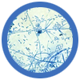
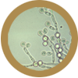
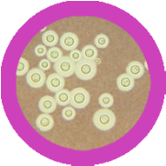
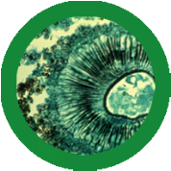
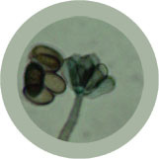
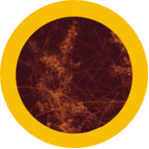
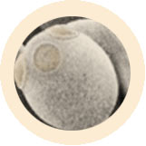
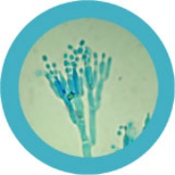
Participant Handout 2b
Tinea

Penicillium

10,000
Fungi
Sac-A-Row-My-Sees
Fungi
Ver-Tee-Sil-Ee-Um
Fungi
Can-Did-A
Fungi
Cryp-Toe-Coccus
Fungi
Ass-Per-Gill-Us
Stack-Ee-Bo-Trys
Fungi
Fungi
Tin-Ee-A
Fungi
Pen-Ee-Sil-Ee-Um
37
37
19
Antibiotic resistance ..........................
8,500,000

175
7, 500
Aspergillus is both beneficial and harmful to humans. Many are used in industry and medicine. This fungus accounts for over 99% of global citric acid production and is a component of medications which manufacturers claim can decrease flatulence!

124
200
Aspergillus
72,000
110,000
184
10,000
198
1
N/A
Usefulness to humans ......................

Max Size (nm) .............................

Antibiotic resistance ..........................
Danger to humans ................................
Number of species ............................

Verticillium
4
1
18
N/A
Usefulness to humans .........................

Max Size (nm) ........................

Antibiotic resistance ..........................
Danger to humans ................................
Number of species ...............................

44
Candida
74
N/A
Usefulness to humans .....................

Max Size (nm) ..............................

Antibiotic resistance .........................
Danger to humans ..............................
Number of species .............................

Cryptococcus
98
N/A
Usefulness to humans .......................

Max Size (nm) ..............................

Antibiotic resistance .........................
Danger to humans ..............................
Number of species ..............................

47
N/A
Usefulness to humans .....................

Max Size (nm) .................

Antibiotic resistance ..........................
Danger to humans .............................
Number of species ..........................

2
83
2
N/A
Usefulness to humans .........................

Max Size (nm) ..............................

Antibiotic resistance ...........................
Danger to humans ..............................
Number of species ..............................

14
16
Danger to humans .............................
12
43
N/A
Usefulness to humans .......................

Max Size (nm) ..........................

Antibiotic resistance ...........................
Danger to humans ............................
Number of species ............................

64
N/A
Usefulness to humans .....................

Max Size (nm) .........................

Number of species .............................

Saccharomyces

Stachybotrys

101, 000, 000
Verticillium is a widely distributed fungus that inhabits decaying vegetation and soil. Some Verticillium may be pathogenic to insects, plants, and other fungi but very rarely cause human disease.
Candida is among the natural flora living in the human mouth and gastrointestinal tract. Under normal circumstances these fungi live in 80% of the human population with no harmful effects, although overgrowth results in candidiasis (Thrush).
Cryptococcus is a fungus which grows as a yeast. It is best known for causing a severe form of meningitis and meningo-encephalitis in people with HIV/AIDS. The majority of Cryptococci live in the soil and are not harmful to humans.

Stratchybotrys (or straw mould) is a black toxic fungus that although itself is not pathogenic, it does produce a number of toxins that can cause a variety of health problems ranging from rashes to life threatening reactions for those with respiratory problems.

Although a variety of fungi can cause foot rashes, Tinea cause the itchy, cracked skin typically between the fourth and fifth toes known as Athlete's foot, which is the most common fungal skin infection. Athlete’s foot affects nearly 70% of the population.

For at least 6,000 years, Saccharomyces cerevisiae (Brewers yeast) has been used to make beer and bread! It is also used to make wine and it is widely used in biomedical research. One yeast cell can turn into 1,000,000 in only six hours.

Penicillium is a fungus that has literally changed the world! Since this discovery, the antibiotic has been mass produced to fight bacterial infections. Unfortunately, due to its overuse many bacterial species have become resistant to this antibiotic.
332, 000
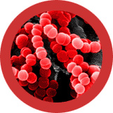
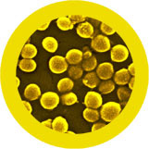
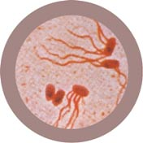
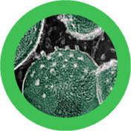
Participant Handout 2c
Salmonella

Streptococcus

Staphylococcus

Chlamydia

Staff-ill-O-coccus
Bacteria
Bacteria
Bacteria
Bacteria
Strep-Toe-Coccus
Sam-on-ella
Clam-id-E-A
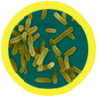
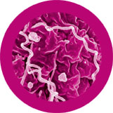
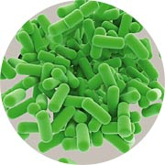
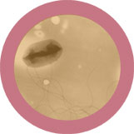
Syphilis is an extremely contagious disease, caused by Treponema bacteria. Symptoms start with a skin rash and flu-like symptoms and can lead to brain damage and death. Syphilis can be cured with antibiotics however resistant strains are becoming more frequent.

Lactobacilli are very common and usually harmless to humans. They are present in the vagina and the gastrointestinal tract, and make up a small portion of the gut flora. These bacteria have been extensively used in the food industry - in yogurt and cheese making.

Many strains of E. coli are harmless, and huge numbers are present in the human and animal gut. In addition, E. coli is among the most studied of all creatures great and small. In some cases, however, E. coli cause both urinary and serious abdominal infections and food poisoning.

Many Streptococcus are harmless to humans and are the normal flora of the mouth and hands. However, some Streptococcus bacteria cause about 15% of sore throats. Strep throat symptoms include sudden fever, stomach aches, and swollen glands.

Meticillin Resistant Staphylococcus aureus (MRSA) are the bacteria responsible for causing difficult to treat infections in hospitals. They are a variation of the common Staphylococcus aureus that have evolved to become resistant to many common antibiotics.

Chlamydia, a sexually transmitted infection (STI) caused by the bacteria Chlamydia trachomatis. It can cause mild symptoms such as discharge from the vagina or penis to more serious complications, i.e. inability to have children or swollen testicles.

Bacteria
Trep-O-Nee-Ma
Bacteria
Bacteria
Lac-Toe-Ba-Sil-Us
Sued-O-Moan-Us
Bacteria
Esk-Er-Ic-E-A
1000
3
89
15
40
Usefulness to humans .......................

Max Size (nm) ..............................

Antibiotic resistance ..........................
Danger to humans ............................
Number of species ..............................

Salmonella are rod shaped bacteria most commonly known for causing food poisoning and typhoid fever. Symptoms range from vomiting to diarrhoea and even death, in worse case scenarios.
Treponema

2000

3
115
8
10
Usefulness to humans .......................

Max Size (nm) .............................

Antibiotic resistance .........................
Danger to humans ..........................
Number of species .............................

Lactobacillus
1500
125
0
195
10
Usefulness to humans ....................

Max Size (nm) ..............................

Antibiotic resistance...........................
Danger to humans .............................
Number of species ..........................

Pseudomonas
5000
126
50
150
80
Usefulness to humans ...................

Max Size (nm) .............................

Antibiotic resistance ........................
Danger to humans ............................
Number of species ..........................

Pseudomonas are one of the most common microbes found in almost all environments. Although some may cause disease in humans, other species are involved in decomposition and bioremediation.

Escherichia
2000
7
54
184
N/A
Usefulness to humans ....................

Max Size (nm) .............................

Antibiotic resistance ......................
Danger to humans ............................
Number of species .............................

1000
21
50
75
20
Usefulness to humans ......................

Max Size (nm) ...............................

Antibiotic resistance ........................
Danger to humans ............................
Number of species ...........................

1000
19
174
20
90
Usefulness to humans .....................

Max Size (nm) ...............................

Antibiotic resistance .........................
Danger to humans ..........................
Number of species ............................

1000
3
37
1
5
Usefulness to humans ........................

Max Size (nm) ..............................

Antibiotic resistance ..........................
Danger to humans ............................
Number of species .............................

Usefulness to humans ......................
Lyssavirus
Lymphocryptovirs

90
1
146
12
N/A
Max Size (nm) .................................

Antibiotic resistance .......................
Danger to humans .........................
Number of species .............................

200
2
21
7
N/A
Usefulness to humans........................

Max Size (nm) ..............................

Danger to humans ..........................
Number of species .............................

2
Rhinovirus
25
28
14
N/A
Usefulness to humans ......................

Max Size (nm) .................................

Antibiotic resistance .......................
Danger to humans ...........................
Number of species ..........................

200
2
64
2
N/A
Usefulness to humans .......................

Max Size (nm) ................................

Antibiotic resistance .......................
Danger to humans ...........................
Number of species .............................

110
7
37
2
N/A
Usefulness to humans ........................

Max Size (nm) .................................

Antibiotic resistance .......................
Danger to humans ............................
Number of species .............................

1500
1
200
0
N/A
Usefulness to humans ........................

Max Size (nm) ..............................

Antibiotic resistance .......................
Danger to humans .........................
Number of species .............................

5
180
10
74
N/A
Usefulness to humans ........................

Max Size (nm) .................................

Antibiotic resistance .......................
Danger to humans ............................
Number of species .............................

Influenza A

Ebola

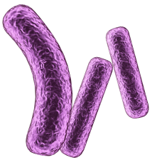
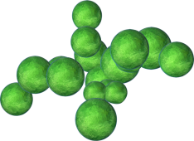

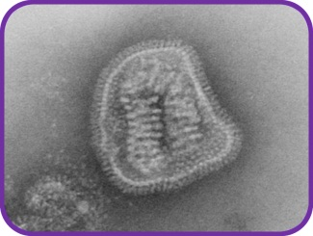
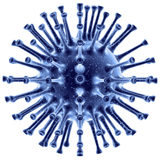

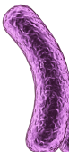
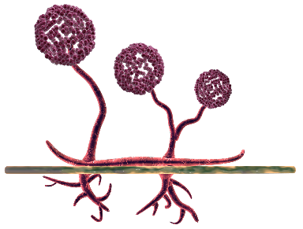
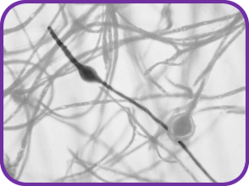
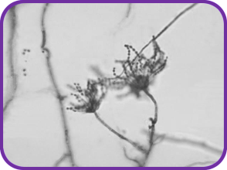
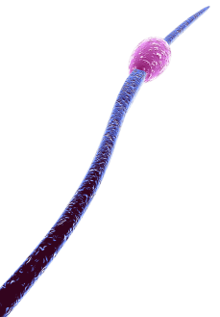
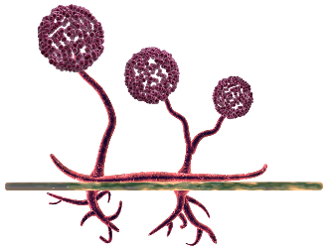
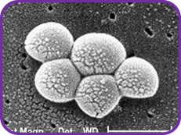
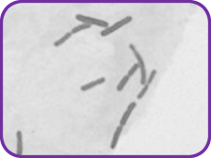
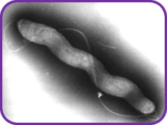
- Microbes are living organisms
- They are so small we need a microscope to see them
- They come in different shapes and sizes
- They are found EVERYWHERE!
- Some microbes are useful or even good for us
- Some microbes can make us ill
Participant Handout 3
What
are
Microbes?
Influenza

- Viruses are even smaller than bacteria and can sometimes live INSIDE bacteria!

- Some viruses make us sick.

- Diseases like CHICKENPOX and the FLU are caused by viruses.

- Viruses can spread from one person to another but it depends on the type of virus.

- Viruses are even smaller than bacteria and can sometimes live INSIDE bacteria!

- Some viruses make us sick.

- Diseases like CHICKENPOX and the FLU are caused by viruses.

- Viruses can spread from one person to another but it depends on the type of virus.

Penicillium Dermatophyte

- Fungi are the largest of all microbes.

- Fungi can be found in the air, on plants and in water.

- Mould, which grows on bread, is a type of fungus.

- Some antibiotics are made by fungi!

- Fungi are the largest of all microbes.

- Fungi can be found in the air, on plants and in water.

- Mould, which grows on bread, is a type of fungus.

- Some antibiotics are made by fungi!

There are 3 different types of microbes:

Microbe
Size
VIRUSES
FUNGI
BACTERIA

FUNGI
VIRUSES
BACTERIA

- There are three different types of bacteria. They look like:
Spirals  (e.g. Campylobacter) | Rods  (e.g. Lactobacillus) | Balls  (e.g. Staphylococcus)
- They are so small that 1000s of bacteria could fit on the full stop at the end of this sentence.

- Some bacteria are helpful in cooking, for example, making yogurt and cheese.

- Some bacteria are harmful and cause infection.

- Bacteria multiply very fast.


Races
Yeast
Participant Worksheet 1
Procedure
`

- Follow the instructions in the Yeast Races Recipe.

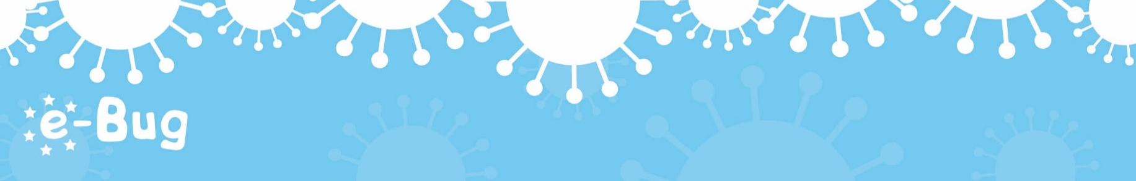

- What caused the dough to rise up the container?
_________________________

- What is this process called?
_________________________

- Why did the dough in container B move faster than container A?
_________________________

- What other food products are the result of bacteria or fungi growing and changing substances?
__________________________

My Conclusions
My Results

Time | YEAST ALONE |  |  | YEAST AND SUGAR
Time | Volume of dough | Change in volume of dough / ml |  | Volume of dough | Change in volume of dough / ml
 | 0 | 0 |  | 0 | 0

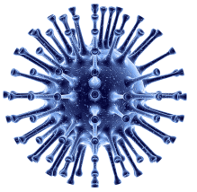
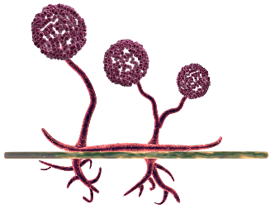
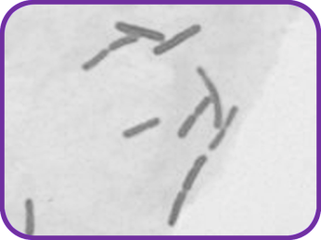
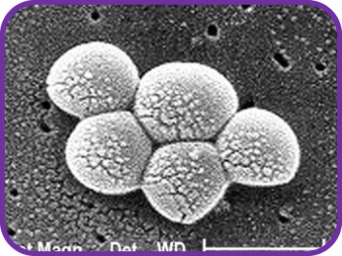
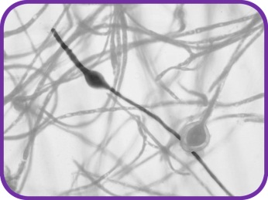
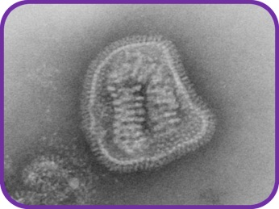
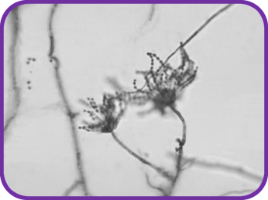
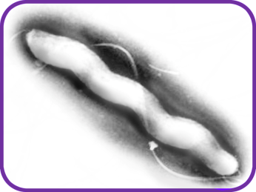
Participant Worksheet 2

There are 3 different types of microbe – bacteria, viruses and fungi.

From the pictures and descriptions, can you work out which microbe is which?

What
microbe
am I?

My name is Influenza but my friends call me the ‘flu’. I’m very generous; I like to give people headaches and fever. I easily spread from person to person through coughing and sneezing. What am I?
Influenza is a:
___________

I’m called a Dermatophyte and I like to live on your skin. I especially like living in damp places like between the toes on sweaty feet! When I live there I give people athlete’s foot! What am I?
Dermatophytes are:
___________

My name is Lactobacillus. People call me ‘friendly’ because I change milk into yogurt! When you eat me in yogurt I live in your guts and help you digest other food. What am I?

Lactobacillus is a:
___________

My name is Campylobacter. I have a pretty spiral shape and I like to live in chickens but if I get into your tummy I make you very ill – I can give you diarrhoea! What am I?

Campylobacter is a:
___________

My name is Penicillium and you’ll find me growing on old oranges or stale bread making them look mouldy. Humans use me to make an antibiotic known as Penicillin which can make them better, but only from bacterial infections! What am I?
Penicillium is a: ___________

My name is Staphylococcus. I am round in shape and I like to live in your nose or armpit! If I live on your skin I can give you spots. If I get into your bloodstream I can make you ill! What am I?

Staphylococcus is a:
___________

28
Participant Worksheet 2
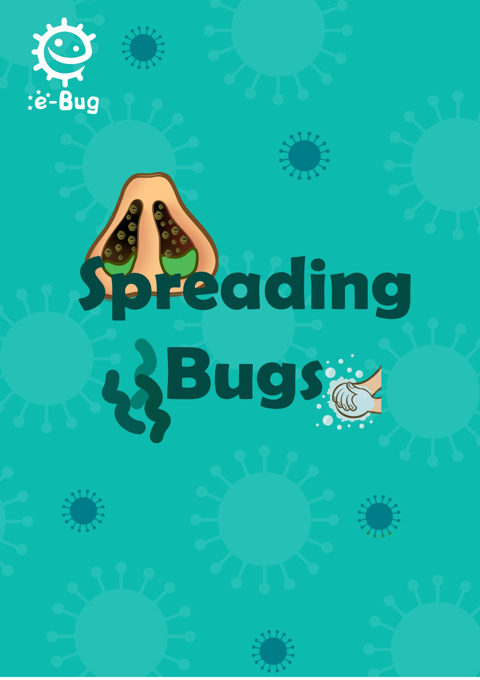

Page 29
Spreading Bugs
Spreading Bugs

Introduction
This session gives an overview of the spread of infection including how microbes are spread through sneezing and how proper hand washing with soap can break the chain of infection. The session aims to teach participants how poor hand hygiene and respiratory hygiene can lead to the spread of microbes and disease.

Learning outcomes
Aim to understand that:
- Microbes, including antibiotic resistant bacteria, spread very easily from you to other people
- Everyone carries microbes on their skin, mouth and gut, and healthy people can carry antibiotic resistant bacteria
- The best way to stop your colds and flu spreading to others is catching your coughs and sneezes in a tissue or in your sleeve if you have no tissue (not your hands). Try to always have a clean tissue with you
- The best way to stop harmful microbes spreading to family and friends is by washing our hands
- How, when and why to wash our hands
Materials required
Activity 1: A sneezing runway, green sneezer bottle, green food colouring, measuring tape, gloves, tissues.
Activity 2: 2 washing up bowls, water, a box containing GloGerm gel and a UV light, kitchen roll, bin liners, hand soap.
Activity 3: A copy of PH3, water, a sink or washing up bowl, hand soap.
Activity 4: Small plastic bowls, water, washing up liquid, pepper, cocktail sticks.
Activity 5: 2 washing up bowls, water, glitter, kitchen roll, bin liners, hand soap.
.

Key words
Soap Transmission
Hygiene Infectious
Transfer Contagious
Antibiotic resistance

Available web resources
Video demonstrations of activities 1 and 2.
PH3 - 6 steps of handwashing poster.
‘Spreading Bugs’ poster.

30
Spreading Bugs

Background information
Colds, flu and other respiratory tract infections are the most common infections in the community and are the most easily spread. They are mostly caused by viruses and, as such, cannot be treated by antibiotics. Generally bed rest and drinking plenty of fluids are recommended, however, if symptoms persist then a visit to the local doctor is required. Symptoms of colds and flu include headache, sore throat and fever. People with colds can also have runny noses!

The most common mode of spread is indirect, through coughs and sneezes. Microbes can also be spread via a more direct route, through human contact (touching, kissing) and eating contaminated food. Sneezing is a way in which our body tries to get rid of any harmful microbes and dust we might inhale. The harmful microbes and dust get caught on the nose hair and tickle our nose. The nose sends a message to the brain which then sends a message back to your nose, mouth, lungs and chest telling them to blow the irritation away. In the case of colds and flu, millions of viral particles rush out and contaminate the surfaces on which they land; this could be our food, hands or things we touch.

Workplaces are a haven of microbes which spread rapidly from person to person via touch and some of these will be harmful. Washing our hands is the best way to stop the spread of harmful microbes and prevent people getting sick.

Our hands naturally secrete oil which helps keep our skin moist and stops it getting too dry. This oil provides a perfect place for microbes to grow and multiply and also helps microbes ‘stick’ to our skin. Our skin and hands are also covered by our good bacteria – such as harmless species of Staphylococcus. Washing our hands regularly helps remove other microbes we collect from our surroundings (e.g. home, school, garden, animals, pets, food). Some of these other microbes can make us ill if we eat them or get into our chest or under our skin.

Washing hands in water alone eliminates visible dirt and grime, however, soap is required to break up the oil on the surface of the hands which traps microbes. Warm water (rather than cold) increases compliance of hand washing and can improve the performance of some soaps.

Hand gels can be used in addition to hand washing with soap and water but should not be used as a substitute because hand gels are not effective against norovirus.

31
Spreading Bugs

Hands should be washed:
- Before, during and after preparing food, especially raw meat and dirty vegetables
- After using the toilet
- After touching/handling pets or animals or animal waste
- After coughing, sneezing or blowing your nose
- If you’re ill or have been around ill people
- After changing babies nappies

Introduction
Ask the group ‘if there are millions of disease-causing microbes in the world that live everywhere, why aren’t we ill all the time?’ Provide participants with PH1 (The Chain of Infection) and PH2 (Breaking the Chain). Use the Chain of Infection PowerPoint presentation available on the e-Bug Senior Teacher Hand Hygiene webpage to help explain this. The ‘Spreading Bugs’ poster can be used to show how microbes can be spread and why, when and how we should wash our hands.

Highlight that there are many different ways in which microbes can be transmitted to people. Ask participants if they can think of any. Examples include through the food we eat, the water we drink and bathe in, the things we touch and from sneezing (for adults through blood when sharing needles or from dirty tattoo parlours, or during sexual contact).

Explain to participants that many diseases are airborne and spread in tiny droplets of water, carried around in the air, which are coughed and sneezed into the air by people. Tell them that diseases spread in this way range from colds and flu, to rarer, more serious infections like chicken pox, also measles, pneumonia and chest infections.

Continue to discuss colds and flu and that it is likely that everyone has had one, explaining that they are caused by a virus and not bacteria and, as such, cannot be cured by antibiotics. Explain that it is very important for everyone’s health that people cover their mouth and nose when they cough and sneeze as this can reduce the spread of infection.

Ask participants: How many of you have washed your hands today? Ask why they washed their hands (because they looked dirty or to wash away any microbes that might be on their hands), and what would happen if they didn’t wash away the microbes (they might get ill).

Tell the participants that we use our hands all the time, and that they pick up millions of microbes every day. Although many of these are harmless some could be harmful.
32

Explain to the class that we spread our microbes to our friends and others through touch, and this is why we wash our hands.
Spreading Bugs

Explain to students that they are going to do an activity to show them how microbes are spread through sneezing and an activity on how best to wash their hands to remove any harmful microbes.

The following pages describe 5 hygiene activities. Choose 2 or 3 of the most appropriate activities for your group from the recommended and optional.

Recommended Activities
33
The following three activities are recommended.
Activity 1 – The Snot Gun (10-20 mins)
Advance preparations:
1. Create a sneezing runway by placing 3 – 4 tables in a row with a vertical back board and covering them with white paper.
2. Fill one spray bottle per group with water and green food colouring.
3. Have disposable gloves ready for the activity.
4. Have large kitchen roll sheets ready for the activity.

Instructions:
- Divide the participants into groups of 4 – 5
- Each group should be provided with the sneezing runway, a sneezing bottle, a glove and a giant tissue. Provide each participant with PW1. Ensure they have read and understood the instructions before starting the activity.
- To demonstrate the distance a sneeze and microbes in the sneeze travel, members of each group should take turns holding the bottle at the end of the runway and simulate a sneeze by squeezing the trigger once over the paper. Before ‘sneezing’ (squeezing the trigger) members should predict how far and wide the sneeze will go and fill this in on their results sheet (PW1). After ‘sneezing’ participants should measure and record how far and how wide each of their sneeze has spread and fill this on their results sheet.
- The next step is to observe what happens when we put our hand over our mouth when we sneeze; the microbes stay on our hands and can spread to anything we touch. One member of each group should be the ‘sneezer’ and the second member should hold a gloved hand about 2 – 5cm away from the spray bottle. Participants should fill both predicted and actual outcomes on their results sheet.
- Finally, we want to observe what happens when we cover our mouth with a tissue during sneezing. Ask a different participant in each group to be the ‘sneezer’ and ask another participant to hold the tissue directly in front of the spray nozzle. Members of the group should fill in both predicted and actual outcomes on PW1.
- Discuss with participants, what happened when a hand or tissue was used? What should we do next with the hand or tissue? (wash/throw in the bin).
Spreading Bugs

Learning outcomes achieved:
- Microbes, including antibiotic resistant bacteria, spread very easily from you to other people when you cough and sneeze.
- The best way to stop your colds and flu spreading to others is catching your coughs and sneezes in a tissue or your sleeve if you don’t have a tissue.
- The best way to stop harmful microbes spreading to family and friends is by washing our hands.

Activity 2 – Horrid Hands (10-15 mins)

- Explain to the participants that microbes are everywhere and they get on to our hands from the things that we touch. We then pass these on to other people. Washing our hands is the best way to remove these microbes.
- Explain when we should wash our hands – before and after preparing food, after using the toilet, after touching animals and after coughing or sneezing.
- Ask the participants to line up one behind the other like a queue. If there are more than 5 participants, form 2 queues so that there are no more than 5 participants per queue.
- Squeeze a little GloGerm gel into the participant at the front of the line’s hands and ask them to rub in the ‘pretend microbes’.
- The person at the front should then turn around and shake hands with the person behind them, and so on, until they have all shaken hands with the person behind them in the queue.
- Use the UV light to show the participants how the germs got passed down the line – point out how dirty their hands are and how the germs spread because they didn’t wash their hands. The person at the back of the queue should still have germs on their hands.
- Ask participants to rinse their hands in the washing up bowls as they would usually and give kitchen roll to each person to dry their hands.
- The UV light can be used again to see how many germs remain.
- Demonstrate the proper way to wash hands with soap and ask them to follow your movements: do the six step technique – palm to palm, back of the hands, in between the fingers, back of the fingers, the thumbs, and tips of the fingers (illustrated on PH3).

Alternative to UV gel: see Activity 5.

34
Spreading Bugs

35

Learning outcomes achieved:
- Microbes, including antibiotic resistant bacteria, spread very easily from you to other people
- Everyone carries microbes on their skin, mouth and gut, and healthy people can carry antibiotic resistant bacteria
- the best way to stop harmful microbes spreading to family and friends is by washing our hands
- how, when and why to wash our hands

Activity 3 – 6 Steps of Hand Washing (5-10 mins)
- Provide participants with PH3.
- Go through PH3 together as a group to show the 6 steps of hand washing.
- Get participants to practice washing their hands correctly.
- Explain to the participants that you should spend the same amount of time washing your hands as it takes to sing ‘Happy Birthday’ twice or another song they will remember to use.

Learning outcomes achieved:
- The best way to stop harmful microbes spreading to family and friends is by washing our hands
- How, when and why to wash our hands

Spreading Bugs

Optional Activities
Activity 4 – Pepper Experiment (10-15 mins)
This activity aims to show why washing with soap and water is better than using water alone. If cocktail sticks are used, course leaders should help participants to ensure safety. The bowls must be rinsed after each group for this to work. It is recommended to practice this experiment before the session.

- Set up the activity by filling a bowl with water and sprinkling pepper on the surface.
- Tell participants that the surface of the water in the bowls represents their hands, and that the pepper represents harmful microbes that need to be washed away.
- Dip the end of a cocktail stick (or participants can use their finger) into a plain bowl of water and then into the pepper water. Gently swirl the cocktail stick around and explain that using water to wash your hands only moves the microbes around.
- Dip the cocktail stick into a bowl of washing up liquid and then into the pepper water.
- The pepper ‘microbes’ will move towards the edges of the bowl as the soap hits the surface of the water.
36
- Tell the participants that this shows why using soap when you wash your hands is important, because it breaks up the oils on the surface of your hands that microbes stick to and then they can be rinsed away under running water.
- Rinse the pepper water bowls, dry with kitchen towels and reset between groups.
- Hand out PH4 and ask participants to do the experiment themselves.

Discussion:
The experiment with and without soap should have been different. When the soap was on the cocktail stick the pepper should have moved towards the edges of the bowl. Our hands have oil on the surface which microbes stick to. When we use soap, the oil is removed and the microbes can be washed away – just like the pepper was pushed to the edge of the bowl with the soap!

Learning outcomes achieved:
- The best way to stop harmful microbes spreading to family and friends is by washing our hands

Spreading Bugs

Activity 5 – Glitter Microbes (10-15 mins)
This activity is the same principal as Activity 2, however instead of using UV gel you can use glitter to show the spread of microbes.

Activity 6 – Germ Defence (10-15 mins)
This activity is a website called Germ Defence that acts as a tool to help you reduce the likelihood of getting colds, flu and stomach upset. The simple steps will help prevent you from catching colds, flu and stomach upsets and from passing them onto people you live with.
National Institute for Health and Care Excellence (NICE) have recommended Germ Defence as a good public health learning tool and research has shown that by using Germ Defence you are likely to have less illnesses, and if you do get ill it won't be for as long.
The Germ Defence website can be accessed here:
www.pips.ecs.soton.ac.uk/player/play/germdefence

37
Spreading Bugs

38
Discussion
Discuss what the group have learnt today with open questions and refer to the ‘Spreading Bugs’ poster.
What have you learnt today?
How has the activity changed the way you wash your hands?
When is it important to wash your hands?

Lead the discussion to reflect back on the learning objectives.
- Microbes spread very easily from you to other people.
- The best way to stop your coughs, colds and flu spreading to other is catching your coughs and sneezes in a tissue or sleeve if you do not have a tissue.
- Always keep a clean tissue with you in your pocket or bag.
- The best way to stop harmful microbes spreading to family and friends is by washing our hands.
- To use soap when washing hands, and to wash all parts of our hands, including thumbs. Remember not to splash and dash! Use the song you have chosen to time your hand washing.

Extension questions.
1. Based on what we have done today, what have you learned about the spread of microbes?
Microbes can pass very easily from person to person through sneezing and touch. This can also include antibiotic resistant bacteria.
2. If we don’t wash our hands after sneezing into them, what might happen?
We can still transfer the harmful microbes found in a sneeze to other people when we touch them.
3. Which method is best for preventing the spread of infection: sneezing into your hand or sneezing into a tissue? Why?
Sneezing into a tissue because the microbes get trapped there and we can then throw the tissue away. If you do not have a tissue, sneeze into your sleeve.
4. What do we need to make sure we do with tissues after use?
Throw them away to prevent further transmission of microbes.
5. When do we need to wash our hands?
After sneezing, coughing, going to the toilet, touching pets/animals, touching raw meat.

Spreading Bugs
39

Action Plan
Discuss with participants if they remember the points in their action plan from the last session. If they did, how did they do this and if not why.
Then ask participants to complete their action plan for this session. Hand out the individual pocket sized sheet for participants to keep for themselves as well as the full sized sheet to be returned to the group leader. This worksheet will be used again in the final session.
Ask participants to either choose one of the action plans from below or to make up their own if they are confident enough.
1. Reduce the spread of microbes by:
a. Carry tissues or toilet paper with you all the time, agree where to keep this
b. Choose a song to use when washing hands
c. Use soap every time you wash your hands, and wash every part of your hands
d. Wash hands after sneezing, going to the toilet, touching food and animals
e. Throw tissues in the bin after use

Acknowledgements
This session was written by the e-Bug team and assisted by the Kingfisher Treasure Seekers Community Group.
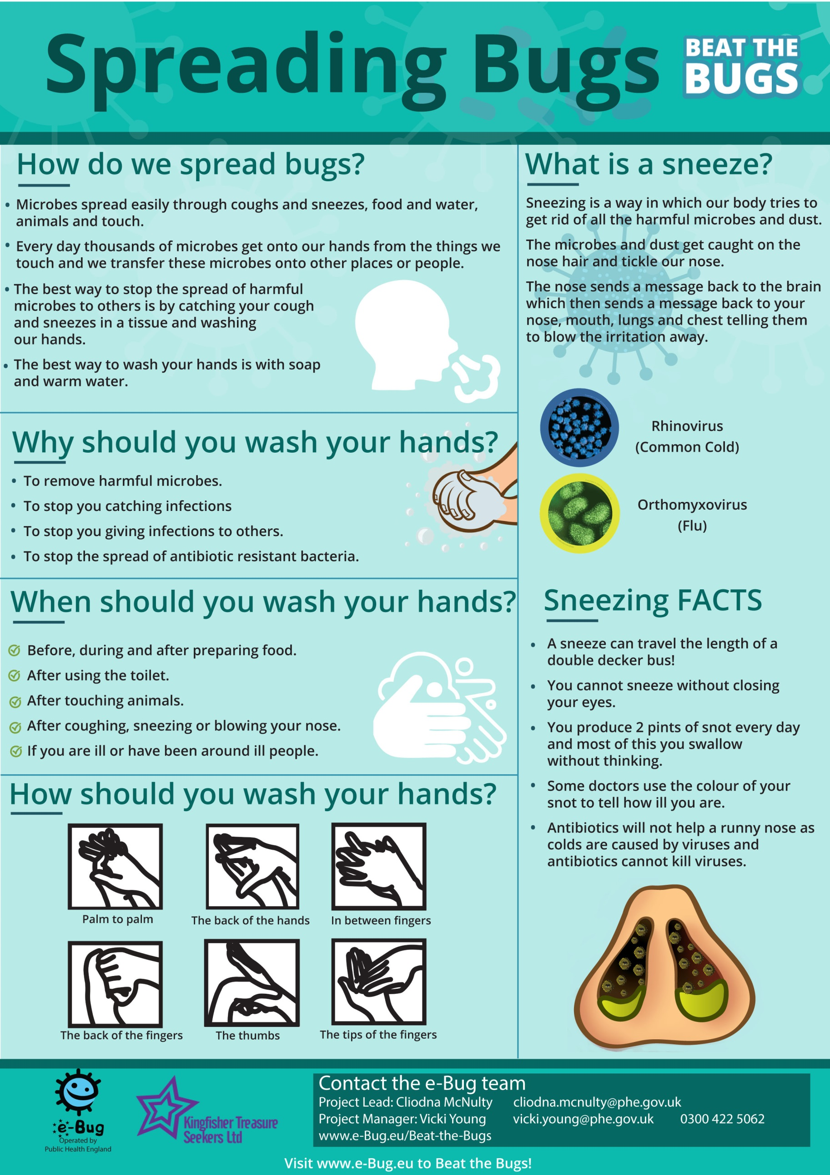
Page 39

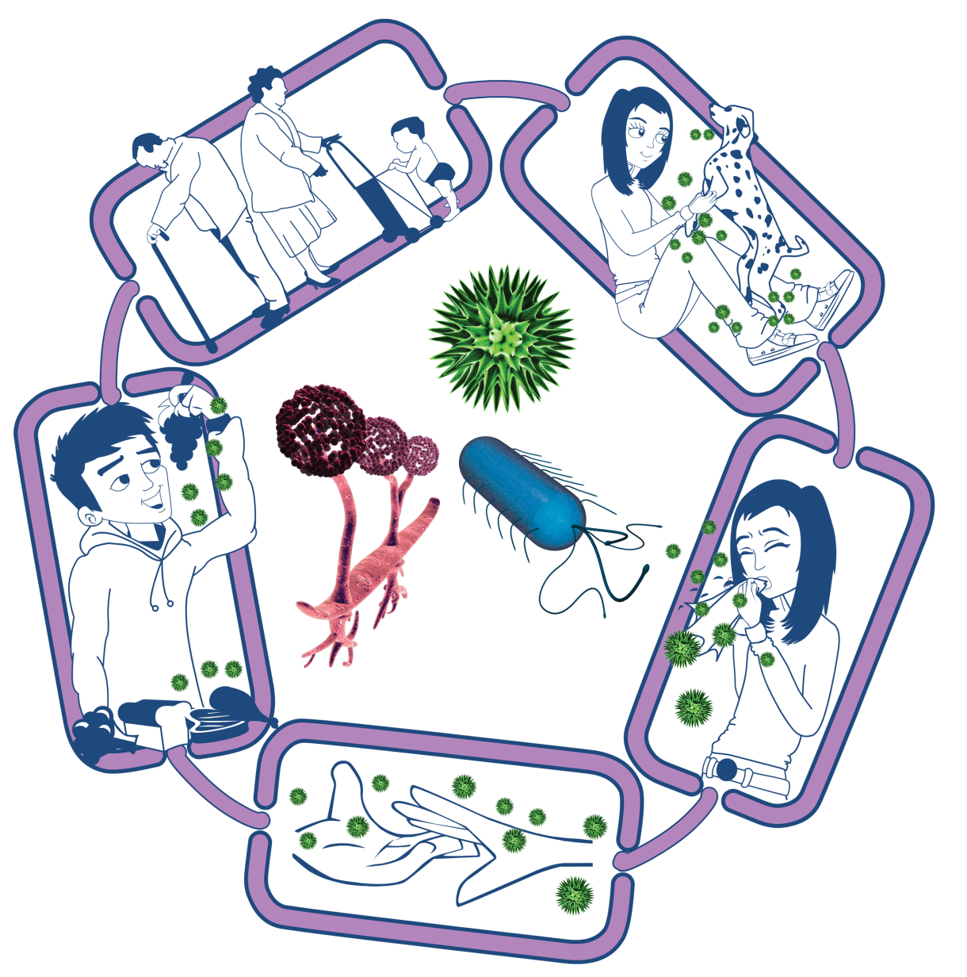
Way out for microbes
Harmful microbes need a way to get out of an infected person or source before they can spread to someone else. Routes include:
- Sneezing, coughing, saliva
- Bodily fluid
- Juices from raw meat and poultry

Spread of Infection
Harmful microbes need a way to be passed from a source to a person. This can be through:
- Direct touch/contact
- Sexual transmission

Harmful microbes are also spread via:
- Hands, hand contact surfaces (e.g. door handles, keyboards, toilets)
- Food contact surfaces
- Air

Source of Infection
Someone or something carrying the harmful microbes that causes the infection. There are many different sources of infection, these can include
- People already infected
- Pets or animals
- Contaminated food

Participant Handout 1
Way in for microbes
Harmful microbes need a way to enter the body before they can cause an infection. This can be through:
- The food we eat
- Inhalation of aerosols
- Open cuts or sores
- Things we put in our mouths

People at risk from infection
We are all at risk from infection, but some are at greater risk:
- People on medication e.g. chemotherapy
- The very young/elderly
- People with underlying diseases e.g. HIV/AIDS, diabetes

The Chain of Infection
Source of Infection
- Isolate infected people
- Take care with raw food
- Wash pets regularly
- Dispose of nappies and soiled clothing appropriately

Way out for microbes

Prevent any
- Coughs and sneezes
- Faeces
- Vomit
- Bodily fluid
Getting onto surfaces or hands

Participant Handout 2
Spread of Infection
- Wash hands thoroughly and regularly
- Cover cuts and open sores
- Take appropriate precautions during sexual activity

Way in for microbes
- Cover cuts and open sores with a water proof dressing
- Cook food properly
- Take care to drink only clean water

People at risk from infection
Everyone
- Take appropriate vaccinations
High risk people
  - Keep away from people who are infectious
  - Take extra care about cleanliness
  - Take extra care when cooking and preparing food

Breaking the Chain of Infection
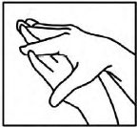
Palm to palm
The back of the hands
The back of the fingers
The thumbs
The tips of the fingers
In between the fingers
Hand
Washing
of
Steps
6
The

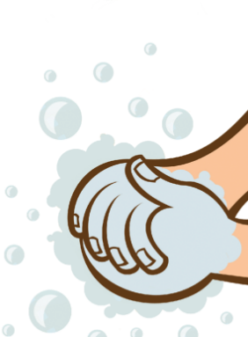

Participant Handout 4
Experiment
Water
Soap
Pepper

Ingredients

- 1 Bowl (a cereal bowl will be fine)
- Some water
- A sprinkle of black pepper or other spice
- Some hand soap or washing up liquid
- Cocktail sticks (optional)

- A Towel
- A Pen
- A Notebook
- A Camera (optional)

Method

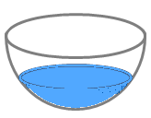
- Fill the bowl with water, but not right to the top.


- Sprinkle some black pepper or spice onto the surface of the water.
It should float on top.

- Dip your finger (or cocktail stick) into the centre of the water and watch what happens to the pepper. Take a photo to record what has happened.

- Dry your hand, and then dip your finger (or cocktail stick) into the soap.

- Dip your soapy finger into the water. Watch what happens
to the pepper. Take a photo to record what has happened.

What happened with and without the soap?

Sneezes

How far did your sneeze travel?
 |  | Student 1 | Student 2 | Student 3 | Student 4 | Student 5
Sneeze | Length (cm)
Sneeze | Width (cm)
Sneeze with hand | Length (cm)
Sneeze with hand | Width (cm)
Sneeze with tissue | Length (cm)
Sneeze with tissue | Width (cm)

Hand in front of sneeze
What did you think would happen when you put the hand over the mouth to sneeze?

What actually happened? (Where and how far did the sneeze travel?)

Tissue in front of sneeze
What did you think would happen when you put the tissue over the mouth to sneeze?

What actually happened? (Where and how far did the sneeze travel?)

Super
Participant Worksheet 1
My Observations
My Conclusions

- If we don’t wash our hands after sneezing into them what might happen?
____________________________________________

- What should we do with a tissue after sneezing into it?
____________________________________________

- Which is best for preventing the spread of infection, sneezing into your hand or into a tissue? Why?
____________________________________________

Participant Worksheet 1
46
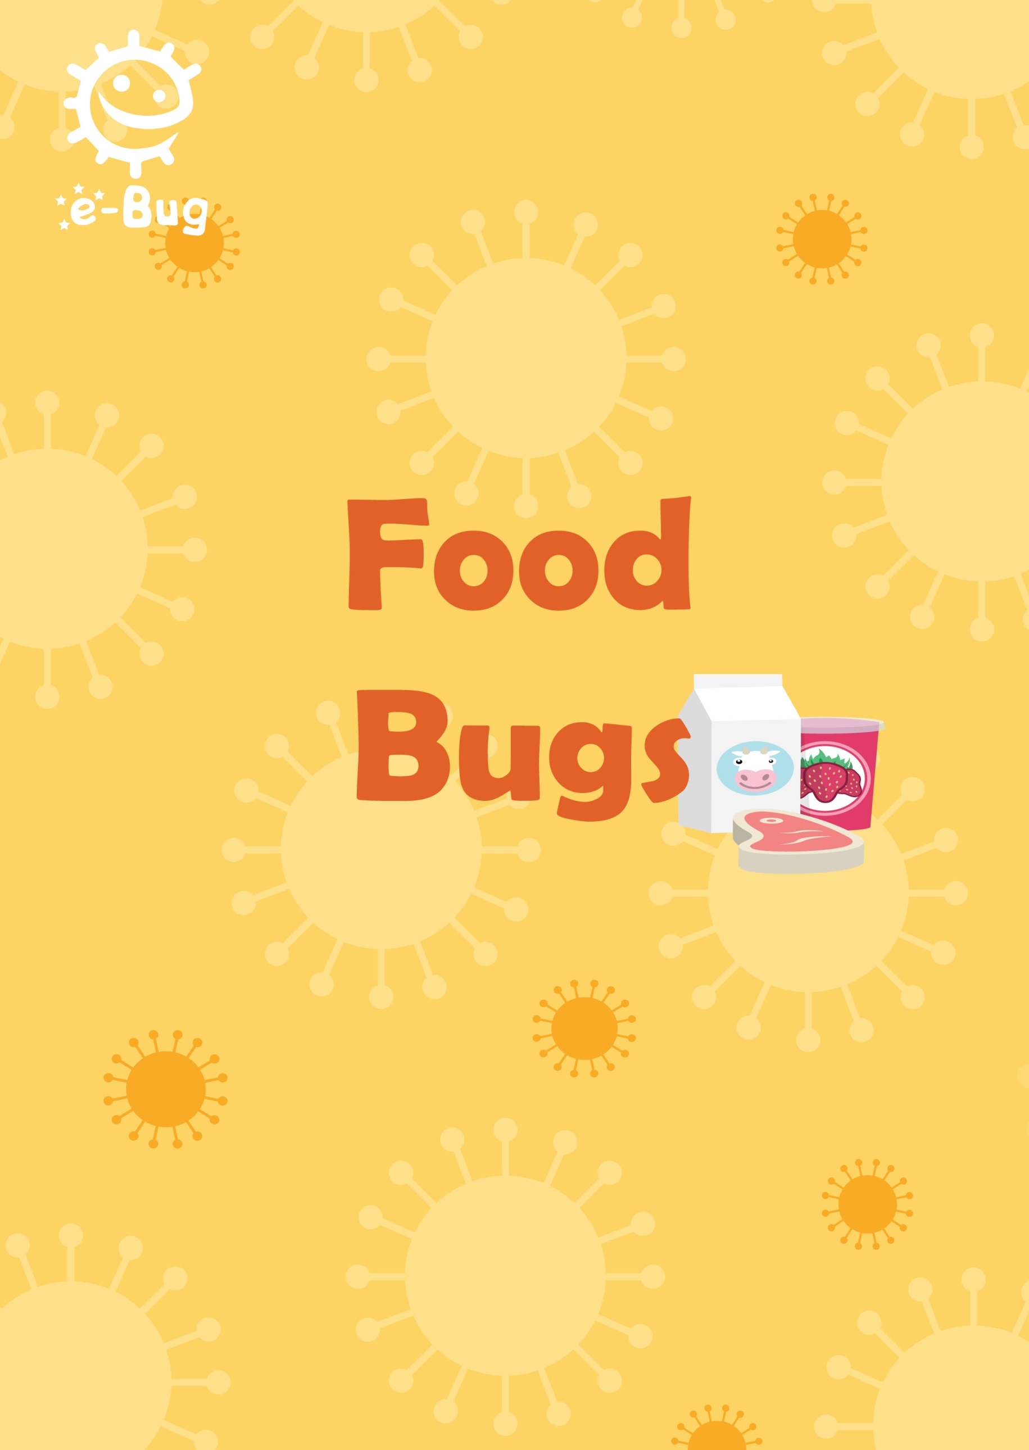
Page 47
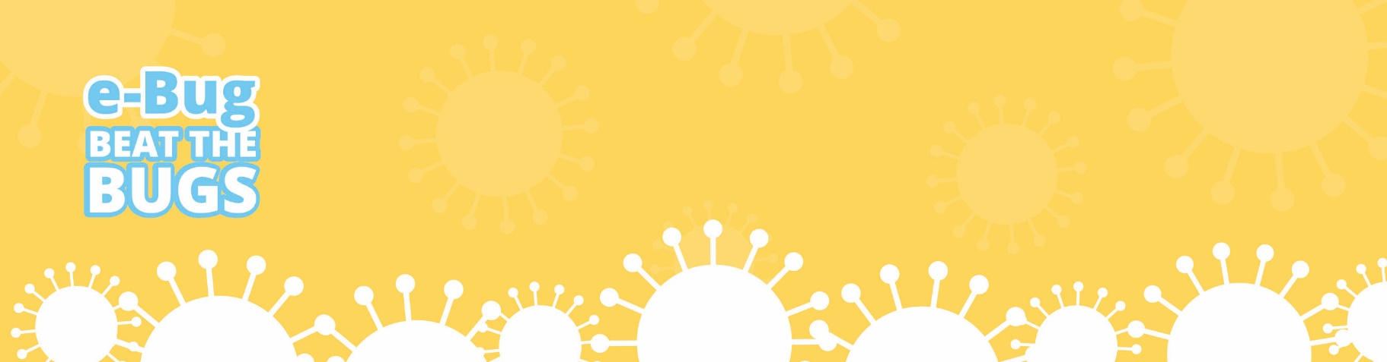
Food Bugs

Introduction
This session teaches participants how easily potentially harmful microbes on raw food can transfer to humans. The interactive quiz activity will show participants how to prepare food safely and the food labelling activity will help them to understand what is meant by the food labels shown on foods.

Food storage will also be addressed in an activity which allows participants to learn how to correctly store food in the fridge to help prevent contamination between food products and therefore food poisoning at home and in the work place.

Learning outcomes
Aim to understand that:
- Microbes are found on most of our food, but harmful ones are mainly found on uncooked meat, unwashed salad and raw vegetables
- Bacteria multiply very quickly; cooking food properly can kill harmful microbes, and refrigeration only stops microbes growing, it doesn’t kill them
- To stop getting ill, it is really important to wash your hands before and after preparing food and to wash cooking utensils and surfaces with appropriate products
- Most foods should only be reheated once, until it is piping hot
- Where and how to store different foods in the fridge
- The difference between ‘use by’ and best before

48
Key words
Food hygiene, microbe, refrigeration, food safety, food storage, food labelling, food poisoning, cross-contamination

Available web resources
Kitchen Check Quiz PowerPoint
Fridge Raiders PowerPoint
Label Sort PowerPoint
‘Food Bugs’ Poster

Materials required
Activity 1,2 and 3 – PowerPoint Slides available on www.e-bug.eu/beat-the-bugs/
Activity 4 – A variety of foods, two boxes/containers
Activity 5 - Toy ovens, plastic chopping boards, plastic food including demonstration meats, plastic knives, paper plates, white play dough for chicken fillets, GlowGerm powder and a UV light.

Food Bugs

Background information
Harmful microbes found in food can lead to food poisoning, which can be very dangerous. The symptoms of food poisoning can last for days and include stomach pains, diarrhoea, vomiting, nausea (feeling sick) and fever (high temperature). The symptoms usually come on suddenly, but can occur several days after eating contaminated food. In most cases food poisoning will get better on its own within 2 days. People should seek medical help if they have severe pain with a tender tummy, if they have blood in their stool (faeces) or diarrhoea for over 5 days.
Not all microbes associated with food are harmful; here are examples of some of the useful and harmful microbes associated with food.
Useful Microbes can be used to make food and drink, e.g. the yeast Saccharomyces cerevisiae is used to make bread and beer. Lactobacilli bacteria are used in yogurt and cheese making.
Harmful Microbes can cause food poisoning e.g. the bacteria Salmonella, E. coli and Campylobacter are commonly found on raw meats and can cause diarrhoea and vomiting in humans and in rare circumstances death.
Norovirus which causes ‘winter vomiting’ can also cause food poisoning when those with the illness contaminate the food they handle; this is quite easy as millions of viruses are found in just 1 gram of vomit!
Food Spoilage Microbes do not usually cause harm to humans. These are generally mould or bacteria, e.g. the fungus Rhizopus stolonifer causes bread mould and the bacterium Pseudomonas can cause the green discolouration on bacon and other meat. The red colour sometimes present on food is caused by the bacteria Serratia marcescens. Before scientists knew what this was, people commonly thought it was blood, in fact when it was found on communion wafers it was thought of as the blood of Christ, it was hence known as the miracle bacteria.

49
Food Bugs

How can we prevent food poisoning and delay food spoilage?
Most microbes we find on food grow best in warm, damp places. They generally dislike places that are too hot and are killed at temperatures above 70ºC. In cooler temperatures, below 5ºC, most bacteria multiply very slowly, if at all. Some bacteria will die at this low temperature, but many survive and can start to multiply again if desirable conditions return. So we keep our food in the fridge to stop bacteria growing and cook our meat well before we eat it to kill the bacteria. Our fridges should be kept between 0ºC and 5ºC. Some viruses and spores, such as Clostridium perfringens need prolonged cooking or higher heat to reliably kill them.
Sometimes harmful microbes found on food can spread to other foods, for example via hands, or kitchen utensils and cause illness when those foods are eaten. They can also be spread if raw meats are washed and microbe’s splash onto work surfaces or other foods. This is known as cross-contamination.
Cross-contamination can also occur in the fridge, which is why it is important to store food correctly. Meats and other raw foods should be kept on the bottom shelf and should be covered, while other foods such as cheeses, milk and yoghurt should be kept on the upper shelves. This prevents juices from the meats and other raw foods from dripping onto other items in the fridge. The fruit and vegetables can be kept in the allocated drawers in the fridge or, if there aren’t any, above the meat and raw foods.
It is important that food is only reheated once. Bacteria grows best at the temperature ‘danger zone’ (between 4° and 60° C), food will be at this temperature at each cooling and heating stage. Some bacteria can produce toxins and spores; parts of the microbe that can survive cooking temperatures and make us ill. If you re-heat your food more than once, there are more opportunities for these harmful microbes to grow.
Labels placed on food are used to determine when it is safe to eat the food, as well as when the quality of the food is at its best. ‘Use before’ refers to when the food is safe to eat and ‘best before’ dates refer to when the food will be at its best quality, but it is worth noting that consumption after this date will still be safe.
Food Bugs

50
Food Bugs

Introduction
Firstly recap on the previous session to reinforce some of the learning points. Then explain to the participants that they are going to learn about food hygiene, and why preparing and storing food properly is so important. In addition to learning the biological aspects of food hygiene (e.g. why food needs to be refrigerated), they will be learning about the practicality of food hygiene such as how to keep themselves safe when preparing food.
The ‘Food Bugs’ poster can be used to show how microbes can be used in the food industry, but also how microbes can be found on food which can be harmful to us.
Ask the participants what they already know about food hygiene. Possible questions include:

- Do you know what we mean by the term food hygiene?
- Have you ever had food poisoning? (This could be vomiting or diarrhoea)
- Would you still work if your job included handling or preparing food and you had recently had food poisoning? (Answer: You should not work for 2 days after the diarrhoea or vomiting has stopped)
- What do you think causes food poisoning? (Answer: bacteria, viruses and toxins)
- What foods can cause food poisoning? (Answers: unwashed fruit and vegetables, raw meat, foods contaminated by a food handler)
The following pages describe 5 food hygiene activities. Choose the appropriate activities for your group.
The 5 food hygiene activities could be set up in a workshop style. Split the participants into groups and assign each group to one of the activities. After 10-20 minutes let the participants know that they can move on to the next activity.

51
Food Bugs

Recommended Activities
The following three activities are recommended.
Activity 1 – Kitchen Check (10-20 mins)
Set up the Kitchen Check PowerPoint quiz (available on www.e-bug.eu/beat-the-bugs) on a computer, tablet or projector.
The participants will go through an interactive quiz which follows the preparation of a meal. Along the way, the participants have to make decisions about what to do next and answer questions. After clicking on their answer, they will find out if they are correct or not, and a short explanation will be displayed.
At the end of the quiz, participants will understand where food hygiene risks lie and will be able to apply it to their own food preparation practices.
Learning outcomes achieved:
- Microbes are found on most of our food, but harmful ones are mainly found on uncooked meat, unwashed salad and raw vegetables
- To stop getting ill or spreading microbes, it is really important to wash your hands before and after preparing food and to wash cooking utensils and surfaces with appropriate products

Activity 2 – Fridge Raiders (10-20 mins)
This activity will be set up on a table and will have a large picture of a fridge and pictures of foods that are kept in the fridge. You may wish to laminate the pictures if you are able to do so. The Fridge Raiders PowerPoint (available on www.e-bug.eu/beat-the-bugs) contains the images which can be printed and cut out. An answer sheet for the course leader is included at the end of this section (Educator Sheet 3).
The participants will place the foods in the fridge in the correct place. Ask the participants which foods should also be covered up to prevent cross-contamination.

52
Food Bugs

The participants will learn how to store food safely, and that refrigeration only slows the growth of microbes, it doesn’t kill them.
Learning outcomes achieved:
- Where and how to store different foods in the fridge
- Bacteria multiply very quickly; cooking food properly can kill harmful microbes, and refrigeration only stops microbes growing, it doesn’t kill them

Activity 3 – Label Sort (10-20 mins)
In this activity, participants will match up food labels to their correct explanation. The labels and descriptions can be found in this resource pack (PW1) or on the Label Sort PowerPoint (available on www.e-bug.eu/beat-the-bugs). From here they can be printed and cut out, to allow participants to arrange the labels on a table. An answer sheet for course leaders is included at the end of this section (Educator Sheet 4). You may wish to laminate the labels if you are able to do so. You may like to use the photo examples of food labels or alternatively you can bring in your own food to discuss the labels.
This activity will teach the participants what is meant by each label and will offer guidance on how to follow it so that they can keep themselves safe from possible food poisoning.
Learning outcomes achieved:
- The difference between ‘use by’ and ‘best before’

53
Food Bugs

Optional Activities
Activity 4 – Food Sort (10-20 mins)
This activity will help participants identify that microbes can be useful and harmful. Participants are required to sort different foods according to whether they contain or are made with useful/good microbes or contain harmful/food spoiling microbes. It would be good to bring in a variety of foods to make the activity more visual but ensure that the participants know not to consume the food. Foods to include are:

- Bread – made with yeast, a fungi, which helps the bread to rise = Good Microbes
- Vegetables e.g. dirty carrots – may contain harmful microbes found in the soil =
Bad microbes
- Yoghurt – contains useful bacteria that helps us to digest food = Good microbes
- Raw Chicken –contain harmful bacteria which cause food poisoning = Bad microbes
- Milk – contains useful bacteria that helps us to digest food = Good microbes
- Fruit e.g. apples, tomatoes – may contain harmful microbes found in the soil or other people who have handled them if not washed = Bad microbes
- Eggs – may contain harmful bacteria which cause food poisoning = Bad microbes
- Cheese – good bacteria are used to make cheese = Good microbes
- Raw sausages - contain harmful bacteria which cause food poisoning = Bad microbes
Participants can sort the food into two different boxes, labelled good microbes and bad microbes.

Learning outcomes achieved:
- Microbes are found on most of our food, but harmful ones are mainly found on uncooked meat, unwashed salad and raw vegetables

54
Food Bugs

Activity 5 – How clean is your kitchen? (10-20 mins)
In this experiment the participants make a chicken dinner and then the UV light is used to show how germs have spread around the kitchen area. Try to make sure participants have access to chopping boards, plates, plastic food and microwaves and encourage them to ask questions.

Advance preparations:
1. Prepare chicken fillets from playdough and cover in GlowGerm powder.
2. Set out the food, chopping boards and toy ovens.

Instructions:
- Invite the participants to prepare a chicken dinner using the play dough chicken fillet. Ask them to cut up the chicken with a plastic knife.
- Encourage the participants to cook the chicken in the oven and select other foods to go in the dinner.
- Afterwards ask them what they forgot to do whilst making their food - wash their hands.
- Point out that they should have used different chopping boards for cutting up the chicken and preparing the raw ingredients – in a professional kitchen they use different coloured chopping boards for different groups of food.
- Say you can see where the germs from the chicken fillet have spread using the special ‘microbe detector’ UV light.
- Float the UV light over their hands and kitchen equipment to show where the bad germs have spread.
- Explain what types of harmful bacteria (e.g. Salmonella, Campylobacter, E. coli) can be found in raw meat and the importance of hand washing whilst cooking and before eating a meal. Use the different types of plastic meats to help explain.
- Ask them if they think that harmful microbes can be found on other types of food as well. Explain that harmful microbes can be found on other foods too, so for instance it is important to wash vegetables and fruit well before eating.

Learning outcomes achieved:
- Microbes are found on most of our food, but harmful ones are mainly found on uncooked meat, unwashed salad and raw vegetables
- To stop getting ill, it is really important to wash your hands before and after preparing food and to wash cooking utensils and surfaces with appropriate products.
55
Food Bugs
Food Bugs

Discussion
Ask the participants what they have learnt today. Refer to the ‘Food Bugs’ poster in the discussion. Make sure the following areas are discussed:

- What causes food poisoning? (bacteria)
- How should you avoid getting food poisoning? (Washing your hands, washing fruit and vegetables, cooking food thoroughly, storing food correctly)
- How should food be stored in the fridge? (see group leader answer sheet)
- When should you wash your hands? (Before preparing food, after using the toilet, after touching pets) And kitchen surfaces? (Before and after preparing food)
- What food labels do you remember? (use by, best before etc.)
- Should you go to work with vomiting or diarrhoea if you handle food in your job? (No you should be well for 2 days before returning to work)
Ask the participants what they will do differently now at home?

Action Plan
Discuss with participants if they stuck to their action plan from the last session. If they did, how did they do this and if not, why.

Then ask participants to complete their action plan for this session. Hand out the individual pocket sized sheet for participants to keep for themselves as well as the full sized sheet to be returned to the group leader. This worksheet will be used again in the final session.
Ask participants to either choose one of the action plans from below or to make up their own if they are confident enough.

1. Reduce chance of food poisoning by:
a. Washing hands before and after handling food such as chicken or dirty fruit or vegetables.
b. Clean kitchen surfaces and utensils before and after preparing food.
c. Not eating food that has been out of the fridge for more than 8 hours.
d. Washing fruit and vegetables before eating them.
e. Not eating food that is past its use by date.
56
Food Bugs

Preparation for Session 3 “Mouth Bugs” – Diet Diary
Ask Participants to prepare for an activity in the next session by keeping a diet diary for the week, recording what they have eaten including drinks and snacks, print out 3 copies so that participants can complete 3 days of the week.

Pre-completed diet diary sheets are also provided should participants be unable to complete this in advance.

Acknowledgements
This session plan was written by the e-Bug team and assisted by the Kingfisher Treasure Seekers Community Group
57
Mouth Bugs
Diary
Diet

Write down the day and record everything you have to eat or drink (however small) and note the time. Do this for 2 weekdays and one weekend day
Day:
Time | What did you eat? | What did you drink?

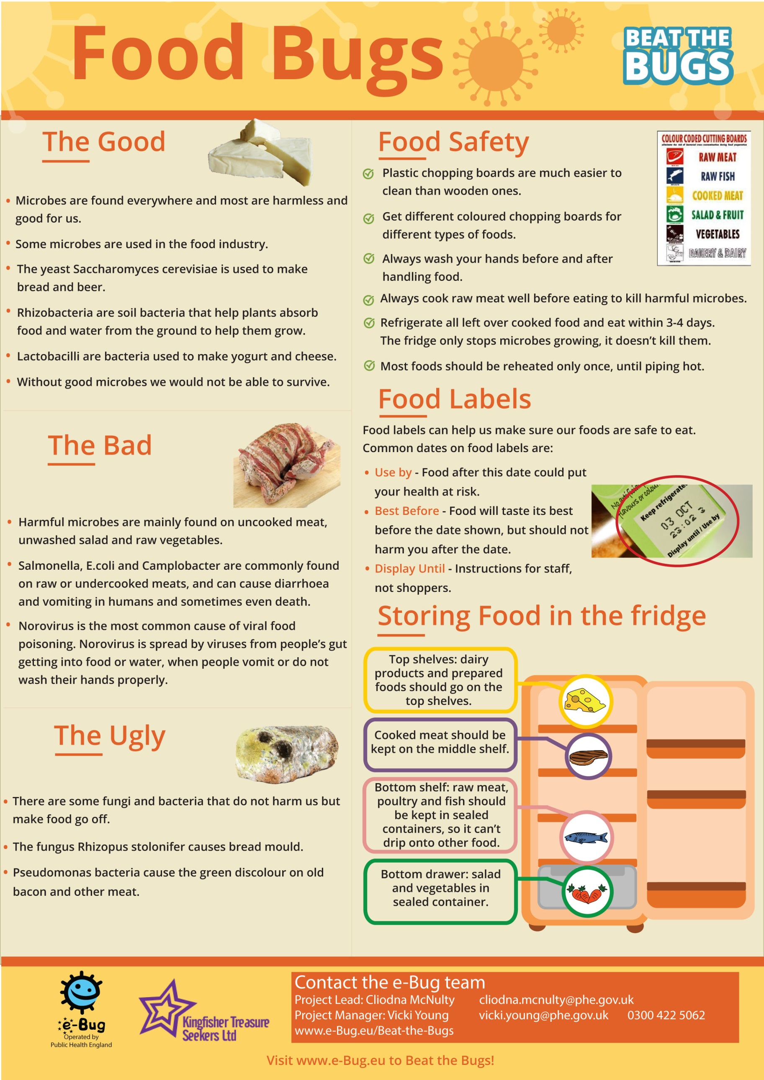
Fridge
Raiders
Educator Sheet 1

Page 60

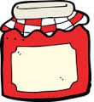


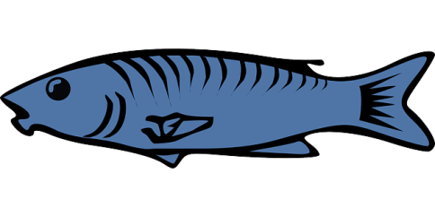
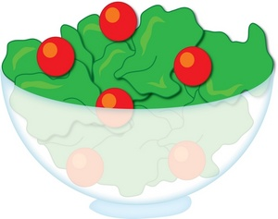

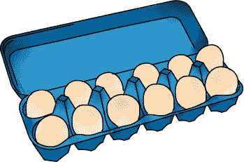

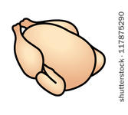
Fridge
Raiders
Educator Sheet 2
Educator Sheet 3
Raiders
Fridge


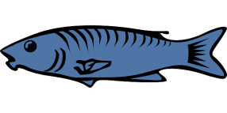

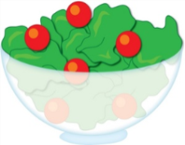
Answer Sheet
62
Store fruit and vegetables and salad in the draw at the bottom of the fridge

Raw meat and fish should be covered and kept on the bottom shelf in the fridge
Cooked meat should be covered and stored away from raw meat
Pre-prepared food, such as this salad, should be covered and kept in the fridge until use
Some jars of food, for example jam, need to be stored in the fridge once opened
Label
Sort
Educator Sheet 4

Match the food label to the correct definition.

Label | Definition
‘Use by’ | These dates are seen on food that goes off quickly, such as meat products and ready prepared salads. Don’t use any food or drink after the end of the date on the label, even if it looks and smells fine. This is because using it after this date could put your health at risk.
‘Best before’ | These dates are about quality not safety. This food will taste its best before the date shown. Eating it after this date will not mean you will get ill but the flavour might not be as good. These dates appear on a wide range of frozen, dried, tinned and other foods.
‘Display until’ | Retailers often use these dates on their shelves, mainly for stock purposes. These are not required by law and are instructions for shop staff, NOT for shoppers.
‘Consume within 3 days of opening’ | This label means that food should be eaten within the amount of days it says on the packaging. After this date the food may be unsafe to eat.
‘Keep refrigerated once opened’ | This label means that once you have removed the packaging and exposed the food to the air it should be refrigerated so that the microbe growth can be reduced.

63
Educator Sheet 4
Sort
Label

“Use by” label examples
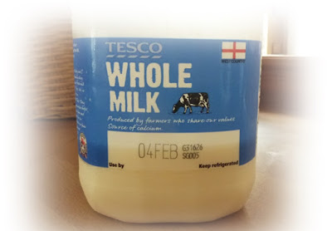
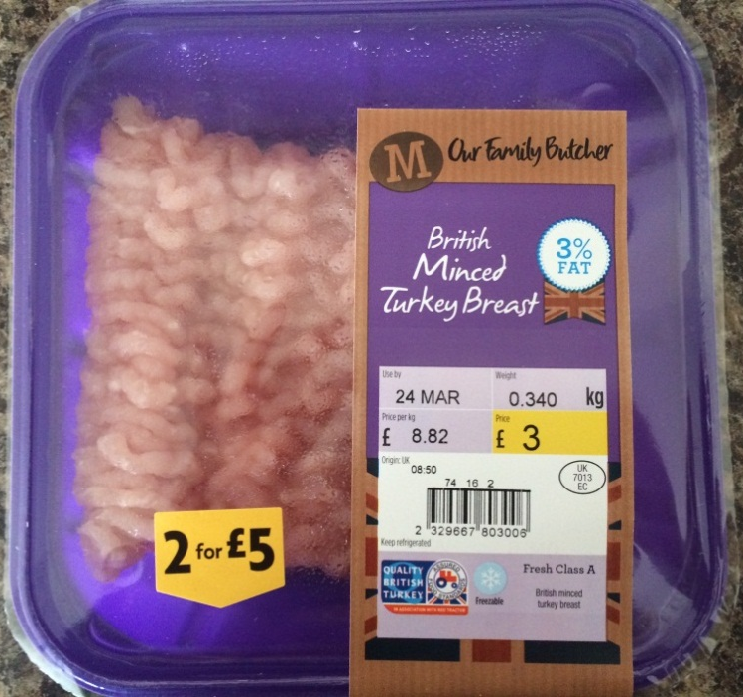
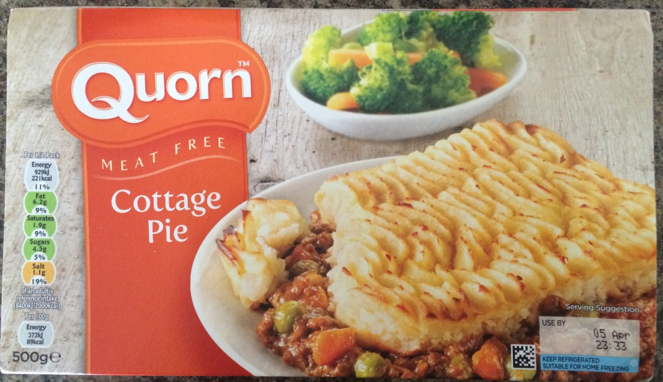
64
Educator Sheet 5
Sort
Label

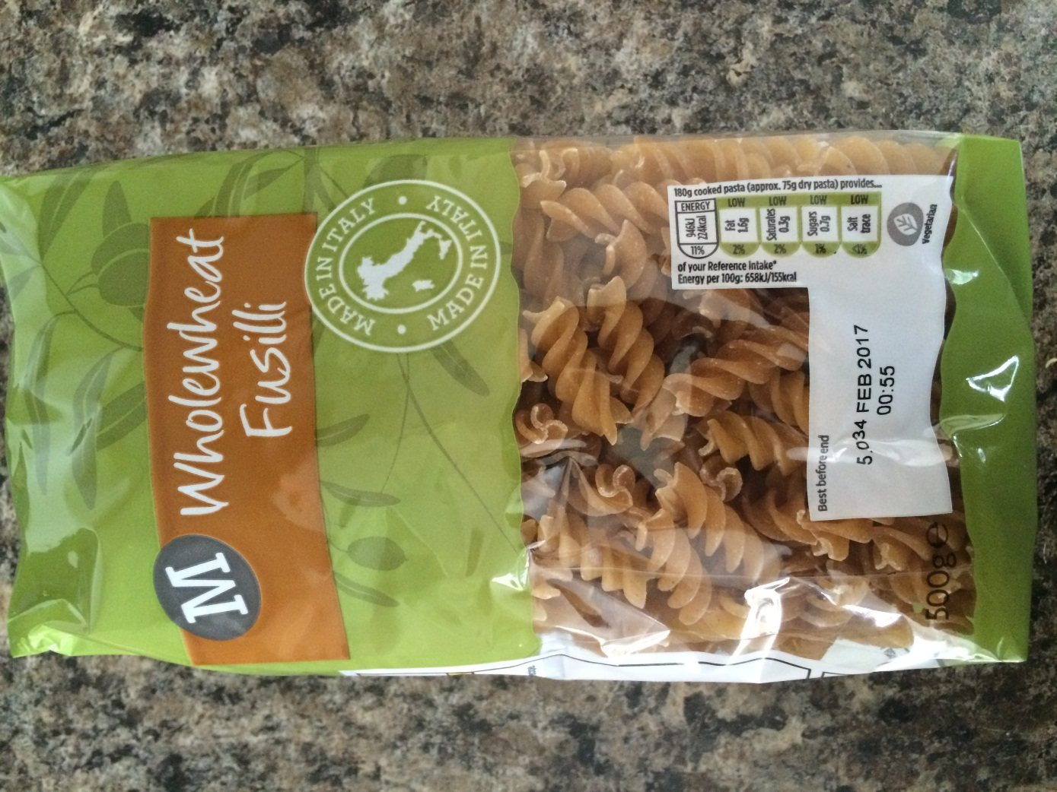
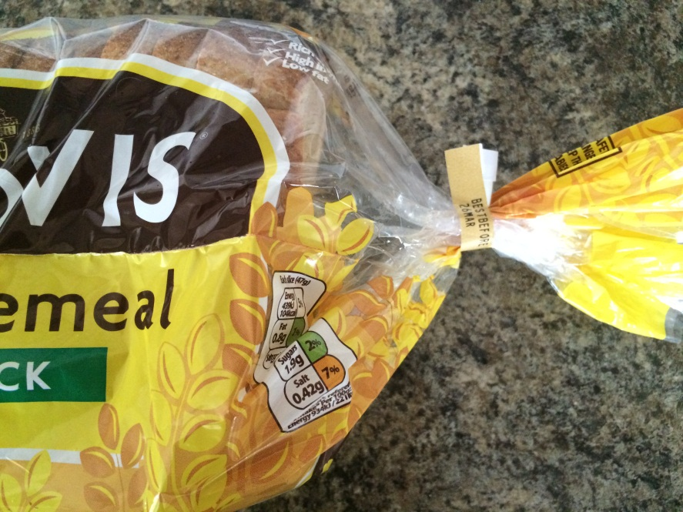
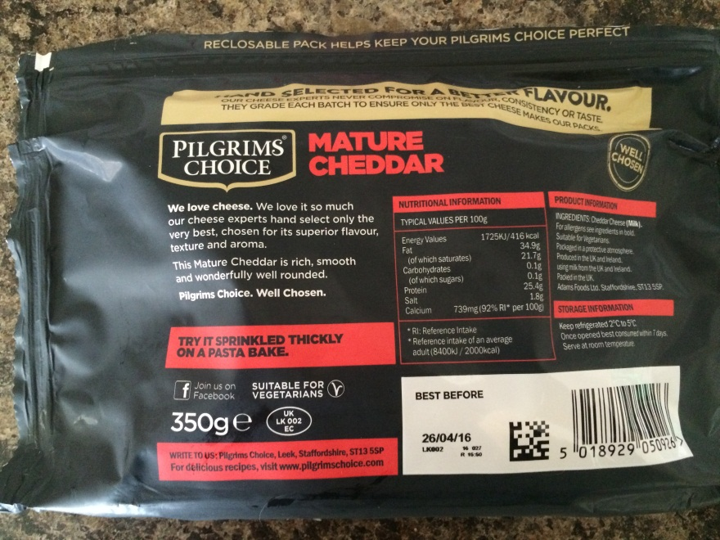
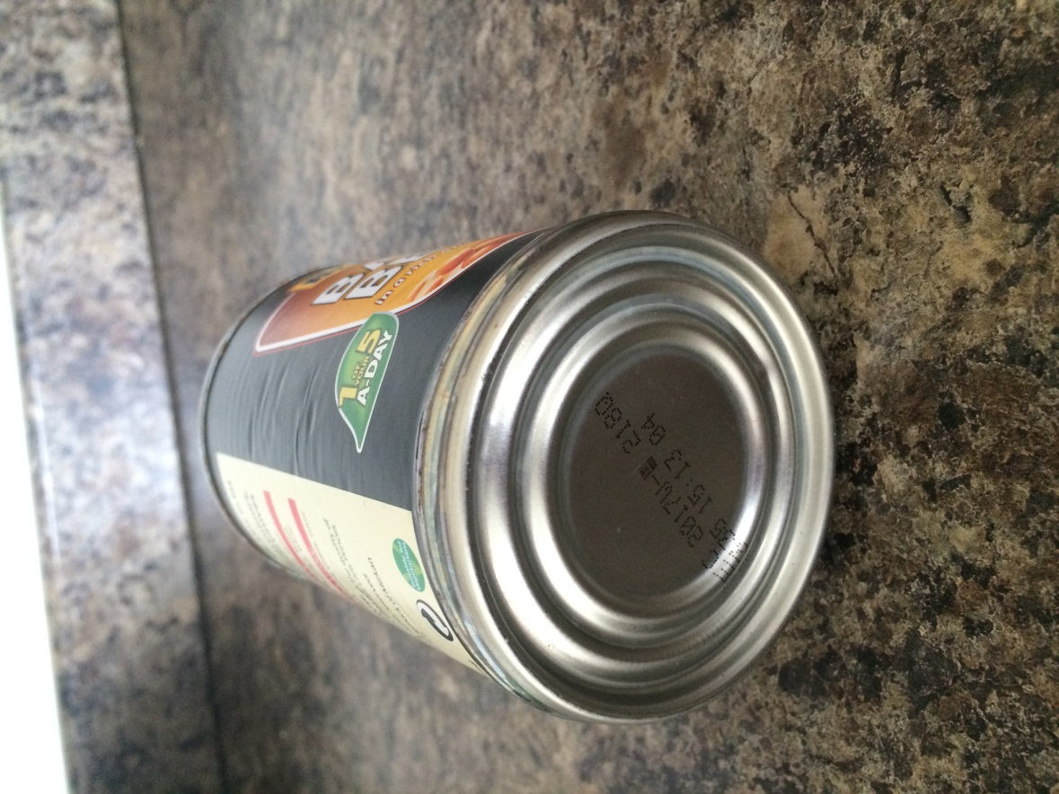
“Best before” label examples
65
Sort
Label
Educator Sheet 6

“Display until” label examples

66


Sort
Label
Participant Worksheet 1
Match the food label to the correct definition.
These dates are seen on food that goes off quickly, such as meat products and ready prepared salads. Don’t use any food or drink after the end of the date on the label, even if it looks and smells fine. This is because using it after this date could put your health at risk.
These dates are about quality not safety. This food will taste its best before the date shown. Eating it after this date will not mean you will get ill but the flavour might not be as good. These dates appear on a wide range of frozen, dried, tinned and other foods.
Retailers often use these dates on their shelves, mainly for stock purposes. These are not required by law and are instructions for shop staff, NOT for shoppers.
This label means that once you have removed the packaging and exposed the food to the air it should be refridgerated so that the microbe growth can be reduced.
This label means that food should be eaten within the amount of days it says on the packaging. After this date the food may be unsafe to eat.
Use by
Best before
Display until
Consume within 3 days of opening
Keep refrigerated once opened

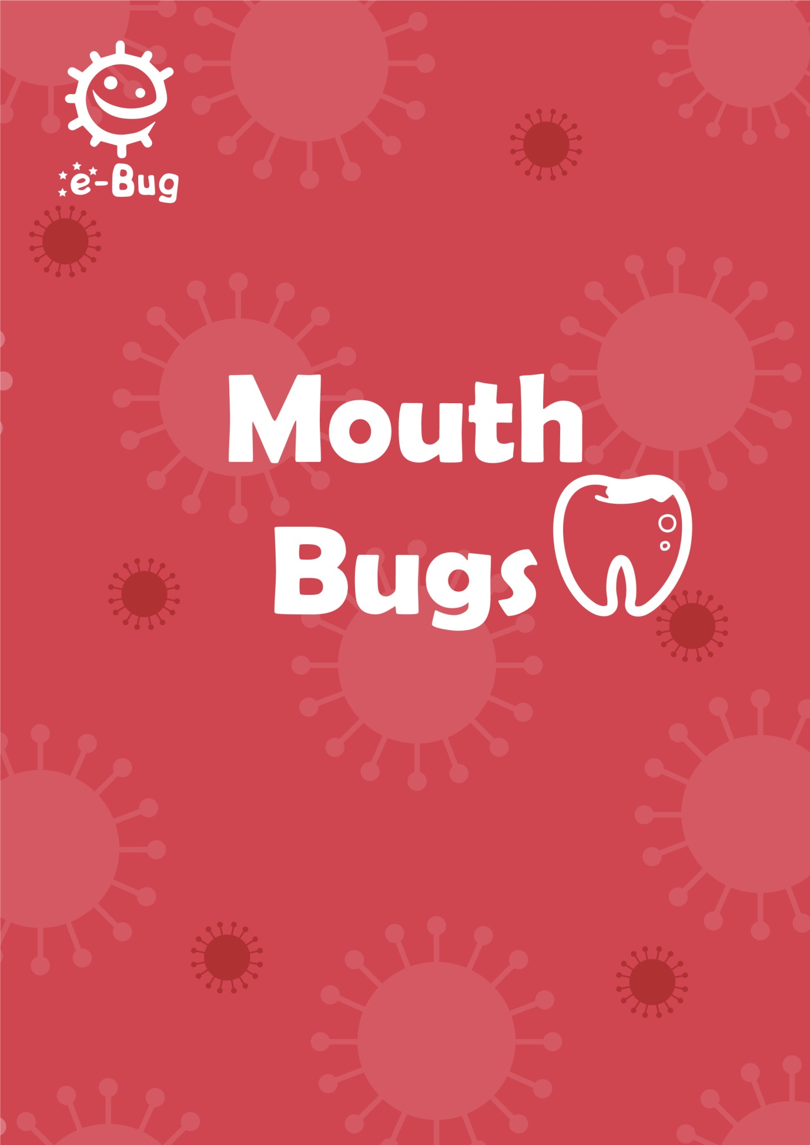
68
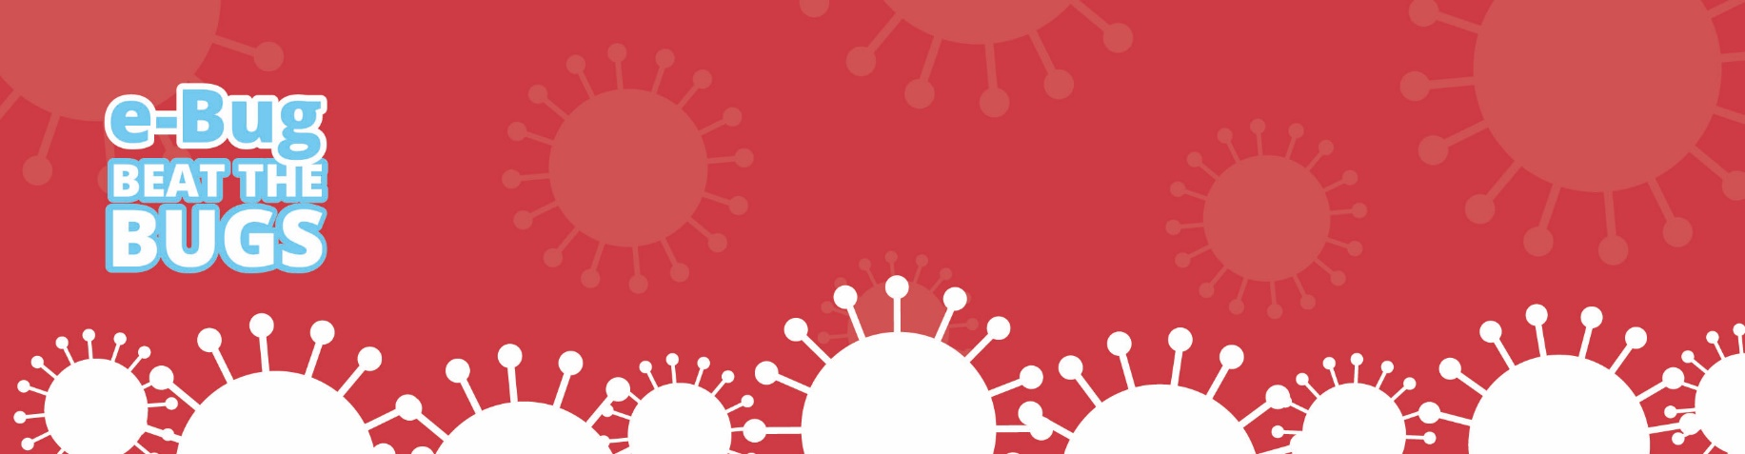
Mouth Bugs

Introduction
This session covers how to prevent tooth decay by demonstrating the importance of limiting sugar intake and brushing teeth twice a day. Participants will look at the sugar in foods and drinks and carry out an activity to identify the amount of sugar contained in different soft drinks. If a participant consents, a plaque disclosing tablet can be used to show plaque on teeth.

Learning outcomes
Aim to understand:
- What dental plaque is and how it forms
- Which foods and drinks cause tooth decay
- The consequences of tooth decay
- How to brush teeth effectively
- That limiting sugary foods and drinks can reduce tooth decay

70
Key words
Bacteria
Plaque
Tooth Decay
Sugar
Acid
Fluoride toothpaste
Tooth brushing

Available web resources
“How to keep your teeth happy and
healthy” PowerPoint
Diet Diary
Video on tooth brushing
‘Mouth Bugs’ poster

Materials required
Activity 2: Empty drinks bottles, teaspoons, sugar, clear plastic sandwich bags
Activity 3: Plaque disclosing tablets, tooth brush, toothpaste

Mouth Bugs

Background information
Normally our first teeth come through (erupt) around 6 months until we have a full set of 20 baby (primary) teeth by the time we are 2 years old. These primary teeth begin to get wobbly and fall out (exfoliate) usually when we reach 6 years old, and are replaced by the permanent (adult) teeth. By 12 years old we have 28 adult teeth which if we look after, can last for the rest of our lives.

Some people will have 4 extra teeth at the back of their mouth called wisdom teeth. These come through our gums when we are about 18-20 years old, so some people can have 32 adult teeth in total.

Bacteria will develop on all our teeth, clumping together to form a sticky substance called dental plaque. You will see this in your own mouth as a creamy line around your teeth or sometimes feel it as a furry layer with your tongue. Given the right environment, these bacteria can cause tooth decay (caries).

When we consume sugary foods and drinks which contain free sugars, this is classified as a sugar attack to our teeth. Free sugars are those added by the cook, consumer or manufacturer including those sugars naturally present in honey, syrups and fruit juices, but excludes whole fruits and unrefined carbohydrates such as brown rice and whole wheat pasta. Sugar attacks should be kept to a minimum and limited to mealtimes to reduce the risk of tooth decay.

The bacteria in the plaque use the sugars and make acid as a by-product. Over time the acid begins to dissolve the mineral from the outer surface of our teeth (the enamel). As more enamel is dissolved by the acid, a hole (cavity) appears which can spread into the second layer of tooth (the dentine). As the decay process continues, the cavity continues to grow and can irritate the nerve inside the tooth causing pain.

If no dental treatment is given, the tooth decay (caries) can spread and the bacteria infect the nerve, which can lead to an abscess (lump on the gum) that is filled with pus. This can make you very poorly and the tooth will usually need to be removed (extracted).
Tooth decay can be prevented by limiting the number of times we eat foods and drinks with added sugar and tooth brushing twice a day with fluoride toothpaste.
71
Mouth Bugs

Fluoride in toothpaste can help strengthen our teeth and slow down caries. For best effect, teeth need to be brushed twice a day. The most important time to brush teeth with fluoride toothpaste is before going to bed at night. To make it easy to remember it is best to add tooth brushing to a twice daily hygiene routine morning and night, and keep your toothbrush and paste in sight.

Introduction (15 mins)
Begin the session by asking the participants when they last went to the dentist. Do all participants have a regular dentist? Ask what they understand by the term tooth decay. By using the background information section and the ‘Mouth Bugs’ poster, introduce to the participants that tooth decay is a preventable disease. Explain that they will learn what causes tooth decay and simple steps they can take to prevent it.
Show the ‘How to keep your teeth happy and healthy’ PowerPoint presentation (available at www.e-Bug.eu/beat-the-bugs). Use the questions within the presentation to promote discussion and gather what knowledge the group already has.

Recommended Activities:
The following two activities are recommended.

72
Mouth Bugs

Activity 1 – Healthy Diet (10-15 mins)
In this activity, participants will look at their own diet diaries and identify sugar attacks. Participants will learn which foods and drinks cause tooth decay and understand the benefits of limiting sugary foods and drinks.
Participants should have completed their diet diaries in advance of the session. If participants do not have completed diet diaries, ask what they had to eat the previous night and that morning. Alternatively, you could use the sample diet diaries provided (PH1) that are suitable for discussion purposes. Please note the sample diet diaries do not represent healthy or unhealthy diets.
Remind participants that a sugar attack to our teeth occurs whenever we consume sugary foods or drinks. Ask participants to underline sugar attacks on their diet diaries, and to add up how many attacks there are. To help participants, discuss which foods contain a high amount of sugar.
To prevent tooth decay, sugar attacks should be kept to a minimum and limited to meal times.
Optional: If you have time during a follow up session, you could repeat this activity to see if the number of sugar attacks has decreased since the session.
Learning outcomes achieved:
- Which foods and drinks cause tooth decay
- That limiting sugary foods and drinks can reduce tooth decay
73
Mouth Bugs

Activity 2 – How much sugar? (15-20 mins)
Ask participants first if they add sugar to their hot drinks, and if so how much. Participants should complete this activity in groups of 2-3.
Provide each group with a different empty drink bottle from a popular brand (include flavoured and plain water and a range of soft and fizzy drinks), a teaspoon, a bag of sugar and a clear plastic sandwich bag.
Before they begin, each participant should be asked to look at the nutritional information label and identify how much sugar is contained within each bottle. Help group members to find this information.

Example of traffic light food labelling now used for most products.
Nutritional information on a small bottle of orange juice

Participants should be asked to fill each bag with the equivalent amount of sugar contained within each drink (1 teaspoon is approximately 4 grams).
Once the activity is complete, each group can present their findings (drink name, amount of sugar in grams and number of teaspoons of sugar). Discuss the results – which drink contains the most sugar? Which contains the least?
74
Mouth Bugs

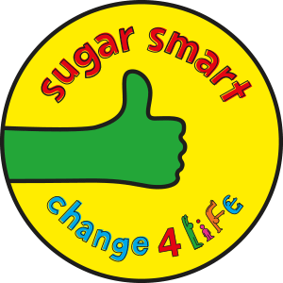
Alternatively participants can use the Change4Life Sugar Smart app to find out how much total sugar is in your everyday food and drink. The sugar smart app is free to download:
At the app store: www.itunes.apple.com/gb/app/change4life-sugar-swaps/id1015850256?mt=8
At Google play store: https://play.google.com/store/apps/details?id=com.PHE.SugarSwaps&hl=en_GB

Remind participants that drinks containing sugar are a sugar attack to our teeth, and this can increase the risk of tooth decay. Drinking only water and plain milk is recommended.
Learning outcomes achieved:
- Which foods and drinks cause tooth decay
- That limiting sugary foods and drinks can reduce tooth decay
- Drinking water and plain milk is best
75
Mouth Bugs

Optional Activity

Activity 3 – How to clean your teeth? (10-15 mins)
In this activity you will need one volunteer who consents to using a plaque disclosing tablet. If applicable, please get consent from the appropriate adult/carer. The tablets contain a harmless dye that reacts with the plaque on our teeth, allowing areas with plaque to become visible.
Ask the volunteer to first brush their teeth (provide them with a new toothbrush and toothpaste). Then ask the volunteer to chew a plaque disclosing tablet, following the manufactures guidelines. Remaining plaque on their teeth will become visible. Ask the volunteer to point out which areas still contain plaque.
Show the group one of the videos, which describes how to brush your teeth:
www.youtube.com/watch?v=Z_7bBppIINc
www.youtube.com/watch?v=Hej8amtKna0
As an alternative to the videos you could use a large tooth brushing model and demonstrate how to brush your teeth.
- Ask how their tooth brushing differs from that in the video. What changes can they make to improve their tooth brushing?
Do not rinse your mouth with water after brushing your teeth, just spit; this leaves a layer of protective fluoride on the teeth.
- Ask how long we should brush our teeth for?
The ideal time is 2 minutes, however time is less important than quality of brushing- you should brush all of the surfaces of the teeth and gum line, remembering the back teeth as well.
76
Mouth Bugs

- Define what dental plaque is and how it can be removed.
Dental plaque is the slimy stuff on your teeth and is formed by clumps of bacteria. Bacteria multiply more when there is sugar on our teeth and form acid which can make holes in our teeth (tooth decay). Brushing our teeth well removes the bacteria and dental plaque and helps prevent tooth decay. Tooth decay can lead to holes in our teeth which may grow and become very painful, you may lose the tooth or teeth affected.

Learning outcomes achieved:
- How to brush teeth effectively
- What dental plaque is and how it forms
- The consequences of tooth decay

77
Mouth Bugs

Discussion
Ask participants what they have learnt during today’s session, and refer to the ‘Mouth Bugs’ poster during the discussion. Ask what they will do differently now at home?
Recap the key messages:
- How do we get dental decay?
Bacteria in our mouths breakdown sugars we eat and use them to produce substances including acid and plaque. The plaque helps the bacteria clump together and stick to the teeth. If this is not brushed away regularly, the acid dissolves our teeth causing cavities (holes).
- Which foods should we limit, and only have occasionally?
Foods and drinks containing sugar should be limited and only had occasionally. Snacking during the day and at bedtime on sugary foods and drinks (especially fizzy drinks!) should be avoided to prevent dental decay.
- How often should we brush our teeth, and how?
It is essential to brush our teeth twice daily, at night and in the morning, using a pea-size amount of toothpaste containing fluoride. After brushing it is important to spit but not rinse (to leave a protective layer of fluoride on the surface of our teeth).
If any participants do not have a regular dentist, show them where to find the information they need. Participants can locate their nearest dentist, by following the link: www.nhs.uk/Service-Search/Dentist/LocationSearch/3
This website gives information on the closest dentist surgery, how to get in touch and how highly each surgery is rated.
78
Mouth Bugs

Action Plan
Discuss with participants if they stuck to their action plan from the last session. If they did, how did they do this and if not why.
Then ask participants to complete their action plan for this session. Hand out the individual pocket sized sheet for participants to keep for themselves as well as the full sized sheet to be returned to the group leader. This worksheet will be used again in the final session.
Ask participants to either choose one of the action plans from below or to make up their own if they are confident enough.
1. Reduce chance of dental decay by:
a. Choose a song to make sure you brush your teeth for 2 minutes
b. Set a reminder twice a day to remind you to clean your teeth
c. Clean every part of the mouth, including gums and back teeth equally
d. To spit but not rinse after brushing so that there is a protective layer of fluoride on the surface of the teeth
e. Cutting down on sugary foods and drinks e.g. swapping chocolate bar for a bunch of grapes.
f. Use the sugar swap app to tell them how much sugar is in the things they are eating

Acknowledgements
This session plan was written by the e-Bug team and assisted by the Kingfisher Treasure Seekers Community Group and Barts and the London School of Medicine and Dentistry.
79
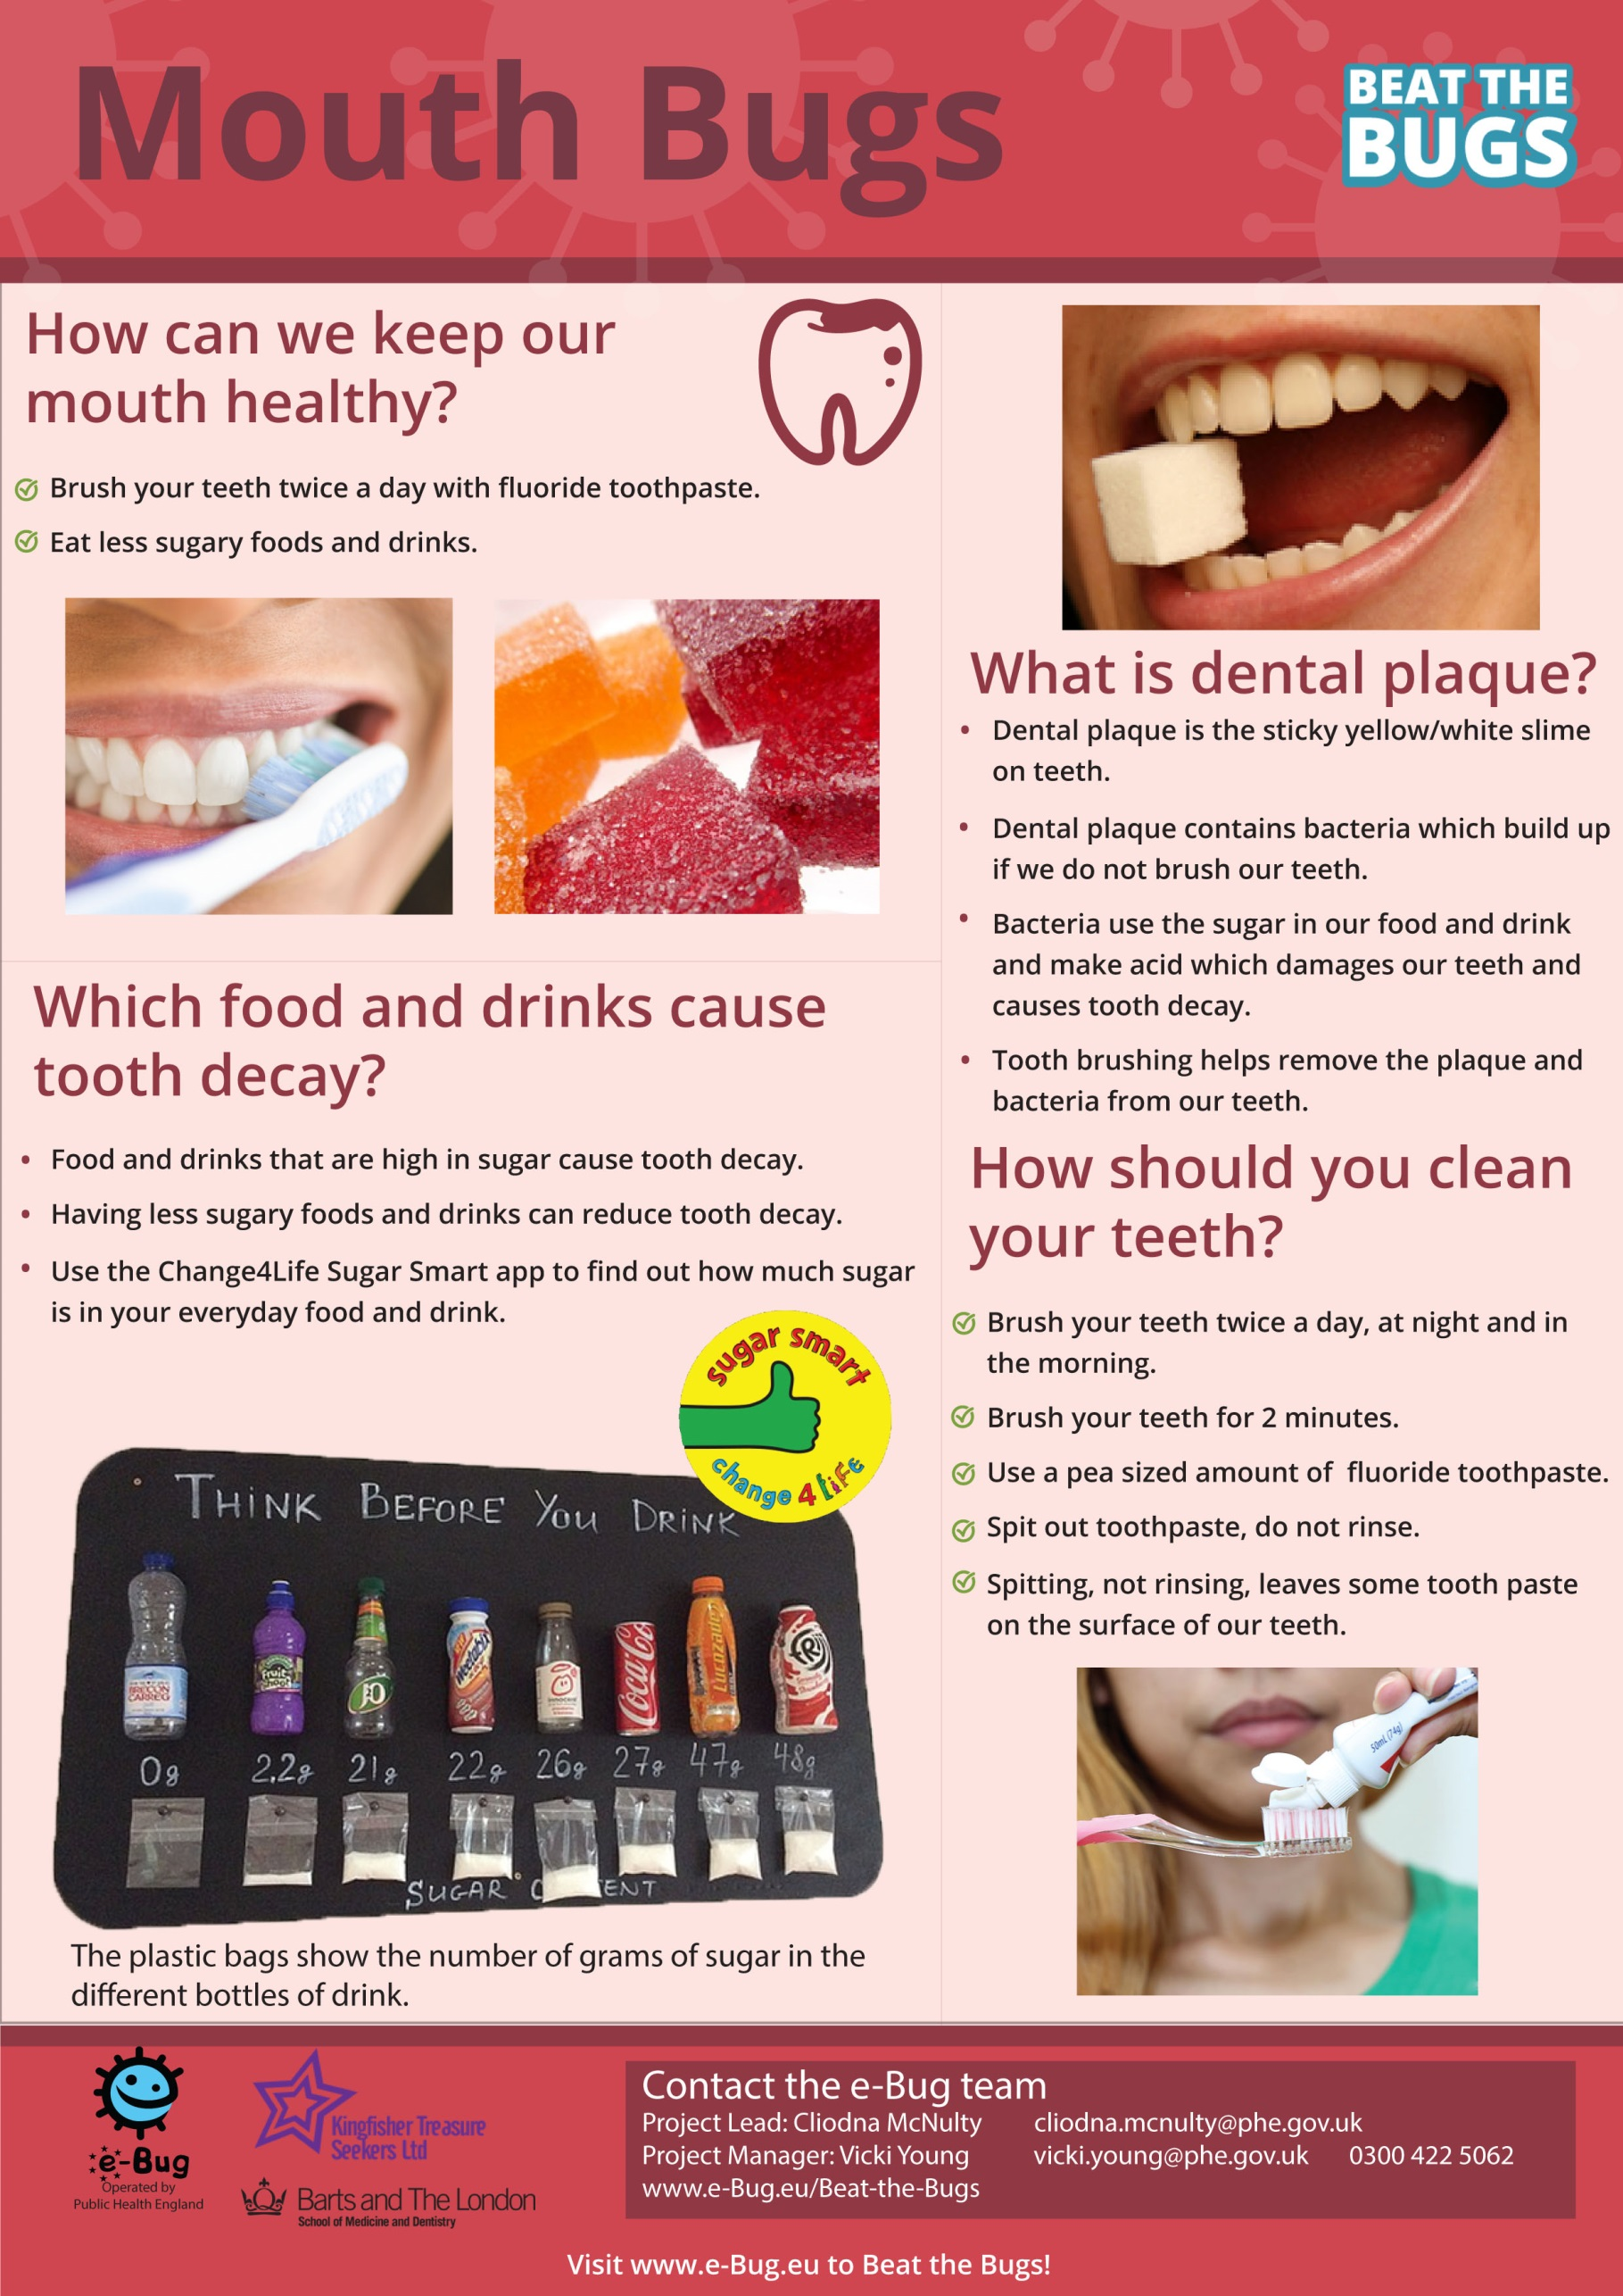

Diary
Diet
Participant Handout 1a

Example 1

Day: Friday
Time | What did you eat? | What did you drink?
8 am | Cornflakes with milk and sugar | Orange juice  Tea with milk and sugar
11am | Chocolate bar | Coffee with milk and sugar
1pm | Cheese sandwich and crisps | Can of coke
3pm | Apple and packet of sweets | Orange squash
6pm | Chicken dinner with potatoes and vegetables  Slice of chocolate cake with ice cream | Apple juice  Milk

Diary
Diet
Participant Handout 1b

Example 1
Day: Saturday
Time | What did you eat? | What did you drink?
9 am | Fry up with bacon, eggs, sausage and toast | Orange juice  Tea with milk and sugar
11am | Packet of crisps | Fizzy drink
1pm | Baked potato with baked beans and cheese | Can of lemonade
3pm | Chocolate bar | Tea with milk and sugar
6pm | Fish and chips  Apple pie and cream | Apple juice
8pm | Biscuits | Tea with milk and sugar
Diary
Diet
Participant Handout 1c

Example: 1
Day: Monday
Time | What did you eat? | What did you drink?
9 am | Coco pops and milk | Fruit smoothie  Tea with milk and sugar
11am | Chocolate bar | Diet coke
1pm | Ham sandwich and crisps | Orange juice  Tea with milk and sugar
3pm | Chocolate biscuits | Coffee with milk and sugar
6pm | Pizza and chips  Sticky toffee pudding and custard | Glass of Coke
8pm | Chocolate | Milk
Participant Handout 1d
Diet
Diary

Example 2
Day: Friday
Time | What did you eat? | What did you drink?
8 am | Porridge with banana and blueberries | Tea with milk
11am | Apple | Coffee with milk
12 30 pm | Tuna salad sandwich | Water  Tea with milk
3pm | Carrot sticks and dip | Water
6pm | Chicken dinner with potatoes and vegetables  Fruit salad with natural yoghurt | Water
8pm | Orange | Milk


Participant Handout 1e
Diary
Diet

Example 2
Day: Saturday
Time | What did you eat? | What did you drink?
9 am | Scrambled eggs on toast | Tea with milk
11am | Cucumber sticks | Water
1pm | Bowl of soup and bread | Coffee with milk
3pm | Handful of nuts | Water
6pm | Chicken and vegetable stir fry  Rice pudding | Water
8pm | Handful of grapes | Tea with milk

Participant Handout 1f
Diet
Diary

Example 2
Day: Monday
Time | What did you eat? | What did you drink?
9 am | Cornflakes and milk with sliced banana | Tea with milk
11am | Orange | Water
1pm | Ham salad sandwich | Tea with milk
3pm | Handful of blueberries | Coffee with milk
6pm | Salmon and potato salad  Strawberries and natural yoghurt | Water
8pm | Sliced mango | Milk
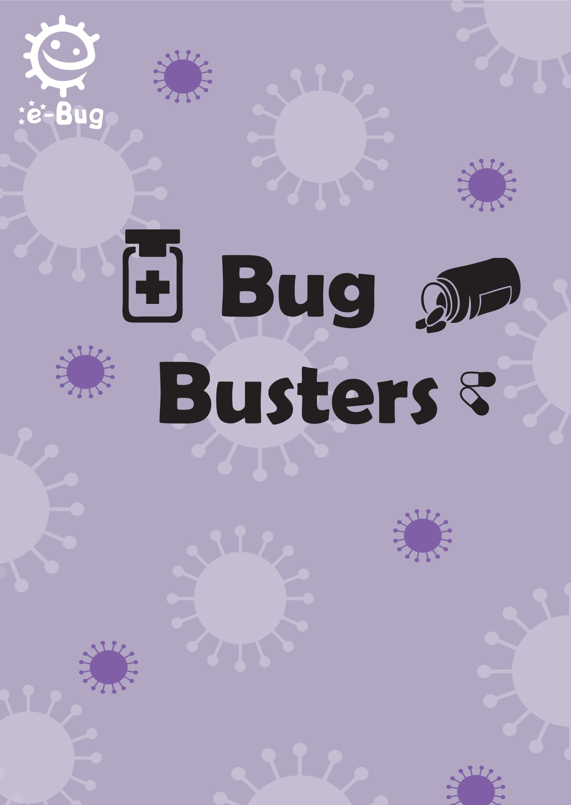

Page 87
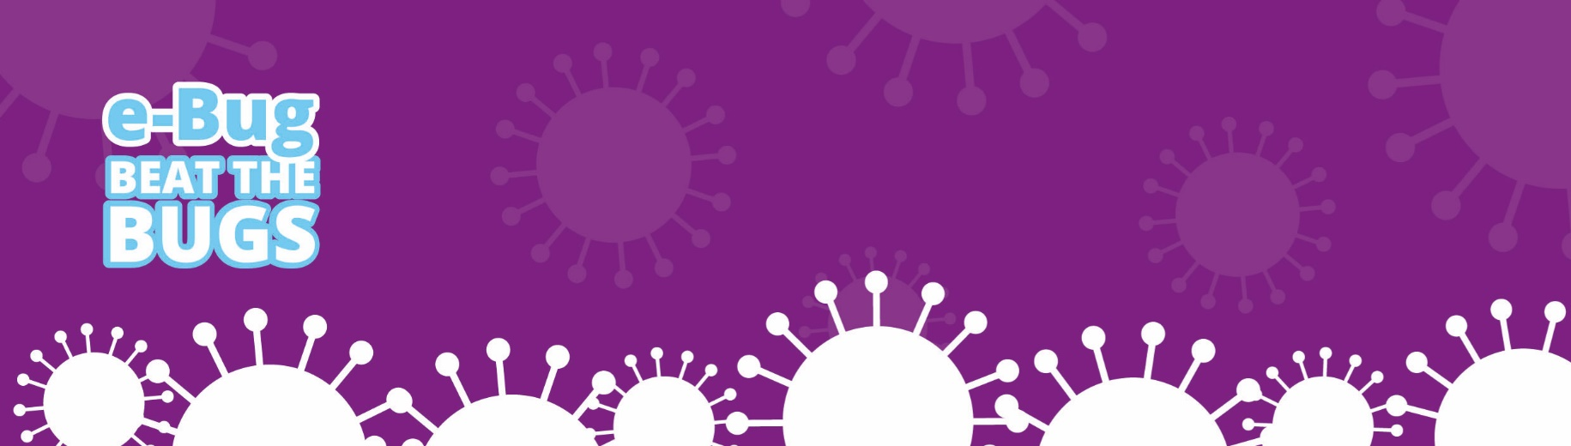
Bug Busters

Introduction
During this session, participants will learn what antibiotics are, when to take antibiotics and how to take antibiotics correctly. A demonstration will introduce antibiotic resistance and a participant activity will show how easily antibiotic resistant bacteria spread. Participants will be encouraged to think about self-care and how they can treat future infections.
Learning outcomes
Aim to understand that:
- Most common infections (sore throats, coughs, colds, flu, ear infection, sinus infection) will get better by themselves through time, bed rest, liquid intake and healthy living
- Take antibiotics exactly as given by your doctor or nurse
- You must not use other people’s or any leftover antibiotics
- Only use antibiotics when you really need them
- If you over use antibiotics they might not work when you really need them for a severe infection such as meningitis, pneumonia or kidney/urine infection
- Some bacteria can no longer be killed by antibiotics and this is called antibiotic resistance
- Remember, antibiotics kill our own useful bacteria
- Antibiotic resistant bacteria spread easily from person to person
Key words
Antibiotic, Disease, Illness, Immune system, Infection, Medicine, Symptom, Antibiotic Resistance, Bacteria, Virus

Available web resources
Patient stories
Gut microbiome video
‘Bug Busters’ poster

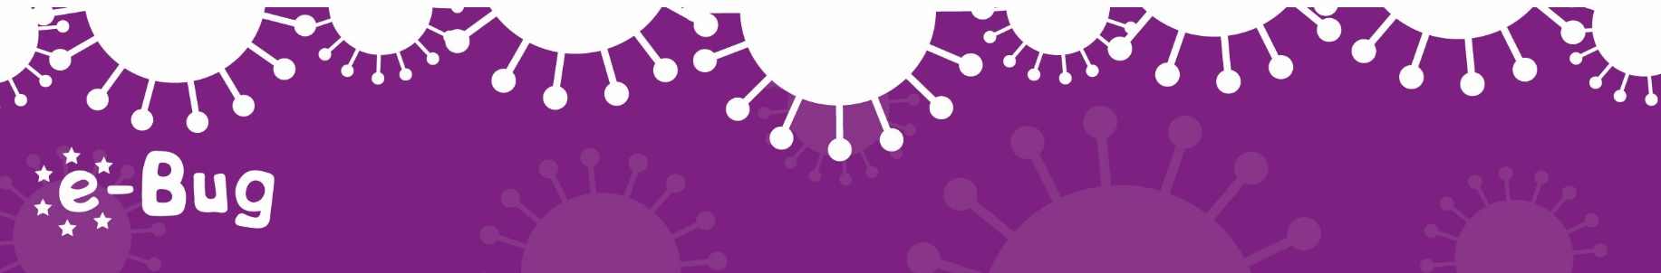
88
Materials required
Activity 1: Balloons, tape, pin
Activity 2: Red and gold glitter
Activity 3: Participant worksheet (PW1) and educator answer sheet

Bug Busters

Background information
The body has many natural defences to help fight against bad microbes that can cause infection – the skin stops microbes entering the body, the nose has a sticky membrane trapping microbes if they are inhaled, tears contain substances which kill bacteria and the stomach produces acid which can kill many microbes. Generally by living a healthy life (eating the right food, drinking plenty of water and getting lots of rest) these natural barriers work on a daily basis to keep us healthy. However, in some cases, microbes can cross these barriers and enter our bodies.
The majority of the time the immune system defeats any harmful microbes entering the body; however, in some cases the immune system needs help. Antibiotics are special medicines used by doctors to kill harmful bacteria. Some antibiotics stop the bacteria reproducing and others kill the bacteria. Antibiotics treat infectious diseases caused by bacteria, such as meningitis, tuberculosis and pneumonia. They do not harm viruses, so antibiotics cannot treat diseases such as colds and flu, which are caused by viruses.
Before antibiotics were invented harmful bacteria were life threatening. Today, however, many bacterial infections are easily treated with antibiotics – but the bacteria are fighting back! Through increased exposure to the antibiotics, bacteria are becoming resistant to them. This means that bacterial infections are once again becoming life threatening. Infections caused by antibiotic resistant bacteria pose a serious health risk. Patients who are immuno-compromised (through cancer or HIV treatment, pregnancy or other illnesses) are less able to control the infection with antibiotics. Resistant bacteria can pass their resistance on to other bacteria in our gut and these can spread easily if we do not wash our hands.
We can help prevent antibiotic resistance by:
- only using antibiotics prescribed for you by your doctor because each prescription is targeted to each patient and each infection
- always take the antibiotics exactly as prescribed otherwise the bacteria are not completely destroyed and the infection can come back
- don’t use antibiotics for simple coughs and colds because antibiotics do not kill viruses and overuse increases bacterial resistance
89
Bug Busters

Overuse of antibiotics can also damage our useful bacteria which are found in our gut. These useful bacteria help us to digest food and they play an important role in our immune system.

Introduction (10-15 mins)
Talk through common infections such as coughs, colds, flu, tonsillitis etc., and ask the group if they have had them. Ask what they did to treat the infection – did they go to the doctor, how did they look after themselves at home, how long did the infection last?
Explain that most infections are caused by viruses and recap from session one where viruses are found and what illnesses they cause. Explain that antibiotics do not work on viruses, and therefore they will not help most infections. Most common infections (sore throats, coughs, colds, flue etc.) will get better by themselves through time, bed rest, liquid intake and healthy living. Reinforce that antibiotics only work on bacterial infections.
Explain that you should only take antibiotics when you really need them and take them exactly as given by your doctor. Reinforce that you must not use other people’s or any leftover antibiotics.
Explain that if we use antibiotics inappropriately, for example by using them when we shouldn’t, they are less likely to work in the future. Ask if anyone has heard of MRSA? Do you know anyone who had a severe infection that didn’t get better? Use the patient stories on the e-Bug Young Adult student website to prompt discussion:

Recommended Activities:
The following three activities are recommended:
90
Bug Busters

Activity 1 – Bacterial resistance (10-15 mins)
What does it mean when we say bacteria (not the patient) are becoming resistant to antibiotics? Explain that bacteria are continually developing ways to avoid being killed by antibiotics, and that this is known as antibiotic resistance. Antibiotic resistant bacteria can be very dangerous.
Explain that you will show a demonstration to describe antibiotic resistance.
Blow up balloons in two different colours and put sellotape or parcel tape on one of the balloons. Clear parcel tape works the best; if sellotape or brown parcel tape is used, several layers may be required for the experiment to work. The sellotape is best placed on the end of the balloon where the balloon is thickest.
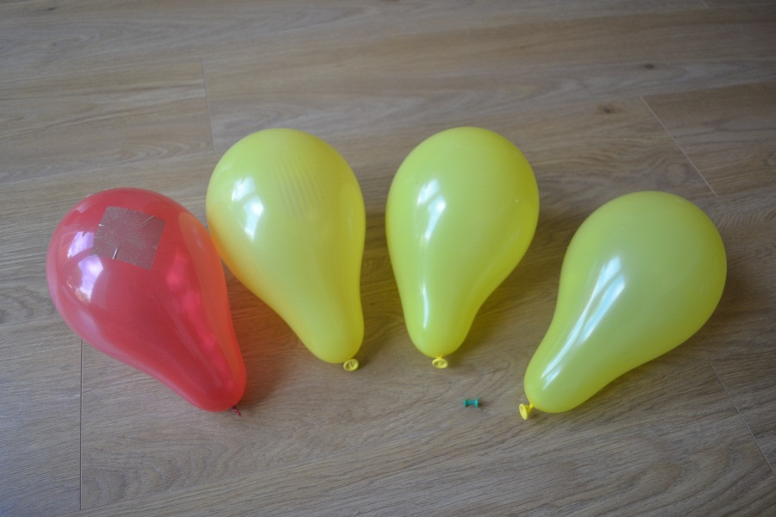
Bacteria
Antibiotic resistant bacteria
Antibiotic

Explain that the yellow balloons represent bacteria and the red balloon with tape on represents antibiotic resistant bacteria. The pin represents the antibiotic.
When we give an antibiotic, bacteria are killed or damaged – pop some yellow balloons with the pin. However in bacteria that are antibiotic resistant, the bacteria are not affected by the antibiotics – put the pin through the sellotape in the red balloons, it will not pop. These bacteria cannot be killed by antibiotics.
91
Bug Busters

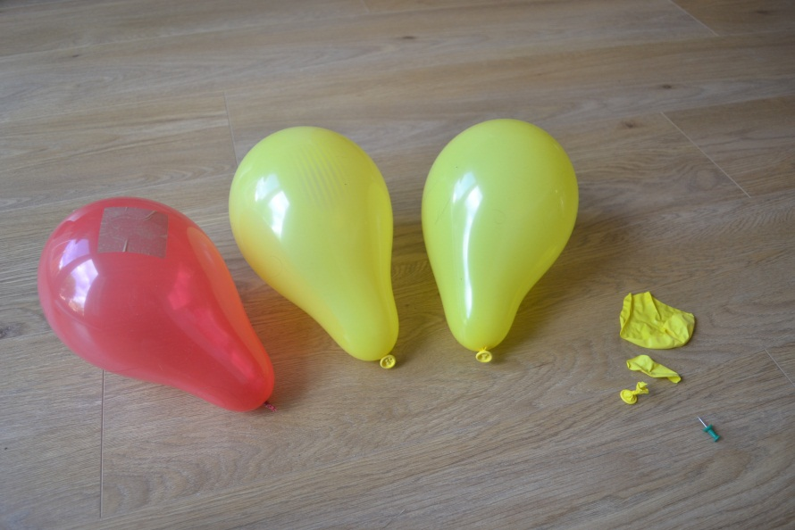
Bacteria killed by antibiotic
Antibiotic resistant bacteria are not killed by antibiotic

Learning outcomes achieved:
- If you over use antibiotics they might not work when you really need them for a severe infection such as meningitis, pneumonia or kidney/urine infection.
- Some bacteria can no longer be killed by antibiotics and this is called antibiotic resistance.
- Remember, antibiotics kill our own useful bacteria

92
Bug Busters

Activity 2 – The spread of resistant bacteria (10-15 mins)
Antibiotic resistant bacteria can spread easily from person to person, just like any other type of microbe.
Use red and gold glitter to demonstrate the spread of bacteria. Gold glitter represents bacteria like in activity 1, and the red glitter represents the antibiotic resistant bacteria. During this activity you can recap the learning outcomes from session 2 (The spread of infection). Remind participants that microbes are found everywhere and can spread easily through touching surfaces and person-to-person contact.
Put both gold and red glitter on one or two participants’ hands and ask them to touch various things around the room and shake hands with other members of the group.
Look at how far the coloured glitter has spread and discuss with the group that bacteria and antibiotic resistant bacteria both spread very quickly. Remind everyone that antibiotic resistant bacteria spreads just as easily as any other type of microbe.
Learning outcomes achieved:
- Antibiotic resistant bacteria spread easily from person to person

Activity 3 – Antibiotics Right or Wrong? (10-15 mins)
Participants will use the ‘true or false’ worksheet provided (PW1) to learn about how to take antibiotics correctly.
Give each participant a copy of the worksheet. The worksheet has 8 statements, which teaches the group not to take antibiotics for coughs and cold, to take antibiotics as prescribed and not to use other people’s or left-over antibiotics.
For each statement, discuss with the group the whether they are right or wrong and reasons why. An answer sheet is provided to aid discussions.
93
Bug Busters

Learning outcomes achieved:
- Most common infections will get better by themselves through time, bed rest, liquid intake and healthy living
- Take antibiotics exactly as given by your doctor or nurse
- You must not use other peoples or any leftover antibiotics
- Only use antibiotics when you really need them
- If you over use antibiotics they might not work when you really need them for severe infections such as meningitis, pneumonia or kidney /urine infection
Activity 4 – Useful microbes (10 mins)
Recap from session one that we have lots of useful microbes in our bodies. Microbes in our gut help us to digest food, and they also help us to fight off harmful microbes.
The overuse of antibiotics can damage our normal/useful bacteria. The following video could be shown: www.youtube.com/watch?v=5DTrENdWvvM (or similar video of gut micro biome)
Learning outcomes achieved:
- Overuse of antibiotics can damage our normal/useful bacteria

Activity 5 – Antibiotic Guardian (5 mins)
Show participants the antibiotic guardian video located on the e Bug Young adult page here: www.e-bug.eu/young_sub.aspx?cc=eng&ss=11&t=Antibiotic%20guardian%20videos
The video explains the importance of antibiotics and how we can help the fight against antibiotic resistance by becoming an antibiotic guardian. Participants can visit the website at: www.antibioticguardian.com to make their pledge to become an antibiotic guardian and receive a certificate.
Learning outcomes achieved:
- If you use antibiotics when you don’t need them, they are less likely to work in the future when you really need them for severe infections such as meningitis, pneumonia or kidney /urine infection
- Bacteria are becoming resistant to antibiotics due to our overuse of antibiotics
94
Bug Busters

Discussion
Ask what the participants have learnt in this session? What will you do next time you are ill? Use the ‘Bug Busters’ poster to recap and aid discussion.

Recap the main learning objectives:
- Antibiotics don’t help most infections as they don’t work on viruses
- To treat viruses you should self-care at home
- If you use antibiotics inappropriately, they are less likely to work in the future
- Bacteria are becoming resistant to antibiotics due to our overuse
- Antibiotics cannot kill antibiotic resistant bacteria
- Antibiotic resistant bacteria spread easily from person to person
- Overuse of antibiotics can damage our normal/useful bacteria
- To take antibiotics correctly you should only take them as prescribed and you must not use other peoples or leftover antibiotics

Action Plan
Discuss with participants if they stuck to their action plan from the last session. If they did, how did they do this and if not why. Then ask participants to complete their action plan for this session. Hand out the individual pocket sized sheet for participants to keep for themselves as well as the full sized sheet to be returned to the group leader. This worksheet will be used again in the final session. Ask participants to either choose one of the action plans from below or to make up their own if they are confident enough.

1. Help to reduce antibiotic resistance by:
a. Not going to the doctor for coughs, colds, sore throats and flu.
b. Always return unused antibiotics to the pharmacy.
c. Ask the pharmacist next time you are ill about what I can take to self care at home.
d. Not using somebody else’s antibiotics.
e. Signing up to become an antibiotic guardian and making a pledge to reduce antibiotic resistance. (This could be one of the above pledges).

Acknowledgements
This session plan was written by the e-Bug team and assisted by Dr Nick Francis and Dr Nina Gobat of Cardiff University, and Kingfisher Treasure Seekers Community Group.
95
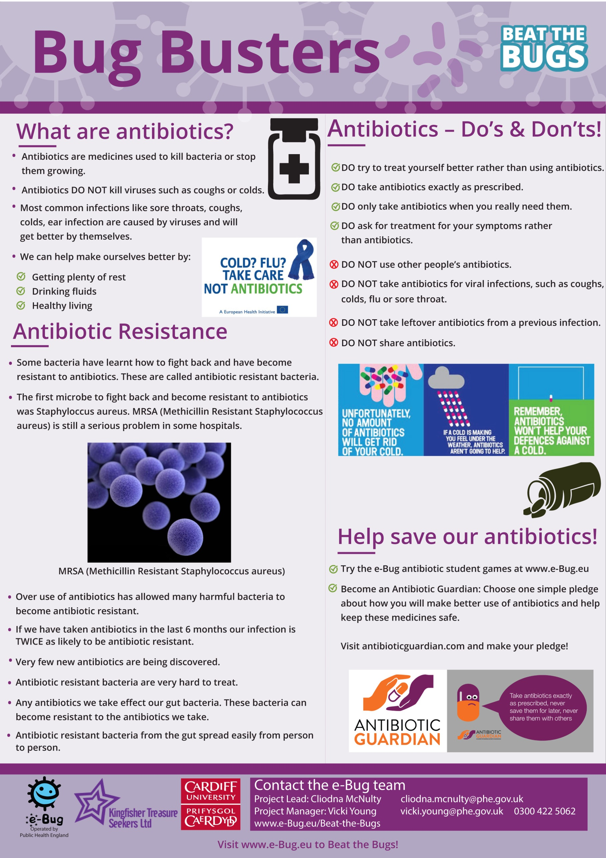

Wrong?
Right or
Educator Sheet 1

Below are the answers to the Antibiotics ‘Right or Wrong?’ worksheet.
Statement | Right or Wrong | Reason
He was coughing and sneezing everywhere. You would have thought the doctor would have given him antibiotics! | Wrong | Most common infections will get better by themselves through time, bed rest, liquid intake and healthy living. Antibiotics do not work on viruses.
My doctor told me to take my antibiotics for 7 days so that is what I did. | Right | Take antibiotics exactly as given by your doctor or nurse.
When my friend was ill, I gave her my old antibiotics. I like helping my friends. | Wrong | You must not use other people’s or any leftover antibiotics.
Antibiotics don’t help coughs and colds; you just need bed rest, lots of fluids and eat healthy. | Right | Most common infections will get better by themselves through time, bed rest, liquid intake and healthy living. Antibiotics do not work on viruses.
All drugs are bad for you. I can’t see the point in taking antibiotics. | Wrong | Antibiotics can help severe infections such as meningitis, pneumonia or kidney/urine infections.
My doctor gave me antibiotics to take for 7 days but I feel better after 3 days so I’m going to stop taking them. | Wrong | Take antibiotics exactly as given by your doctor or nurse. Even if you feel better after 3 days you might still have the infection.
My headache and flu symptoms are really getting me down. I think I need antibiotics! | Wrong | Most common infections like flu will get better by themselves through time, bed rest, liquid intake and healthy living. Antibiotics do not work on headaches or viruses.
I don’t take antibiotics unless I really need them as they might not work in the future. | Right | If you over use antibiotics they might not work when you really need them for a severe infection.

Right or
Wrong?
Participant Worksheet 1
Page 97

Discuss: Which of these statements are right or wrong?
My doctor told me to take my antibiotics for 7 days so that is what I did.
He was coughing and sneezing everywhere. You would have thought the doctor would have given him antibiotics!
When my friend was ill, I gave her my old antibiotics. I like helping my friends.
Antibiotics don’t help coughs and colds; you just need bed rest, lots of fluids and eat healthily.
All drugs are bad for you. I can’t see the point in taking antibiotics.
My doctor gave me antibiotics to take for 7 days but I feel better after 3 days so I’m going to stop taking them.
My headache and flu symptoms are really getting me down. I think I need antibiotics!
I don’t take antibiotics unless I really need them as they might not work in the future.
1
2
3
4
5
6
7
8

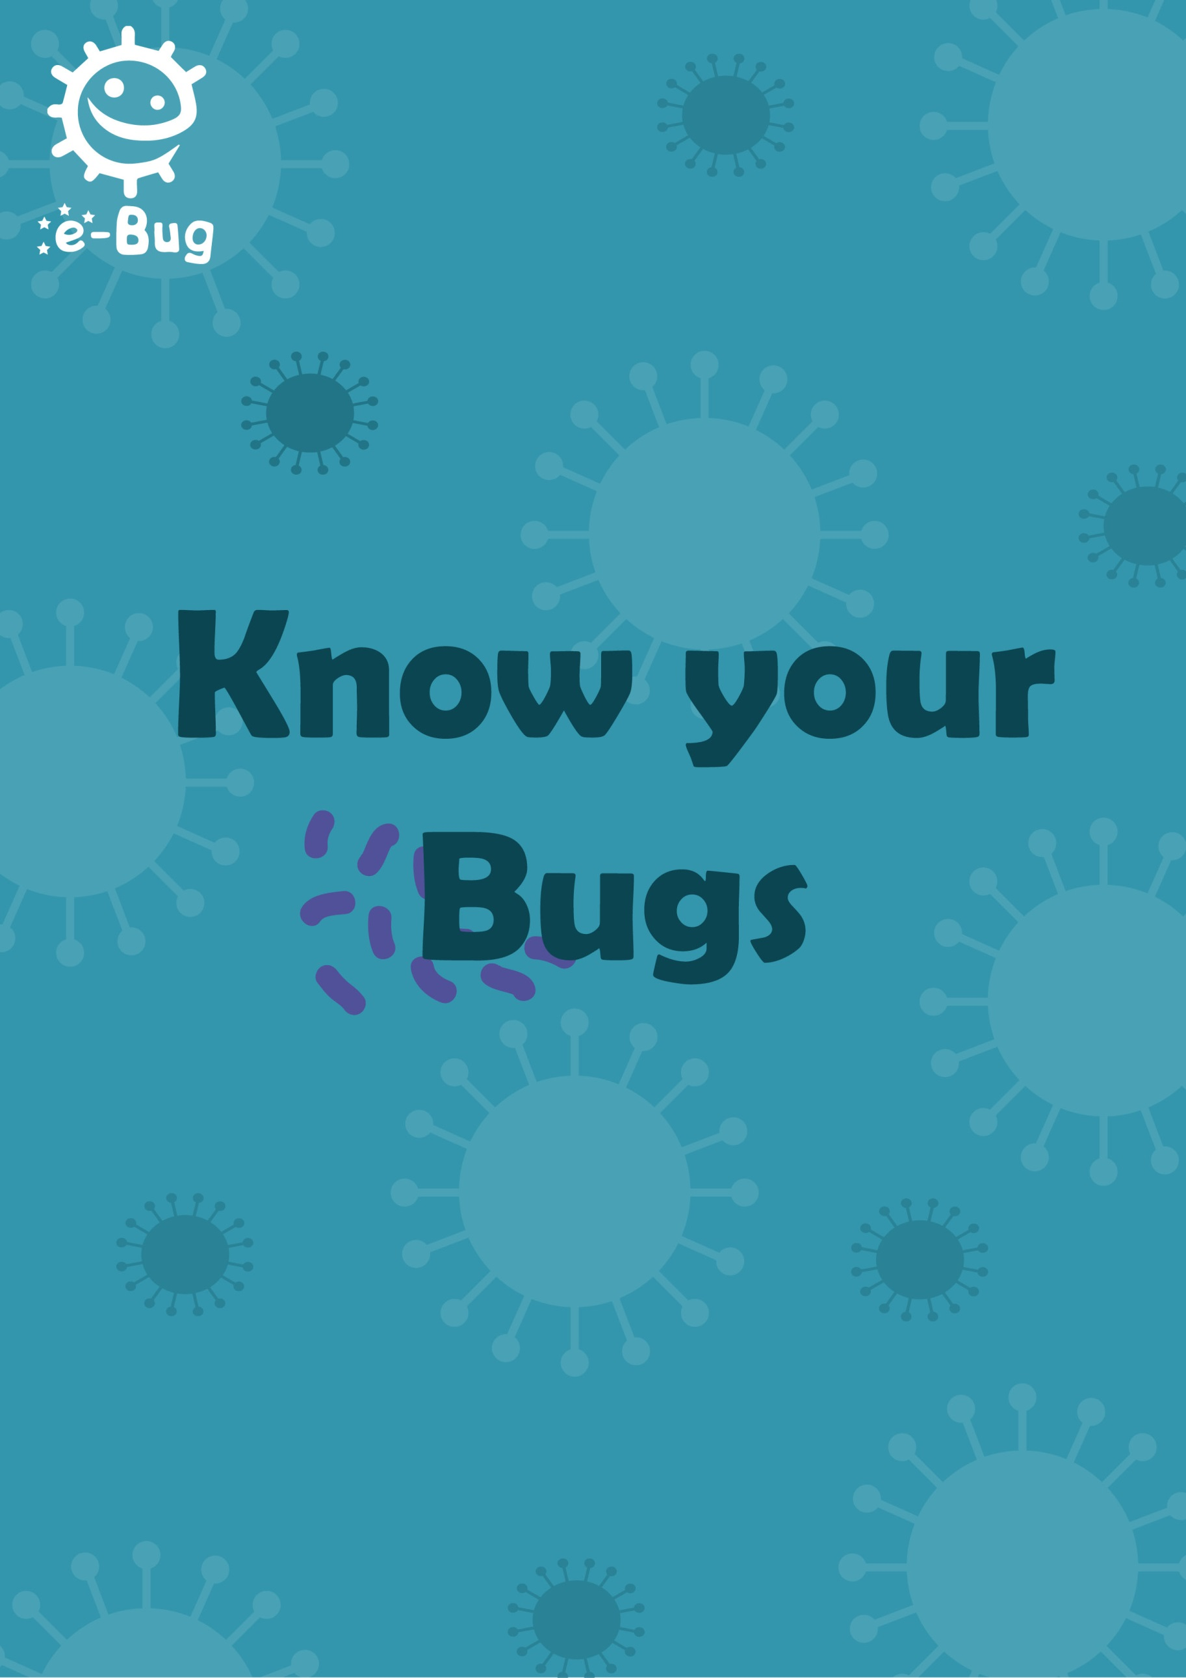

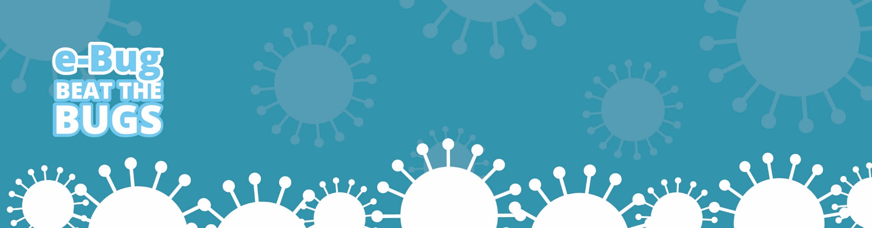
Know Your Bugs

Introduction
The aim of this session is to bring together everything the participants have learnt throughout the course and to get participants thinking about their own health and antibiotic use. We would like to empower participants to make decisions on their own health, hygiene and self-care.

Learning outcomes
Aim to understand:
- How to self-care at home when they are ill
- When to go to the doctor
- Where to access health information
- What information can be gained from healthcare leaflets
Key words
Doctor, information, leaflet, website, app, online

Available web resources
Link to healthcare leaflets
Posters for previous sessions

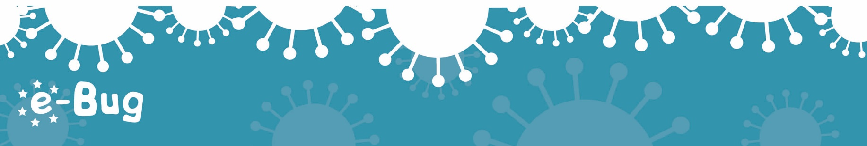
100
Materials required
Printed leaflets
Certificate

Know Your Bugs

Introduction (20-25 mins)
Begin by reminding participants that most infections can be treated at home with rest and fluid. Medication, such as paracetamol, can be used to relieve the symptoms of cold and flu, but it is advisable to speak to a pharmacist who will be able to recommend which medication is required. You should see a doctor if symptoms become more severe or the illness has lasted longer than expected.
Ask participants if they know how long common illnesses normally last. The information is given in the table below:
Your infection | Usually lasts | How to treat yourself better for these infections, now and next time
Middle-ear infection | 4 days | - Have plenty of rest.  - Drink enough fluids to avoid feeling thirsty.  - Ask your local pharmacist to recommend medicines to help your symptoms or pain (or both).  - Fever is a sign the body is fighting the infection and usually gets better by itself in most cases. You can use paracetamol (or ibuprofen) if you or your child are uncomfortable as a result of a fever.  - When you cough or sneeze, use a tissue or your sleeve if you have no tissue (not your hand) and wash your hands well to help prevent spread of your infection to your family, friends and others you meet.
Sore throat | 7 days
Common cold | 10 days
Sinusitis | 18 days
Cough or bronchitis | 3 weeks
Winter vomiting | 2-3 days

Next, re-cap the previous sessions on the course. Ask participants which was their favourite session and why. Which activities did they enjoy? For each activity participants discuss, ask what they learnt.

101
Know Your Bugs

Give the participants their pledge sheets from each session on the course. In small groups, ask the participants to discuss each session.
For each session, discuss:
- What did the participants learn?
- Have they kept their pledge?
- Since the session, what are they doing differently/what have they changed?

Activity 1 – How to take antibiotics correctly (15 - 20 mins)
Participants will use the worksheets provided (PW1, PW2 and PW3) to learn about how to take antibiotics correctly.
Give each participant a copy of the worksheets. The worksheets have three scenarios, which teaches the group not to take antibiotics for coughs and cold, to take antibiotics as prescribed and not to use other people’s or left-over antibiotics.
For each scenario, discuss with the group the possible correct and incorrect answers. An answer sheet is provided to aid discussions.
Learning outcomes achieved:
- How to self-care at home when they are ill
- When to go to the doctor
102
Know Your Bugs

Activity 2 – Accessing Health Information Online (15 mins)
Ask the participants where they usually find health information? The students may talk about websites or leaflets. What websites do the participants use? Discuss websites and apps that provide good information.

Websites:
- NHS choices– (www.nhs.uk/pages/home.aspx)
Participants can search for their local NHS services, GP, A+E or dentists, and also search for their symptoms to get an idea about where and how they could seek help.
- Patient- (www.patient.info)
Another helpful website for participants to search for symptoms and health information
- Time to change (www.time-to-change.org.uk) or Mind (www.mind.org.uk) for information on mental health.
- Treat Yourself Better (www.treatyourselfbetter.co.uk)
Advice on how to treat cold and flu symptoms at home, including information on how long symptoms will last

Untrustworthy websites to avoid:
Be sure to tell participants to watch out for untrustworthy websites. These can be ones that are out of date, trying to sell something, or requesting your information. The best domain names of trustworthy websites are: .gov, .org, or .edu
Wikipedia is one to avoid –anyone can edit pages and these can commonly contain errors.

Apps:
- ‘Sugar Swap change4life’ App developed by Public Health England. Allows you to scan the bar code of drinks and shows you how much sugar is in it.
- Brush DJ- This free award-winning app, developed by a dentist plays 2 minutes of music from your devices music library while you brush your teeth and also has a visual display showing where to brush.
103
Know Your Bugs

Activity 3 – Health Information Leaflets (15 mins)
A selection of leaflets can be provided to the participants. Ask if they think they would find them useful. What information do the leaflets give? When might you use these?

Talk through the leaflets and allow the participants to become familiar with the type of language used and what information can be gained from them.

Recommended leaflet
Managing Your Infection: A step by step guide on how to manage your infection
Downloadable from www.e-Bug.eu/Beat-The-Bugs under the “Know Your Bugs” section.

The leaflet is designed to be printed as an A5 booklet and is a pictorial self-care leaflet suitable for a range of community groups.

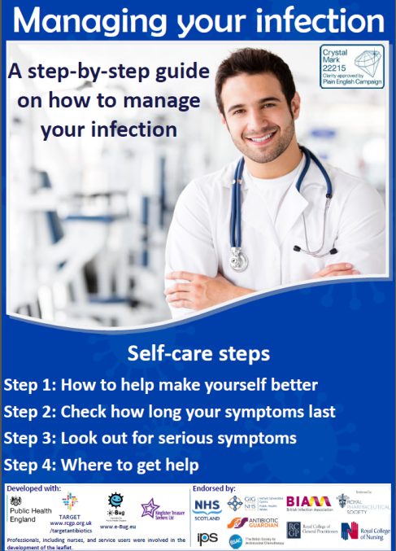
The Managing Your Infection leaflet provides information on how you can help make yourself better when you are ill, how long symptoms usually last, what serious symptoms to look out for and where to get help.
The main aims of the leaflet are:
- to provide community groups with information on self-care

- to increase awareness and change behaviour around antibiotic use in community groups

104
Page 104
Know Your Bugs

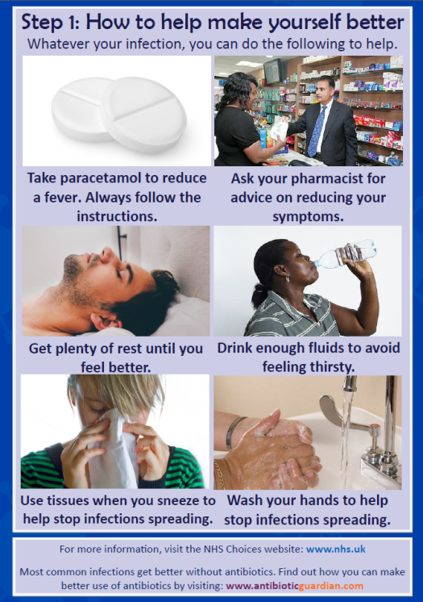
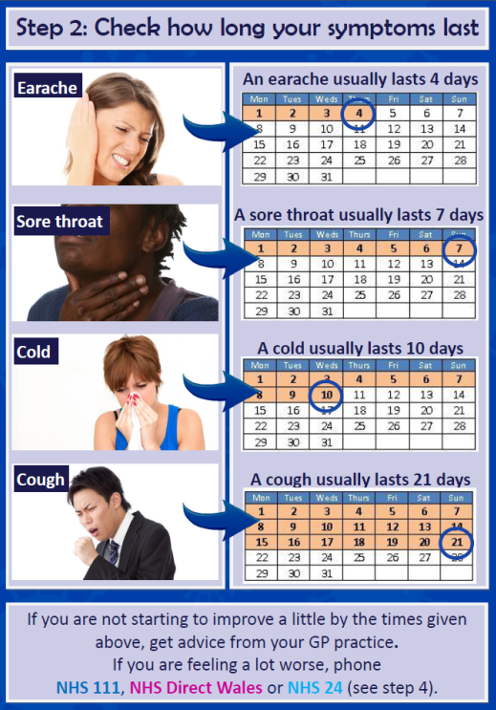

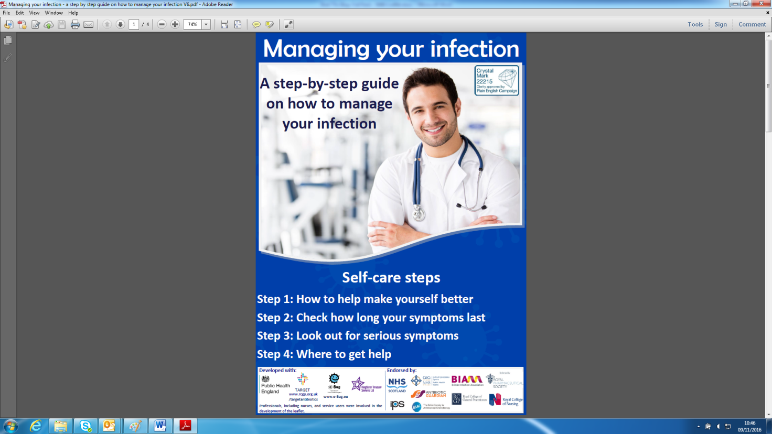
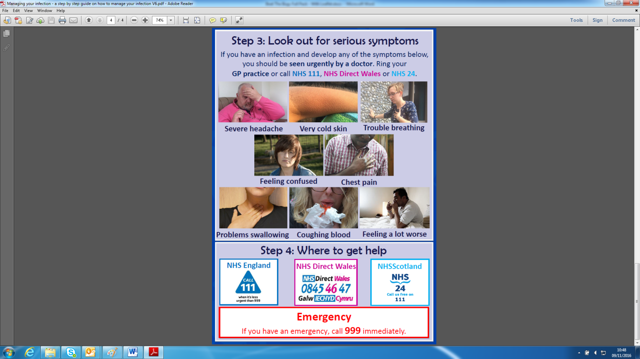

Optional leaflets:
- When Should I Worry? (www.whenshouldiworry.com/resources/Booklet_England.pdf)
Guide for parents on coughs, colds, earache and sore throats
- Treating Your Infection Patient Leaflet (www.rcgp.org.uk/clinical-and-research/toolkits/~/link.aspx?_id=9FCF9DA4B4A045519593320478DFD9E7&_z=z)
Includes information on how long common illnesses last
- Self-care Forum factsheets (www.selfcareforum.org/fact-sheets/)
Particularly the fact sheets on coughs, sore throats and common cold
- Caring for coughs booklet (www.biomedcentral.com/content/supplementary/1748-5908-8-134-S1.pdf)
105
Know Your Bugs

Discussion
Ask what the participants think is the main thing they will take away from the course. Remind participants of their pledges and encourage them to keep going with their lifestyle changes. Use the posters from previous sessions to recap on the course.
If appropriate you may give each participant a certificate to show completion of the course (included with this lesson plan).

Acknowledgements
This session plan was written by the e-Bug team and assisted by the Kingfisher Treasure Seekers Community Group
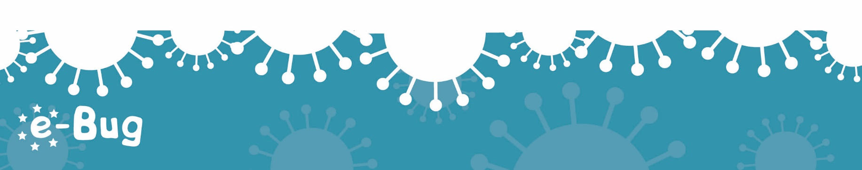
106
Educator Sheet 1
Antibiotics
Scenarios

Scenario 1
Amy had a runny nose and really sore throat so she went to the doctor
Discussion points:
- Many infections get better on their own without the need for antibiotics.
- Antibiotics won’t make a difference to how long your symptoms/illness/infection lasts.
- All runny noses are caused by viruses which antibiotics do not work on – so there is no point having an antibiotic.
- If you become ill very quickly, have a red throat with high temperature and no cough or runny nose, more likely to benefit from antibiotics.

Scenario 2
Alisha has a urine infection and has been prescribed antibiotics by her doctor
Discussion points:
Correct options:-
- Do what the doctor says and take them for the 3 days.
- Take the left-overs back to the chemist.
- If you take more days, your bugs are more likely to become resistant, and the antibiotics won’t work the next time you need them.
- Don’t take any extras as that will kill more of your useful bugs in your gut too.
Incorrect options if needed:-
- Keep the rest for next time.
- Stop taking them now. What’s the point in taking them if you are feeling better?
- Take the whole pack and then you’ll definitely kill the bugs.

107
Scenarios
Antibiotics
Educator Sheet 2
Page 107

Scenario 3: Chloe was talking to her friend Jamie about her headache and cough.

 | Correct | Incorrect
Gosh no, I shouldn’t take anyone else’s antibiotics.
Great idea – we have some left-over from when my sister had an ear infection.
Yes I had a cough a few weeks ago and went to the out of hours and they gave me a prescription, but I didn’t bother to cash it in. I’ll do it now!
I don’t have any antibiotics in the cupboard – don’t you always take them back to the chemist?
I’ve never had any antibiotics – so we don’t have any in the cupboard.
I had a water infection last month. I’ll use the left-over antibiotics from them.
I shouldn’t take antibiotics that are left over.
I don’t have any at home, but I’ll ask Josie, she is always at the doctor with her coughs.
I only take antibiotics if the doctor prescribes them.
I think I should just take some pain relief and go to bed.

108
Scenarios
Antibiotics
Participant Worksheet 1
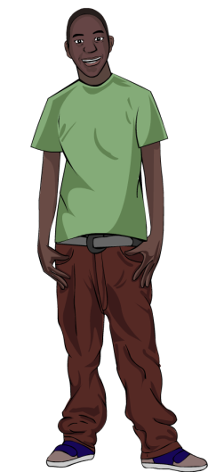
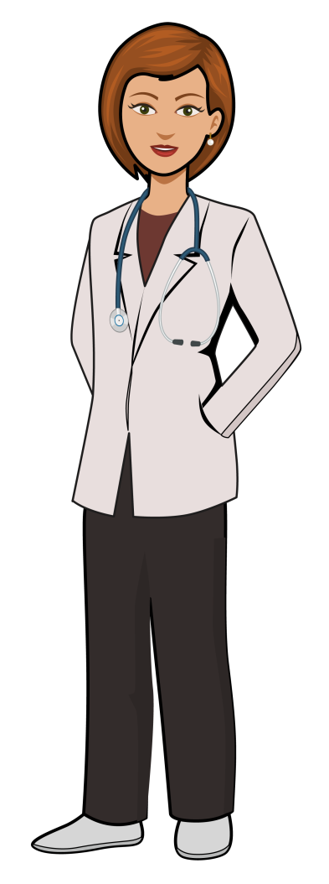

Scenario 1: Ash had a runny nose and really sore throat so he went to the doctor.
Doctor: A runny nose isn’t helped by antibiotics. Go home and go to bed, take some pain killers for your sore throat.
DISCUSSION
Discuss whether you agree or disagree with Ash going to the pharmacy?
Discuss what you think Ash might be worried about?

Ash: What if I get really bad?
Doctor: I know sore throats can make you feel really ill and they can last a week. The pharmacist will be able to give you something for your pain.
Ash: But I’m really ill. Surely antibiotics will help?
Scenarios
Antibiotics
Participant Worksheet 2

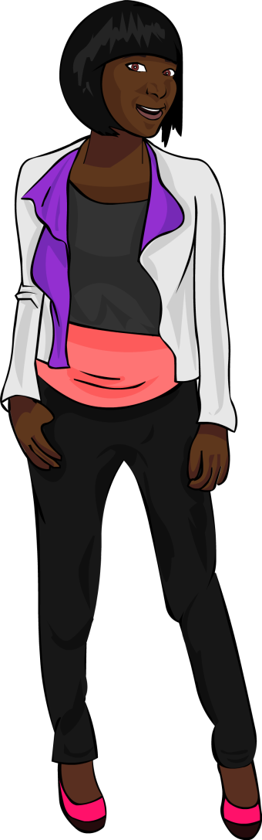
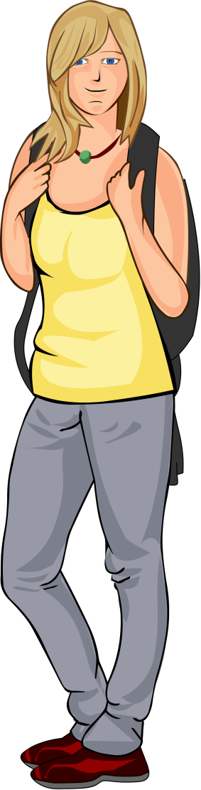
DISCUSSION
Discuss whether you agree or disagree with Anna?

Discuss what you think Alisha should do with
her leftover antibiotics?

Scenario 2: Alisha is talking to her friend Anna about her urine infection. Alisha has been prescribed antibiotics by her doctor.
Anna: Why don’t you just take them, it will make sure you get rid of all the infection.
Alisha: I’ve been given antibiotics for my urine infection. The doctor told me to take them for 3 days, morning and evening. After 3 days I’ve still got some left, what shall I do with the ones left over now I feel better?

Participant Worksheet 3
Scenario 3: Chloe was talking to her friend Jamie about her headache and cough.
Scenarios
Antibiotics

Chloe: My headache really hurts and I have a bad cough
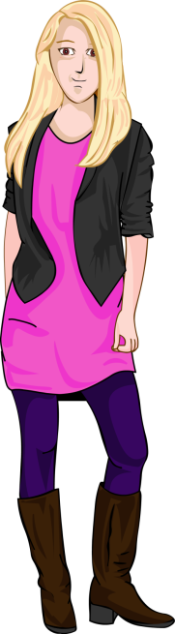
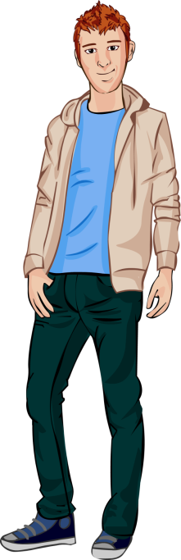

Jamie: Don’t you have any antibiotics in a cupboard at home you could take?

What should Chloe say? Discuss the correct and incorrect options.
Statement | Correct | Incorrect
Gosh no, I shouldn’t take anyone else’s antibiotics.
Great idea – we have some left-over from when my sister had an ear infection.
Yes I had a cough a few weeks ago and went to the out of hours and they gave me a prescription, but I didn’t bother to cash it in. I’ll do it now!
I don’t have any antibiotics in the cupboard – don’t you always take them back to the chemist?
I’ve never had any antibiotics – so we don’t have any in the cupboard.
I had a water infection last month. I’ll use the left-over antibiotics from them.
I shouldn’t take antibiotics that are left over.
I don’t have any at home, but I’ll ask Josie, she is always at the doctor with her coughs.
I only take antibiotics if the doctor prescribes them.
I think I should just take some pain relief and go to bed.

Page 110

112
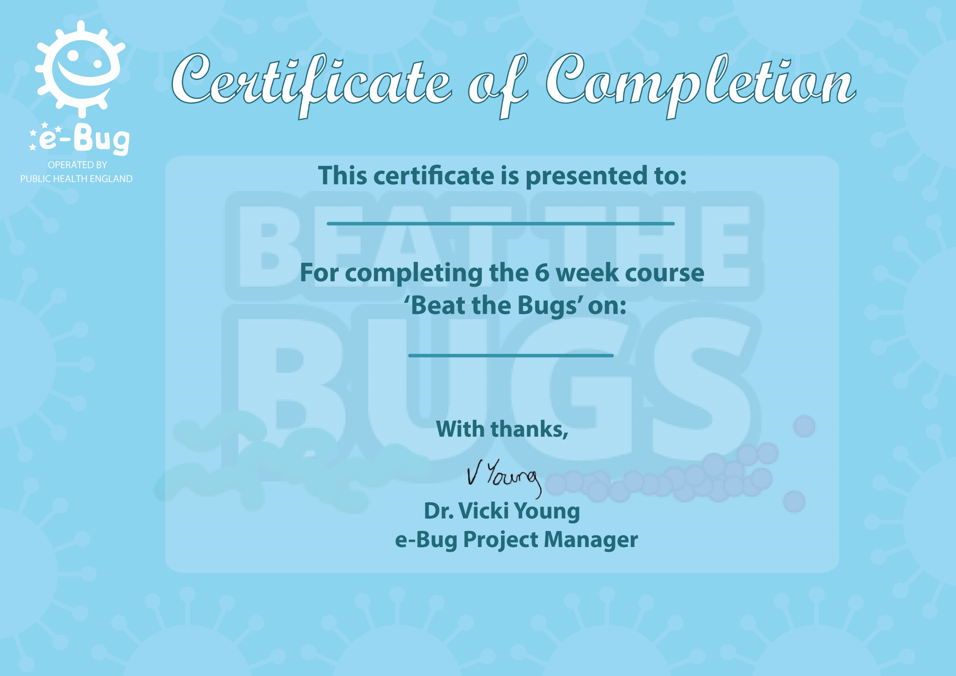

114

These ‘Action Plans’ are to be filled out and handed back to the course leader.
Name:
Plans
Action
1. Meet the Bugs
My favourite activity was:

After this session I will remember that (please circle):
- There are 3 types of microbes

- Viruses are very small microbes and cause coughs, colds, sore throats and flu.

- We have useful microbes in our bodies which we should try to protect.
Or write your own:

115
2. Spreading Bugs
My favourite activity was:

After this session I will (please circle):
1. Carry tissues with me
2. Sing a song when washing hands
3. Use soap to wash hands
4. Always wash hands after going to the toilet
Or write your own:
These ‘Action Plans’ are to be filled out and handed back to the course leader.
116
Name:
Plans
Action
4. Mouth Bugs
My favourite activity was:

After this session I will (please circle):
- Choose a song to clean my teeth

- Clean my teeth twice a day all over my mouth, including gums

- To spit but not rinse after brushing

- Cut down on sugary foods and drinks
Or write your own:
3. Food Bugs
My favourite activity was:

After this session I will (please circle):
1. Wash hands before and after handling food
2. Clean kitchen surfaces and utensils
3. Wash fruit and vegetables before eating
4. Not eat food that is past it’s used by date
Or write your own:
These ‘Action Plans’ are to be filled out and handed back to the course leader.
5. Bug Busters
My favourite activity was:

After this session I will (please circle):
- Return unused antibiotics to the pharmacy

- Ask the pharmacist next time I am ill about what I can take

- Never take somebody else’s antibiotics

- Sign up to become an antibiotic guardian
Or write your own:

.
Name:
Action
Plans




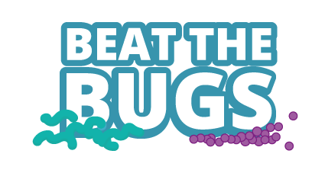
117
This pack contains a series of educational hygiene and self-care resources for community groups.

This six week course has information, suggested lesson plans and possible activities for you to use in your community groups to help you inspire
and inform individuals.

This project was led in collaboration with the Primary Care Unit, Public Health England, and Kingfisher Treasure Seekers, with assistance from the following bodies: Cardiff University and The Barts and the London School of Medicine and Dentistry.

