

SW2 - Healthy Hands Hand Washing Chart
FRI
I washed my hands before school
I washed my hands after breaktime
I washed my hands before lunch
THU
WED
TUE

MON
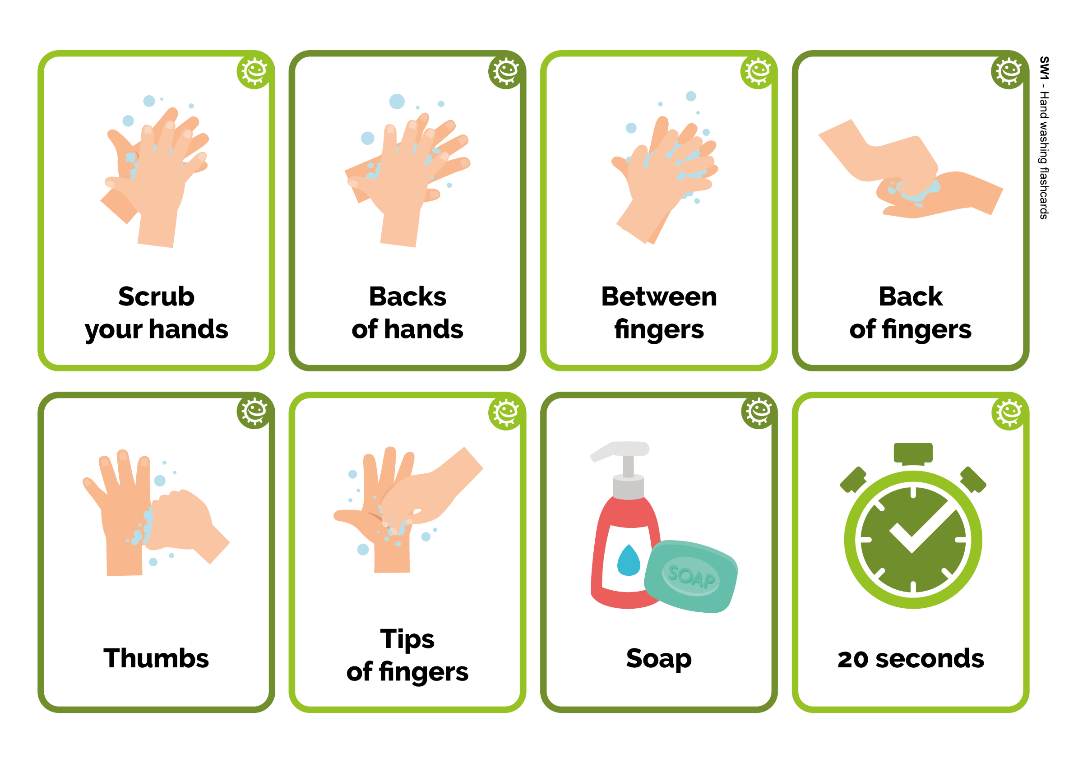
Healthy Hands Handwashing Chart
Name
Class
Add a picture or star each time you wash your hands!
SW1 – Hand Washing Flashcards
Back
of fingers
20 seconds
Soap
Backs
of hands
Scrub
your hands
Thumbs
Tips
of fingers
Between
fingers

