
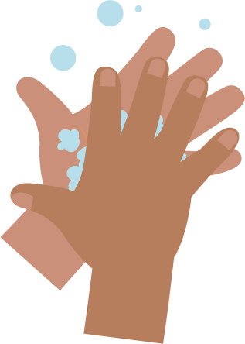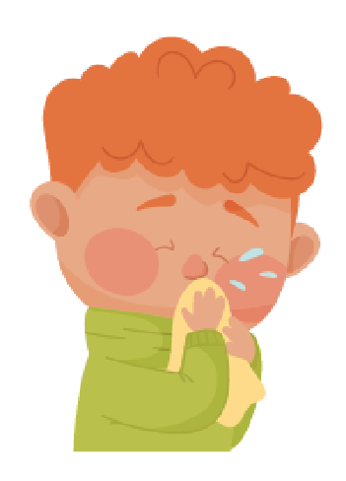
_______________________________

SW1 - Picture Sequencing Activity – place hand washing in the correct order

Blowing Your Nose

Writing Activity
Write instructions for the correct way to blow your nose.
Use the pictures below to help you.
wash hands
bin
tissue
blow
Step 1

_______________________________
Step 2

_______________________________
Step 3

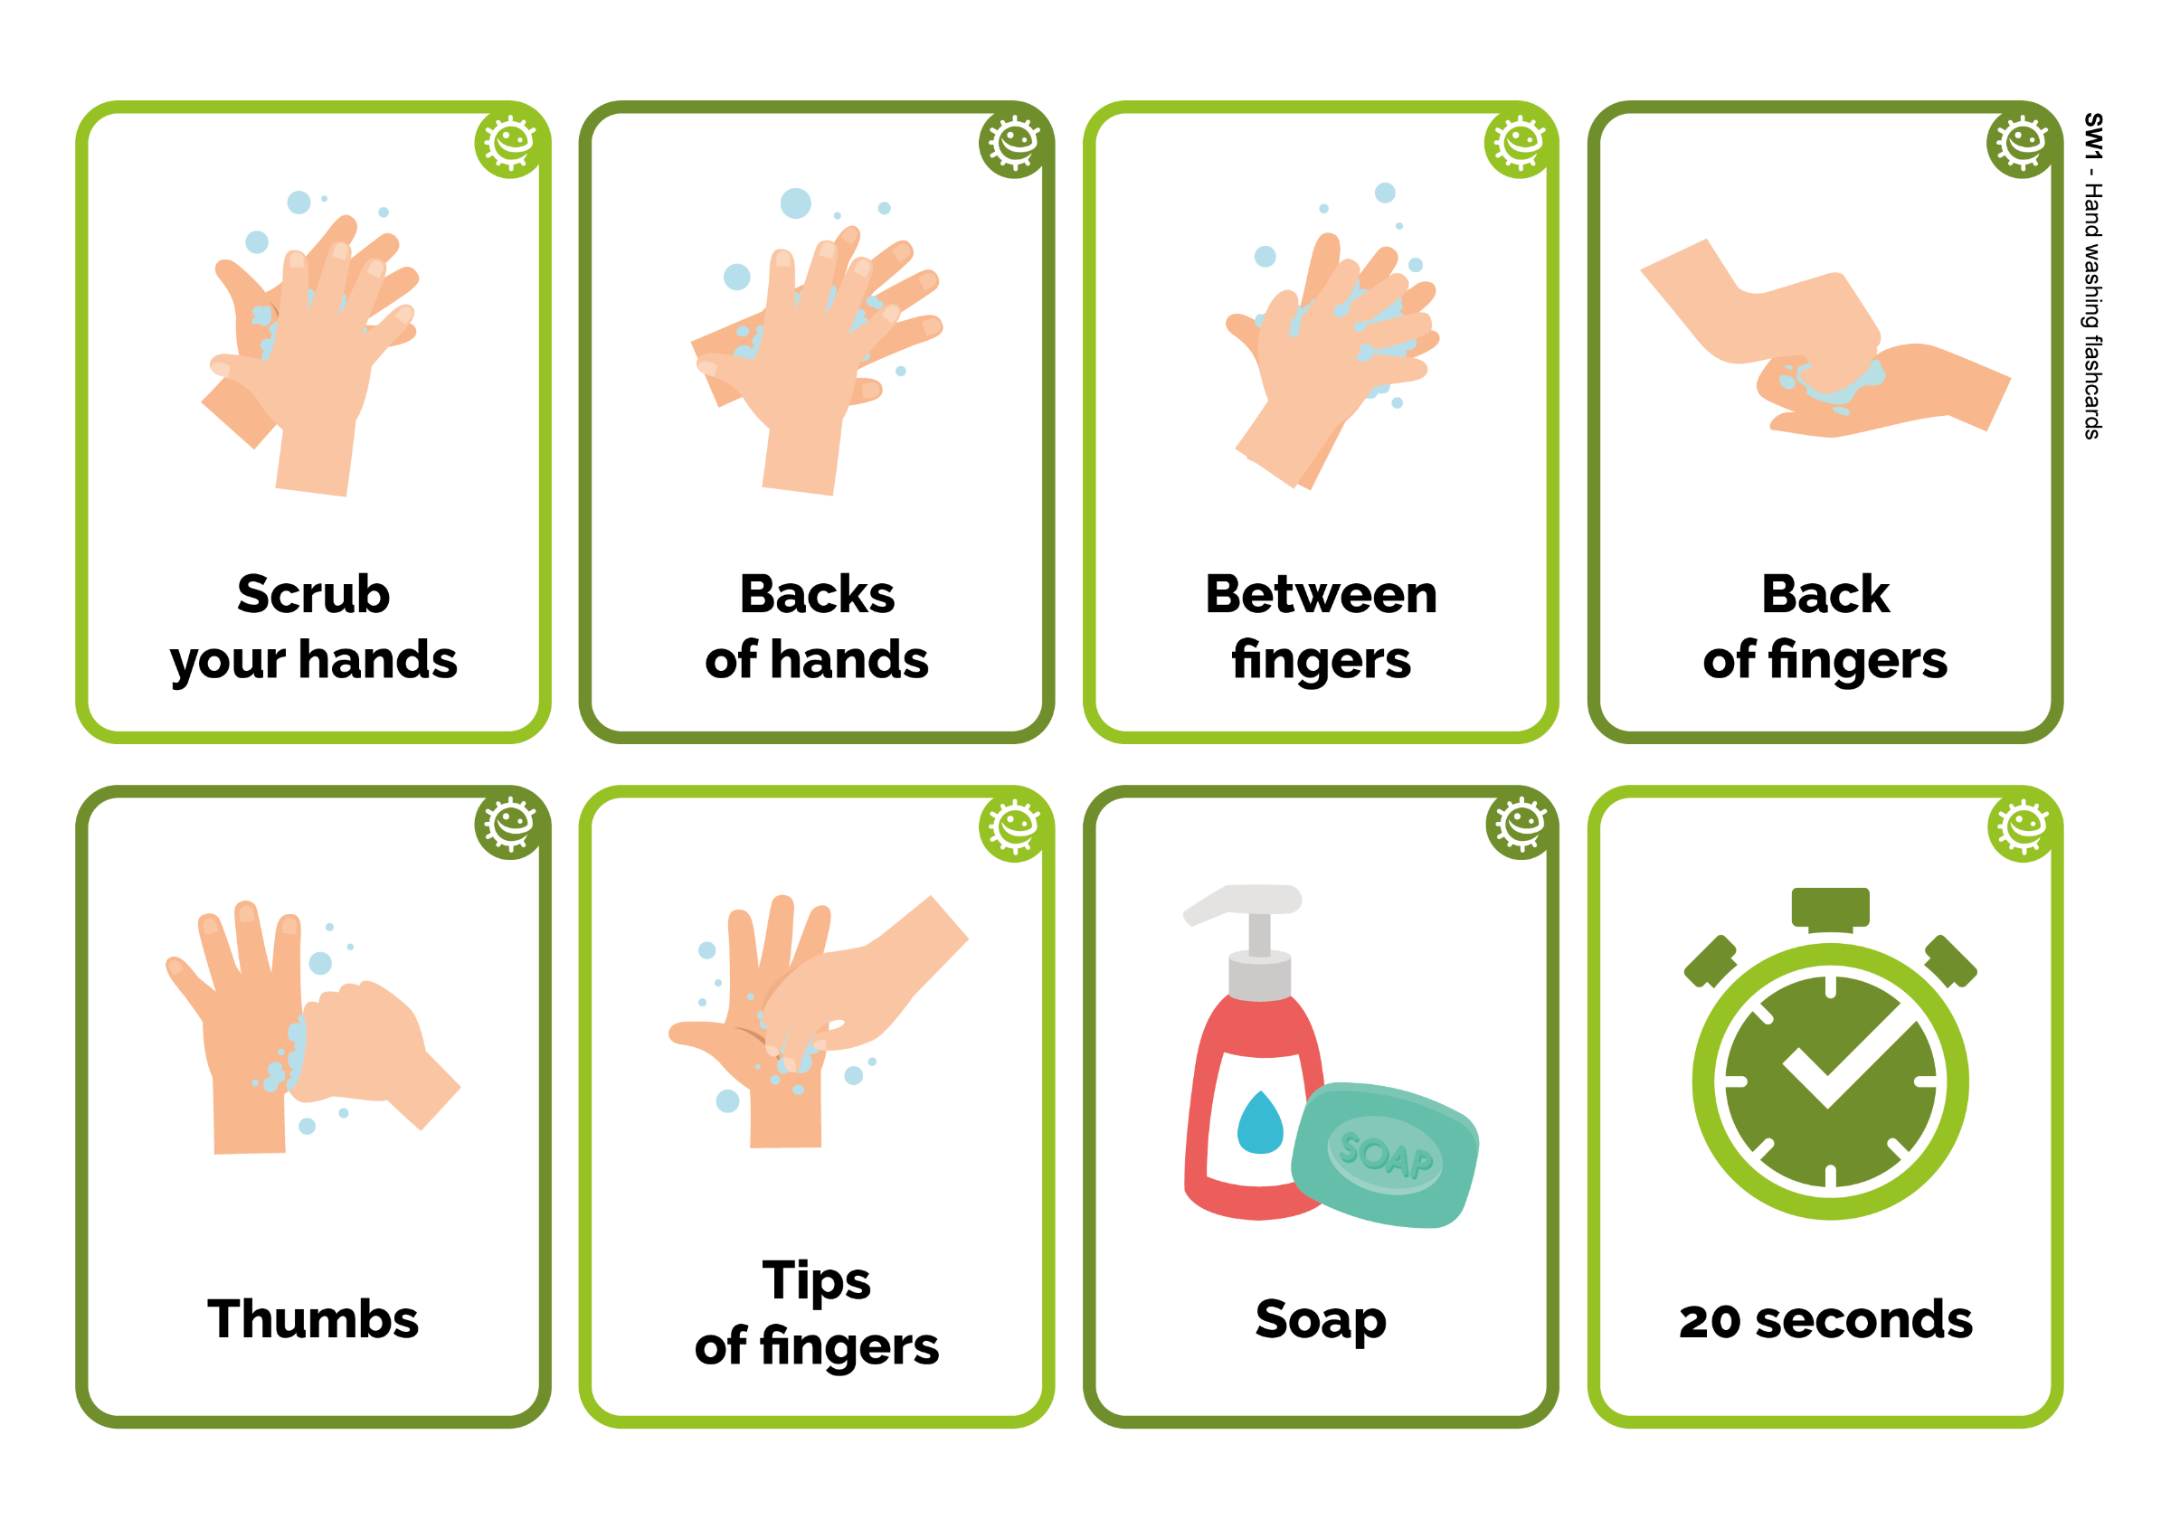
_______________________________
Step 4
SW1 – Hand Washing Flashcards
Back
of fingers
20 seconds
Soap
Backs
of hands
Scrub
your hands
Thumbs
Tips
of fingers
Between
fingers

