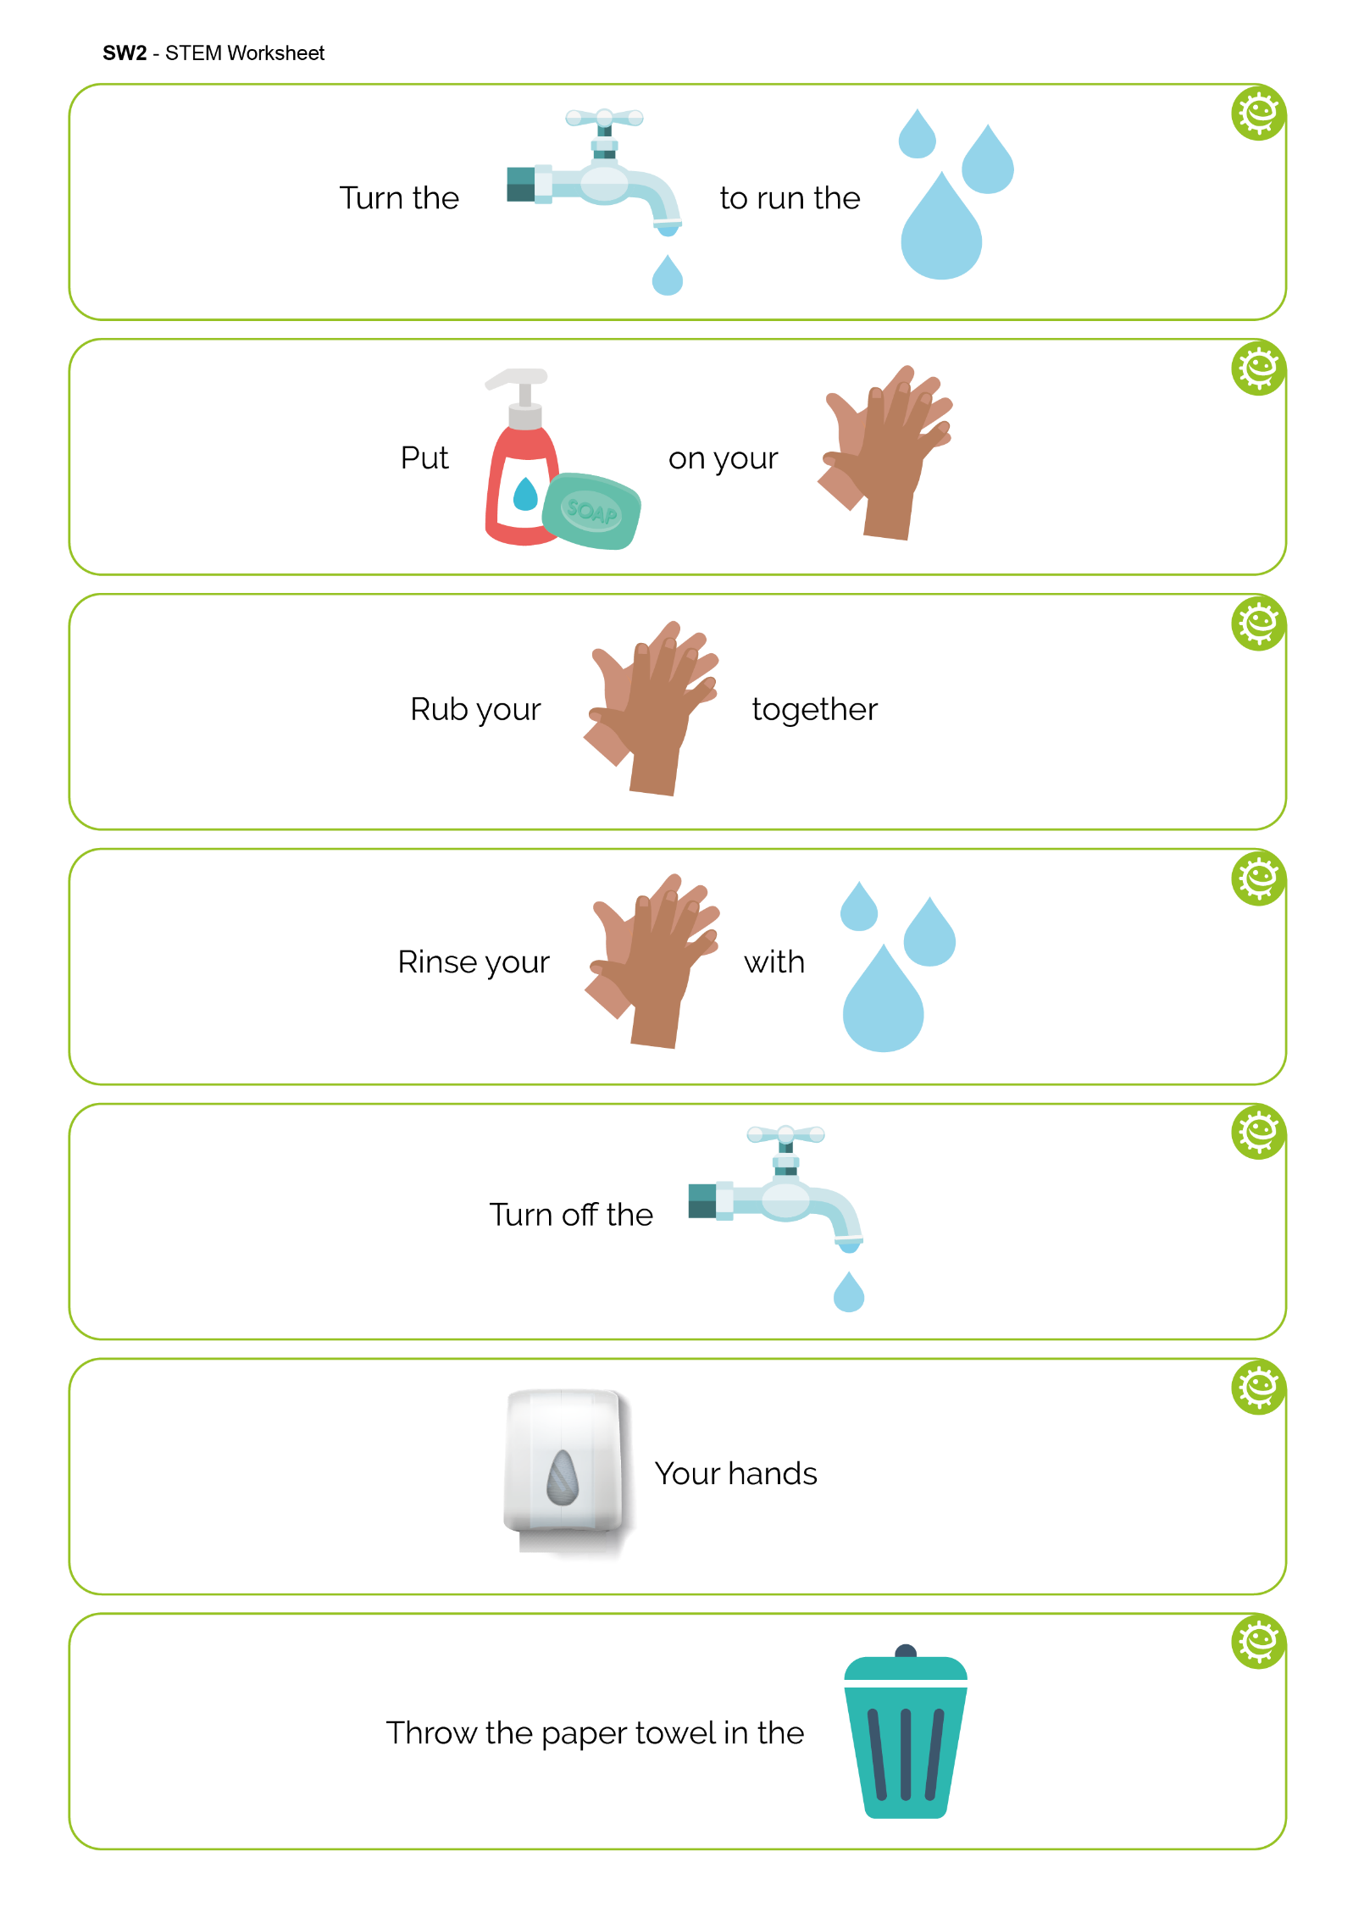

SW2 - Healthy Hands Fill in the Blank Worksheet
Turn the
to run the
Put
on your
together
Rub your
Rinse your
with
Turn off the
Your hands
Throw the paper towel in the

