SH2 - Microbe Mania Fun Fact Sheet


Microbe Mania
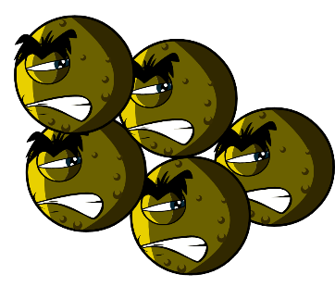

Fact Sheet

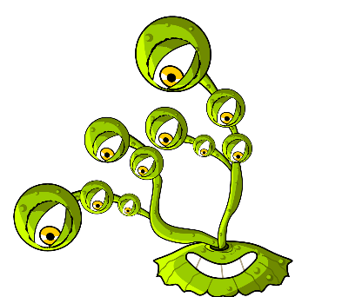
- There are more microbes on the planet than any other type of living thing.
- Microbes are the oldest form of life on Earth. They’ve been here for four billion years!
- Microbes are found everywhere on Earth, even inside volcanoes.
- Some microbes can glow in the dark. People once used glowing pieces of fungi growing on wood to light the way.
- Humans would not be able to live without microbes. Some microbes produce oxygen which we need to breathe, and others help plants to grow which we eat.

What is a microbe?
Microbes are also called germs or bugs. There are three types of microbes: bacteria, viruses and fungi. Some microbes can make us ill, but most are very useful to us.

Where are microbes found and what do they look like?
Microbes are found everywhere. They come in all shapes and sizes.

Make your own microbes
Use modelling clay to create your own microbes.
Decide what type of microbes you have made:
Virus, bacteria, or fungi, and whether it is useful or harmful. For ideas, download pictures of microbes from
www.e-bug.eu. Ask an adult to help you make your own modelling clay – see TS1 for the recipe.
Surprise your friends and family with these fun facts…!

