

SH3 - Microbe Example Sheet 1
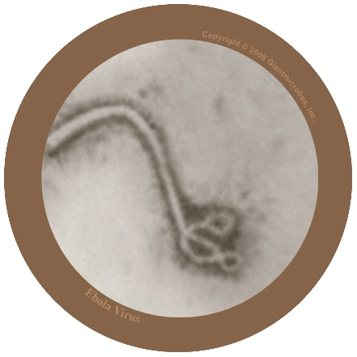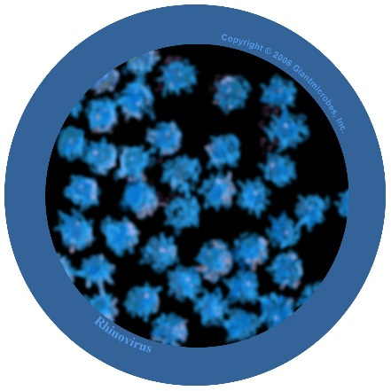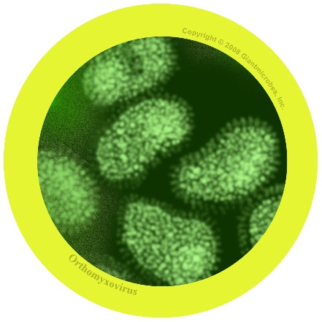

Filovirus
File-o-vi-rus

About
- Filovirus is harmful to humans and causes a disease called Ebola.
- It has been in the news as people living in Africa have caught the virus and many have died.
- The virus lives naturally in wild animals in Africa and is not found in other continents.

Symptoms and treatment
- Ebola virus makes people very unwell and in worst cases, death.
- People with Ebola will need special treatment and hospital care to help get better.

Rhinovirus
Rye-no-vye-rus

About
- Also known as the common cold
- It is a virus that is harmful to humans

Symptoms and treatment
- Causes runny nose, sneezing, sore throat, and coughing
- Spreads from person to person by coughs and sneezes and unwashed hands
- Treatment is rest and plenty of fluids to feel better.

Influenza virus
In-floo-en-za

About
- Also known as the flu virus
- It is a virus that is harmful to humans

Symptoms and treatment
- Causes fever (high temperature), runny nose, sore throat, muscle pains, cough, feeling tired
- Spreads from person to person by coughs and sneezes and unwashed hands
- Treatment is rest and plenty of fluids to feel better. If very unwell, an antiviral medicine may help.

