Spread of Infection: Hand Hygiene
Key Stage 2

Lesson 4: Hand Hygiene
By taking part in a classroom experiment, students learn how microbes can spread from one person to another through touch and why it is important to wash hands properly.

Learning Intention

All pupils will:
- Understand how proper hand hygiene helps prevent the spread of infection, including when, why, and how to wash hands effectively.
Northern Ireland Curriculum Links

Curriculum Key Elements
- Personal Health and Moral Character

Curriculum Skills
- Communication
- Using Mathematics
- Thinking
- Problem Solving and Decision Making
- Being Creative
- Working with Others

Curriculum Areas of Learning
- Personal Development and Mutual Understanding (PDMU)
- The World Around Us (TWAU)

 Lesson 4: Hand Hygiene

Resources Required

Main Activity: Healthy hands

Per group
- Copy of SH1
- Copy of SH2
- Basin (or sink)
- Hand soap
- Paper towels
- Pens
- Water
- Oil based UV gel or powder and UV lamp or cooking oil and cinnamon/eco-friendly glitter

Per pupil
- Copy of SW1
- Copy of SW2

Activity 2: What have we missed

Per group
- Copy of SH2
- Blank paper
- Finger or body paints (non-toxic and washable)
- Smocks/aprons to cover clothing for younger groups
- Hand washing facilities or basin with soap and water
- Paper towel for drying hands

Extension Activity 1: Fill in the Blanks

Per pupil
- Copy of SW3

Extension Activity 2: Hand Hygiene Quiz

Per group
- Copy of SW4

Extension Activity 3: Sequencing Activity

Per pupil
- Copy of SH3

Supporting Materials
- SH1 How Clean are Your Hands
- SH2 Hand Washing Poster
- SH3 Washing Your Hands Sequencing Activity
- SW1 Student Recording Sheet
- SW2 Hand Print Student Worksheet
- SW3 Hand Hygiene Fill in the Blank Worksheet
- SW4 Hand Hygiene Quiz

Advanced Preparation

Main Activity: Healthy Hands
- Arrange four desks side by side for the 4 stations. Each desk should contain one of the following:
  - A sign reading ‘No hand washing’
  - A basin of water, paper towels and a sign reading ‘Wash for 3 seconds’
  - A basin of water, paper towels and a sign reading ‘Wash for 20 seconds’
  - A basin of water, hand soap, paper towels and a sign reading ‘Wash in Water and Hand Soap for 20 seconds’

Activity 2: What Have We Missed?
For each pupil prepare:
- Smock or shirt to cover clothing
- A small dollop of finger paint
- Basin with water and soap if hand washing facilities not available (could be used for group of 2-3).


. Lesson 4: Hand Hygiene

Key Words
Bacteria
Hygiene
Infection
Microbe
Soap
Transfer

Modifications
- If UV gel or powder and a UV lamp are unavailable, ask the pupils at the front to cover their hands in cooking oil or an equivalent non-harmful oil and sprinkle well or cover with cinnamon or eco-friendly glitter.
- Pupils with additional needs: The use of eco-friendly glitter allows the pupils to feel the 'microbes' on their skin. It might help pupils if you demonstrate what will happen in this activity.

Weblinks
e-bug.eu/eng/KS2/lesson/ Hand-Hygiene

Health & Safety
If social distancing does not allow pupils to shake hands, gel could be transferred by having pupils touch objects and see how the gel transfers from hands to surfaces (or vice versa), with the hand washing and cleaning of objects to follow. If appropriate, this can be combined with a PE game where you cover a ball/baton with gel, play a game and then show the pupils how the gel from the object has spread around by the room by touch. 2. It is essential to ensure that use of the lamp is supervised and that pupils place their hands under the UV radiation for as short a time as possible. It is also vital that pupils do not stare directly at the UV lamp; the eyes are most at risk from extended viewing of UV radiation. Depending on the design of the UV lamp that is available, it should be held firmly, for example with retort stands and clamps, so that the radiation shines downwards onto the bench and that the lamp cannot be moved and shone into pupils’ faces.

For safe microbiological practices in the classroom consult CLEAPPS
www.cleapps.org.uk

Introduction
- Begin the lesson by asking how many pupils have washed their hands today. Ask them why they washed their hands (to wash away any dirt or microbes that might be on their hands) and what would happen if they didn’t wash away the microbes (they might get ill if any harmful microbes from their dirty hands gets in their mouth or an open cut, or they could pass them on to someone else).
- Tell the pupils that we use our hands all the time, they are naturally covered with microbes that live in our bodies and pick up millions of microbes from the environment every day. Although many of these microbes are harmless, some could be harmful. Explain to the pupils that we spread microbes to our friends and others through touch, and this is why we wash our hands. One study found that people touch their face 23 times per hour, about 280 times a day. Explain that touch is an important sense to give information to our brain, but we should be aware of how easy it is to spread microbes when our hands are dirty.
- Explain to pupils that they are going to carry out an activity to show how best to wash their hands with soap and water and remove any of the harmful microbes which may be on their hands.

Activity

Main Activity: Healthy Hands
- Divide the class into four equal groups.
- Ask each pupil to stand in a row one behind the other and assign groups as follows:
  - No hand washing
  - Wash hands in water for 3 seconds
  - Wash hands in water for 20 seconds
  - Wash hands in water with soap for 20 seconds
- Ask the first person in each group to close their eyes and cover their hands in UV gel or powder. This is to avoid pupils washing their hands more thoroughly than they usually would. Ask the lead person to wash their hands according to the group they are in.
- Once completed, they should open their eyes, turn around and shake hands with the person behind them. It is important that they shake hands firmly and well. The second person should then shake hands with the third person and so on until everyone in the group has shaken hands with the person in front of them.
- When the task is complete, turn down the lights and shine the UV lamp over everyone’s hands, starting with group A. Pupils should notice the difference in the number of microbes on the hands of pupils in different groups.
- Ask pupils to complete SW1 to record the results of the experiment. Provide pupils with SW2 and ask them to colour the hands to replicate the results of the experiment. SH1 can be used as a guide.
- Ask pupils to follow a teacher demonstration of the six-step hand washing technique using SH2 six steps poster. Ensure that pupils thoroughly wash their hands with soap and water.
- Explain that hand sanitiser can be applied using the same steps but then needs to be allowed to dry and is not washed off like soap. Remember to shake the UV gel or powder before starting and to change the water if it starts to get murky.

Activity 2: What have we missed?
- Ask pupils to wear the protective clothing and sit down.
- Explain pupils will learn the best way to wash their hands to remove germs by pretending that paint is soap.
- Put a small squirt of paint in each of the pupil’s hands. Ask the groups to close their eyes and pretend they are washing their hands. Only give them about 5 seconds to do this and explain that this is to see what happens if we wash our hands for too short a duration.
- Ask pupils to open their eyes and hold up their hands.
- Discuss what part of their hands is missing the soap. Ask them how they think they could make sure that all their hands are covered with soap, so the germs can be washed away/killed.
- Use the six steps of hand washing poster (SH2) to explain how to wash hands and for how long. Hand sanitiser can be applied using the same steps but then needs to be allowed to dry.
- At this point pupils may want to make handprints on a blank piece of paper.
- Have the pupils 'wash' with the paint on their hands again (may need to provide additional paint) and see if they cover more of their hands with the soap when they follow the six steps. They can make additional handprints if desired.
- Repeat the six-step hand washing technique.

Discussion
Lead the discussion to reflect on the learning objectives:
- Microbes spread very easily from you to other people.
- The best way to stop harmful microbes spreading to others is by washing our hands.
- Use soap when washing hands, and wash all parts of our hands, including thumbs. Remember not to splash and dash! Use a song of your choice to time your hand washing.
- If soap and water isn’t available, hand sanitiser is also effective. You should apply following the six steps and allow to air dry.
Ask the following questions to discuss what the group has learnt:
- What have you learnt today?
- How has the activity changed the way you wash your hands?
- When is it important to wash your hands?

Extension Activities

Fill in the Blanks
Provide pupils with SW3 and ask them to fill in the blanks using the correct words provided. Pupils can complete this activity individually in the classroom or as homework. Answers are available on the e-Bug website.

Hand Hygiene Quiz
SW4 is a fun consolidation quiz. Allocate pupils to groups of 3 or 4 and provide one quiz sheet per team. The team with the most points wins. Answers are available on the e-Bug website.

Sequencing Activity
Pupils can use SH2 as a guide to order the cards in SH3. Ask pupils to place the cards in the correct hand washing order as a useful way to support learning

Learning Consolidation
At the end of the lesson, ask the class to answer the following questions.
- What song will you choose to use when washing your hands? How many steps are there to wash every part of your hands?
Answer: Six steps
- What are the key moments in the day that you must wash your hands?
Answer: Before eating, after using the toilet, after touching animals, after coughing, sneezing or blowing your nose, if you are ill or have been around ill people, when you get home or go into another place like school
- What can you use if you are not able to wash your hands with soap and water?
Answer: Hand sanitiser



SH1 – How Clean are Your Hands Handout

How Clean are Your Hands?
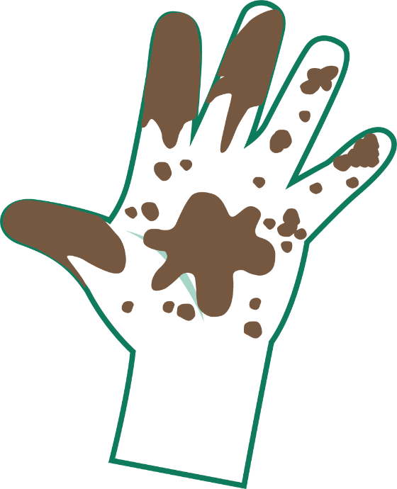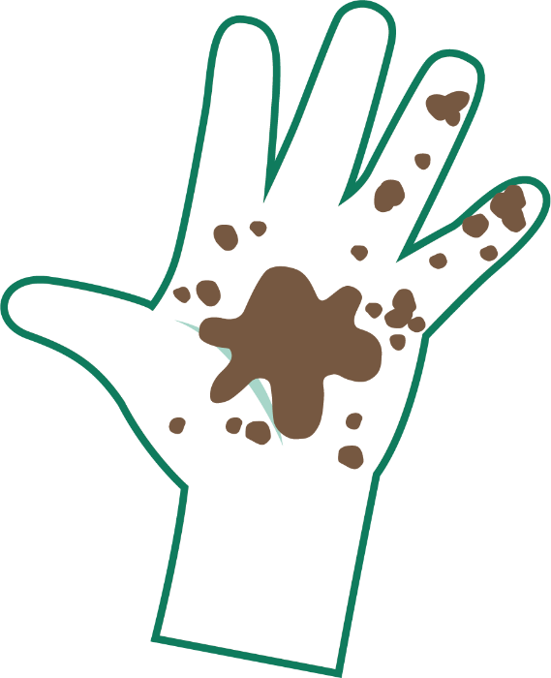
Very Dirty
Dirty

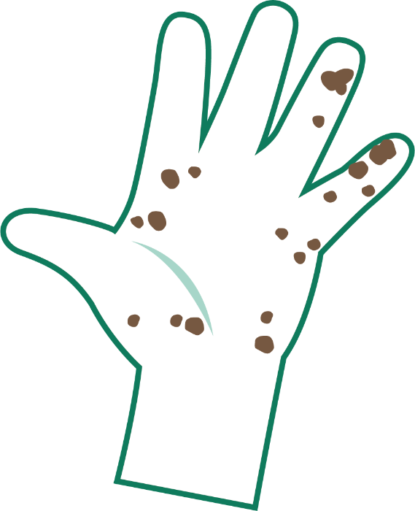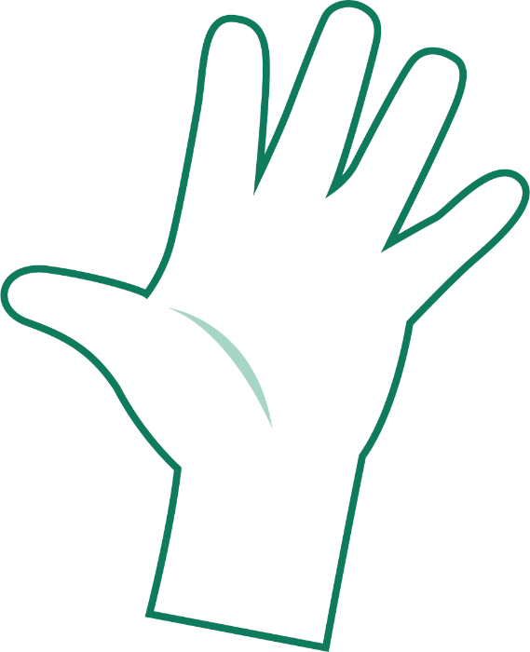
A Bit Dirty
Clean

SH2 – Hand Washing Poster

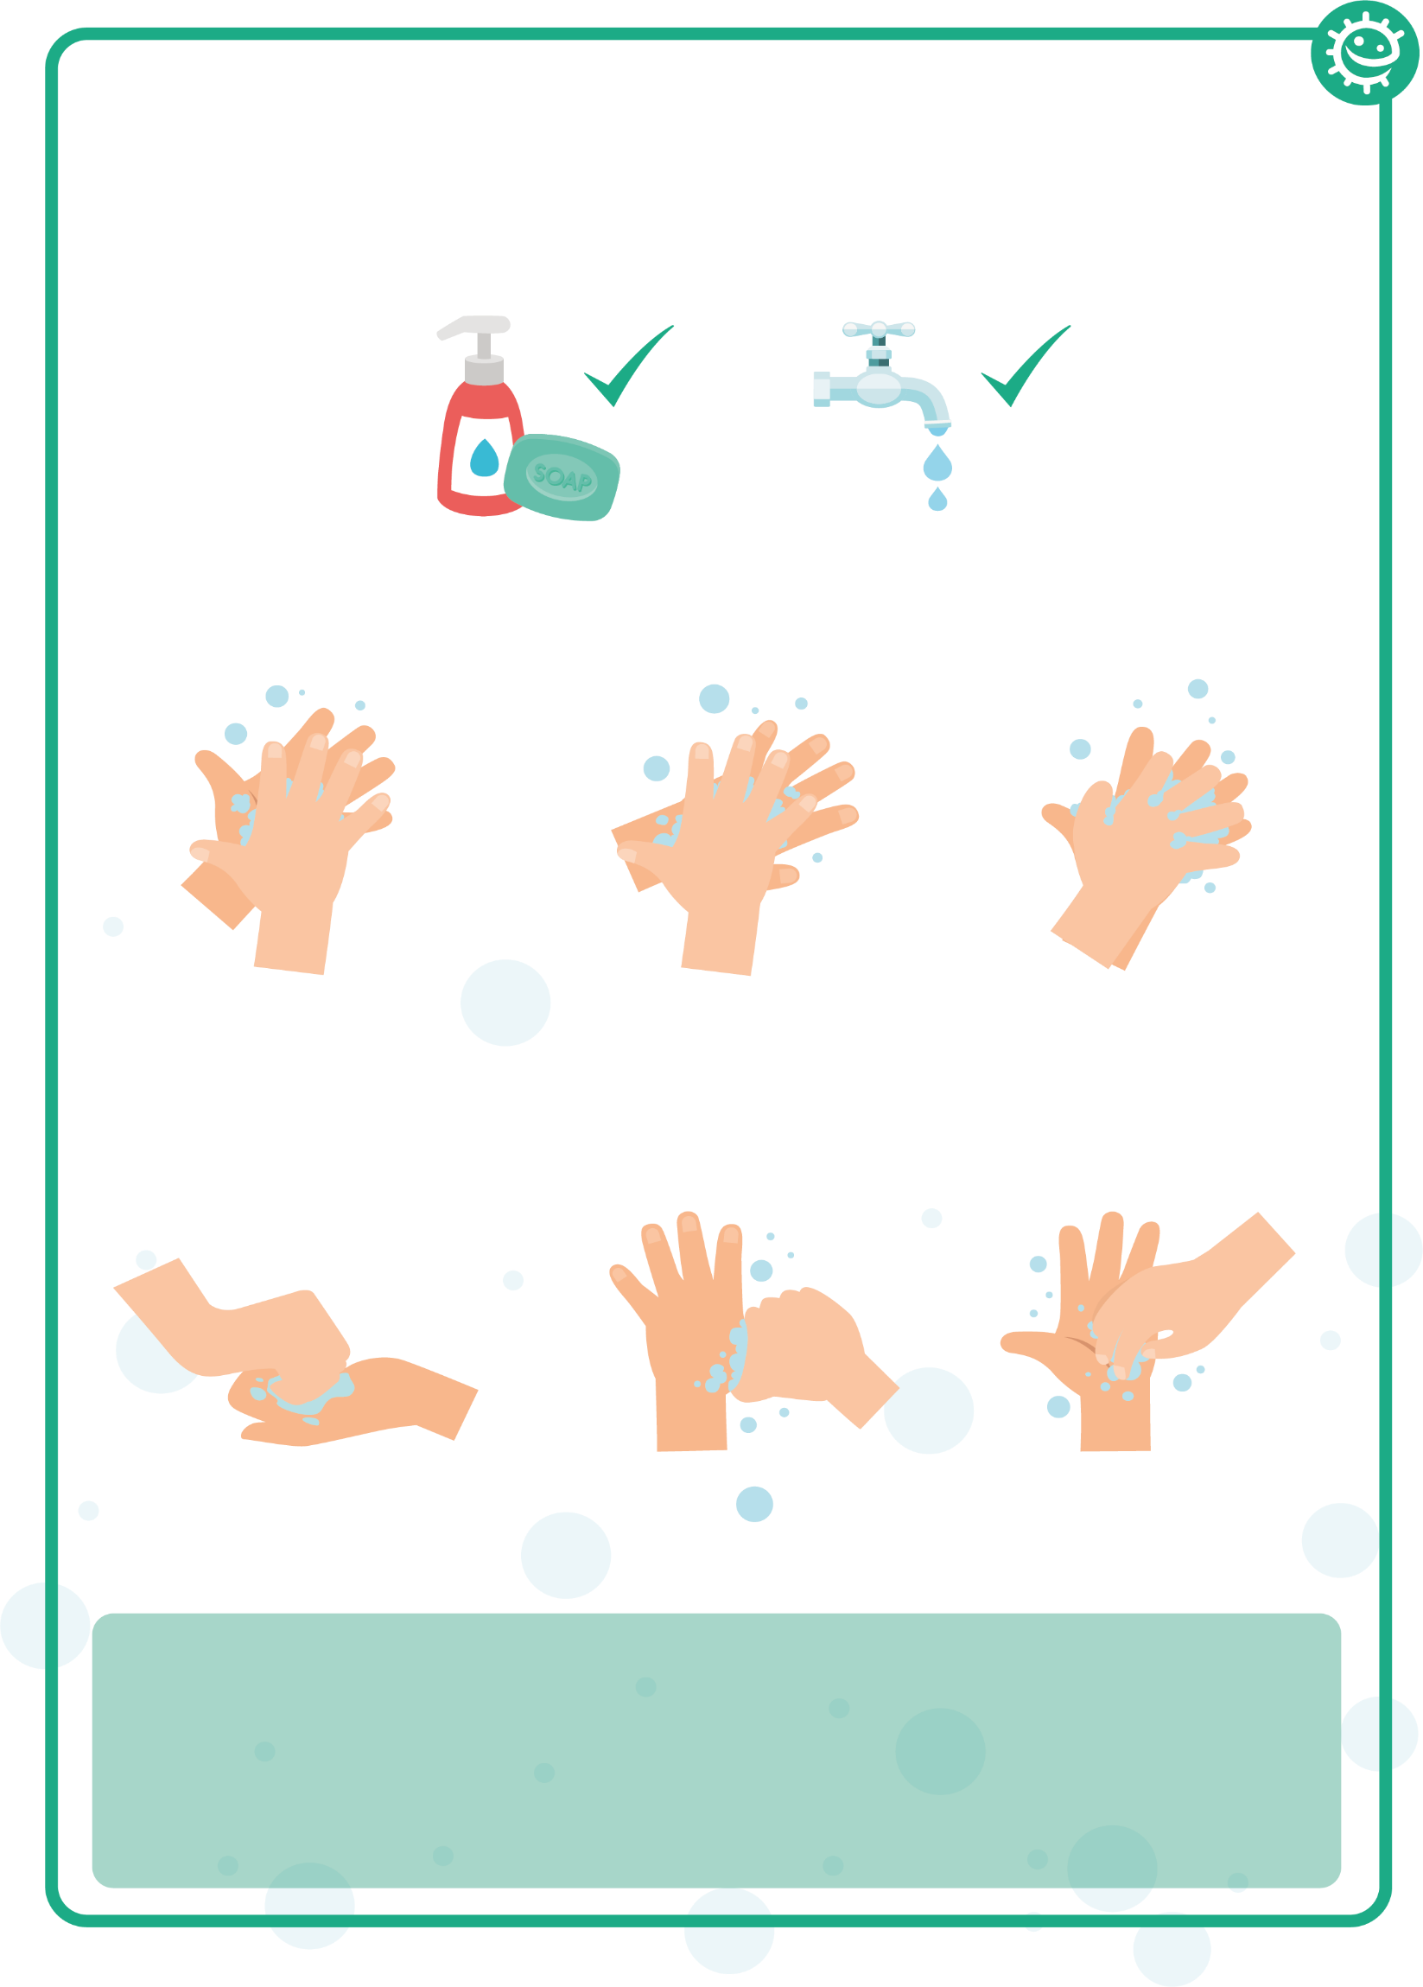
1
2
3
4
5
6
Palm to palm
Back of hands
Between fingers
Back of fingers
Thumbs
Tip of fingers

Wash your hands with soap and water for 20 seconds

To help keep time, sing ‘Happy Birthday’ twice

SH3 - Washing Your Hands Sequencing Activity

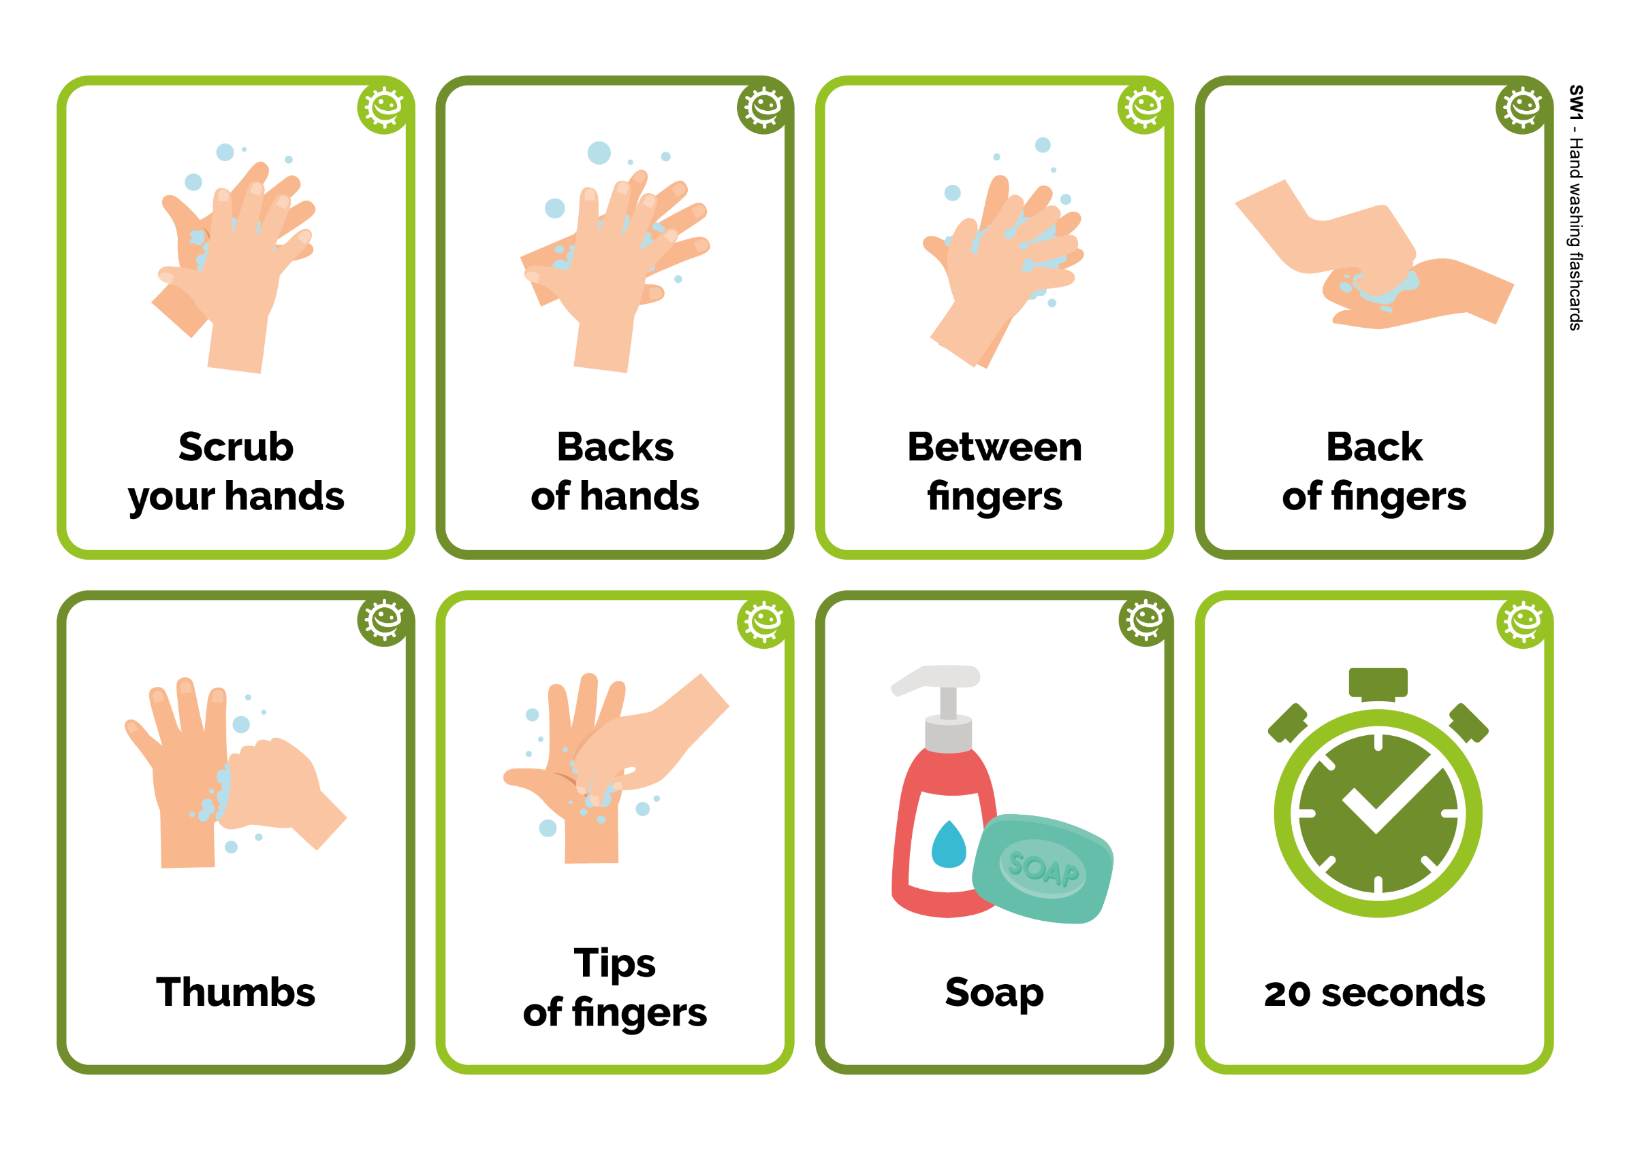
Back
of fingers
Back
of fingers
20 seconds
Between fingers
Soap
Backs
of hands
Backs
of hands
Tips of fingers
Scrub
your hands
Scrub
your hands
Thumbs

SW1 - Student Recording Sheet 1/2

Healthy Hands Procedure
 | Student 1 | Student 2 | Student 3 | Student 4 | Student 5
No wash (control)
Wash for 3 secs
Wash for 20 secs
Wash with soap and water for 20 secs
After the activity, use the ‘How Clean are Your Hands?’ guide to write your results in the box provided and see how far the microbes have spread
After washing (or not) and shaking hands
On the next page draw where you saw microbes after hand washing and shaking, for your group only.

The method of hand washing that removed most microbes from the lead person was:
- Wash for 3 seconds
- Wash for 20 seconds
- Wash for 20 seconds with soap & water

The method of hand washing that removed fewest microbes from the lead person was:
- Wash for 3 secs
- Wash for 20 secs
- Wash for 20 secs with soap & water
The method of hand washing which spread the most microbes along the line was:
- Wash for 3 secs
- Wash for 20 secs
- Wash for 20 secs with soap & water
The method of hand washing which removed the fewest microbes along the line was?

Draw a graph of how far the microbes spread for all four groups (including control).

SW1 - Student Recording Sheet 2/2
Fascinating Fact
90% of germs on the hand are found under the nails!

My conclusions:
- What is the best way of getting rid of microbes from our hands?
_________________________________________
- What difference does using soap make?
_________________________________________
- When should we wash our hands?
_________________________________________

SW2 - Handprint Student Worksheet

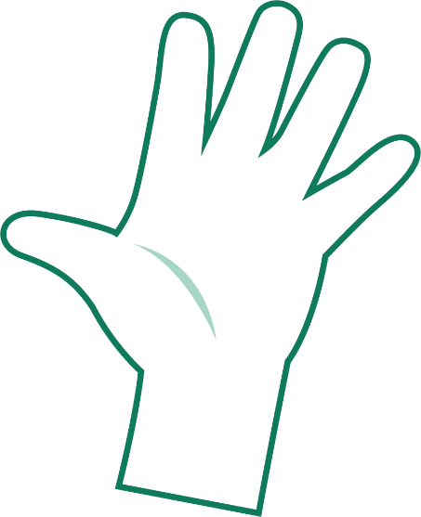
Student 3
Student 5
Student 2
Student 4
Student 1

SW3 - Hand Hygiene Fill in the Blanks Worksheet

Complete the sentences below using the key words
Our hands are naturally covered with _ _ _ _ _ _ _ _ that live on our
bodies and pick up millions more from our environment everyday.

Microbes can _ _ _ _ _ _ easily from child to child when we touch each other.

Although some microbes can be useful, others can be harmful and cause _ _ _ _ _ _ _ _ _.

_ _ _ _ _ _ _ _ _ _ _ is the most effective way of reducing and preventing the spread of infection.

Washing our hands with _ _ _ _ and water at key moments removes any harmful microbes we pick up on our hands from our surroundings.

We should wash our hands for _ _ _ _ _ _ _ _ _ , which is the length of the happy birthday song twice.

Washing hands in water alone will only remove _ _ _ _ and
grime.

If soap is unavailable, we should use _ _ _ _ _ _ _ _ _ _ _ _ _ as long as there is no visible dirt/other substance on hands.
Key words:
Hand sanitiser, Microbes, Dirt, Infection, Soap, Hand washing,
Spread, 20 seconds

SW4 - Hand Hygiene Quiz

Quiz: Hand Hygiene
Please tick as many answers as appropriate
Name_______________________
How can you spread microbes to others? (2 points)
- By touching them
- By looking at them
- By speaking to them on the phone
- By sneezing
Why should we use soap to wash our hands? (2 points)
- It helps remove invisible microbes too small to be seen by our eyes
- It breaks up the oil on our hands which trap microbes
- It keeps our hands moist
- It doesn’t matter if we use soap or not
Which is NOT one of the 6 steps of hand washing?
(1 point)
- Palm to palm
- The thumbs
- Arms
- In between fingers
Who might be at risk as a result of you not washing your hands properly? (1 point)
- You
- Your family
- Your friends
- All of the above
When should we wash our hands? (3 points)
- After stroking a pet
- After sneezing or coughing
- After watching TV
- After using the bathroom or changing a soiled nappy
How can you stop harmful microbes from spreading?
(2 points)
- Do nothing
- Wash hands in water
- Use hand sanitiser if soap and water are not available
- Wash your hands with running water and soap
After we sneeze into our tissue, we should: (2 points)
- Wash our hands immediately
- Dry our hands on our clothes
- Take antibiotics
- Put the tissue straight into the bin
How long should we wash our hands for? (1 point)
- 10 seconds
- 20 seconds (length of Happy birthday song twice)
- 1 minute
- 5 minutes

