Micro-organisms: Harmful Microbes
Key Stage 2

Lesson 3: Harmful Microbes
Close examination of various illnesses illustrates to pupils how and where in the body harmful microbes cause disease. Pupils test their knowledge of harmful microbes by completing a crossword puzzle, wordsearch and quiz.

Learning Intention

All pupils will:
- Explore how microbes can affect our health, recognising that some can cause illness, how they can spread, and that not all illnesses are caused by microbes.
Northern Ireland Curriculum Links

Curriculum Key Elements
- Personal Health and Moral Character

Curriculum Skills
- Communication
- Thinking
- Problem Solving and Decision Making

Curriculum Areas of Learning
- Personal Development and Mutual Understanding (PDMU)
- The World Around Us (TWAU)

 Lesson 3: Harmful Microbe

Resources Required

Starter Activity: Class discussion

Per class
- Copy of TS1
- Copy of SH1
- Copy of SH2

Main Activity: Mould bread experiment

Per group
- 3 slices of bread
- Water Marker
- 3 resealable plastic bags

Extension Activity 1: Most Wanted Poster

Per pupil
- A4 paper
- Colouring pens/pencils

Extension Activity 2: Bad Bug Challenge

Per pupil
- Copy of SW1

Extension Activity 3: True or False Flashcards

Per pupil
- Copy of SH3

Extension Activity 4: Harmful Microbes Quiz

Per pupil
- Copy of SW2
Supporting Materials
- TS1 Class Discussion Teaching Points
- SH1 & SH2 Class Discussion: Picture Scenarios
- SH3 Harmful Microbes True/False Flashcards
- SW1 Harmful Microbes Crossword and Wordsearch
- SW2 Harmful Microbes Quiz


. Lesson 3: Harmful Microbes

Key Words
Bacteria
Fungi
Germs
Infection
Pathogens
Virus

Health & Safety
Bags must not be opened to provide a closer look at the surface of the bread; this could release fungal spores which could be inhaled and cause respiratory distress. The three bags should be placed, unopened, in the normal waste or in a food waste recycling collection.

For safe microbiological practices in the classroom consult CLEAPPS
www.cleapps.org.uk

Weblinks
e-bug.eu/eng/KS2/lesson/ Harmful-Microbes

Introduction
- Begin the lesson by explaining to the class that sometimes microbes can be harmful to humans. Ask them if they know what makes them ill. Find out how many different words they have for microbes – germs, bugs, etc.
- Explain to the class that a pathogen is a word that refers to the bacteria, viruses and fungi that make you sick. Discuss the various microbes with the class and the illnesses they can cause.
- Highlight to the class that microbes have adapted to live everywhere, such as in our classrooms, houses, bedrooms, all over our body and on food.
- Tell the class that harmful disease-causing microbes can spread easily from one person to another and are called infectious diseases because they can cause an infection.
- Some good news – tell the class that our bodies have our own 'useful' microbes that try to stop the harmful pathogens from causing an infectious disease.

Activity

Starter Activity: Class Discussion with Scenario Prompts
This activity is best suited as a class discussion.
- Show the class SH1 and SH2 which can be displayed on a whiteboard
- Discussion points 1-6 in TS1 match the 6 images displayed in SH1 and SH2 and provide scenarios to prompt discussion
- Begin a discussion by asking pupils to consider the character’s actions and how microbes may be affecting them
- Continue the discussion by asking if anyone in the class has ever suffered from any of these symptoms and if so, what kind of treatment they had
Remember: Hand washing, respiratory and food hygiene activities are covered in more detail later in the pack.

Main Activity: Mouldy Bread Experiment
Mould spores just need the right environment to grow and flourish. In this experiment, pupils will learn the conditions that speed up mould growth on bread.
- Place a slice of bread in each plastic bag and seal properly. Number each bag with a marker.
- Add some water to bag 1. Put it in a dark place.
- Put the second bag in a bright sunny place.
- Put the third bag in the refrigerator.
- Check each bag for a week.
- Examine the slices of bread and ask pupils what they expect to see.
- At the end of the week ask pupils to record their results. Are they what they expected?
At the end of the week, each bag will have a different kind of mould growth. In a bright, sunny place, the temperature is highest which would encourage faster/greater mould growth. In the refrigerator, the low temperature would limit the amount of growth, if at all. The bread stored in the dark, damp conditions should have the most mould growth. Pupils will learn that mould tends to grow faster in warm, wet conditions. Mould growth could also be intermediate between the slices.

Discussion
Check for understanding by asking the pupils the following questions: What is the process which caused the yeast mixture to rise?
- What causes an infection?
Answer: An infection happens when harmful microbes get inside your body and replicate, causing the infected person to get ill. This can happen very quickly or can take a long time.
- Are sore throats always caused by harmful microbes?
Answer: Not all sore throats are caused by harmful microbes, sometimes coughing or having a toothache can cause our throats to become red and sore too.
- Are all illnesses caused by microbes?
Answer: Illnesses caused by microbes are known as infectious diseases. There are also illnesses, such as asthma and hay fever, that are not caused by microbes. These are known as non-infectious diseases.
- Can you think of any infections caused by harmful microbes?
Answer: Athlete’s foot, influenza, measles

Fascinating Fact
Did you know that there are more microbes on the planet than any other species of living thing?

Extension Activities

Most Wanted Poster Design
Asks pupils to make a ‘Most Wanted’ style poster for a harmful micro-organism e.g. Influenza virus, Campylobacter, dermatophyte fungi, Salmonella.
Posters should include: a drawing of the harmful micro-organism, a description, including how it infects humans, where it can be found and symptoms (if applicable).

True/False Flashcards
SH3 includes a set of questions and true/ false answer cards for the pupils. In groups of 3 or 4 ask pupils to raise the cards to answer each of the questions.
The answers to SH3 are as follows:
- Sore Throats are always caused by harmful microbes. Answer: False
- Athlete’s Foot is caused by fungus. Answer: True
- All illnesses are caused by microbes. Answer: False
- Another name for a harmful microbe is a pathogen. Answer: True
- Fungi do not generally kill their hosts. Answer: True
- Influenza virus causes the common flu. Answer: True

Bad Bug Challenge
SW1 provides a fun crossword and word search. Pupils can complete the tasks individually or in pairs to consolidate the lesson. Answers are available on the e-Bug website.

Microbes Quiz
SW2 provides another fun way to consolidate learning. Allocate pupils to groups of 3 or 4 and provide one sheet per team. The team with the most points wins
- Bacteria, virus, fungi
- Everywhere
- Cheese, bread and yoghurt
- Pathogen
- Virus
- Can be useful or harmful
- Pathogen
- All of the above

Learning Consolidation
At the end of the lesson, ask the class the questions below to check understanding:
- Some microbes can be harmful to humans and can cause disease. Provide one example.
- Which microbe is very small and causes coughs, colds, sore throats and flu? Answer: Viruses
- Provide two ways that harmful microbes can spread from person to person.

Alternatively, allow the pupils to work in pairs or small groups to create their own quiz questions. Each group writes 2-3 questions (and answers) on sticky notes or a digital platform. Groups then swap questions and answer those from another group, discussing the correct answers together.



SH1 – Class Discussion Teaching Points

Micro-organisms: Harmful Microbes
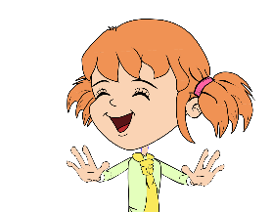
Teaching Points
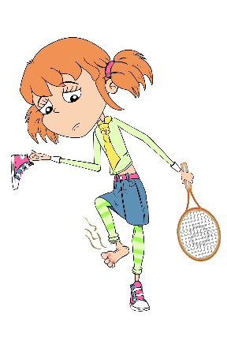
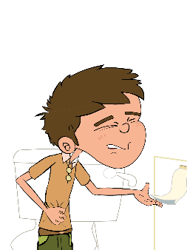
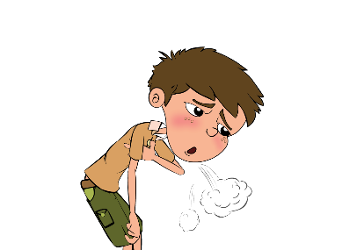
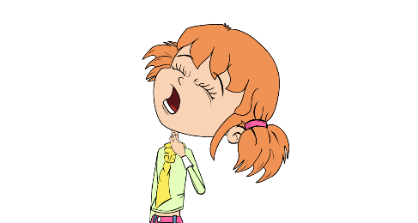
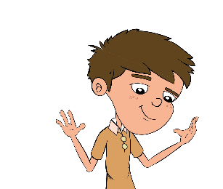
- Eva likes to keep her hands and nails clean. If we look closely at Eva’s hands we can see that they are covered in lots of tiny microbes. These microbes are useful microbes that live on our skin and help keep us healthy.
- Luca is always out playing football and having fun with his friends, however, he doesn’t worry about washing his hands very often. If we look closely at Luca’s hands we can see that they too are covered with lots of tiny microbes although some of these are harmful and could make him very ill if they got inside his body.
- Eva isn’t very well, she has a really sore throat. Sometimes sore throats are caused by coughing and a runny nose, which can make the throat swell up and become quite painful. If this happens then Eva should drink lots of fluids and take painkillers. Sometimes, however, bacteria (e.g. Streptococcus) and viruses can also cause us to have a sore throat.
- In this picture, do you think that Luca is ill because of microbes? The answer is no, Luca has a condition known as asthma which causes him to get out of breath very easily. Asthma is a disease of the lungs and airways but is not caused by microbes. It is important to remember that not all illnesses are caused by microbes.
- What do you think is wrong with Luca in this picture? Poor Luca has eaten undercooked chicken at a BBQ and has now got food poisoning caused by Campylobacter. There are lots of microbes on meat, which although they don’t harm the animal can make us very ill. It is important to cook food properly to kill any harmful microbes which may be present.
- Eva plays tennis and she has sweaty, smelly feet. She is always in a hurry so she doesn’t wash or dry her feet properly. Her feet smell and are also very itchy and swollen in between her toes. This is because fungi known as dermatophytes like to live between the toes, especially if they are damp. They cause a disease known as athlete’s foot which causes your toes to swell up, the skin between them to crack and become VERY itchy and sometimes smelly.

SH1 & SH2 - Class Discussion MS PowerPoint

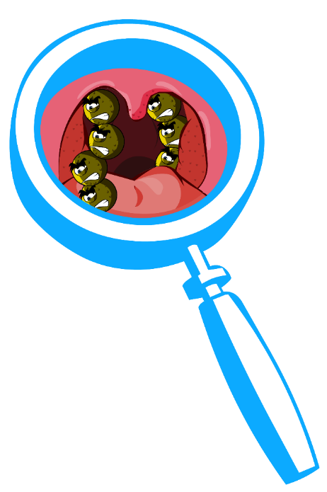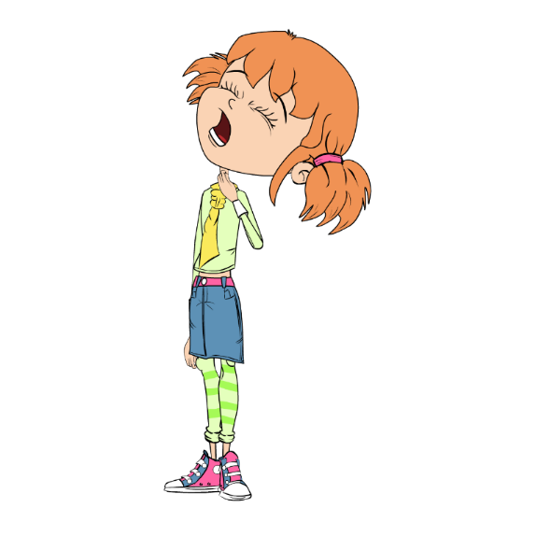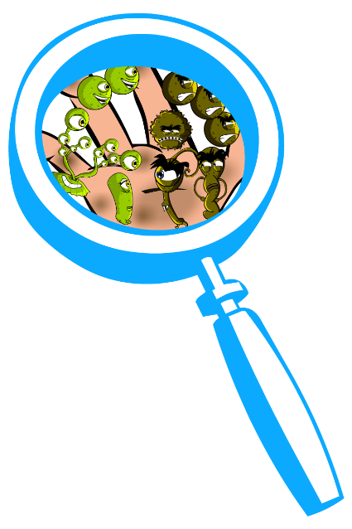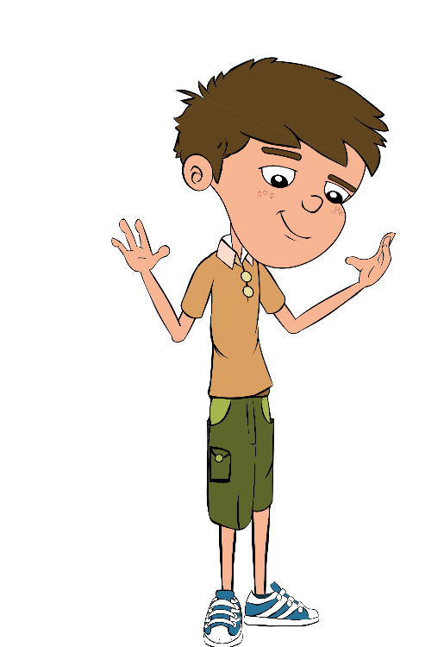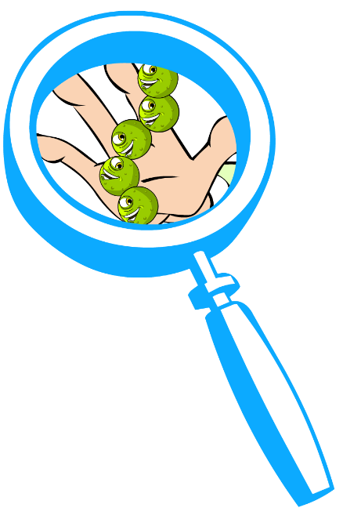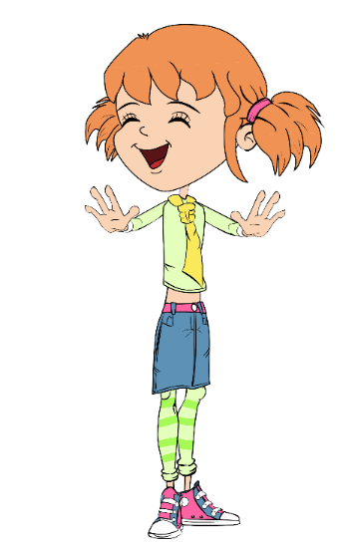

^{Harmful}

^{Microbes}

SH1 & SH2 - Class Discussion MS PowerPoint

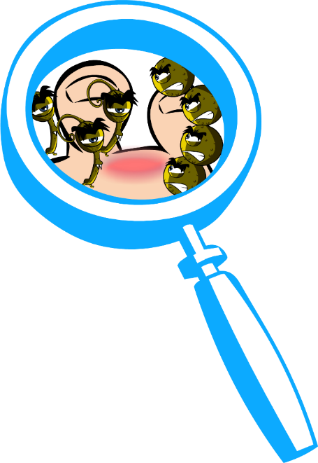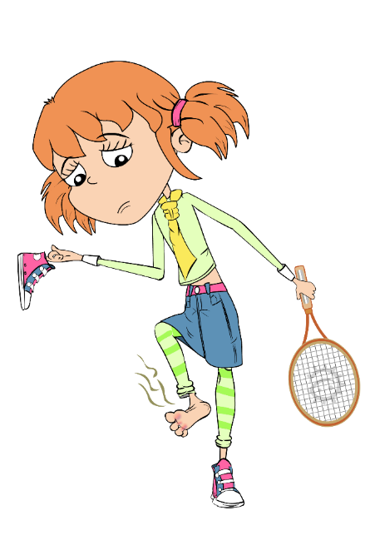
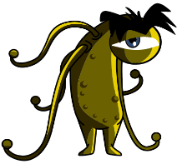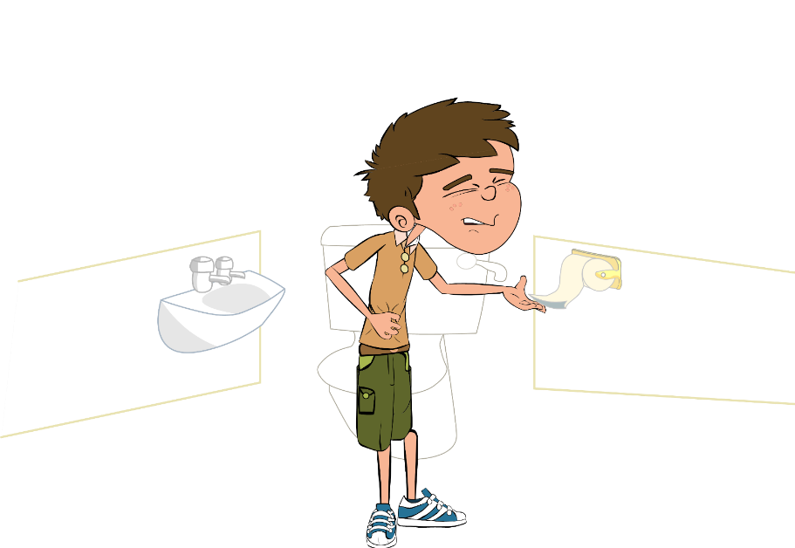
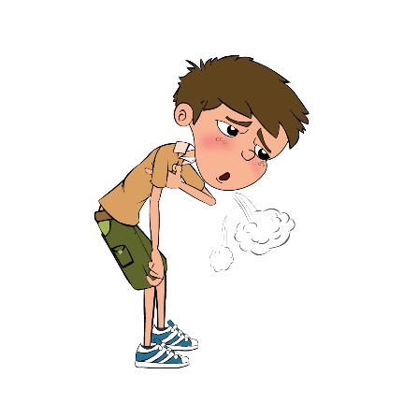

Harmful

Microbes

SH3 - Harmful Microbes True/False Flashcards
All illnesses are caused by microbes?
True or False
Another name for a harmful microbe is a pathogen?
True or False

Fungi do not generally kill their hosts?
True or False
Influenza virus causes the common flu?
True or False

Sore throats are always caused by harmful microbes?
True or False
Athlete’s foot is caused by fungi?
True or False

SH3 - Harmful Microbes True/False Flashcards - Answers
True
False
True
False
False
True
 | ₁ |  |  |  | ₂
 | ₃
₄
 |  |  |  |  |  |  |  | ₅
 |  |  | ₆
 |  |  | ₇
 |  | ₈
 | ₉ |  |  | ₁₀
 |  |  |  |  |  |  |  |  |  | ₁₁
 |  |  |  |  |  | ₁₂
 |  | ₁₃
SW1 - Harmful Microbes Cross and Wordsearch Worksheet

Bad Bug Challenge
Across:
1. I make you do this when you have a cold to spread microbes
by causing a tickle in your throat
4. I am a viral disease that can give you swollen itchy red spots all over your body.
6. If they are not clean what part of your body can spread microbes from person to person. Washing me gets rid of bad
microbes (2 words)
7. I am a viral disease that will give you headaches, a runny nose and make you hot and sweaty.
9. You will get me if you don’t cook your meat properly or wash your hands after handling raw meat (2 words).
12. I am a disease of the lungs, not caused by microbes. I make you so short of breath that you need to use an inhaler.
13. I am another word for pain in your head

Down:
2. I make your eyes swollen and itchy. I am not caused by a microbe. I am caused by an allergy to pollen.
3. How you feel when your body is fighting infection.
5. I am a fungal infection of your feet. I make your toes itchy. I
spread if you don’t wash and dry your feet well. (2 words).
8. I am often seen on teenager’s faces. I am sometimes caused by microbes on the skin.
10. Bad microbes in your tummy can sometimes cause this. If you don’t wash your hands after going to the toilet it can spread around your school.
11. Watch out. Bad tummy microbes can sometimes take you by Surprise and make you do this.

SW1 - Harmful Microbes Wordsearch Worksheet

Bad Bug Challenge
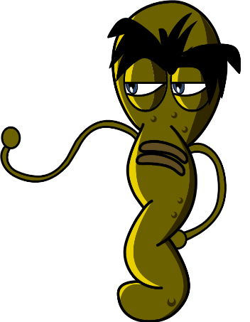
Can you find all the words associated with Bad Bugs in the word search below? Remember that the words can be horizontal (across), vertical (down) or diagonal (top left to bottom right).
F | C | E | A | R | T | M | Y | Y | U | A | N | S | D | F
F | O | M | G | B | F | L | U | M | B | H | N | H | J | K
Z | L | O | N | Z | R | W | K | A | Y | E | A | E | A | L
F | D | S | D | H | G | D | A | S | T | H | M | A | T | A
V | B | H | N | P | H | N | J | O | H | D | D | D | G | T
S | V | V | A | C | O | U | G | H | N | C | I | A | B | H
M | S | O | S | X | J | I | D | F | B | G | R | C | G | L
E | T | G | M | Z | U | N | S | A | M | A | T | H | A | E
A | N | M | D | I | A | R | H | O | E | A | Y | E | J | T
S | Z | X | C | V | T | B | G | T | N | D | H | J | H | E
L | R | T | A | Y | U | N | I | A | O | I | A | F | G | S
E | Q | W | E | R | I | N | F | L | U | E | N | Z | A | F
S | P | O | T | I | O | P | L | B | K | J | D | G | G | O
A | S | D | M | S | L | E | E | P | Y | E | S | S | F | O
H | A | Y | F | E | V | E | R | N | F | G | N | H | K | T
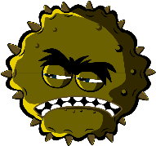
Cough, Cold, Food Poisoning, Dirty Hands, Headache, Hayfever, Asthma, Spot, Flu, Influenza, Athletes Foot, Sleepy, Measles, Vomit

SW1 - Intro to Microbes Quiz

Quiz: Microbes
Please tick as many answers as appropriate

Which of these are microbes?
(3 points)
- Bacteria
- Virus
- Antibiotic
- Fungi
Microbes are found
(1 point)
- In the air
- On our hands
- On surfaces
- Everywhere
Which foods or drinks are
produced through the growth of microbes?
(4 points)
- Cheese
- Bread
- Yogurt
- Fizzy drinks
What is another word for a harmful microbe?
(1 point)
- Infectious
- Antibiotic
- Pathogen
- Flora
Which is the smallest?
(1 point)
- Bacterium
- Virus
- Fungus
- They are all the same size
Microbes:
(1 point)
- Are all harmful
- Are all useful
- Can be harmful or useful
- Have no effect on the
human body
Which of these microbes causes the common cold?
(1 point)
- Bacteria
- Virus
- Antibiotic
Which of these are shapes of microbes?
(1 point)
- Rods
- Balls
- Spirals
- All of the above

