


SH2 – Designabug Example

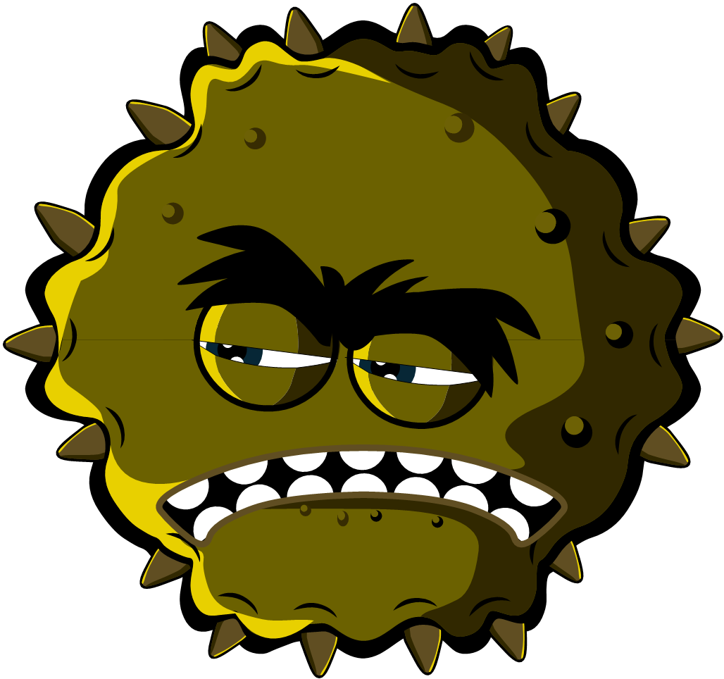
Microbe name
_{Charlotte Sneezysnot}

Designabug
_{Virus}
Microbe type
Useful of Harmful
_{Harmful}
I am a harmful virus and I like to live in your nose. My super sticky grippers help me stick to your nose cells. You don’t want me there because I make you sneeze and cough.
Microbe Story
Special Features
Lots of sticky grippers all around my body and I’m very small
Strength/Weakness
I need to live in your cells do don’t sneeze in a tissue and throw me in the bin – I’ll die

