Micro-organisms: Useful Microbes
Key Stage 2

Lesson 2: Useful Microbes
A yeast racing competition is used to demonstrate to pupils that microbes can be beneficial.

Learning Intention

All pupils will:
- Investigate how microbes interact with their environment, exploring how some support health and are used in beneficial ways, and understanding the factors that influence growth.

Northern Ireland Curriculum Links

Curriculum Key Elements
- Personal Health and Moral Character

Curriculum Skills
- Communication
- Using Mathematics
- Thinking
- Problem Solving and Decision Making
- Being Creative
- Working with Others

Curriculum Areas of Learning
- Personal Development and Mutual Understanding (PDMU)
- The World Around Us (TWAU)

 Lesson 2: Useful Microbes

Resources Required

Main Activity: Yeast races

Per group
- 2 plastic cups
- Flour
- Yeast solution
- Sugar
- 2 Graduated cylinders (or measuring jugs)
- Basin
- Luke-warm water
- Teaspoon

Per pupil
- Copy of SH1
- Copy of SW1

Extension Activity: Fill in the Blanks

Per pupil
- Copy of SW2

Supporting Materials
- SH1 Yeast Races Experiment Handout
- SW1 Yeast Races Recording Sheet
- SW2 Useful Microbes Fill in the Blanks Worksheet

Advanced Preparation
Purchase flour, sugar and dried yeast. Prior to starting the activity make up a liquid yeast solution as outlined on pack purchased. This may vary between different brands.
If made too far in advance the yeast will start to ferment.
NB: do NOT add sugar until stated in the main activity.

. Lesson 2: Useful Microbes

Key Words
Culture
Fermentation
Probiotics

Health & Safety
For safe microbiological practices in the classroom consult CLEAPPS
www.cleapps.org.uk

Weblinks
e-bug.eu/eng/KS2/lesson/ Useful-Microbes

Introduction

Introduction
- Begin the lesson by explaining that microbes can have both harmful and useful effects on our health. Ask the class what they know about useful or ‘friendly’ bacteria. Many pupils will have already heard about probiotic bacteria in yoghurt.
- Explain that microbes are helpful in the breakdown of dead animals and plants, in helping animals and humans digest foods and in turning milk into yoghurt, cheese and butter.
- Highlight that bread dough rises through the action of helpful fungus known as yeast. The yeast eats the sugars present in food and produces gas and acids. These acids change the taste, smell and form of the original foodstuff whereas the gas makes the dough rise.
- Tell the class that in this activity they are going to see exactly how we can use useful microbes to make bread rise.

Activity

Main Activity: Yeast Races
- This activity is for groups of 2-5 pupils.
- Highlight to the pupils that a useful fungus known as yeast is used to make bread. The yeast helps the bread rise through a process called fermentation.
- Supply the class or groups with the Yeast Races Recipe (SH1).
- Ask pupils to carry out the activity in their groups. When the recipe is complete, pupils should observe the yeast and record their observations on the pupil worksheet (SW1).
- Can the class explain why the yeast and sugar solution moved faster than the yeast alone? Pupils should recognise that fermentation was carried out at a faster rate when the sugar was present.

Discussion
Start a classroom discussion on how microbes keep us healthy. Check for understanding by asking the class the following questions:
- What is the process which caused the yeast mixture to rise?
Answer: Yeast growing and using the sugars for energy; the yeast produces gas bubbles which cause the dough to rise.
- What would have happened if there were no live yeast in the mixture?
Answer: Nothing, it’s the growing yeast that causes the breakdown of sugars and makes the dough rise.
- Why was the mixture kept in a basin of warm water?
Answer: Most microbes prefer to grow at 37oC and will multiply faster if grown at this temperature. The faster the microbes grow the more breakdown of sugars will occur and the faster the yeast mixture will rise up the cylinder.
- What other food products are made using bacteria or fungi?
Answer: Cheese, bread, wine, beer, sour cream.

Fascinating Fact
Elie Metchnikoff won the Nobel Prize in 1908 for his ‘discovery’ of probiotics. He was convinced that Bulgarian labourers lived longer than other people because of the microbes in the sour milk they drank. The microbes were later identified as Lactobacillus bulgaricus.

Extension Activities

Microbes and Food Fill in the Blanks Worksheet
Provide pupils with SW2 and ask them to fill in the blanks using the correct words provided. This can be completed in the classroom or as a homework exercise.
Worksheet (SW2) answers:
- Fermentation
- Lactobacillus bulgaricus
- Yoghurt
- Bread
- Cheese
- Carbon Dioxide

Learning Consolidation
At the end of the lesson, ask the class the questions below to check understanding:
- Do microbes have both useful and harmful effects on our health.
Answer: Yes
- Some microbes can help keep us healthy True/False?
Answer: True
- Some microbes can be put to good use in the food industry. List five food or drink items.


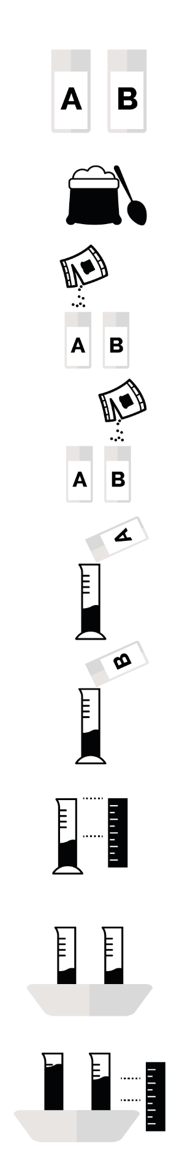

SH1 – Yeast Races Experiment Handout

Yeast Races
Experiment
- Label one of the plastic cups A and one B
- Add four teaspoons of flour to each cup
- Add enough yeast solution to cup A and stir thoroughly until it looks like thick milkshake
- Add enough yeast solution and sugar to plastic cup B and stir thoroughly until it looks like thick milkshake
- Pour the contents of cup A into graduated cylinder A until it reaches about 30ml
- Pour the contents of cup B into graduated cylinder B until it reaches about 30ml
- Record the exact height of the dough in each cylinder
- Place both measuring cylinder into a basin of hot water
- Measure the height of the dough every 5 minutes for 30 minutes

SW1 – Yeast Races Recording Sheet
Did you know? The average adult carries approx. kg of good microbes in their guts – the same weight as 2 bags of sugar
Fascinating Fact
There are trillions of friendly bacteria in the average human gut

Yeast Races
Procedure
Follow the instructions on the yeast races handout
My Results
Yeast only cup (cup A)
Yeast and Sugar (cup B)
Time | Volume of dough (ml) | Change in volume of dough (ml)
0 | 30ml | 0
5
10
15
20
25
30
Volume of dough (ml) | Change in volume of dough (ml)
30ml | 0
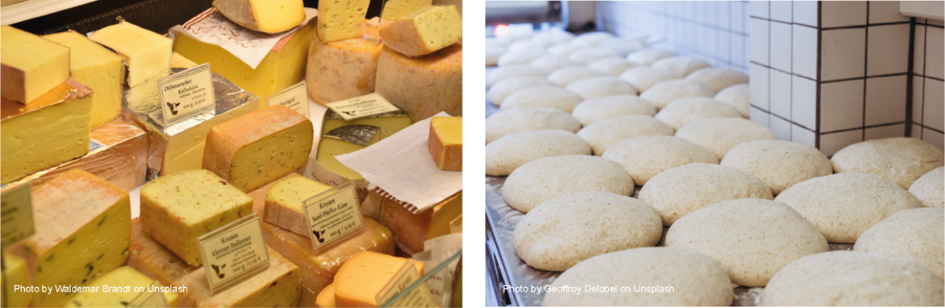
Did you know?

The average adult carries approx. kg of good microbes in their guts – the same weight as 2 bags of sugar
My Conclusions
- What caused the dough to rise up the container?
___________________________________
- What is this process called?
___________________________________
- Why did the dough in container B move
faster than container A?
______________________________________________________________________
Fascinating Fact
There are trillions of friendly bacteria in the average human gut

SW2 – Useful Microbes Fill in the Blanks Worksheet

Microbes and Food
Microbes are single-celled organisms, most of which are useful, although some of them cause illness and disease. One of the main ways in which microbes are useful is in the food industry. Cheese, bread, yoghurt, chocolate, vinegar and alcohol are all produced through the growth of microbes. The microbes used to make these products cause a chemical change known as _ _ _ _ _ _ _ _ _ _ _ _ a process by which the microbes break down the complex sugars into simple compounds like carbon dioxide and alcohol. Fermentation changes the product from one food to another.
Words to use: Lactobacillus bulgaricus, bread, carbon dioxide, fermentation, yoghurt, cheese
When the bacteria Streptococcus thermophilous or _ _ _ _ _ _ _ _ _ _ _ _ _ _ _ _ _ _ _ _ _ _ _ are added to milk they consume the sugars during growth, turning the milk into yoghurt. So much acid is produced in fermented milk products that few potentially harmful microbes can survive there. Lactobacillus is generally referred to as a good or ‘friendly’ bacterium. The friendly bacteria that help us digest food have been termed probiotic bacteria, literally meaning ‘for life’. It is these bacteria that we find in _ _ _ _ _ _ _ _ and probiotic drinks.
Yeast, Saccharomyces cerevisiae, is used to make _ _ _ _ _ and _ _ _ _ _ _ products through fermentation. In order to multiply and grow, yeast needs the right environment, which includes moisture, food (in the form of sugar or starch) and a warm temperature (20° to 30°C is best). When the yeast eats sugar, it changes the sugar into two things: ethanol (a type of alcohol) and _ _ _ _ _ _ _ _ (a gas that makes bubbles). This process, known as fermentation, typically occurs in the absence of the oxygen in the air.
Words to use: Lactobacillus bulgaricus, bread, carbon dioxide, fermentation, yoghurt, cheese

