
Early Years

Spread of Infection: Hand Hygiene

Lesson 1: Hand Hygiene
By taking part in a classroom experiment, children learn why it is important to wash hands properly and learn the best method and order for hand washing.

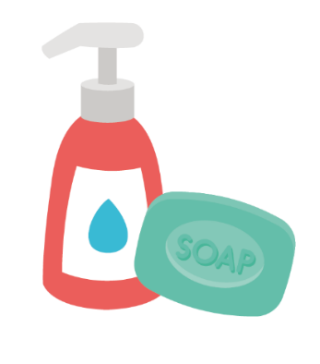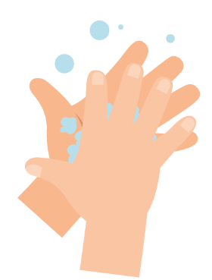

Learning Outcomes

All students will:
- Understand that we wash hands to remove germs (microbes)
- Understand the sequencing of handwashing and nose blowing
- Understand how to blow their nose to minimise the risk of transmission of infection

Curriculum Links

Communication and language development
- Listening and attention
- Understanding
- Speaking

Physical development
- Health and self-care

Expressive arts and design
- Exploring and using media and materials

 Lesson 1: Hand Hygiene

Resources Required

Activity: Balloon hands

Per child
- Disposable plastic/vinyl gloves

Per group or class
- Basin
- Water
- Hand soap
- Washable black marker

Extension Activity: Hand Washing and Nose Blowing Flashcards

Per class
- TS1 Hand Washing and Nose Blowing Flashcards

Extension activity: Picture Sequencing Activity

Per child/ group
- SW1 Picture Sequencing Activity
- Glue sticks & paper or card

Extension Activity: Hand Washing Chart

Per child
- SW2 e-Bug Healthy Hands Hand Washing Progress Chart

Supporting Materials
- TS1 Hand Washing and Nose Blowing Flashcards
- SW1 Picture Sequencing Activity - place hand washing in the correct order
- SW2 e-bug Healthy Hands Hand Washing Progress Chart

Advanced Preparation
- Fill a basin with soapy water
- Inflate vinyl gloves with air and tie at the bottom to create hand balloons
- Draw circles and dots on the balloon hands with washable marker to resemble germs

Lesson 1: Hand Hygiene

Key Words
Hygiene
Soap
Infection

Health & Safety
Ensure that children have no soap allergies or sensitive skin conditions.
For safe microbiological practices in the classroom consult CLEAPPS
www.cleapps.org.uk

Weblinks
www.e-Bug.eu/eng/EYS/lesson/Hand-Hygiene

Introduction
When introducing students to the concept of microbes, you can refer to the teacher refresher section for more information.
- Begin the lesson by asking how many children have washed their hands today? Ask them why they washed their hands (to wash away any dirt or germs microbes that might be on their hands) and what would happen if they didn’t wash their hands (they might get ill as they ingest harmful microbes on their hands).
- Talk to the children about how we use our hands all the time, and that they pick up millions of microbes every day. Although many of these are harmless, some could be harmful. Explain that we spread our microbes to our friends and others through touch, and that this is why we wash our hands.
- Describe key times we should be washing our hands (especially after using the toilet and before eating).
- Explain to the children that they are going to do an activity to demonstrate how microbes are all over our hands and how best to wash them off.

Activity
- Demonstrate how to wash the marker off the balloon hands with soapy water.
- Provide each child with a balloon hand covered in microbes (washable marker).
- The children should take turns thoroughly scrubbing the marker off the balloon hands in the basin of soapy water.
- Have a conversation with the children about what they saw. How long did it take for all the microbes to disappear? Why do you think it’s important to wash our hands? If we didn’t use soap would it have worked?
Children should notice that it is much easier to wash off the marker pen with soapy water.

Now visit e-bug.eu/eng/EYS/ lesson/Hand-Hygiene to find a NHS demonstration and the UKHSA hand washing song to help make the correct technique more memorable for little hands.

Discussion
- Discuss with the children where the microbes on the balloon hands may have come from. Emphasise to children that not all the microbes on their hands are harmful; there may also be useful microbes there too.
- Emphasise to the children that we also need to wash our hands properly. Highlight that microbes like to hide in between fingers and under the nails. It is important to know both WHEN and HOW to wash our hands properly to prevent spreading microbes and potentially infection. When you must sneeze and you can’t wash your hands, a solution may be to sneeze or cough onto your sleeve/elbow.

Extension Activities

Hand Washing and Nose Blowing Flashcards
TS1 is a useful way to support learning. Cards can be cut and laminated for future use or displayed on a whiteboard. Ask children to name the image, the correct word is shown on the card.

Picture Sequencing Activity
Provide SW1 to a child or group. Supply paper, card and glue sticks and ask children to sort the cards into the correct order and stick them onto the paper or card with glue.

Hand Washing Chart
SW2 is a hand washing chart that allows children to mark and keep track of how often they have washed their hands throughout one school-week. Print the sheet and distribute to each child. This could be a classroom or take-home activity to reinforce hand washing behaviours.

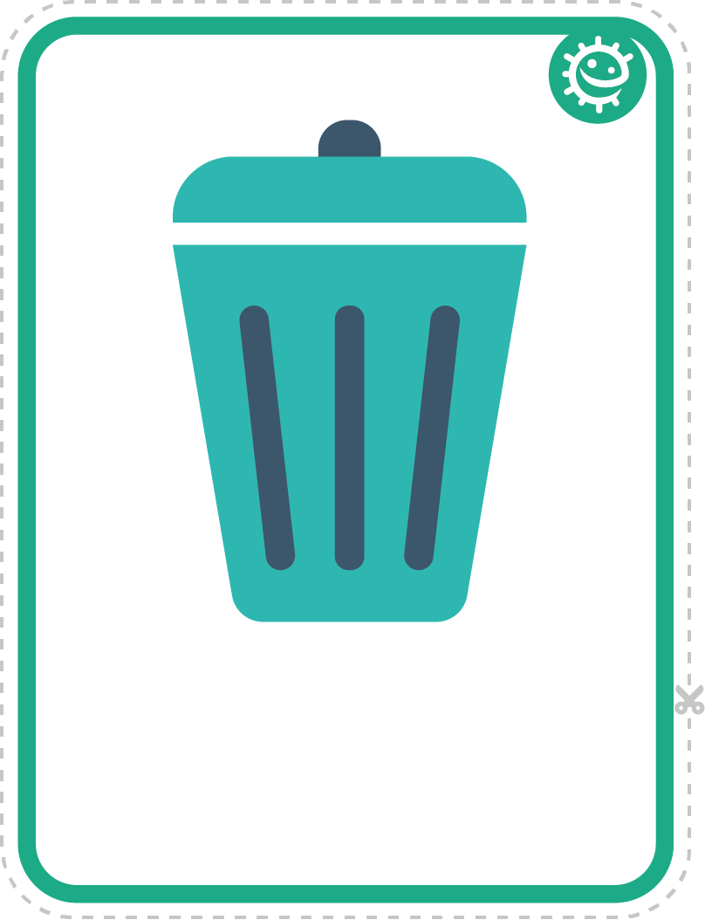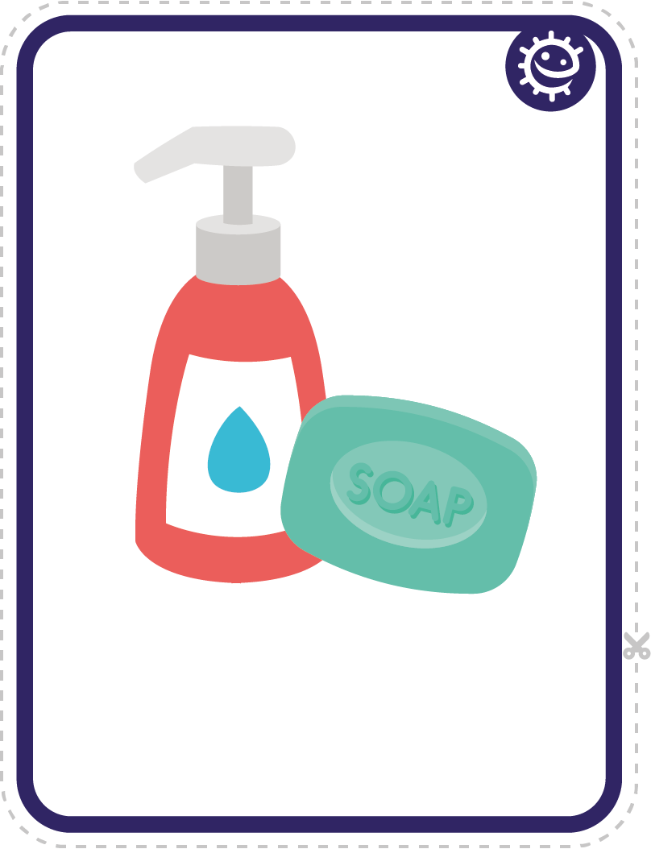

TS1 - Hand Washing and Nose Blowing Flashcards
Bin
Soap

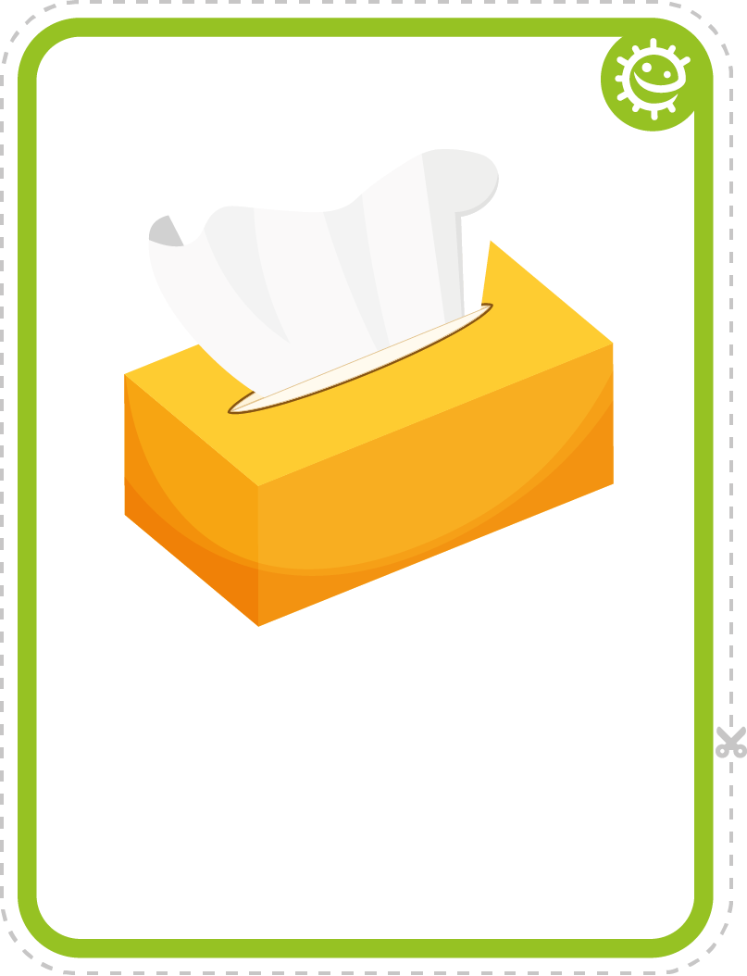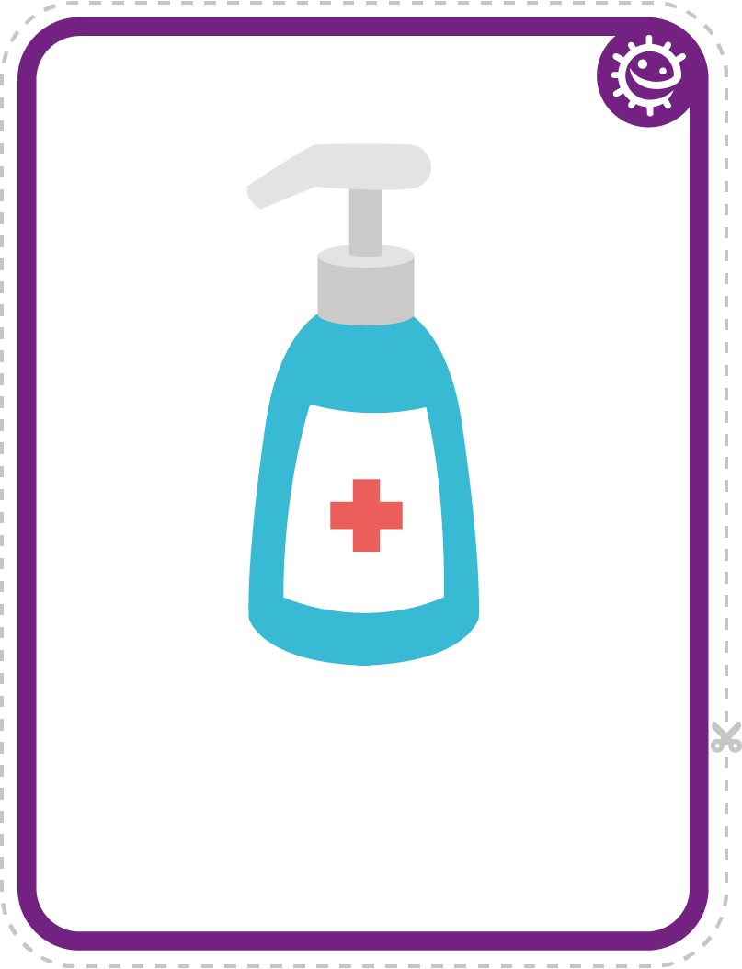
Tissue
Hand sanitiser

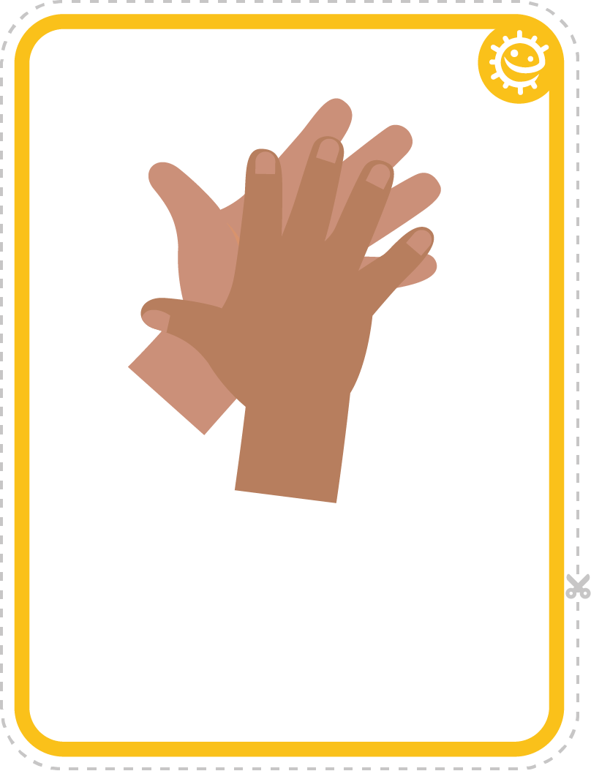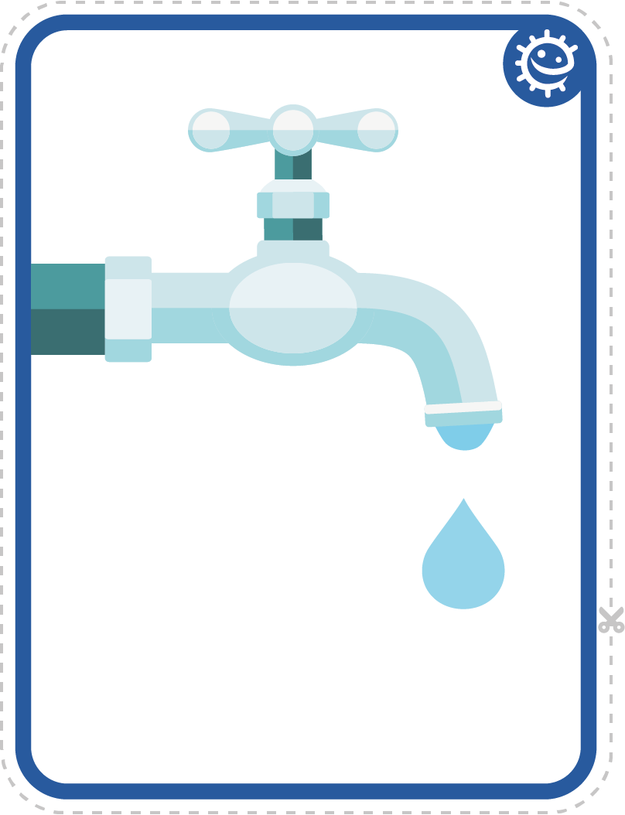
Hands
Tap

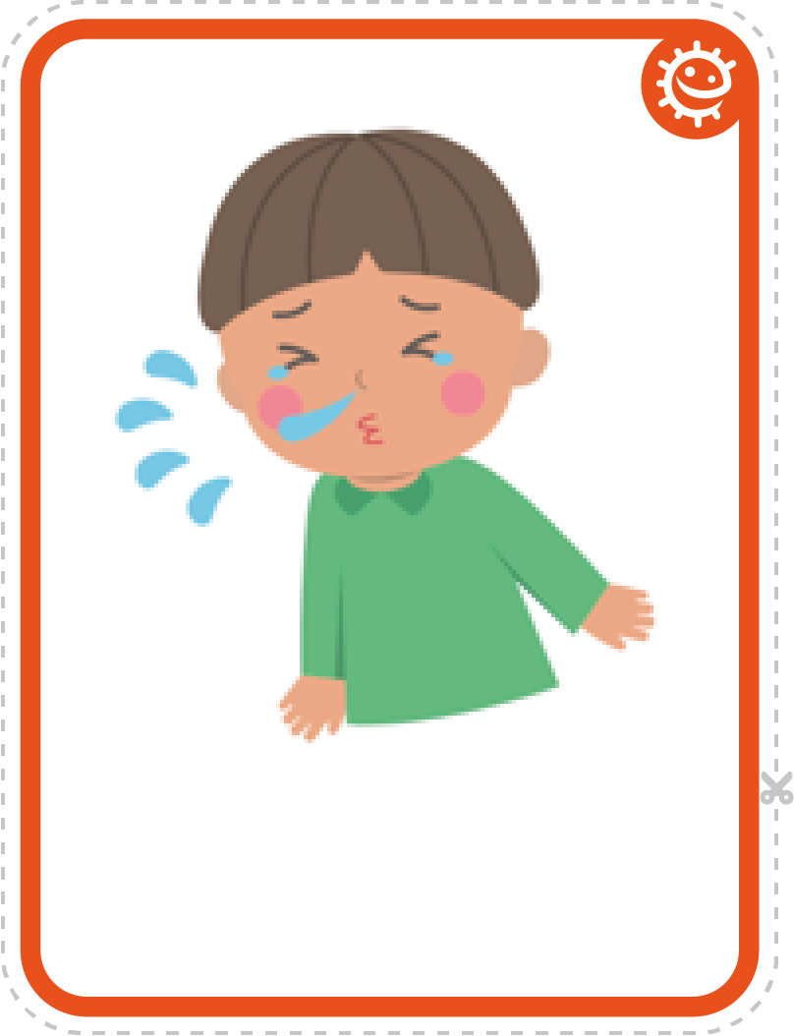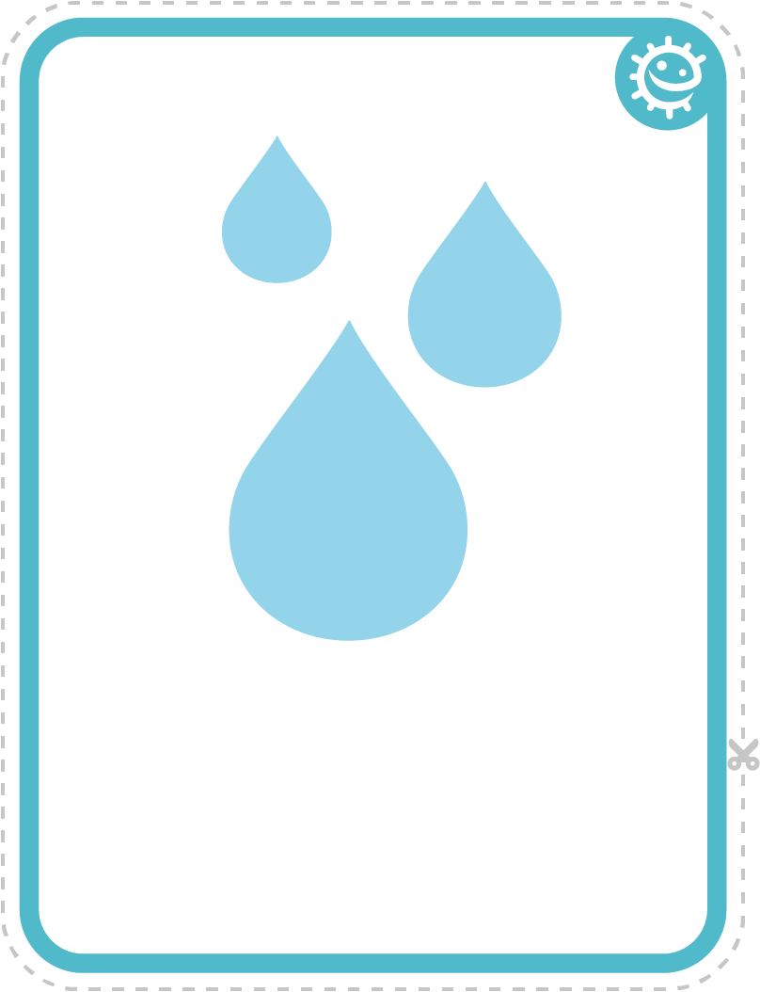
Sneeze
Water

SW1 - Picture Sequencing Activity – place hand washing in the correct order

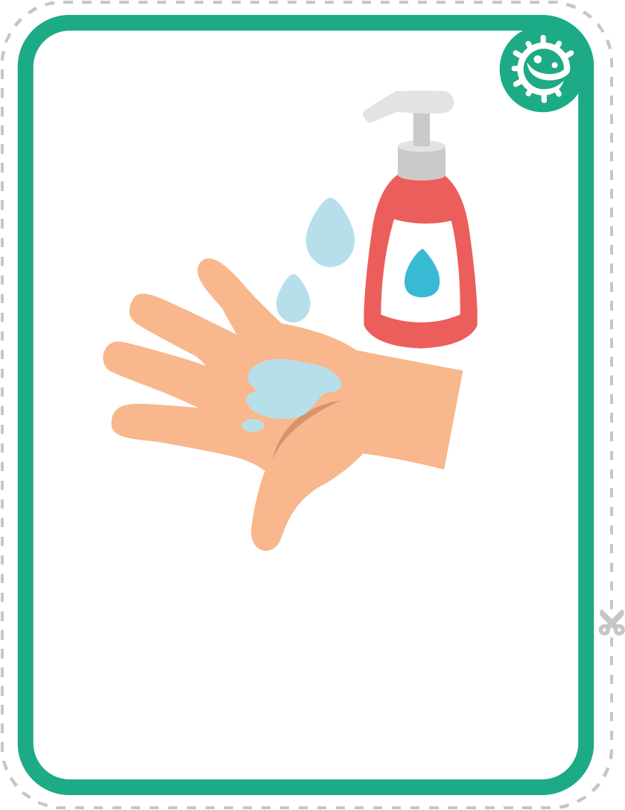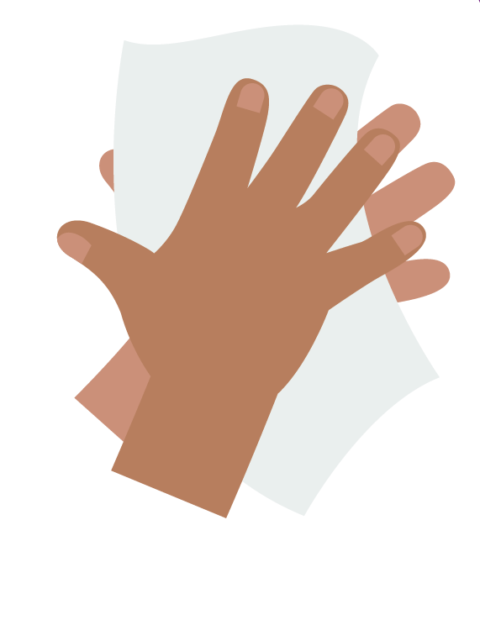
Soap
Dry hands

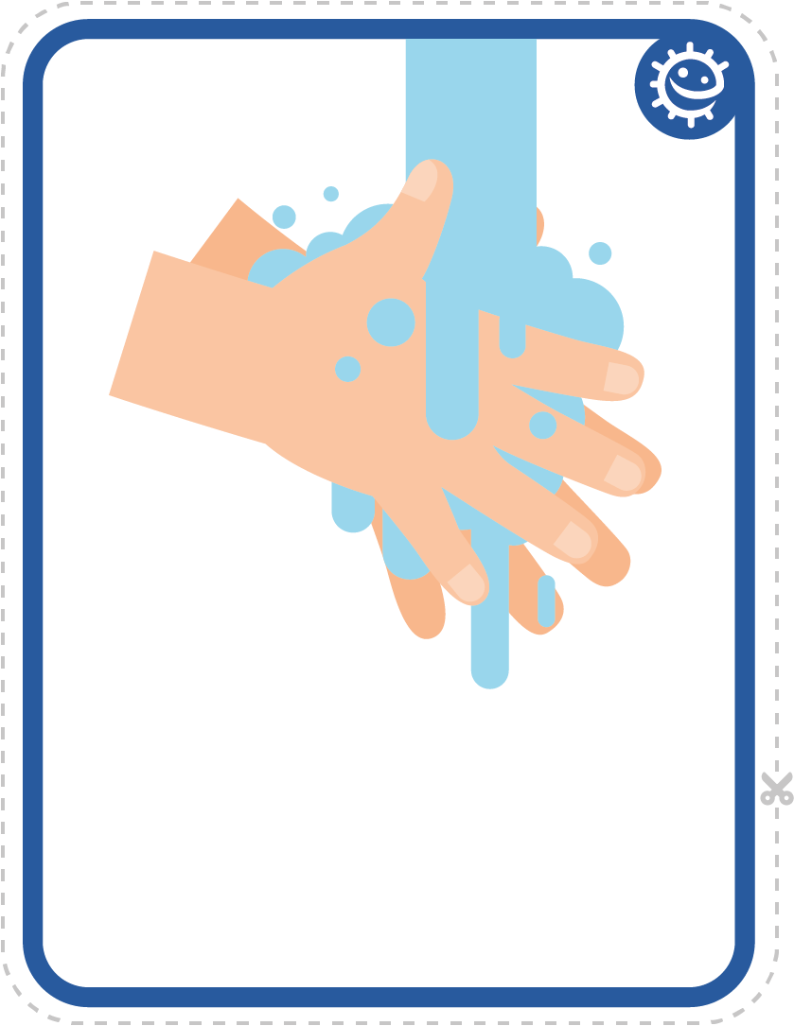
Turn on tap
Rinse hands

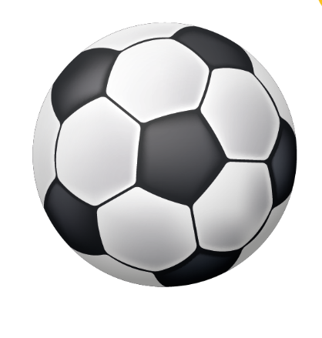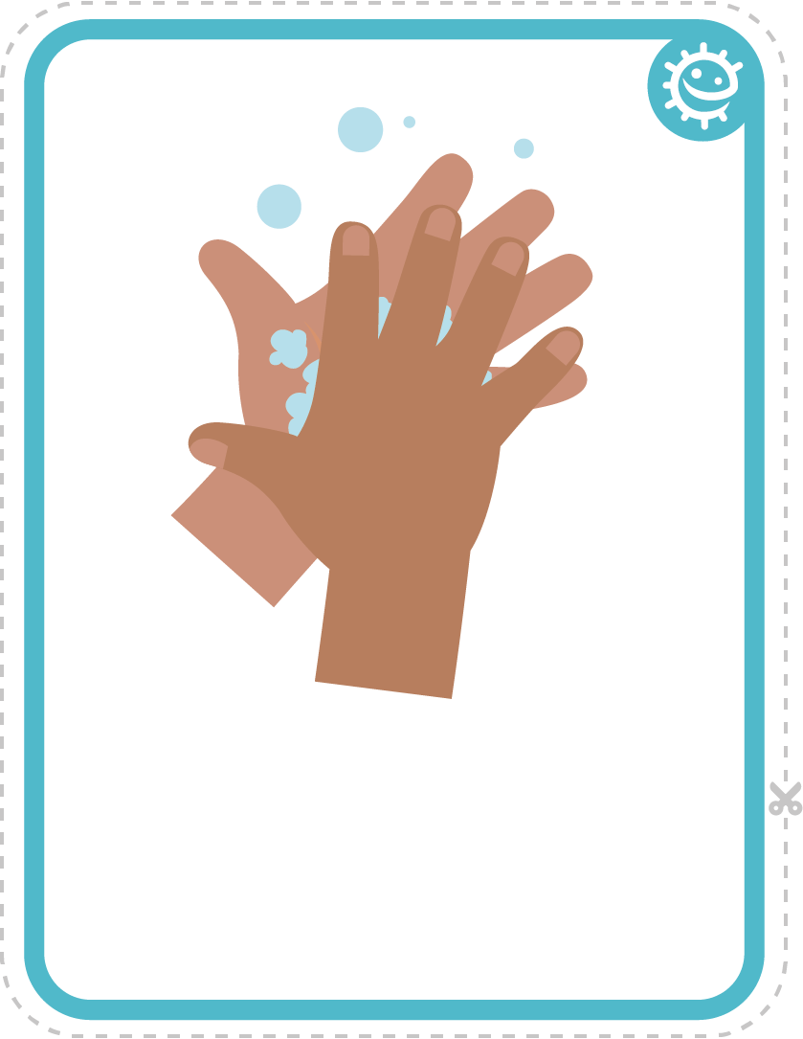
Play outside
Scrub hands


SW2 - Healthy Hands Hand Washing Chart
FRI
I washed my hands before school
I washed my hands after breaktime
I washed my hands before lunch
THU
WED
TUE

MON
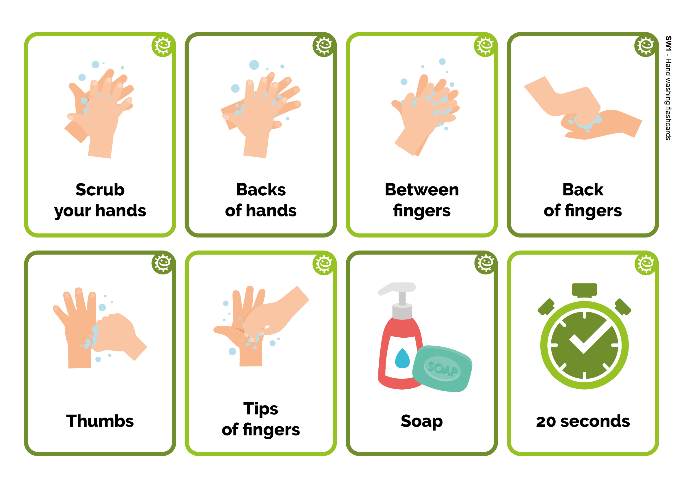
Healthy Hands Handwashing Chart
Name
Class
Add a picture or star each time you wash your hands!
SW1 – Hand Washing Flashcards
Back
of fingers
20 seconds
Soap
Backs
of hands
Scrub
your hands
Thumbs
Tips
of fingers
Between
fingers

