
Early Years

Spread of Infection: Respiratory Hygiene Teacher Guidance

Teacher Guidance
Respiratory infections are infections that happen in the lungs, chest, sinuses, nose and throat, for example, coughs and colds, the flu and pneumonia. These infections can spread from person-to-person through the air, through person-to-person contact (touching hands, hugging, kissing) or by touching contaminated surfaces. The microbes can be spread by getting into the non-infected person’s nose or eyes because they touch their face with contaminated hands. The most common mode of spreading infection is through coughs and sneezes. Sneezing is a way in which our body tries to get rid of any harmful microbes and dust particles we might inhale. The harmful microbes and dust get caught on the nose hair and tickle our nose or might irritate the back of our throat or our lungs. The nose sends a message to the brain which then sends a message back to your nose, mouth, lungs and chest telling them to blow the irritation away. In the case of colds and flu, millions of virus particles rush out and contaminate the surface on which they land; this could be our food or hands.
Colds and flu are the most common illnesses in childhood settings and perhaps among the most contagious. COVID-19 is the name of the disease caused by the virus SARSCoV-2. and can be very contagious. As colds, flu and COVID-19 are caused by viruses, they cannot be cured by antibiotics. When we catch a cold or flu rest and drinking plenty of fluids are generally recommended however, if symptoms persist then a visit to the local doctor or pharmacist is required. Symptoms of colds and flu include headache, sore throat and fever. Colds can also cause runny noses. Many sore throats associated with colds and flu are due to the viruses in the throat making it inflamed and feeling raw. Breathing in through the mouth causes the throat to feel dry and continual coughing can aggravate sore throats and contribute to an aching feeling.
Teaching good respiratory hygiene from a young age, such as covering your coughs and sneezes or regularly washing your hands for 20 seconds, can help prevent the spread of these infections. This is especially important in the approach to the winter cold/flu season each year. It is a natural reflex to put our hands towards our faces when we sneeze, but it is important to replace this action with new habits of respiratory hygiene to reduce the spread of infection:
Cover your sneezes, dispose of tissues, and regularly wash your hands.
- Catch it: cover your mouth and nose with a tissue. If you don’t have a tissue, cover with your upper sleeve or elbow (not your hands).
- Bin it: throw away the used tissue at once to avoid spreading infection to surfaces, or other people.
- Kill it: wash your hands well with soap and water, or hand sanitiser if soap and water are not available, immediately after throwing the tissue in the bin.
We can help prevent the spread of these infections (like the flu and COVID-19) by getting vaccinations. Check government links on why a different flu vaccine is needed each year.
Learning about respiratory hygiene provides a chance to talk to students about vaccinations, a vaccination they may be familiar with is the annual flu vaccine.

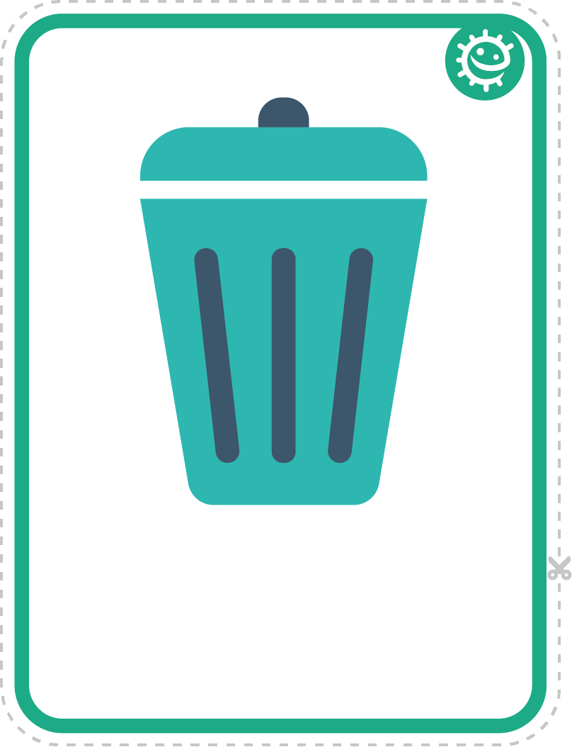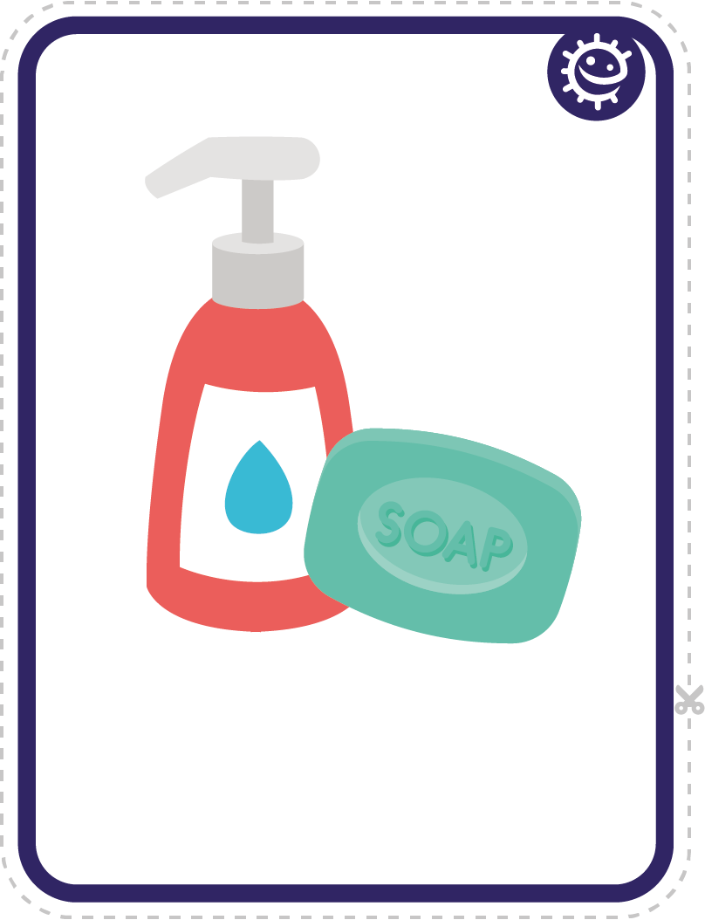

TS1 - Hand Washing and Nose Blowing Flashcards
Bin
Soap

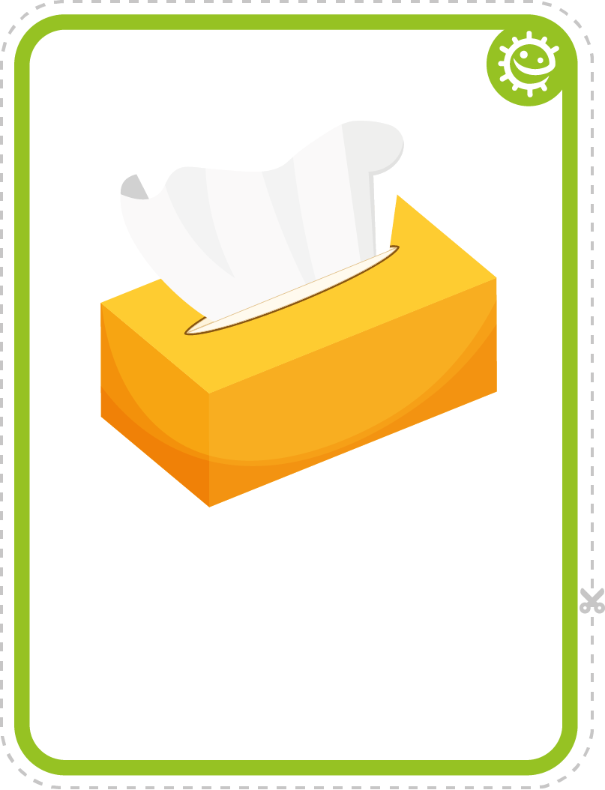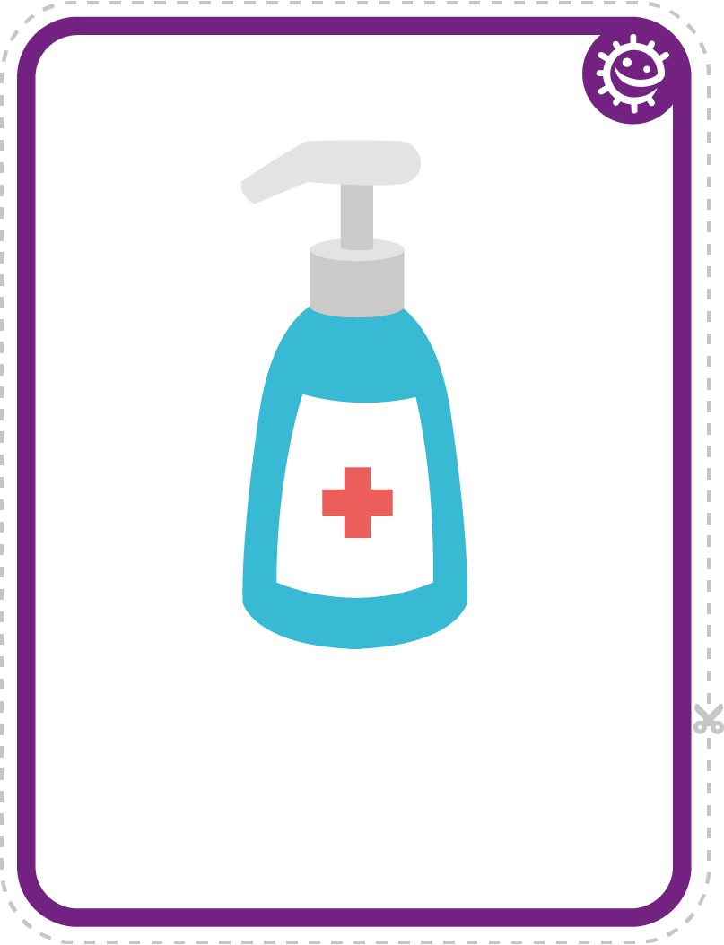
Tissue
Hand sanitiser

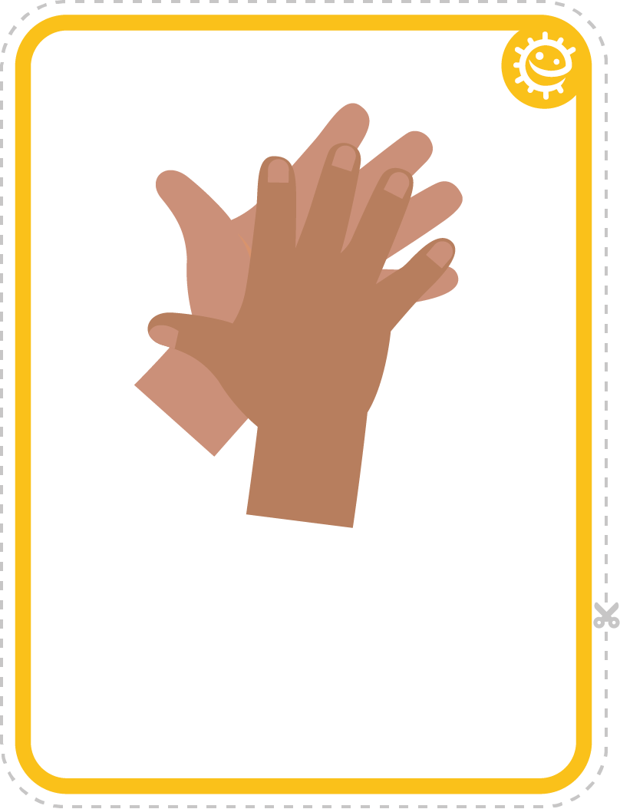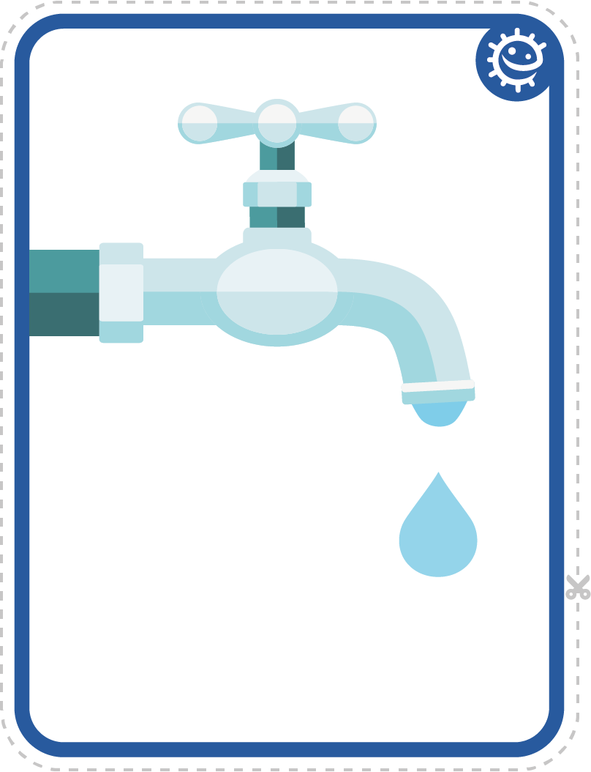
Hands
Tap

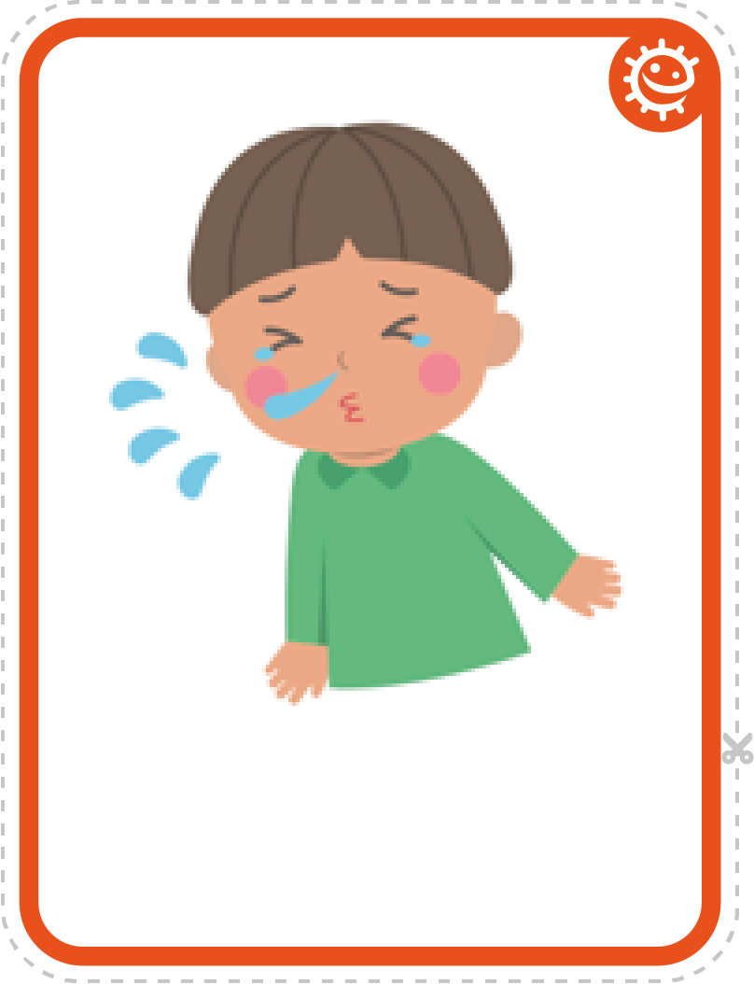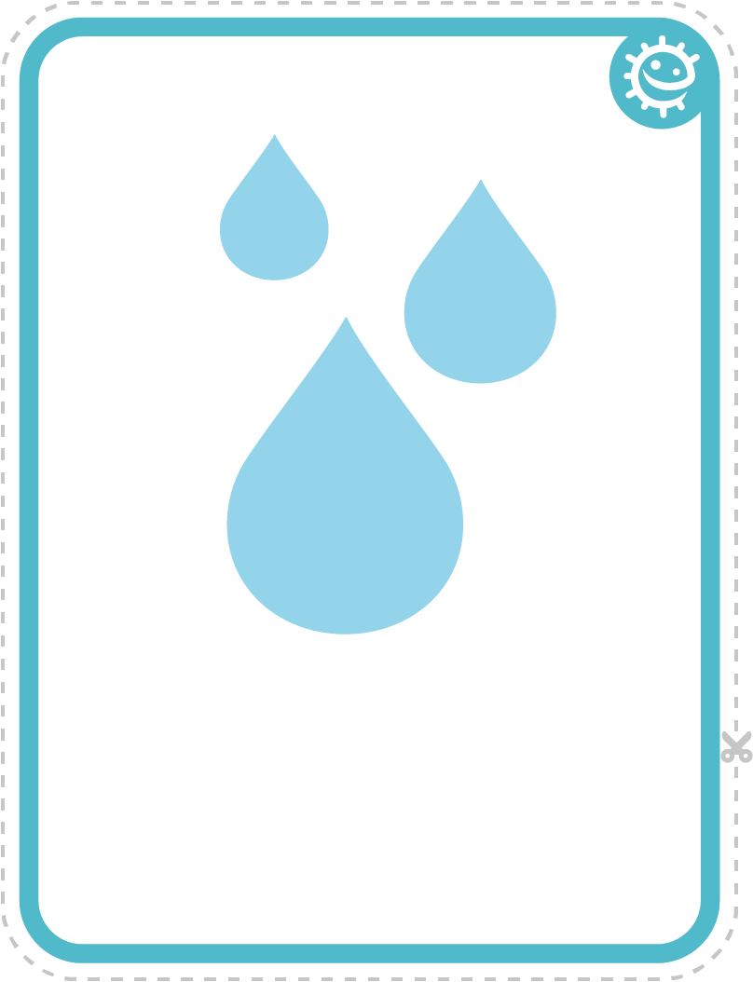
Sneeze
Water


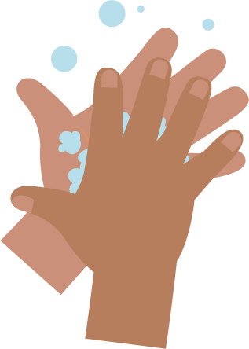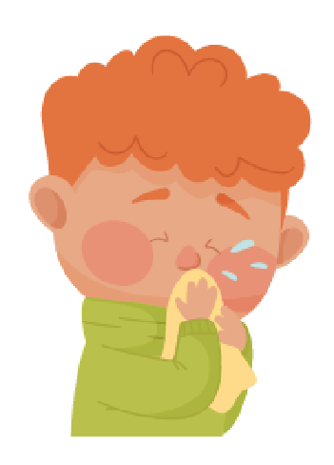
_______________________________

SW1 - Picture Sequencing Activity – place hand washing in the correct order

Blowing Your Nose

Writing Activity
Write instructions for the correct way to blow your nose.
Use the pictures below to help you.
wash hands
bin
tissue
blow
Step 1

_______________________________
Step 2

_______________________________
Step 3

_______________________________
Step 4

