SW3 - Microbe Mania Fill in the Blank Worksheet


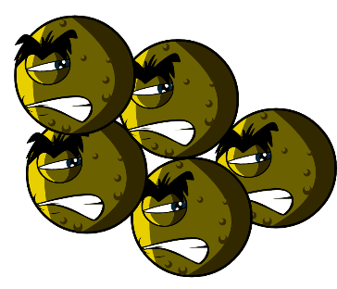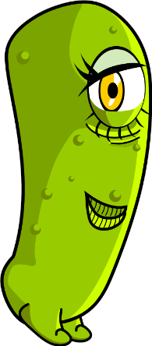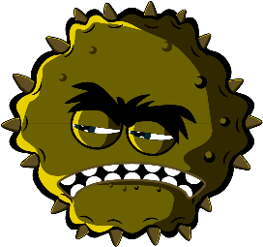

Microbes Worksheet
What have you learnt about microbes?
Complete the sentences below
Germs and bugs are also called _ _ _ _ _ _ _ _
and there are three main types.
The smallest microbe is a _ _ _ _ _ and they can make us poorly with a cough or a cold.
The largest microbe is a _ _ _ _ _ _. We use this to make bread.
Balls, rods and spirals are the three main
shapes of _ _ _ _ _ _ _ _.
Microbes are found _ _ _ _ _ _ _ _ _ _ and even in volcanoes!

