Teacher Refresher Information
Key Stage 1

Oral Hygiene
Normally our first teeth come through our gums (erupt) at around 6 months of age and we will have a full set of 20 baby (primary) teeth by the time we are 2 ½ years old. At around 6 years old our first permanent molars erupt, and the front primary teeth begin to get wobbly and fall out (exfoliate) and are replaced by the permanent (adult) teeth. On average by 12 years old we have lost all of the baby teeth and have 32 adult teeth, which if we look after, can last for the rest of our lives.
Bacteria can grow on teeth, clumping together to form a sticky substance called dental plaque. You will see this in your own mouth as a creamy line around your teeth or sometimes feel it as a furry layer with your tongue. If plaque is not brushed away regularly or there is a high frequency of sugar in the diet, the bacteria within the plaque can lead to tooth decay (caries).
When we eat sugary foods and drinks, bacteria in the plaque can use the sugars to make acid. Over time this can dissolve the outer surface of our teeth (the enamel). As more enamel is dissolved, a hole (cavity) appears. As the decay process continues, the bacteria can reach the nerve and cause toothache.
If no dental treatment is given, the tooth decay (caries) can spread and bacteria can penetrate the nerve, leading to inflammation of the bone and surrounding structures of the teeth which can result in an abscess (lump on the gum) that is filled with pus. This can make you very poorly and the tooth will usually need to be removed (extracted).
Dental health is extremely important; over 23% of children in England have tooth decay and it is the main reason for children aged 5 to 9 being admitted to hospital. The good news is that tooth decay can be prevented by limiting the number of times we eat foods and drinks with added sugar, brushing twice a day with fluoride toothpaste and regularly seeing the dentist to check the health of our teeth and gums.
Fluoride in toothpaste can help strengthen our teeth and slow down the decay process. The most important time to brush teeth with fluoride toothpaste is before going to bed at night. To make it easy to remember it is best to add tooth brushing to a twice daily hygiene routine morning and night.

Healthy Eating
In the UK, 34% of primary school children are now overweight and children are now eating three times more sugar than they should. Half of the sugar children eat comes from unhealthy snacks and sugary drinks. Fruit and vegetables are still the healthiest snack choice.


Key Stage 1

Prevention of Infection: Oral Hygiene

Lesson 4: Oral Hygiene
Students learn how plaque forms and why and how sugary food and drink can damage your teeth.

Learning Outcomes

All students will:
- Understand what dental plaque is and how it forms
- Understand the consequences of tooth decay
- Understand that limiting sugary foods and drinks can reduce tooth decay
- Understand the importance of eating healthier snacks

Curriculum Links

PHSE/RHSE
- Health and prevention

Science
- Working scientifically
- Living things and their habitats

English
- Reading & comprehension
- Writing

 Lesson 4: Oral Hygiene

Resources Required

Activity: Eggshell Experiment

Per group
- Egg shells – cracked and then cleaned out
- Clear cups
- High sugar cola
- Semi-skimmed milk or water
- High sugar juice drink
- Labels for cups

Extension Activity: Tooth Brushing Chart

Per student
- SW1 e-Bug Healthy Teeth Progress Chart

Extension Activity: Healthy Food Swaps

Per class
- TS1 Oral Hygiene True/False Quiz

Per student
- SH1 Healthy Food Choice Fact Sheet
- SH2 Oral Hygiene True or False cards
- SW2 Healthy Food Choice

Supporting Materials
- TS1 Oral Hygiene True/False Quiz
- SH1 Healthy Food Choice Fact Sheet
- SH2 Oral Hygiene True or False Cards
- SW1 e-Bug Healthy Teeth Progress Chart
- SW2 Healthy Food Choice

Advanced Preparation
- Set out 3 cups per 3-4 students and label these as 1 to 3.
- Divide up the eggshells so that each cup has one eggshell half

Lesson 4: Oral Hygiene

Key Words
Bacteria
Plaque
Cavity
Sugar
Acid
Tooth brushing
Decay
Health & Safety
Ensure students do not drink the cola, especially those who may have diabetes. Students with egg or milk allergies or intolerances must not directly handle these components.

See the e-Bug website for alternative activities.

For safe microbiological practices in the classroom consult CLEAPPS
www.cleapps.org.uk

Weblinks
e-bug.eu/eng/KS1/lesson/ Oral-Hygiene

Introduction
- Ask the students to think about their teeth; ask them what are they like (they are hard and white and shiny). Ask the students why they think their teeth are like that (so that they are strong and can chew and bite food).
- Pass around the eggshells, have the students (carefully) examine them. Ask them if they think they are like any parts of their body? The students should be able to identify that they are like their teeth. Tell the students that teeth are made of layers. The eggshell is similar to the hard layer on our teeth called the enamel.
- Explain to the students that throughout the day, germs called bacteria grow on teeth to form a sticky substance called plaque and when we eat sugary foods and drinks the bacteria uses the sugar to attack our teeth (especially the hard outer enamel layer).

Activity
- Explain to the students you will be using the eggshells to show what sugar can do to our teeth.
- Divide the class into groups of 3-4 and give them 3 cups labelled 1-3. Assist them placing one eggshell half into each cup and pouring the three drinks you’ve chosen into the cup.
  - Cola
  - Water (or milk)
  - Juice
- To see the effects, you will need to wait one day. Now, ask the students: What will happen to the egg if you leave it in the drink for a long time? Which liquid will change the egg most? Which liquid will change the egg least? You can record their guesses for tomorrow.
After one day, students will notice a discoloured and partly dissolved eggshell from the cola, an unchanged eggshell from the water (or milk), and a slightly dissolved eggshell from the juice. This demonstrates that high sugar content foods and drinks can damage the enamel.

Discussion
The next day, have the student check on their eggs. What changes can they see? Why do they think that has happened?
Tell the students that the sugar in the drinks has damaged the eggshells and made the shell discolour – remind the students that the eggshell is like the enamel on their teeth, and a lot of sugar can cause damage to their teeth.
Ask the students what they think they should do to keep their teeth healthy? Answers should include:
- Have sugary food and drinks less often and in small amounts
- Brush your teeth twice a day (before school and before bed)
- Using a fluoride toothpaste
- Spit don’t rinse
- Visit your dentist regularly

Extension Activities

Tooth Brushing Chart
SW1 is a useful way to encourage routine tooth brushing. Provide one sheet per student. Ask students to mark or draw a picture every time they brush their teeth to keep track of how often they have brushed their teeth during one school week. This can be completed in the classroom or at home.

Healthy food swaps
Begin by reminding students how the sugar in the cola effected the eggshell. Eating too much sugar is bad for you and can cause tooth decay. Around half the sugar we consume comes from unhealthy snacks and sugary drinks. That is why it is important to choose healthier snacks.
- Fruit and vegetables are a good snack choice; you can eat them on their own or with a healthy dip.
- Dried fruits have a high sugar content and they should be kept to mealtimes only.
Ask the class what their favourite fruit and vegetable snacks are. Tell students that they can swap their unhealthier foods (e.g. sugary breakfast cereals) and drinks (e.g. sugary fizzy drinks, fruit juice and smoothies, full sugar squash) for lower sugar alternatives such as low sugar yoghurt with fruit, lower fat milks, plain waters, or no-added sugar/sugar free squash.
We don’t need to worry about the sugar in whole fruits and vegetable and plain milk and plain yoghurts because this isn’t added sugar.
What other swaps can they think of? Provide students with SH1 Healthy Food Choice Factsheet to help them complete SW2 and ask students to draw their favourite food swaps on SW2.
Food items with the most green labels are considered the healthiest choices and the ideal swap.

Oral Hygiene True of False Quiz
Hand out SH2 to groups of 3 or 4 students. Ask students to cut out the cards and hold them up to answer True or False quiz contained in TS1. Answers are provided on the sheet.

Learning Consolidation
At the end of the lesson, ask the class the series of questions below as a fact checker.
- What is the sticky substance made up of bacteria that clump together on our teeth called?
Answer: Plaque
- Complete the sentence; When we consume sugary foods and drinks, this leads to an attack on our teeth that can lead to?
Answer: Tooth decay
- How many times a day should you brush your teeth with toothpaste.
Answer: At least twice
- After brushing, should you; a) spit out the toothpaste and rinse; b) spit out the toothpaste and don’t rinse?
Answer: you should spit out the toothpaste but don’t rinse (this will allow the fluoride to stay on the teeth for longer).


TS1 - Oral Hygiene True or False Quiz

Healthy Eating

What do you remember?

Are these True or False?
Dried fruits should be
eaten at mealtimes not
as a snack
True
Chocolate biscuits are
a healthier snack than
plain yoghurt and fruit
False
Biscuits contain a lot of added sugar
Lower-fat milk is a
healthier drink choice
than a sports drink
True
Sports drink can contain lots of sugar. Water or lower-fat milk are better choice
Eating too much sugar
can cause tooth decay
True

SH1 - Healthy Food Choice Fact Sheet
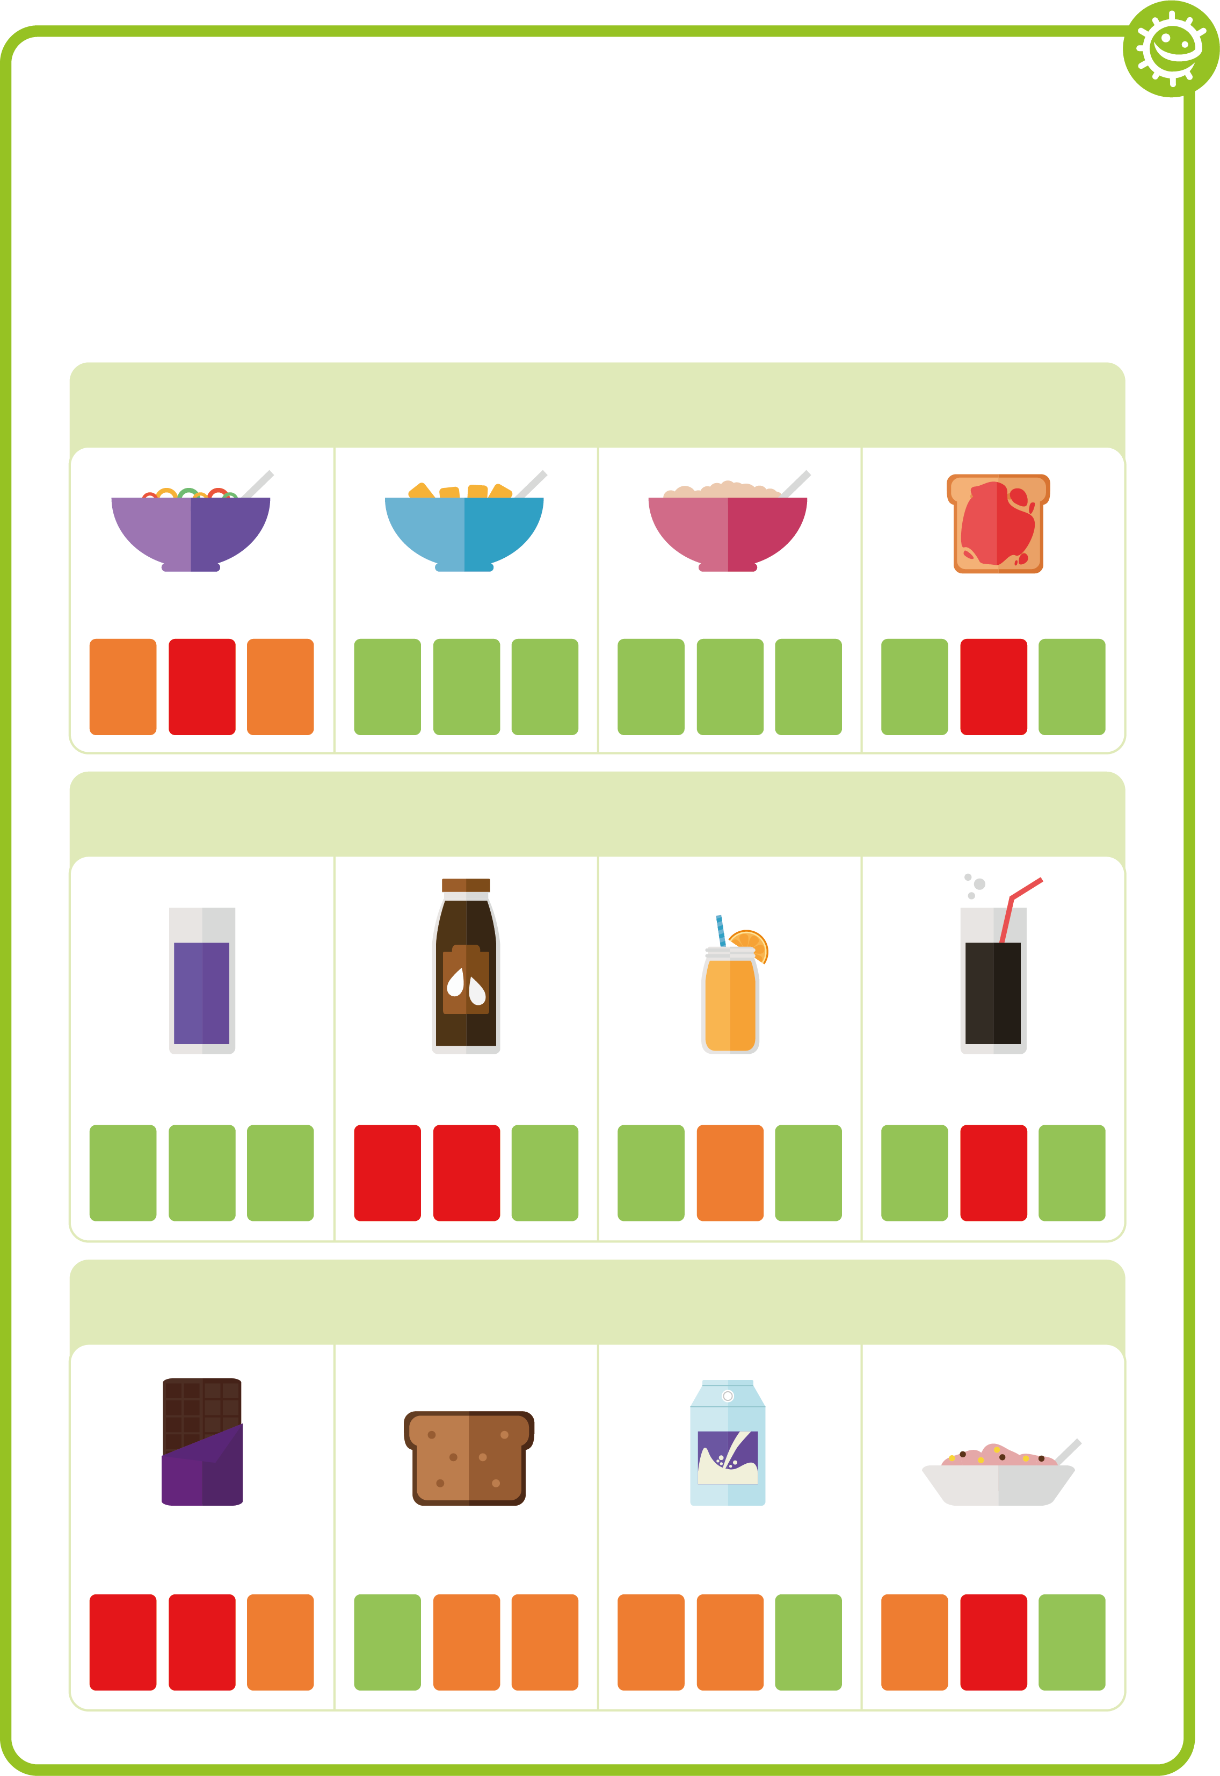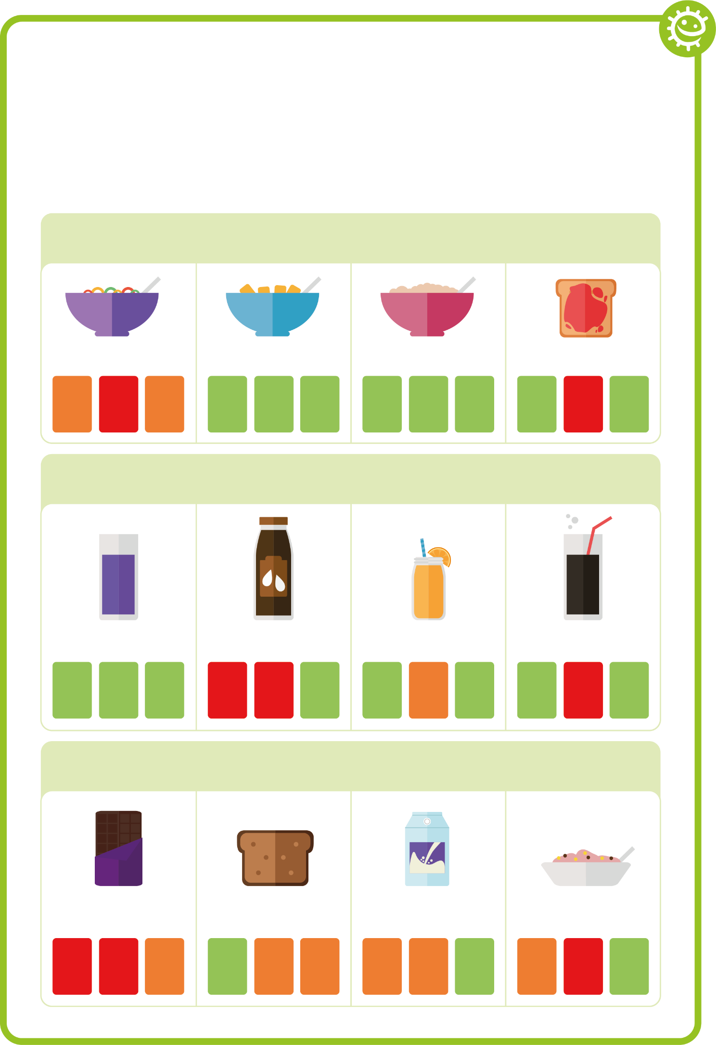

Healthy Food Choice Fact Sheet

Breakfast
Wheat biscuit cereal
Porridge
Jam on toast
High sugar cereal
sugar
fat
salt
sugar
fat
salt
sugar
fat
salt
sugar
fat
salt

Drink
No-added sugar/ sugar free squash and water
Chocolate milk
Orange juice
Full sugar cola
sugar
fat
salt
sugar
fat
salt
sugar
fat
salt
sugar
fat
salt

Snack
Malt loaf
Low sugar yoghurt
Regular yoghurt
Chocolate bar
sugar
fat
salt
sugar
fat
salt
sugar
fat
salt
sugar
fat
salt

SH2 Oral Hygiene True or False Cards
False
False
False
True
True
True

SW1 - e-Bug Healthy Teeth Progress Chart
FRI
I cleaned my teeth in the morning
I cleaned my teeth before bed
I cleaned my teeth for 2 minutes
THU
WED
TUE
MON

Healthy Teeth Brushing Chart
Name

Class

Add a picture or star each time you brush your teeth

SW2 - Healthy Food Choice Exercise

What breakfast, drink and snack would you drink to keep your teeth healthy?
Write your choice
Draw your choice

Breakfast

Drink

Snack

Lesson Four: Prevention of Infection: Oral Hygiene

SH2 Oral Hygiene True / False Quiz
- Dried fruits should be eaten at mealtimes and not as a snack – True; dried fruits contain lots of natural sugars
- Chocolate biscuits are a healthier snack option than plain yoghurt and fruit – False; biscuits contain a lot of added sugar
- Lower-fat milk is a healthier drink choice than a sports drink – True; sports drinks can contain lots of sugar. Water or lower-fat milk are better choices
- Eating too much sugar can cause tooth decay – True; bacteria on our teeth feed on the sugar which creates acid and dissolves our teeth

