

SH1 - Healthy Food Choice Fact Sheet

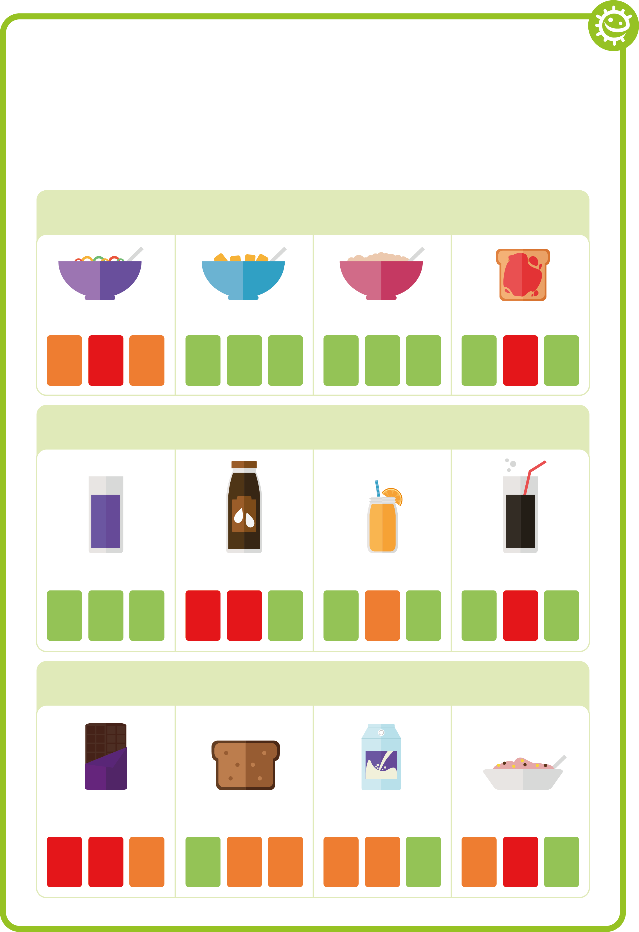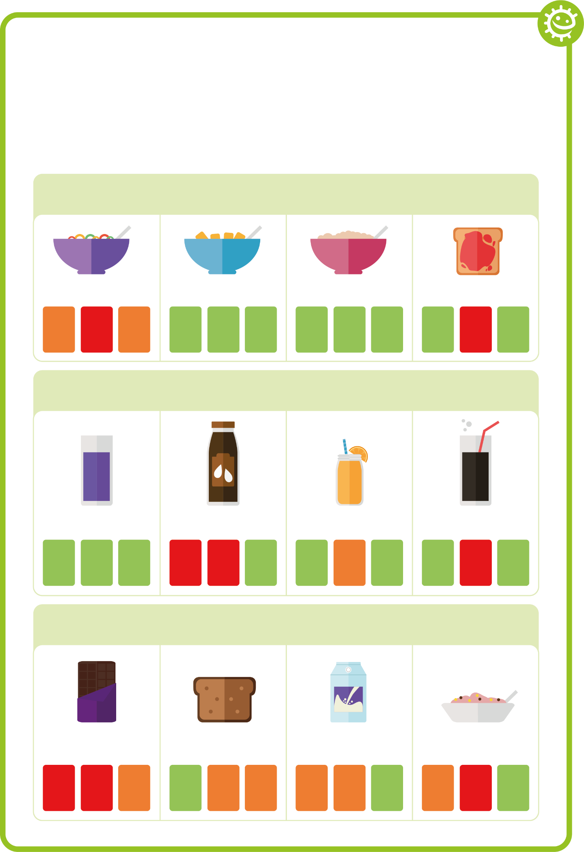

Healthy Food Choice Fact Sheet

Breakfast
Wheat biscuit cereal
Porridge
Jam on toast
High sugar cereal
sugar
fat
salt
sugar
fat
salt
sugar
fat
salt
sugar
fat
salt

Drink
No-added sugar/ sugar free squash and water
Chocolate milk
Orange juice
Full sugar cola
sugar
fat
salt
sugar
fat
salt
sugar
fat
salt
sugar
fat
salt

Snack
Malt loaf
Low sugar yoghurt
Regular yoghurt
Chocolate bar
sugar
fat
salt
sugar
fat
salt
sugar
fat
salt
sugar
fat
salt

