SH1 – Class Discussion


Discuss the types of microbes that are commonly found on or in these foods?
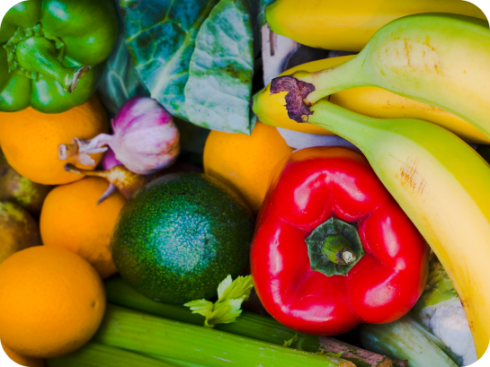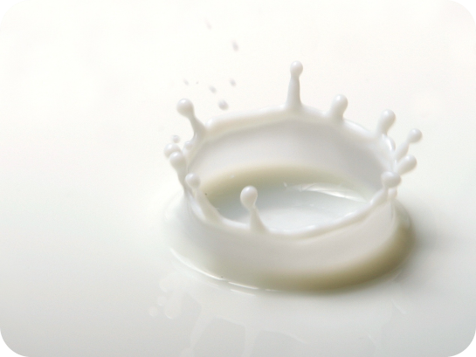
Fruit and Vegetables
Milk


Yoghurt
Bread

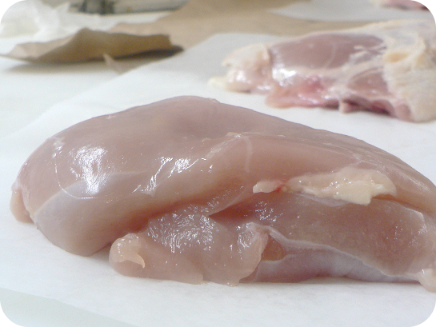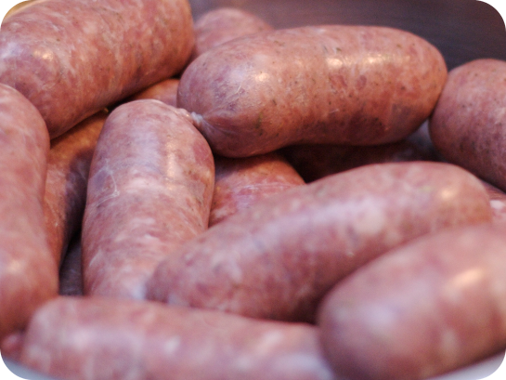
Chicken
Sausages

SH2 - Class Discussion - Answers

Answers
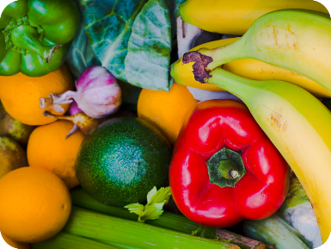
Fruit and Vegetables: Most of the microbes found on fruit and vegetables are harmless, but sometimes harmful microbes can be found in the soil in which they are grown. It is therefore important to wash all fruit and vegetables before cooking and/or eating them.

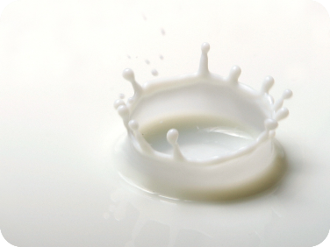
Milk: Fresh milk contains Lactobacillus Bacterium which help us digest food. There can also be harmful microbes that are removed when the milk is heated up (pasteurised) before it is sent to the shops.


Yoghurt: Yoghurt usually contains Lactobacillus
Bacterium which help us digest food.


Bread: The yeast Saccharomyces cerevisiae
helps bread to rise.

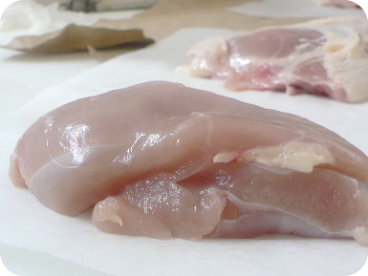
Raw Chicken: Raw chicken may contain
Salmonella, E. coli or Campylobacter Bacterium,
all of which can cause food poisoning in humans.

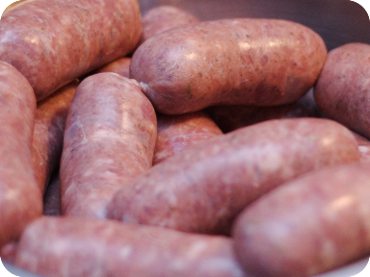
Raw Sausages: Raw meat may contain
Salmonella, E. coli Bacterium which can cause
food poisoning in humans.

