

SH3 – Fridge Raiders


Fridge Raiders

SH4 – Fridge Raiders

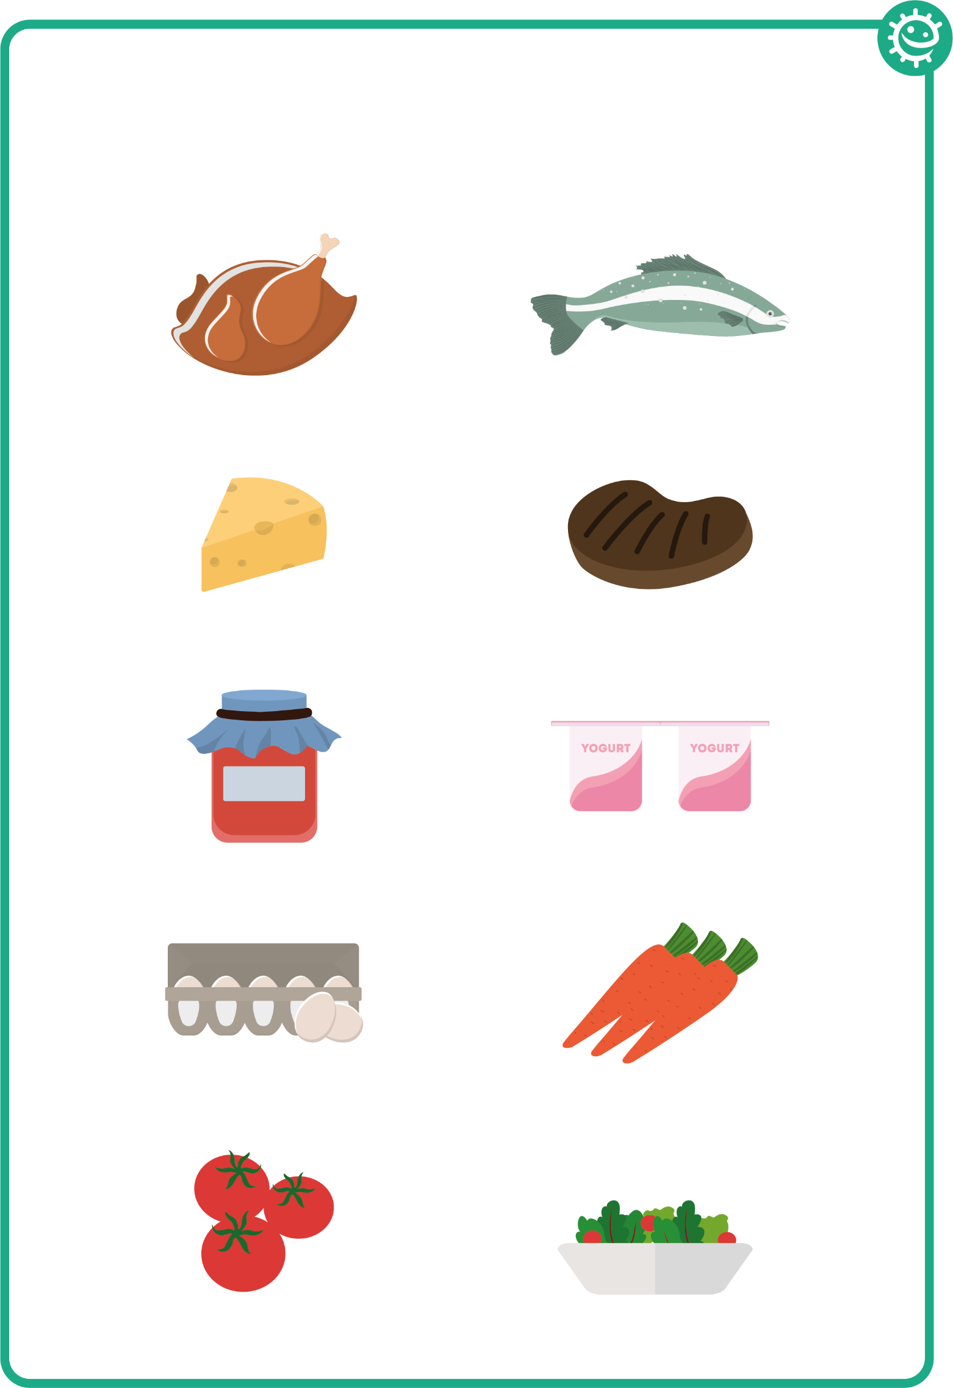

Fridge Raiders

