

SW2 - Spot the Mistakes – low ink

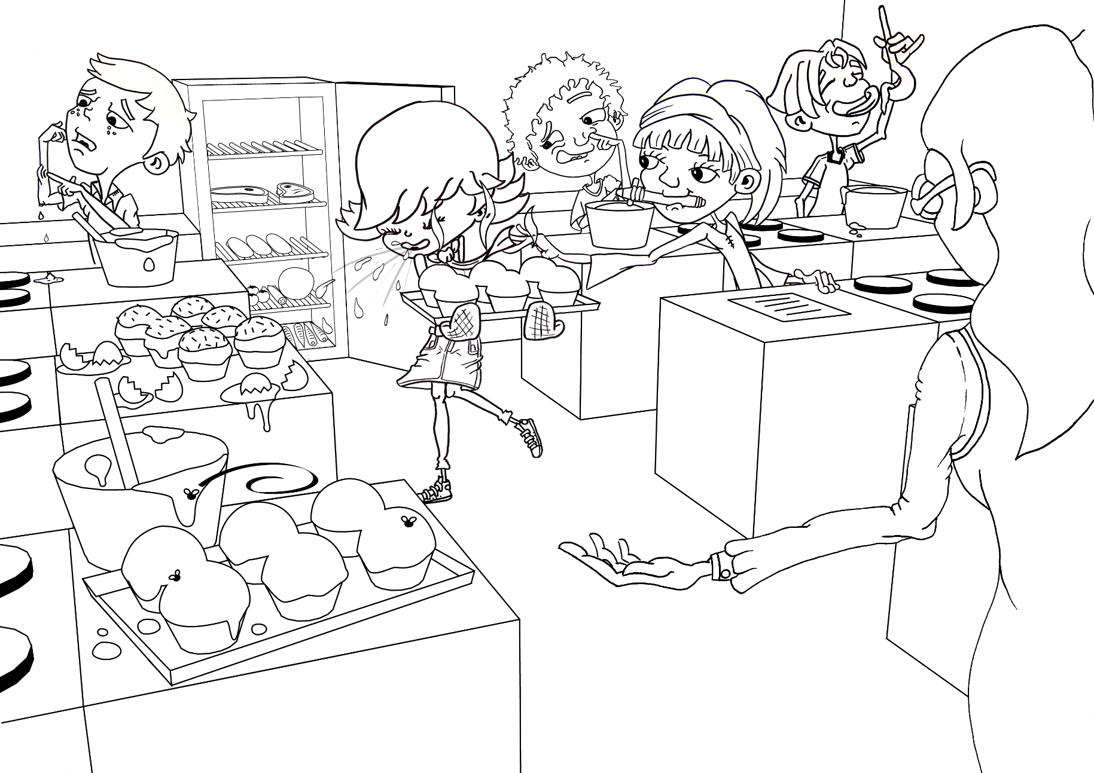
Can you circle 9 things that the students in this cookery class should not be doing and why?

SW2 - Spot the Mistakes – high ink

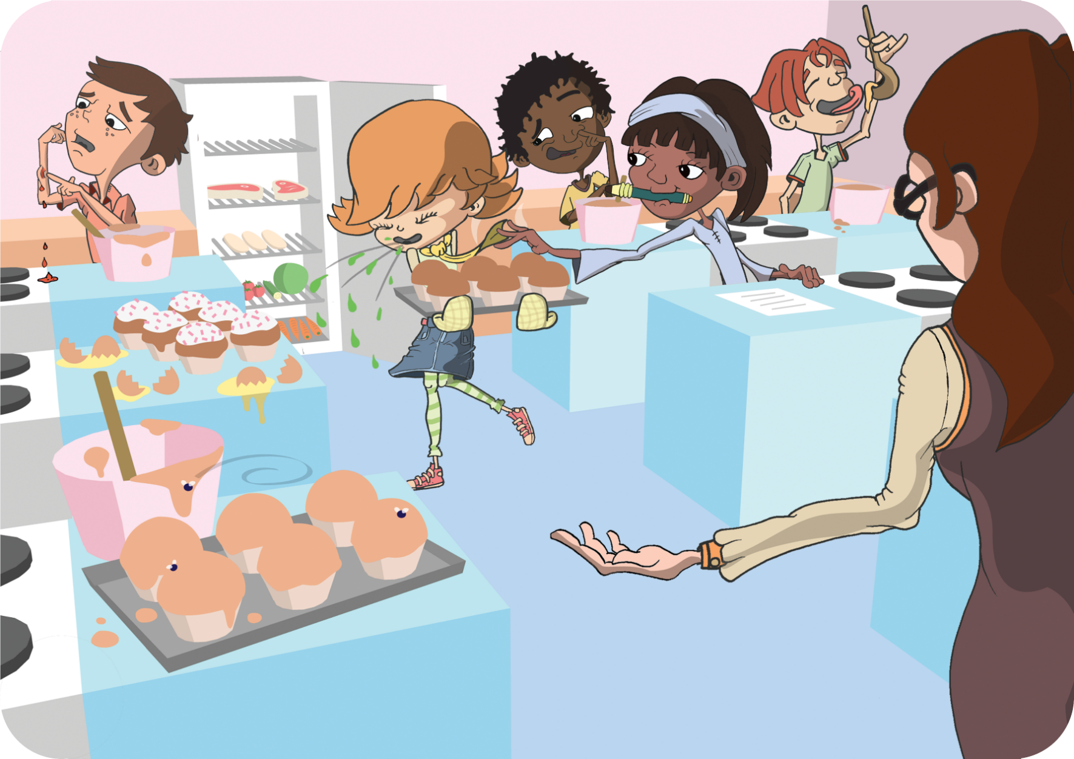
Can you circle 9 things that the students in this cookery class should not be doing and why?

