

TS1 – Fridge Raiders
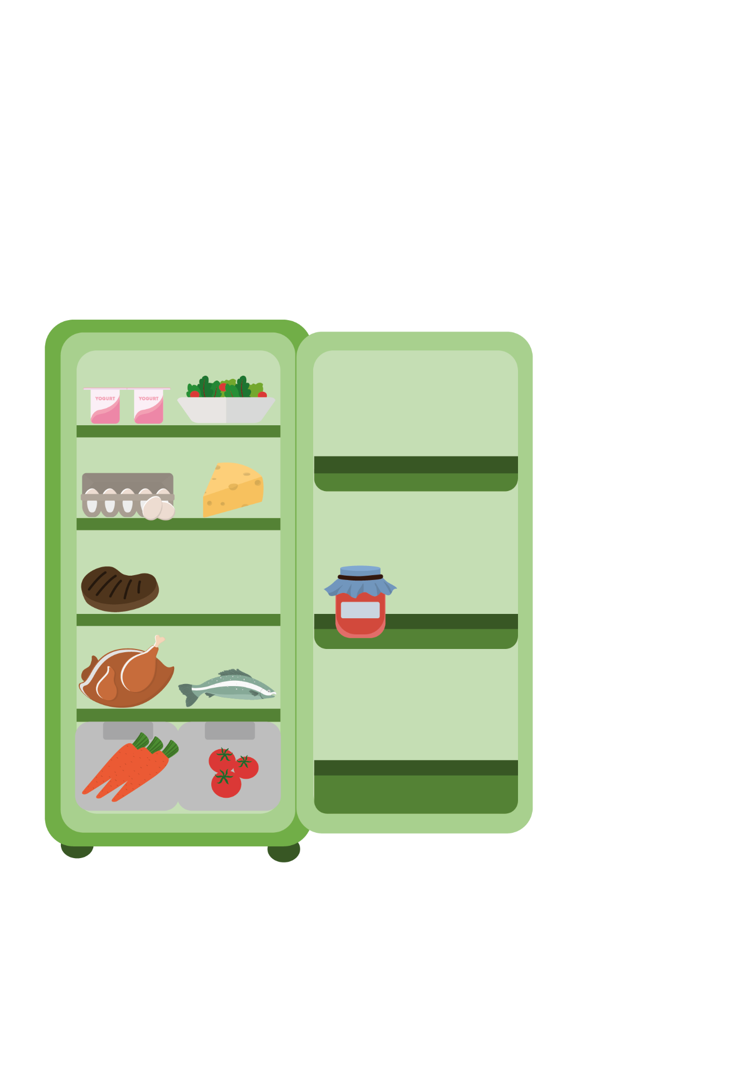

Fridge Raiders – Answer Sheet

Cooked meat should be
covered and stored away
from raw meat
Pre-prepared food, such as
this salad, should be covered
and kept in the fridge until use

Some jars of food,
for example jam,
need to be stored
in the fridge once
opened

Raw meat and fish should be covered and kept on the bottom shelf in the fridge
Store fruit and vegetables and salad in the draw at the bottom of the fridge

