 Micro-organisms: Introduction to Microbes
Key Stage 2

Lesson 1: Introduction to Microbes
Students learn about the different types of microbes – bacteria, viruses and fungi. They learn that microbes have different shapes and that they are found everywhere.

Learning Outcomes

All students will:
- Understand that bacteria, viruses and fungi are three main types of microbes.
- Understand that microbes are found everywhere

Most students will:
- Understand that microbes come in different shapes and sizes and are too small to be seen with our eyes.
- Understand that microbes can be beneficial, harmful or both.

Curriculum Links

PHSE/RHSE
- Health and prevention

Science
- Working scientifically
- Living things and their habitats

English
- Reading & comprehension

Art & Design
- Painting
- Recording observations

 Lesson 1: Introduction to Microbes

Resources Required

Starter Activity: Magazine Microbes

Per student
- A selection of magazines/ newspapers
- Crafting materials including:
- Scissors
- Glue
- Colouring pens
- A3 or large paper to make a collage

Main Activity: Designabug

Per group
- Copy of SH1
- Copy of SH2

Per student
- Copy of SW1
- Copy of SH4
- Colouring pencils
- Stickers for decoration (optional)
- Googly eyes for decoration (optional)
- Print stick/ glue (optional)

Extension Activity: What Microbe am I?

Per student
- Copy of SW2
- Copy of SH3

Extension Activity: What are Microbes?

Per student
- Copy of SW3
- Copy of SH3

Supporting Materials
- SH1 Designabug Microbe shapes
- SH2 Designabug Examples
- SH3 What are Microbes?
- SH4 How Big is a Microbe?
- SW1 Designabug
- SW2 What microbe am I?
SW3 What are Microbes Worksheet

Advanced Preparation
- Prepare a selection of magazines/ newspapers and the materials needed for the starter activity – Magazine Microbes.
- Download a variety of images of everyday items i.e. shoes, and food from various locations for student viewing.

. Lesson 1: Introduction to Microbes

Key Words
Bacteria
Virus
Fungi
Cell
Germ
Microbe
Probiotic
Microscope

Health & Safety
For safe microbiological practices in the classroom consult CLEAPPS
www.cleapps.org.uk

Weblinks
e-bug.eu/eng/KS2/lesson/ Introduction-to-Microbes

Introduction
- Begin the lesson by asking students what they already know about micro-organisms. Explain that micro-organisms, sometimes called microbes, germs or bugs, are living things that are too small to be seen with our eyes; they can only be seen through a microscope.
- Show the students that there are three main types of microbes: bacteria, viruses and fungi. Use the colour handout provided as SH1 to see example microbes.
- Explain that microbes are so small that they can only be seen through a microscope. Provide students with SH4 How Big is a Microbe to demonstrate the different sizes of microbes.
- Highlight to the class that microbes can be found EVERYWHERE: floating around in the air we breathe, on the food we eat, on the surface of our bodies, in our mouth, nose and gut/tummy.
- Explain to the students that some diseases called infections are caused by microbes. Ask the children if they, or anyone in their family, have ever been sick? What was the disease and what do they think caused it?
- Emphasise that although some microbes cause disease, there are also microbes that can be very useful. Ask students to identify some useful microbes. If they cannot, provide examples for them e.g. Lactobacillus in yoghurt and probiotics drinks, Penicillin from fungi, yeast in bread, etc.

Activity

Starter Activity: Magazine Microbes (10-20 mins)
This activity can be carried out either individually or in groups.
- Provide the students with magazines.
- Ask students to look through the magazines and find images of places where microbes can be found (i.e. a picture of a fridge, people, kitchen worktop, shoes, clothes etc.)
- Ask students to cut out the images using scissors and stick onto an A4 piece of paper to make a collage with the title “Where can microbes be found?”
- If time permits and students are comfortable to they can present their posters to the rest of the group.
This will help students understand that microbes are found everywhere.

Main Activity: Designabug
This activity allows students to explore the different types of microbes present in the world by designing their own microbe. An example of the activity can be found in SH2. Provide each group with SH1 and each student a copy of SH2.
- Ask students to decide which microbe bacterium, a virus, or a fungus they want to design.
- And then decide which microbe shape they would like it to be. Use SH1 to help choose a microbe and shape, and SH4 to help students understand the scale of microbes.
- Ask students to decide whether they want their microbe to be a useful or harmful microbe. This will help students understand that microbes are found everywhere.
- Ask students to add some details to their microbe depending on whether they've chosen a useful or harmful microbe to design, this could be eyes, a smile, big bushy eyebrows or long wobbly arms.
- Ask students to give their microbe at least two special features and a strength or weakness.
- Ask students to provide a backstory about their microbe, this could include where this microbe lives and what they like to do.
- Finally, ask students to name their microbe, this could be a combination of their own name and the microbe shape.
At the end of the activity provide students with examples of realist microbes so they can compare their own designed microbes with real microbes that exist in the world. You can use SH1 for real microbe examples.

Discussion
At the end of the activity, explain to the participants that microbes are found everywhere even on the magazine they were looking through. Stress that microbes are found all over our skin, mouth, gut and hands. Most are completely harmless that we carry without knowing.

Discuss that the bacteria on our bodies are important as they act as a barrier to stop other more harmful bacteria entering your body and making you ill.

Fascinating Fact
Antonie van Leeuwenhoek created the first ever microscope in 1676. He used it to examine various items around his home and termed the living creatures (bacteria) he found on scrapings from his teeth ‘animalcules’.

Extension Activities

What Microbe am I?
Provide each participant with a copy of SW2 and SH3. Ask students to read the descriptions and using the information on SH3 students should decide whether the microbes are bacteria, virus or fungi.

The answers are as follows:
- Staphylococcus is a bacterium
- Lactobacillus is a bacterium
- Dermatophytes are fungi
- SARS-CoV-2 is a virus
- Penicillium is a fungus
- Campylobacter is a bacterium

What are Microbes? Fill in the Blanks Worksheet
Provide each student with a copy of SW3. Ask students to fill in the blanks using the correct words provided. Students can complete this in class or as a homework activity.

Learning Consolidation
At the end of the lesson, ask the class the questions below to check understanding:
- What are 3 main types of microbe?
Answer: Bacteria, viruses and fungi
- All microbes can be seen by the naked eye, True/False?
Answer: False
- On what objects can microbes be found? Answer: Microbes are found everywhere Are microbes useful, harmful or both?
Answer: Both

SH1 – Designabug Types and Shape Outlines



Designabug
Microbe Types and Shape Outlines

Virus
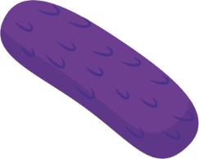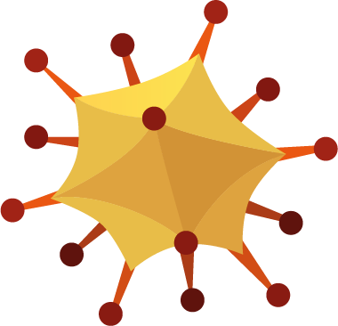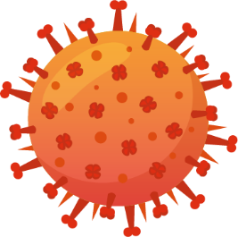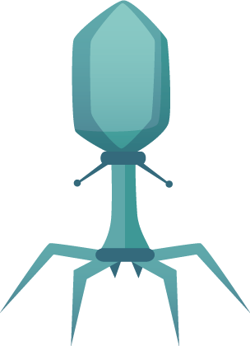
Polyhedral
Enveloped
Complex

Fungi
The life cycle of a mushroom
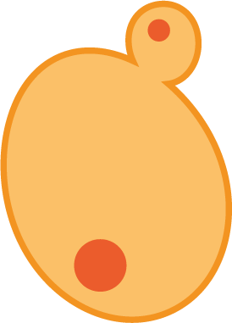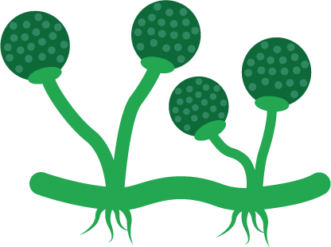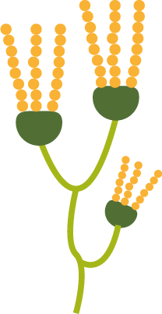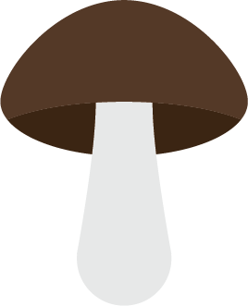

Bacteria

Coccus
Diplococci
Streptococci
Staphylococci
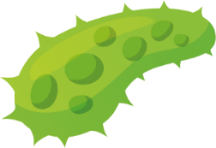
Bacillus
Diplobacilli
Vibrio
Corkscrew’s form
Borrella burgorferi

Streptobacilli

SH2 – Designabug Example

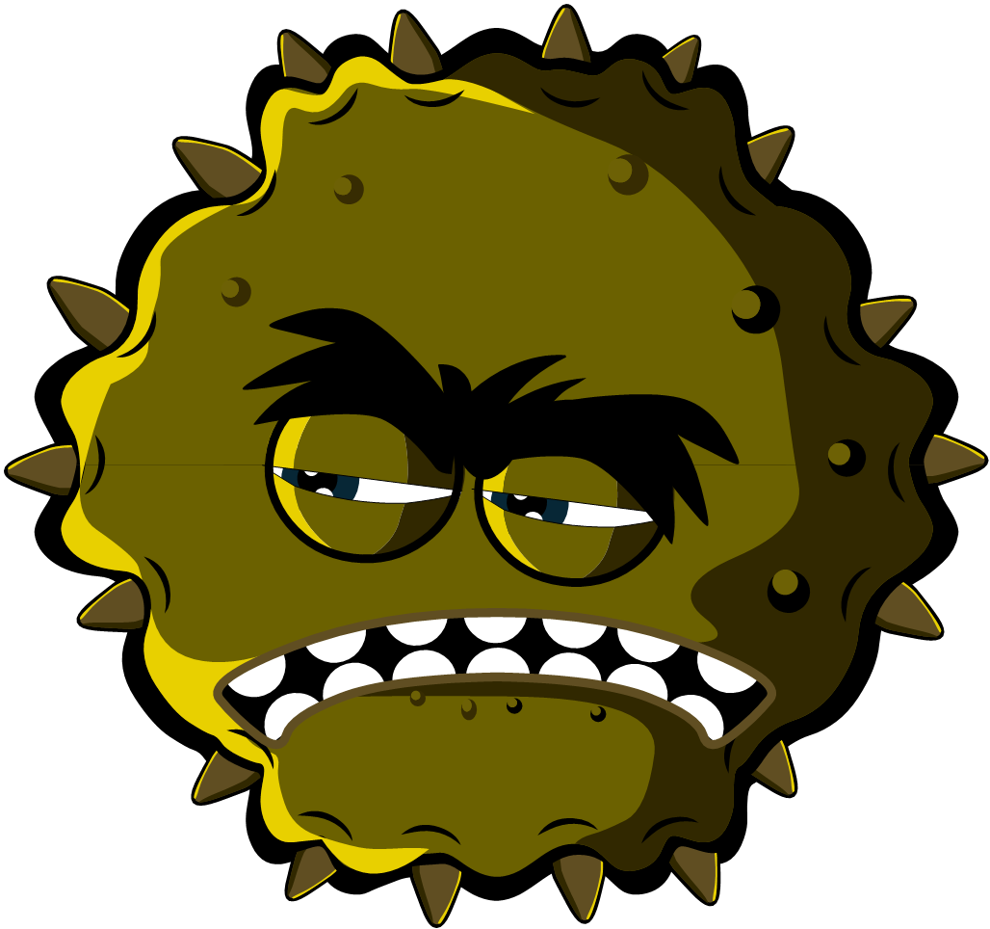
Microbe name
_{Charlotte Sneezysnot}

Designabug
_{Virus}
Microbe type
Useful of Harmful
_{Harmful}
I am a harmful virus and I like to live in your nose. My super sticky grippers help me stick to your nose cells. You don’t want me there because I make you sneeze and cough.
Microbe Story
Special Features
Lots of sticky grippers all around my body and I’m very small
Strength/Weakness
I need to live in your cells do don’t sneeze in a tissue and throw me in the bin – I’ll die

SH3 – What are Microbes?
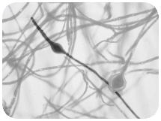
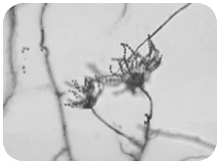
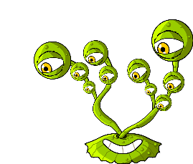
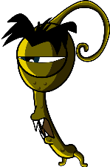
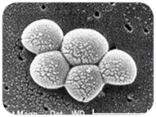
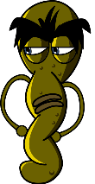

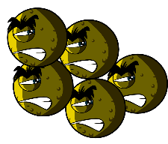
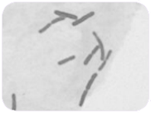
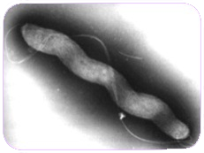
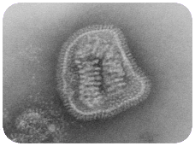
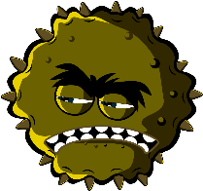
Fungi are the largest of all microbes.
Fungi can be found in the air, on plants and in water.
Mould, which grows on bread, is a type of fungus.
Some antibiotics are made by fungi.
Dermatophyte
Penicillium
Fungi
Bacteria are so small that 1000s could fit on the full stop at the end of this sentence.
Some bacteria are helpful in cooking, for example, making yoghurt and cheese.
Some bacteria are harmful and cause infection.
Bacteria multiply very fast..
Balls
(Staphylococcus)
Rods
(Lactobacillus)
There are three different types of bacteria.
They look like:
Bacteria
Spirals
(Campylobacter)
Viruses
Influenza
Viruses are even smaller than bacteria and can sometimes live INSIDE bacteria.
Some viruses make us sick.
Diseases like CHICKENPOX and the FLU are caused by viruses.
Viruses can spread from one person to another but it depends on the type of virus.

What are Microbes?
- They are found EVERYWHERE!
- Some microbes are useful or even good for us
- Some microbes can make us ill
- Microbes are living organisms
- They are so small we need a microscope to see them
- They come in different shapes and sizes
There are 3 different types of microbes:

SH4 – How Big is a Microbe

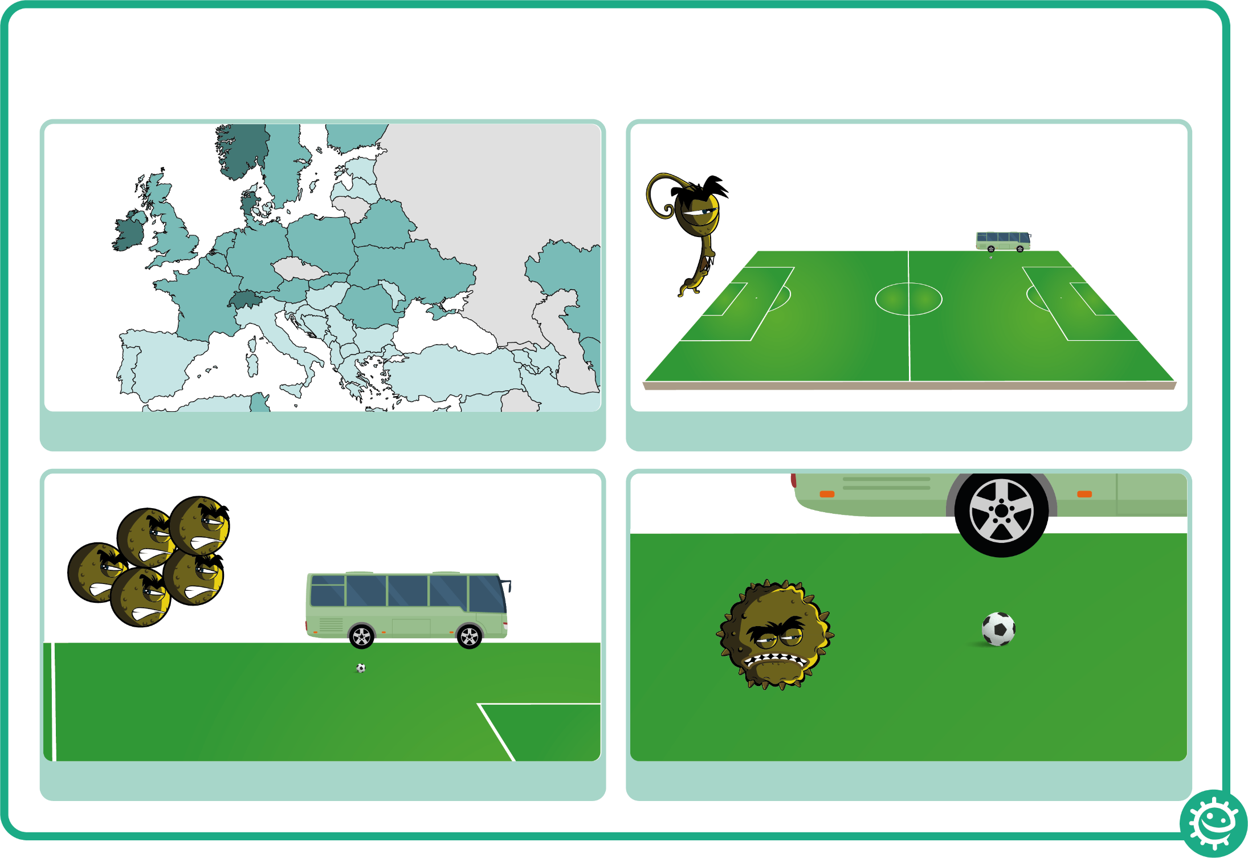

How Big is a Microbe?
2. A fungus would be the size of a football pitch
4. A virus would be the size of a football
3. A bacterium would be the size of a bus
1. If you were as big as Europe..

SW1 – Designabug Worksheet

Microbe name

Designabug

Microbe type
Useful of Harmful

Microbe Story
Special Features

Strength/Weakness



SW2 – What Microbe am I?

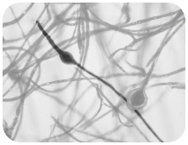
My name is Campylobacter. I have a pretty spiral shape and I like to live in chickens but if I get into your tummy I make you very ill – I can give you diarrhoea. What am I? Campylobacter is a ______________________
I’m called a Dermatophyte and I like to live on your skin. I especially like living in damp places like between the toes on sweaty feet. When I live there I give people athlete’s foot. What am I? Dermatophytes are:
______________________

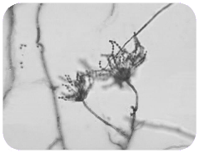
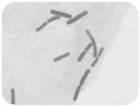
My name is Penicillium and you’ll find me growing on old oranges or stale bread making them look mouldy. Humans use me to make
an antibiotic known as Penicillin which can make them better, but only from bacterial infections. What am I? Penicillium is a:
______________________
My name is Lactobacillus. People call me ‘friendly’ because I change milk into yoghurt. When you eat me in yoghurt I live in your
guts and help you digest other food. What am I?
Lactobacillus is a:
______________________

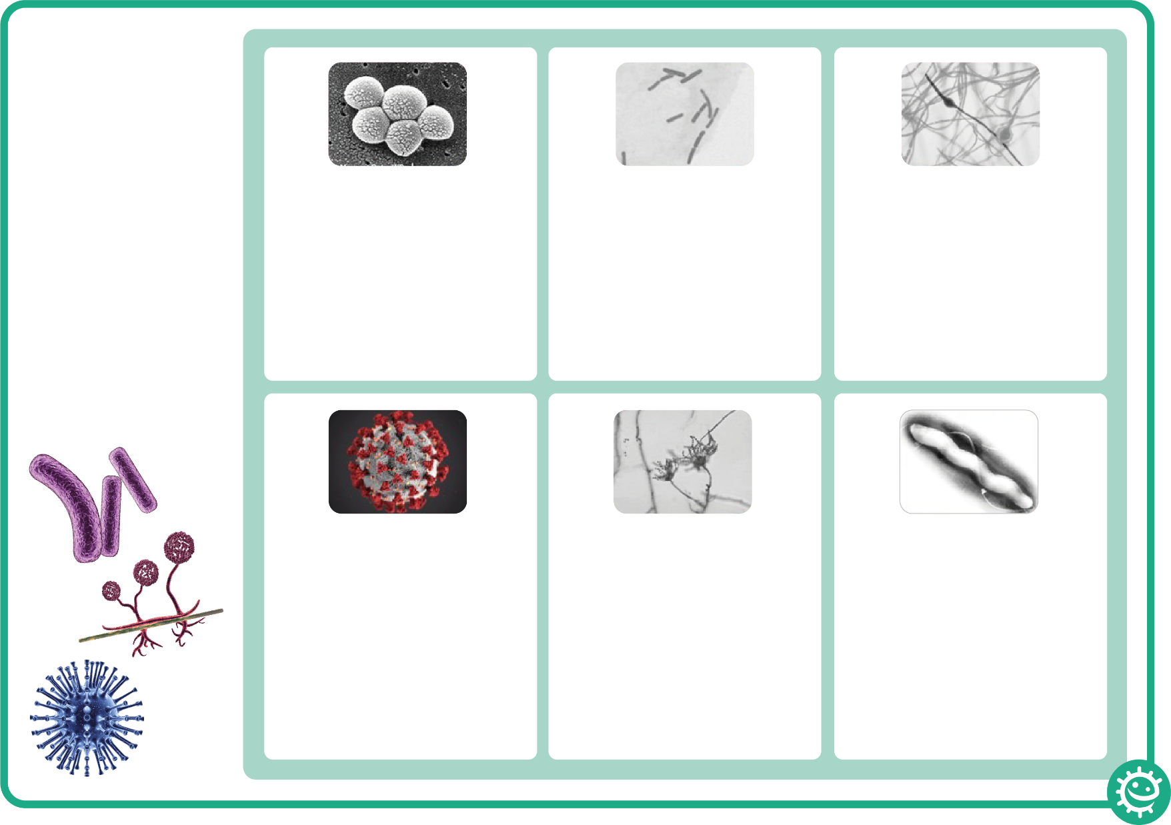
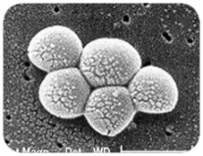
My name is SARS-CoV-2
although some people call me Covid-19. People don’t really like me because I can make them really ill. I easily spread from person to person through coughing and sneezing. What type of microbe am I? SARS-CoV-2 (COVID-19) is:
______________________
My name is Staphylococcus. I am round in shape and I like to live in your nose or armpit. If I live on your skin I can give you spots. If I get into your bloodstream I can
make you ill. What am I?
Staphylococcus is a:
______________________

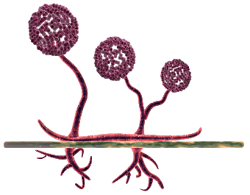
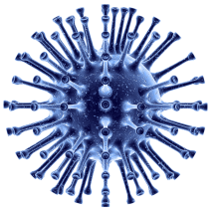
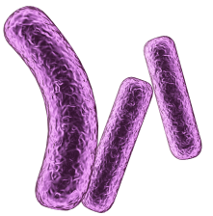

What Microbe am I?
There are 3 different
types of microbe –
bacteria, viruses
and fungi.
From the pictures and
descriptions, can you
work out which
microbe is which?

SW3 – What are Microbes Worksheet

What are Microbes?
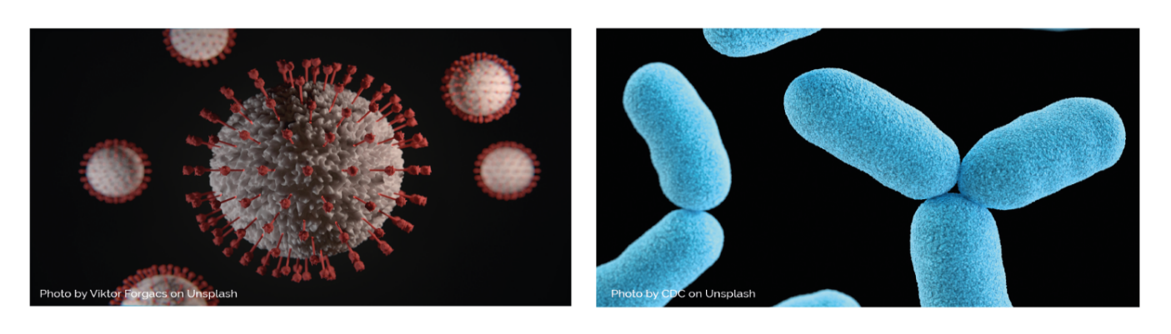
______________, more commonly known as germs, bugs or microbes, are
tiny living things too small to be seen with the naked eye. They are found
almost everywhere on earth.
Some microbes are useful, and others can be harmful to humans. There
are ______ main groups of microbes:
__________ are the smallest of the three microbes described and can be
harmful to humans. Viruses cannot survive by themselves. They need a
‘host’ cell to survive. Once inside the host cell, they rapidly multiply and
destroy the cell in the process. One type of virus is SARS-CoV-2.
Fungi are the largest of the three microbes described and are multicellular
organisms (made up of more than one cell). Some fungi are useful,
and some can be harmful to humans. For example, Saccharomyces is a
_________ that is used to help bread rise.
Bacteria are ____________________organisms that are smaller than fungi
but larger than viruses. They can be divided into three main groups by their
shapes – cocci (balls), bacilli (rods) and spirals. Cocci can also be broken
down into three groups by how the cocci are arranged: staphylococci
(clusters), streptococci (chains) and diplococci (pairs). These shapes can be
used to identify the type of infection a patient has. If a single bacterial cell
was scaled up 5,000 times it would be the size of a garden ______.
Words to use: Viruses, pea, micro-organisms, single-celled, three, yeast

