

SH4 – How Big is a Microbe

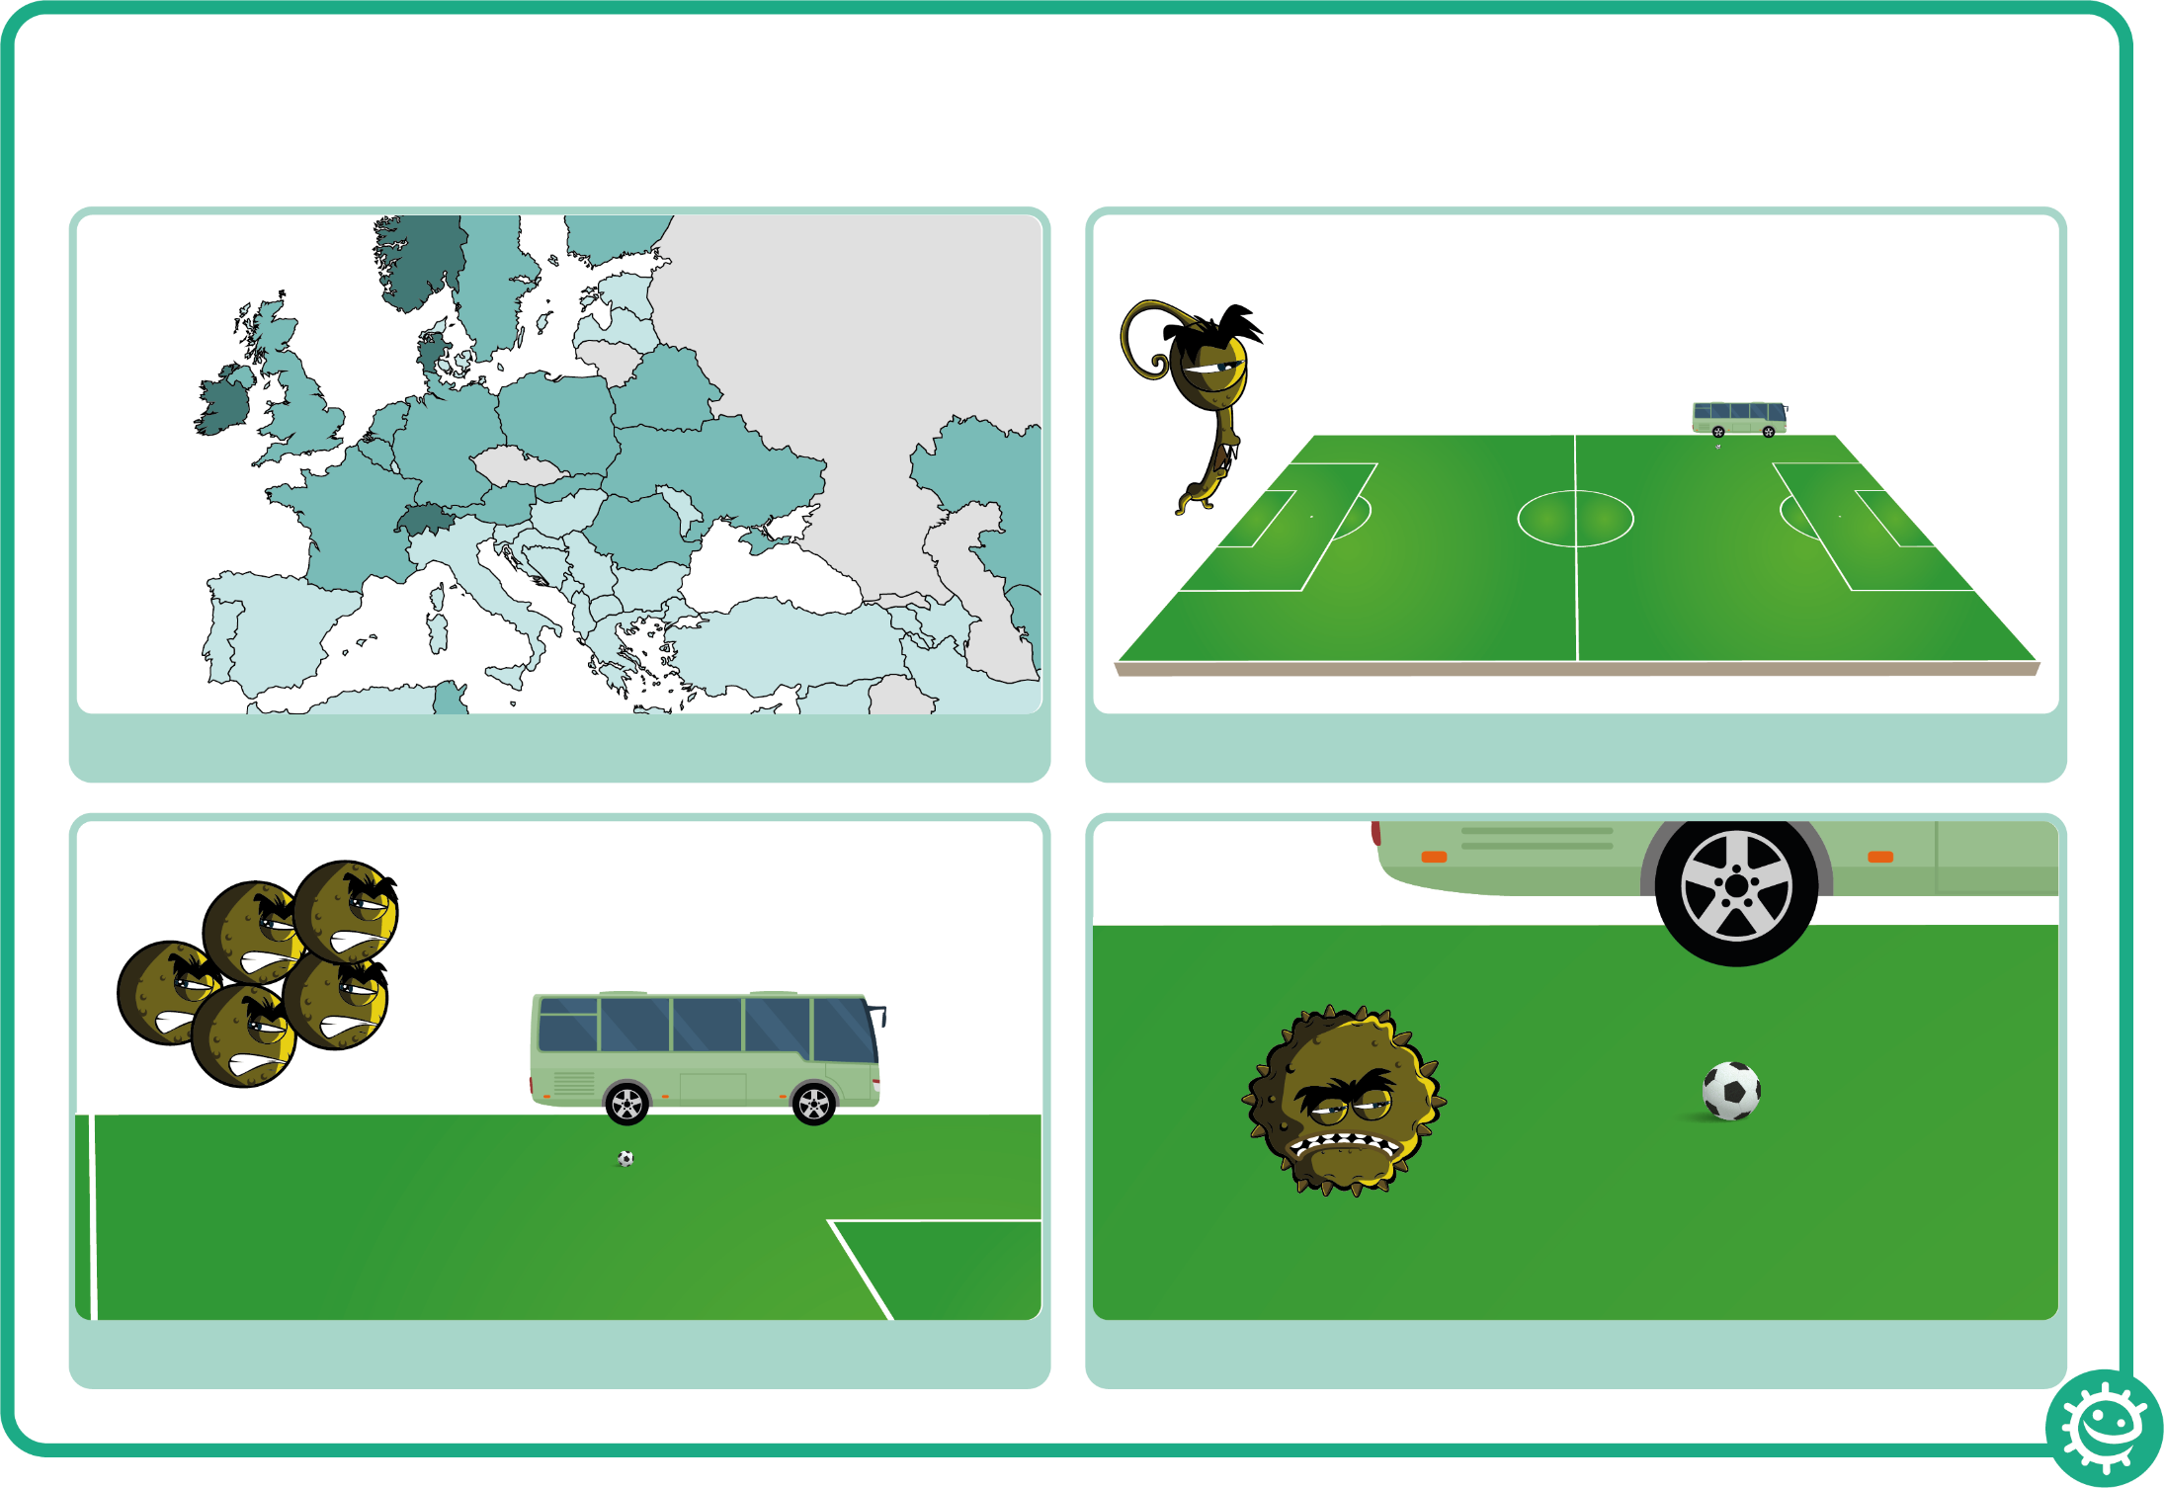

How Big is a Microbe?
2. A fungus would be the size of a football pitch
4. A virus would be the size of a football
3. A bacterium would be the size of a bus
1. If you were as big as Europe..

