

SW2 – What Microbe am I?

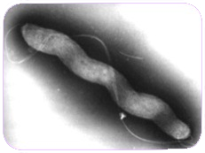
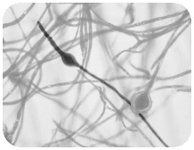
My name is Campylobacter. I have a pretty spiral shape and I like to live in chickens but if I get into your tummy I make you very ill – I can give you diarrhoea. What am I? Campylobacter is a ______________________
I’m called a Dermatophyte and I like to live on your skin. I especially like living in damp places like between the toes on sweaty feet. When I live there I give people athlete’s foot. What am I? Dermatophytes are:
______________________

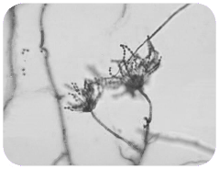
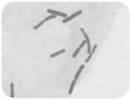
My name is Penicillium and you’ll find me growing on old oranges or stale bread making them look mouldy. Humans use me to make
an antibiotic known as Penicillin which can make them better, but only from bacterial infections. What am I? Penicillium is a:
______________________
My name is Lactobacillus. People call me ‘friendly’ because I change milk into yoghurt. When you eat me in yoghurt I live in your
guts and help you digest other food. What am I?
Lactobacillus is a:
______________________

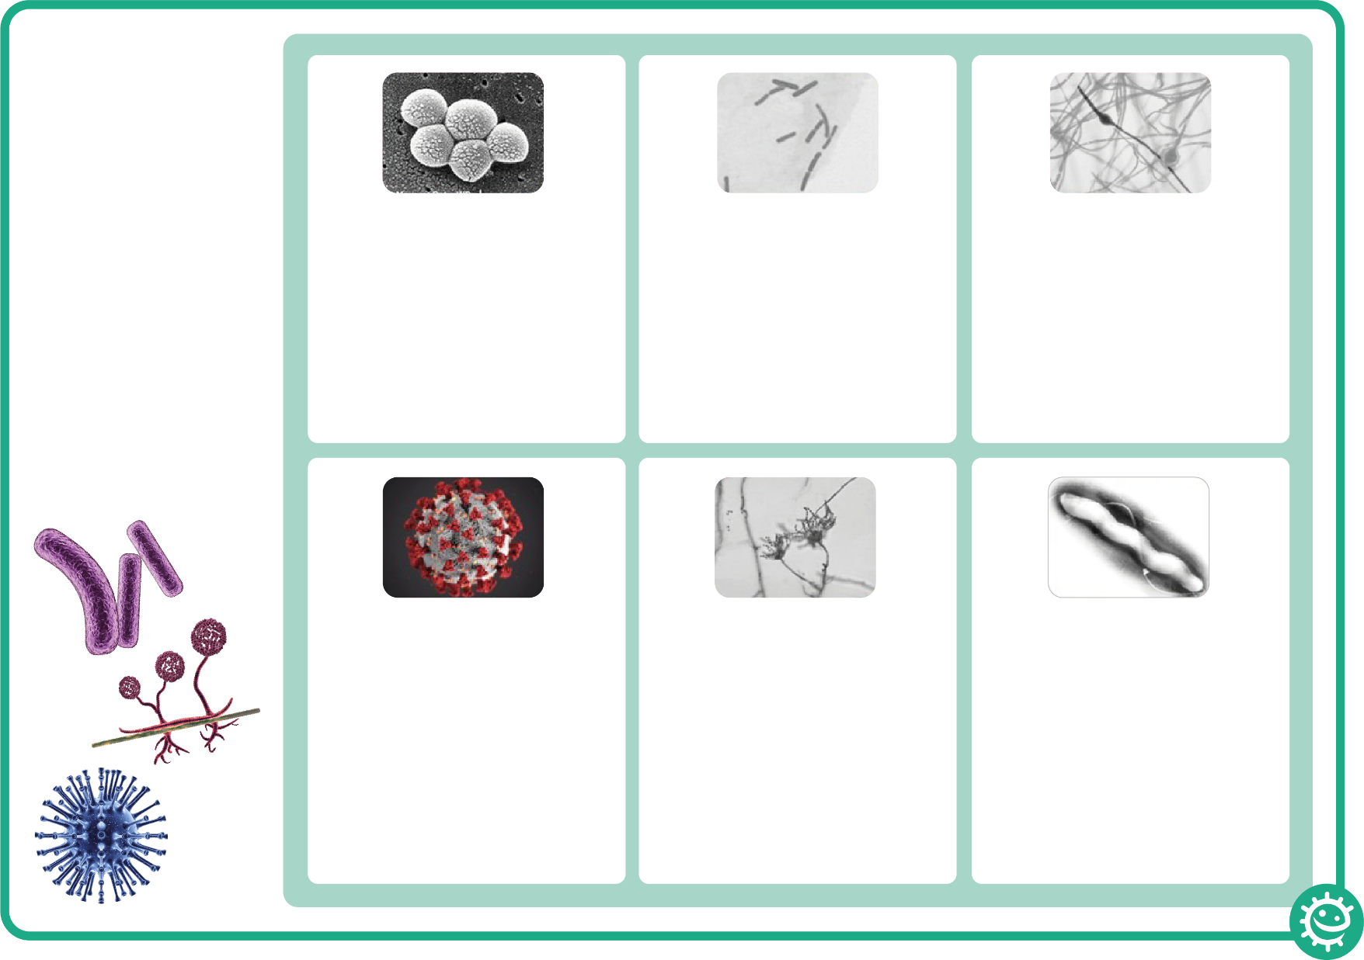
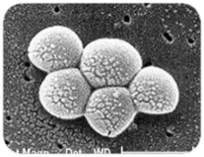
My name is SARS-CoV-2
although some people call me Covid-19. People don’t really like me because I can make them really ill. I easily spread from person to person through coughing and sneezing. What type of microbe am I? SARS-CoV-2 (COVID-19) is:
______________________
My name is Staphylococcus. I am round in shape and I like to live in your nose or armpit. If I live on your skin I can give you spots. If I get into your bloodstream I can
make you ill. What am I?
Staphylococcus is a:
______________________

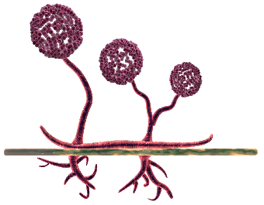
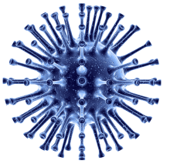
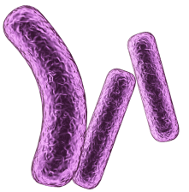

What Microbe am I?
There are 3 different
types of microbe –
bacteria, viruses
and fungi.
From the pictures and
descriptions, can you
work out which
microbe is which?

