
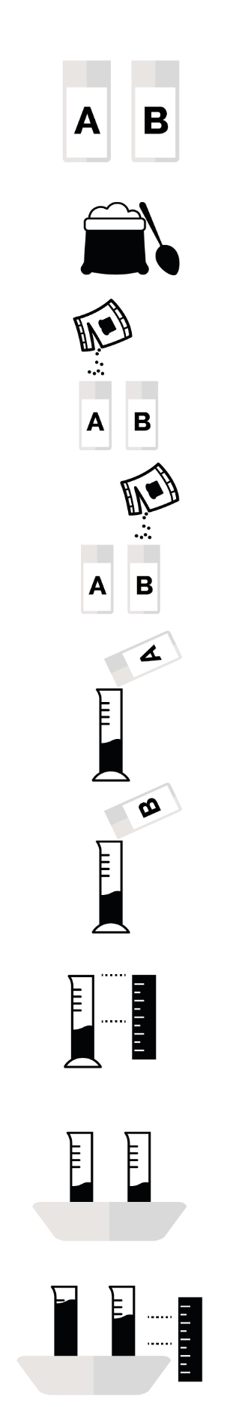

SH1 – Yeast Races Experiment Handout

Yeast Races
Experiment
- Label one of the plastic cups A and one B
- Add four teaspoons of flour to each cup
- Add enough yeast solution to cup A and stir thoroughly until it looks like thick milkshake
- Add enough yeast solution and sugar to plastic cup B and stir thoroughly until it looks like thick milkshake
- Pour the contents of cup A into graduated cylinder A until it reaches about 30ml
- Pour the contents of cup B into graduated cylinder B until it reaches about 30ml
- Record the exact height of the dough in each cylinder
- Place both measuring cylinder into a basin of hot water
- Measure the height of the dough every 5 minutes for 30 minutes

