

SH1 – Historic Heroes Student Handout

Historic Heroes
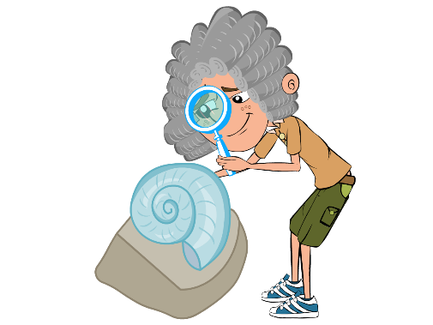
Edward Jenner was born in 1749. As a young boy, Edward
enjoyed science and nature, and spent hours on the banks
of the River Severn looking for fossils. In 1770, at the age of
twenty-one, he began training as a doctor in London. Two
years later Edward began to practise as a doctor in his
hometown of Berkeley, Gloucestershire.

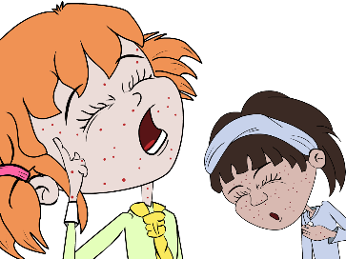
During this time, people were terrified of a horrible disease
called smallpox. People who got this disease got severe
scarring from lesions and sometimes even died. As a
doctor, Edward Jenner listened to what the country people
said about smallpox. They believed that someone who
caught a different mild infection called cowpox from their
cows would not catch the much more serious smallpox.

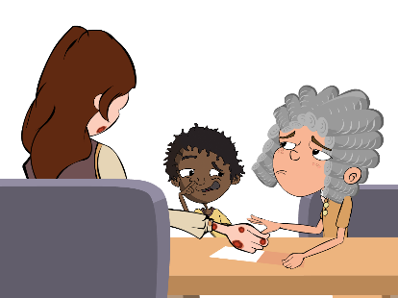
Jenner carried out an experiment to see if the people were
right. In 1796 a milk maid called Sarah Nelmes came to
Jenner complaining of a cowpox rash on her hand that she
caught from Blossom the cow. Jenner took some of the pus
from the cowpox rash on Sarah’s hand. He scratched some
of the pus into the hand of an 8-year-old boy called James
Phipps, the son of his gardener. James fell ill with cowpox
but soon recovered.
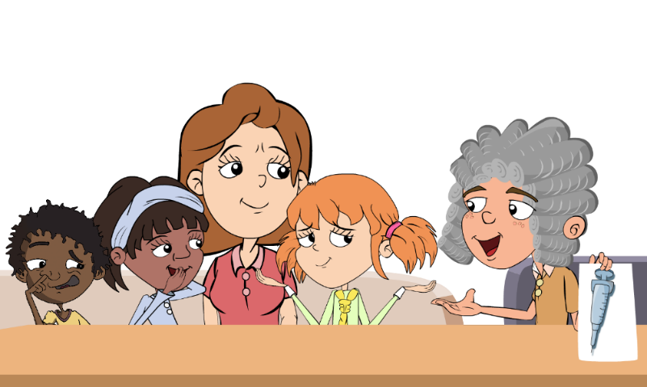
Jenner then took some pus from someone with the dangerous disease, smallpox, and scratched this into James’ arm. James developed a scab but did not develop smallpox, Jenner’s theory was right. Jenner's discovery came to be known as vaccination from the Latin word for a cow: vacca. Jenner went on to vaccinate all the local children with the cowpox to stop them from getting the more dangerous smallpox disease.

