

SH2 - Breaking the Chain of Infection Poster

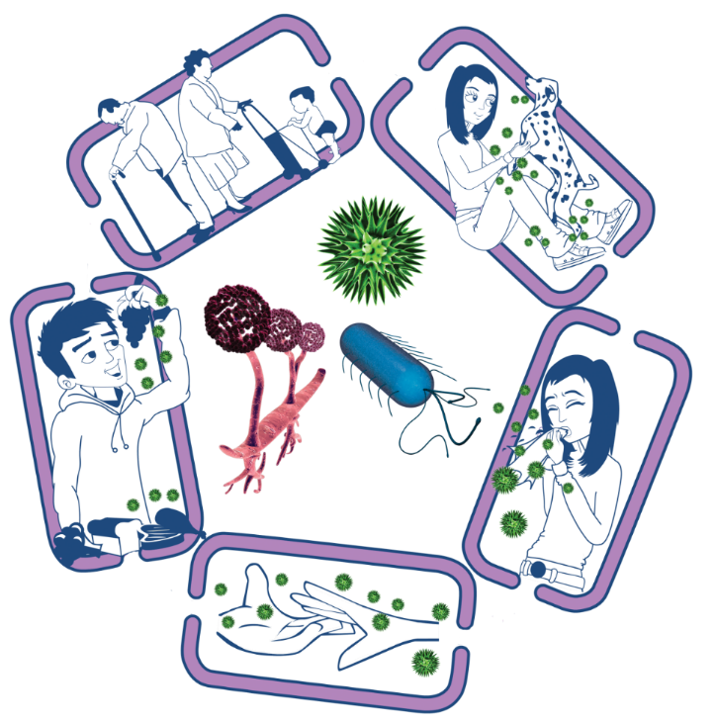
Source of infection
• Isolate infected people
• Take care with raw food
• Wash pets regularly
• Treat pets for pathogens when needed
• Dispose of nappies and soiled clothing appropriately
Way out for microbes
Prevent any:
• Coughs and sneezes
• Faeces
• Vomit
• Bodily fluid
Getting onto surfaces or hands
Spread of infection
• Wash hands thoroughly and regularly
• Cover cuts and open sores
• Take appropriate precautions during
sexual activity

The Chain of Infection
People at risk from
infection
Everyone:
• Take appropriate vaccinations
High risk people:
• Keep away from people who are infectious
• Take extra care about cleanliness
• Take extra care when cooking and preparing food
Way in for microbes
• Cover cuts and open sores with a water proof dressing
• Cook food properly
• Take care to drink only clean water

