

SH3 - Hand Washing Poster

Wash your hands with soap and water for 20 seconds
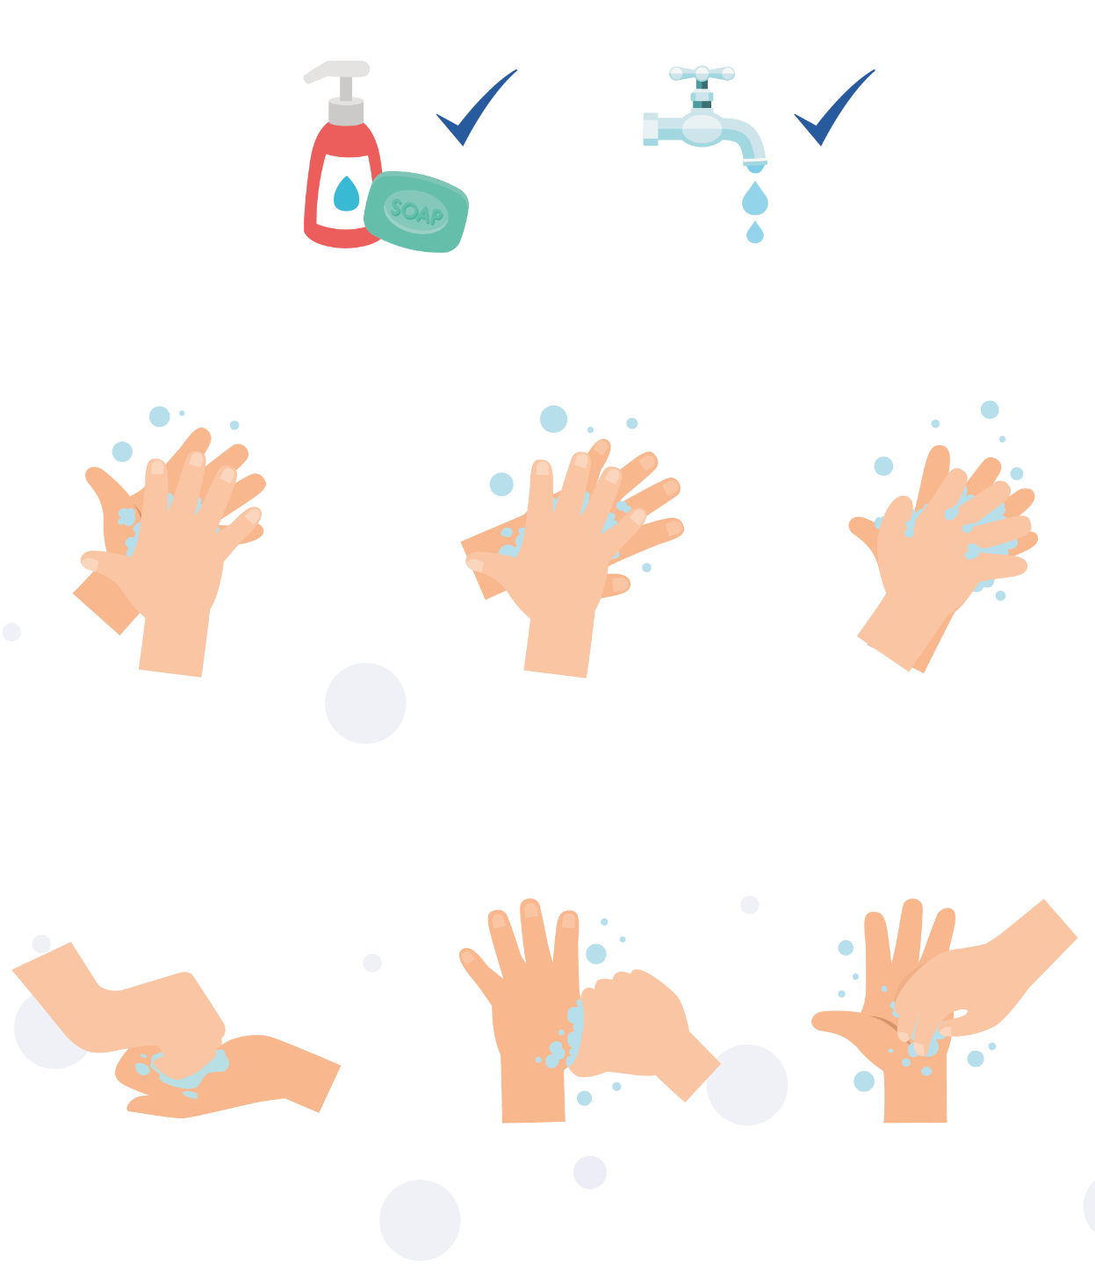

1
2
3

Palm to palm
Back of hands
Between fingers
4
5
6

Back of fingers
Thumbs
Tip of fingers
To help keep time, sing ‘Happy Birthday’ twice

