
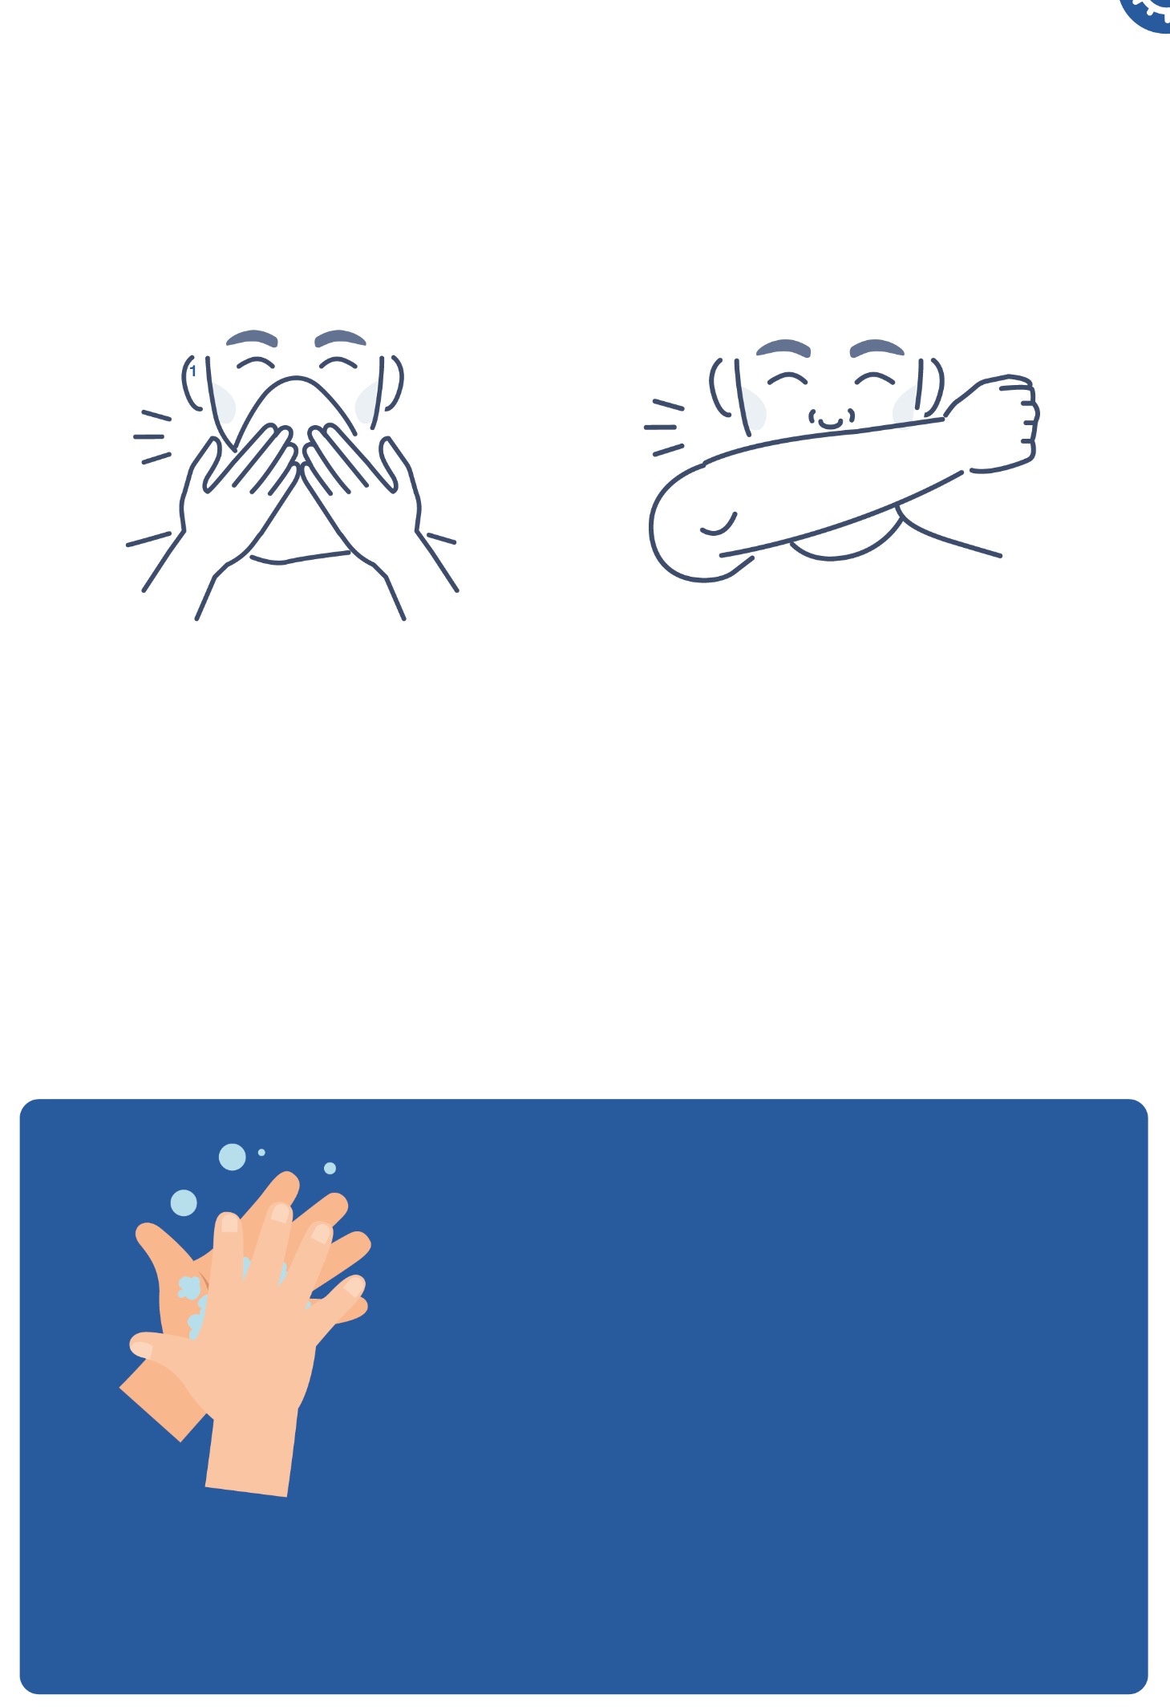

SH1 - Respiratory Hygiene Poster

Cover your coughs and sneezes
1

Use a tissue if you have one
If you have no tissue use your sleeve

2
Wash your hands for 20 seconds with soap and water.
To help keep time - sing ‘Happy Birthday’ twice

