
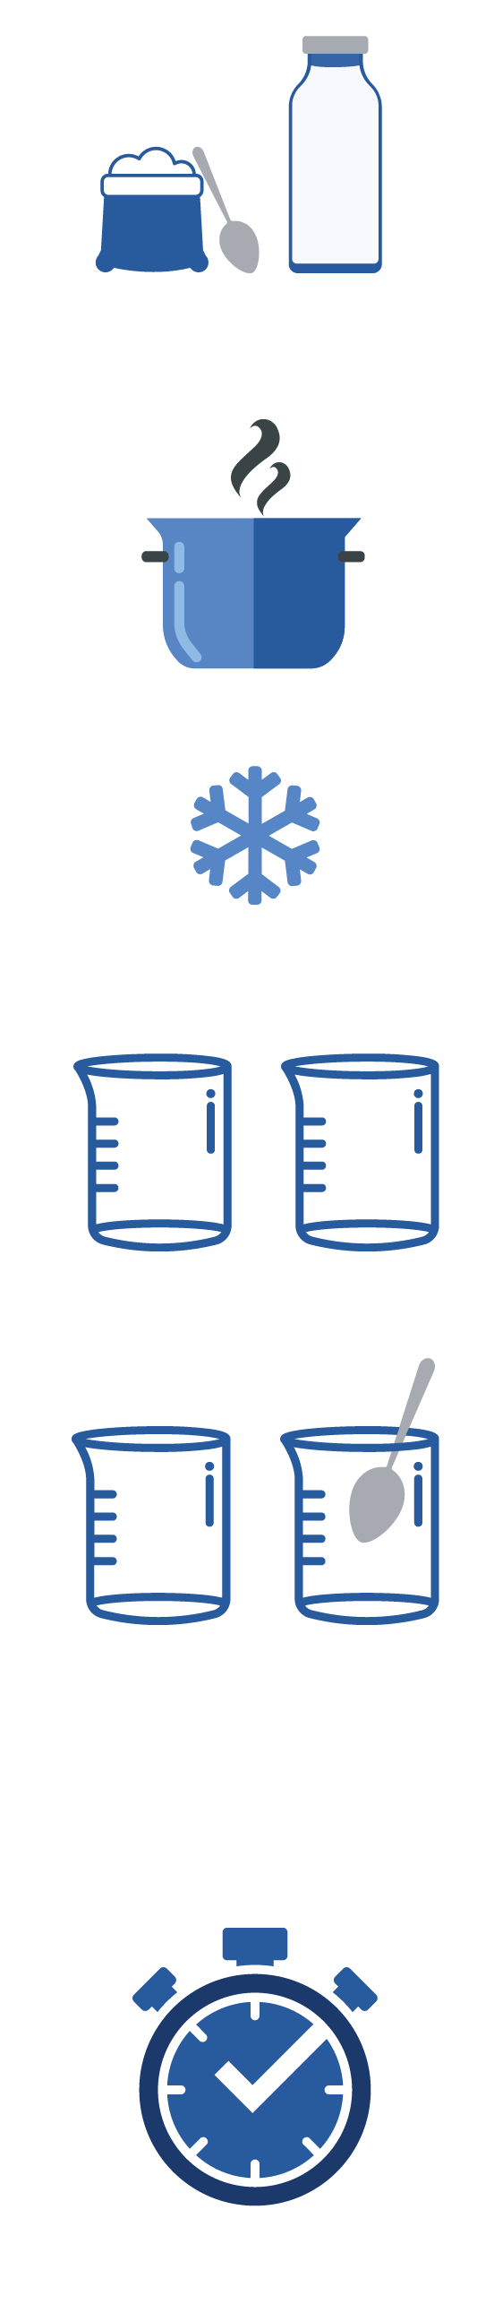

SH1 - How to Make Yoghurt Instructions

How to Make Yoghurt
Experiment
- Add two tablespoons of powdered, skimmed milk to 500ml (one pint) of whole milk.

- Bring the mixture to a boil over medium heat for 30 seconds, stirring constantly to kill any unwanted bacteria present. Take care it does not overflow!

- Cool to 46-60°C.

- Divide the cooled mixture into 2 sterile beakers and label test 1 and test 2.
Test 1 : add 1-2 teaspoons of live yoghurt
Test 2 : add 1-2 teaspoons of sterile yoghurt

- Stir both mixtures well using a spoon previously sterilised by standing it in boiling water.

- Cover each container with aluminium foil.

- Incubate the mixtures at 32-43°C in a hot water bath, for 9-15 hours until desired firmness is reached.

