
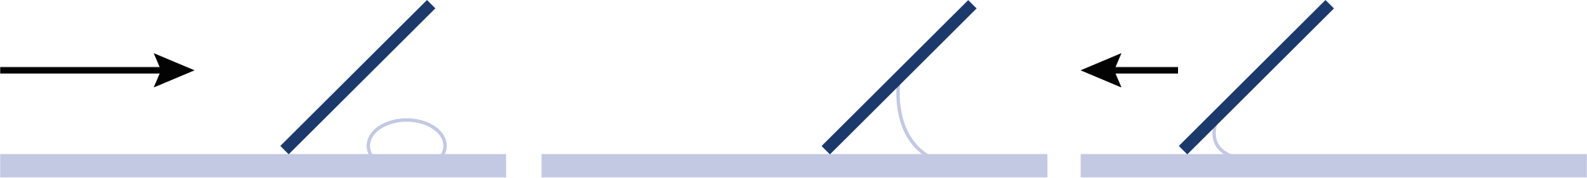

SW2 - Microscopic Yoghurt Observation Sheet

How to Make Yoghurt
Procedure
Test 1
- Place a small drop of yoghurt onto one side of a glass microscope slide.
- Taking a second clean slide, streak the yoghurt across the length of the slide creating a thin smear.
- Leave the slide to air dry and then pass once through a Bunsen flame in order to heat fix the smear.
- Cover the smear with a few drops of Methylene Blue and leave for 2 minutes.
- Wash off any excess stain by running under a slow running tap.
- Cover smear with a cover slip and examine the slide under a high powered microscope.
- Record your observations below.

Test 2
- Repeat steps 1-7 above using sterile yoghurt instead of live culture yoghurt.

How to prepare a smear:
Yoghurt
1. Approach
2. Adhesion
3. Advancement
Observations
What did you see in the yoghurt smear?
__________________________________________________________________________________________________________________
What did you see in the sterile yoghurt smear?
__________________________________________________________________________________________________________________
What, in your opinion, caused the difference?
__________________________________________________________________________________________________________________

