

SW2 - World Map Activity
Russia
Far East
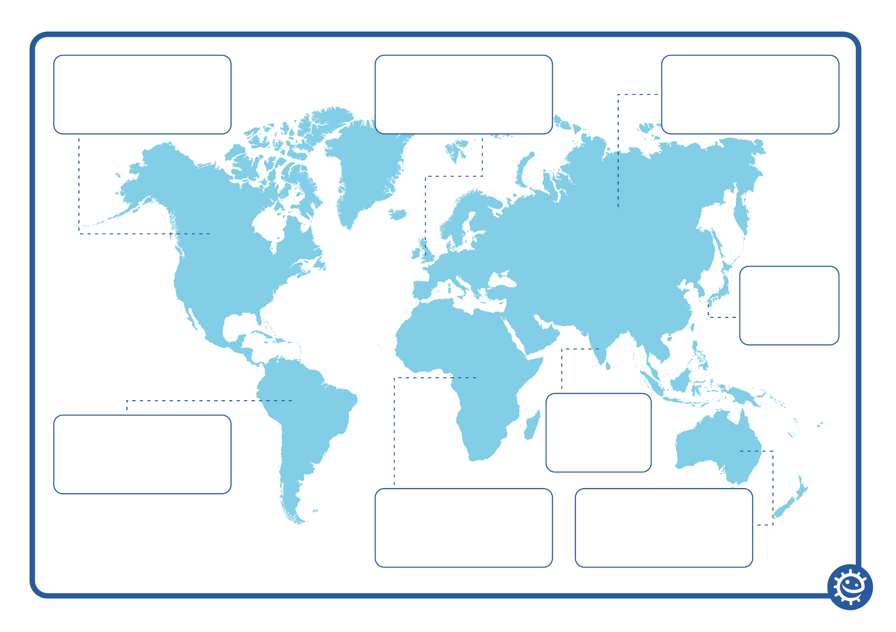
Asia
Australia

Western Europe
Africa

Canada
S. America

