

SH1 - How Big is a Microbe?
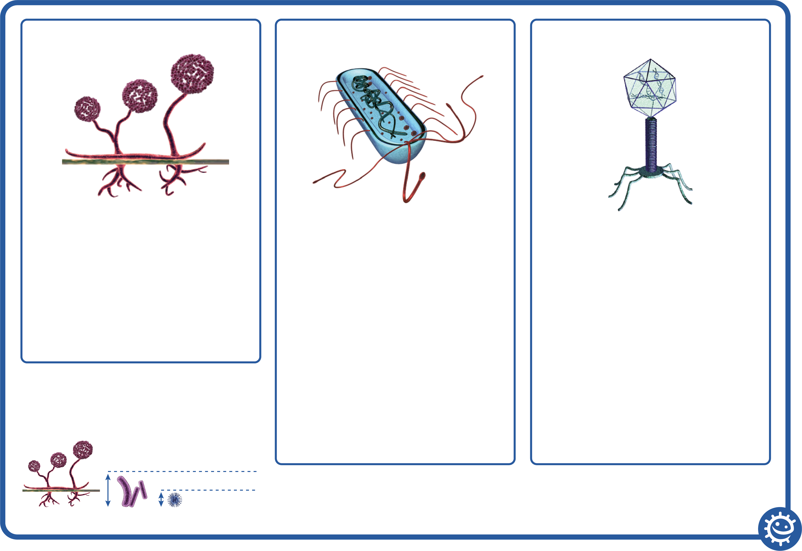
Viruses
Glycoproteins
Nucleic acid
Capsid
Viruses are NOT free living – they MUST live inside another living cell/organism
Capsid
Double lipid layer holding the cells
genetic material.
Glycoproteins
These serve 2 purposes:
- Anchor the virus to the host cell.
- Transport genetic material from the
virus to the host cell.
Nucleic acid
Either DNA or RNA material, but viruses rarely contain both. Most viruses contain RNA material.
Bacteria
Chromosome
Cytoplasm
Cell membrane
Cell wall
Bacteria are free living and are found everywhere
Chromosome:
Genetic material (DNA) of the cell.
Cell wall:
The cell wall is made of peptidoglycan and maintains the overall shape of a bacterial cell.
Cell membrane:
Lining the inside of the cell wall providing a boundary for the contents of the cell and a barrier to substances entering and leaving.
Cytoplasm:
Jelly like substance inside of the cell
holding the contents.
Fungi
Sporangi-ophore
Sporangia
Rhizoids
Sporangia:
Spore producing body.
Sporangiophore:
Filamentous stalk on which the
sporangium forms.
Rhizoids:
The sub-surface hyphae are specialized for food absorption.
Microbe size
Viruses 1x
Fungi 100x
Bacteria 20x

